January 1, 2023

Sem Plasmeijer

Fontys Hogescholen ICT

Risk ANAlysis

Scrimfinder

Contents

1. trust Boundary 2

2. Misuse cases 3

2.1 cases 3

4. Roles and Credentials 4

# trust Boundary

Trust Boundary or Boundary Crossing is a way of describing where data and scripting changes its level of trust. Trust meaning level of privilege or the uncertainty of an action within the system. Examples are user input or pulling from an un-verified API but might also describe parts where an execution gets more privilege to the system, think of access to root.

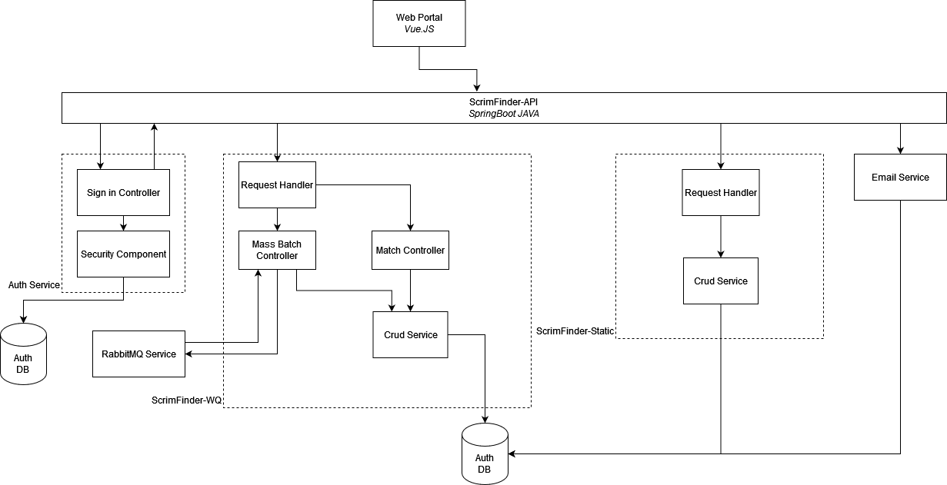

1st boundary

2nd boundary



The first boundary in ScrimFinder is set at the frontend, like many other web applications ScrimFinder makes use of user input to create, delete and get different data points. To secure this boundary we can implement our own security features but most if not, all will be handled by Vue.JS tested security protection. To harbour these protections SonarCloud will be used to find potential vulnerabilities.

The second trust boundary defines access to the database. The main ScrimFinder-API has two purposes: monitor, log and observe the application and secure the and verify incoming data. After crossing the 2nd boundary API’s and data can be stored within the database.

# Misuse cases

Opposite of use cases, misuse cases are meant to find potential malicious outcomes with a system and finding ways to reroute, mitigate or prevent these cases. ScrimFinder has three main goals:

1. Connect clubs.
2. Create tournaments / matches.
3. Manage tournaments / matches.

## cases

**Misuse case 1:**

|  |  |
| --- | --- |
| Summary | A club creates an account with false information. |
| Path | Create an account, provide wrong information. |
| Triggers | When creating a match, the second team might be put in jeopardy either through unsafe travel or extra costs due to faulty information. |
| Mitigation | Collaboration with KNZB regarding club information, set up verification team, don’t allow for sign up and only use invitations |

**Misuse case 2:**

|  |  |
| --- | --- |
| Summary | Tournament are created but not all teams are given the same number of matches or opportunities by the tournament creator. |
| Path | Create a tournament, create matches with some teams receiving an advantage. |
| Triggers | Puts fair play in jeopardy |
| Mitigation | Tournament can only be created using the automated tool after a group of verified teams has been added to it. |

**Misuse case 2:**

|  |  |
| --- | --- |
| Summary | Teams don’t give correct match results |
| Path | Match has been played, 1 team provides score, score is not correct |
| Triggers | Puts fair play in jeopardy |
| Mitigation | Both teams and the referee need to verify the score of the match. |

# Roles and Credentials

Within the chapter we will define which role has which authorization to the main use cases that are defined within ScrimFinder. There is also a fifth role Administrator, but this role is reserved for quick edits or when immediate change is required. This role has access to the whole system and is there as a safeguard for exception cases.

|  |  |  |  |  |
| --- | --- | --- | --- | --- |
| Access | Club | Team | Referee | Player |
| Create Club |  |  |  |  |
| Create Team |  |  |  |  |
| Create Tournament |  |  |  |  |
| Create Matches |  |  |  |  |
| Assign Team Head |  |  |  |  |
| Assign Team Coach |  |  |  |  |
| Assign Tournament Organizer |  |  |  |  |
| Verify Match Results |  |  |  |  |
| Manage Match Data |  |  |  |  |
| Manage Match Information |  |  |  |  |
| View Player Profile |  |  |  |  |
| View Team Profile |  |  |  |  |
| View Club Profile |  |  |  |  |
| View Referee Profile |  |  |  |  |
| View Tournament |  |  |  |  |
| View Match |  |  |  |  |