STUDENT INTERN CURRICULUM VITAE

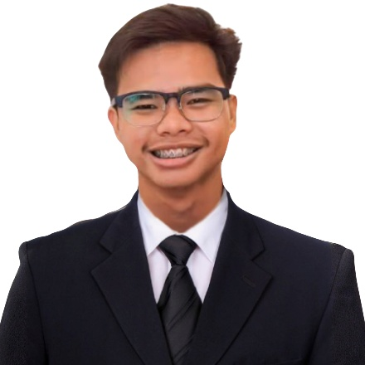

JIRO LUIS FANDIÑO MANALO
821 Purok 4 Barangay Santa Rosa
Alaminos, Laguna (4001)
jiroluis.bizz@gmail.com
+639991810510

EDUCATIONAL BACKGROUND
Baccalaureate: BACHELOR OF SCIENCE IN INFORMATION TECHNOLOGY
Pamantasan ng Lungsod ng San Pablo
Barangay San Jose, San Pablo City Laguna
2022- Present

Secondary Education: St. Joseph School
141 Colago Avenue San Pablo City, Laguna
2016-2022

Elementary Education: Alaminos Elementary School
Alaminos, Laguna
2010-2016

CONFERENCE(S), TRAINING(S), SEMINAR(S) ATTENDED
“CISCO: Introduction to Data Science Certification,” Cisco Networking Academy, Self-Paced, January 4, 2026
“CISCO: Data Science Essentials Certification,” Cisco Networking Academy, Self-Paced, January 5, 2026
“CISCO: Data Science Essentials with Python Certification,” Cisco Networking Academy, Self-Paced, January 5, 2026

SKILL(S) AND TALENT(S)
Technical Skills
- Computer Literate
- Knowledge in MS Office
Personal Skills
- Ability to adapt to the environment
- Oral and Written Communication
- Goal Oriented
- Time Management
Programming Skills
- Basic programming concepts
- Web based programming
- Writing simple algorithms

Job Title: VICE PRESIDENT - EXTERNAL
Agency: College of Computer Studies and Technology Student Council
Address: Brgy. San Jose, City of San Pablo, Laguna
Date: 2024 – 2025

Job Title: PRESIDENT
Agency: College of Computing Sciences and Engineering Student Council
Address: Brgy. San Jose, City of San Pablo, Laguna
Date: 2025 – Present

Job Title: FREELANCE IT DEVELOPER
Agency: Self-Employed / Freelance
Address: Barangay Santa Rosa, Alaminos Laguna
Date: 2025 – Present
EMPLOYMENT DETAILS

I hereby certify the above information is true and correct.

JIRO LUIS FANDIÑO MANALO
02/02/2026

Data Privacy Statement: I agree to the collection and processing of my data for the purpose of facilitating the application as student intern in accredited companies. I understand that my personal information is protected under RA 10173 otherwise known Data Privacy Act of 2012, and that I am required to provide truthful information.

