

LocalGigs
Final Year Project Interim Report

DT211c
BSc in Computer Science (Infrastructure)

James Ward
Mark Foley

School of Computing
Dublin Institute of Technology



Abstract
The objective of this project is to enable people to find upcoming live music events that are taking place in their geographical location. The person will be able to get directions to and book tickets for these live music events. The application will make recommendations to the person based on their musical interests and the musical interests of other persons with similar taste. The persons musical taste will be determined by the artists they have in their Spotify playlists. The weighting for the predictions made will be based on the number of tracks the person has for any given artists. The more tracks the person has for these artists in their playlists the greater the preference the person has for these artists. Therefore, similar artists can be recommended to the person based on the interests of other persons who have a similar liking for these artists but who also have artists unknown to the person in their playlists.

This project will consist of four sections. The first of these sections will be the predictive analytics system. This system will be developed mainly in the programming language Python. This section of the project will handle the data processing, taking in data from the user’s profile, sorting and cleaning this data and using a pre-trained machine learning model that will implement a collaborative filtering approach to make recommendations to the user. This model will continue to learn with each prediction it makes adding each users’ information to the model making it increasingly more accurate with each user. This model will be hosted serverless in a cloud service provider so as the model is only operational when required.

The second part of this project is the backend controller built in Python using the Django framework. This section of the project will handle the connectivity between the machine learning model, the front end, the mobile application and the database. This section will be responsible for scraping the user’s musical preference data from their Spotify accounts and data from the Ticketmaster API for the events. It will be used to create API endpoints that will be utilized by all other sections of the project. It will handle the database management for the user facing and interactive parts of the application. The machine learning model will have its own database to optimize performance. This section will also be hosted in one of the cloud service providers and will be deployed using Docker.

The third part of this project will be the Web Application, it will be developed using the Angular framework. This part of the project will provide the users with a profile style interface where they can add details about themselves and view events that have been recommended to them. They will be able to save these events for future reference. The user will also be able to get directions to the venue using a map provided by Leaflet. The user will also have the ability to search for events themselves. This part of the project will also be deployed to a cloud service provider using Docker.

The fourth and final part of this project will be the Android mobile application, this part of the project will be developed using the Ionic framework which utilizes Angular on top of Cordova. Unless there is time, this application will provide a rudimentary interface that will offer some of but not all the functionality of the website. The recommended events will be displayed to the user along with the events they have saved. They will have a map and be able to locate and get directions to the events. This part of the projects will be deployed to the google play store for users to download.

Link to repository: https://github.com/SemajDraw/LocalGigs

Contents
Abstract 2
1 Project Statement 5
1.1 Project Background 5
1.2 Project Objectives 6
2 Research 7
2.1 Background Research 7
2.2 Alternate Existing Solutions 9
2.3 Technologies Researched 9
3 Approach and Methodology 17
3.1 Software Development Lifecycle 17
3.2 Predictive Data Analytics Software Lifecycle 19
4 Design 20
4.1 Front End 20
4.2 Back End 21
4.3 Database 23
4.4 Deployment 24
5 Prototyping and Development 25
5.1 Website 26
5.2 Ionic App 31
5.3 Predictive Analytics Model 32
5.4 Deployment 33
6 Testing 34
7 Issues and Risks 34
7.1.1 Attaining and Processing Quality Data 34
7.1.2 Picking the right model 35
7.1.3 Processing power 35
7.1.4 Overfitting and Underfitting the model 35
7.1.5 Integrating every user with the model 36
7.1.6 Request limits on free API’s 36
7.1.7 Deployment cost 36
7.1.8 Learning new languages and frameworks 37
8 Plan and Future Work 37
Bibliography 38

Project Statement
The overall objective for this project is to build a web and mobile application that will implement a predictive analytic model to recommend live music events to users. It will provide the user with an enjoyable and easy to use platform with which they can utilize to discover, organize, locate and get directions to these music events. These events may be for their favourite artists, the artists they like, but would not necessarily go out of their way or remember to book a gig for, and to recommend events to the user for artists they may not know or would never have thought to go and see, but will probably like. I have decided to take this approach to providing this service based on many of the most popular media distribution platforms today. Predictive analytics plays a crucial role in the modern age of media distribution, distributers such as Spotify, Netflix and YouTube to name but a few rely heavily on their predictive models to keep users interested in their service and to keep them streaming their content for hours on end. They do this by constantly recommending media to the user that they believe the user will enjoy. These recommendations are based on the interests and preferences of the user and other users with similar interests.

My application will make its predictions by gathering data from the users Spotify playlists. This data will be the artists the user has in their Spotify playlists and the number of tracks for these artists. Weighting for the artists will be determined based on the number of tracks a user has for any given artist. The data gathered will be cleaned and processed into a format that is usable by the predictive model. The model will operate on a collaborative filtering approach very similar to the way Netflix and Spotify recommend media to their customers. Once the model has made its predictions these predictions will be queried against Ticketmaster’s API in order to find all upcoming events that the user may be interested in. The results of these queries will be displayed to the user in the web and mobile applications where the user can purchase tickets from Ticketmaster, listen to the artist on their social platforms such as YouTube and Spotify and get directions to the venue.

Project Background
Based on my own experiences of missing out on seeing artists perform live due to not having easy medium to search through, and the countless times I have heard from my peers that they also have had a similar experience. I decided to develop this application so that any person who wishes to use it may never miss out on the next great musical event in their location. Part of the intention of this application is to try and draw attention to some of the artists that are less well known to the user. This will enable the user and the artist can benefit in kind by the increase in awareness of the artist. As a lover of music and a musician I can understand this problem from both angles. More times than I can remember I have found out about artists, that I know well, and not so well, but very much like who have recently played shows near me that I would have attended had I known in advance. I hope through developing this application to try and bridge some of the void that exists in today’s music industry and the musical circles, to provide users with the ease of use and access that we all crave in this fast-paced modern world and to provide the artists with another platform through which they can be freely publicised. In the age of digital media distribution where artists receive minimal royalties for their work, they need all the free publicity and attendees at their gigs they can get.

Project Objectives
- Source and obtain data about the current listening habits of Spotify users
Gather the initial data required to train the predictive model, this data needs to be authentic and plentiful in order to get an accurate map of the likes and dislikes of many different types of people. As musical taste is so subjective the data needs to cover a wide variety of artists and their respective genres.

- Clean the data
The data that is gathered will require some pre-processing to filter down the data and remove any irrelevant features. This is essential to making accurate predictions. Noisy data could drastically alter the predictions that are made to the user in a non-productive manner.

- Build and train the predictive model
The predictive model needs to be built and trained with the clean data in order to make predictions for the user.

- Generating predictions and continuous learning
The model will be supplied with data from the controller that will be cleaned, and predictions will be made against it. This data will also be used to train the model, implementing the user’s preferences into its future predictions.

- Query API with predictions
The predictions will be user to make queries to the Ticketmaster API to find upcoming events for the predicted artists

- Display the available predictions for use
The predictions that return data from the Ticketmaster API will be displayed to the user in the mobile and web applications. From there the user will be able to purchase tickets to the events, listen to the recommended artists and get directions to the venue.

Research

Background Research

Music has long been a medium that for the most part brings people together. It is capable of making us feel complex emotions, that each one of us is able to perceive similarly but still have our own unique opinion on. It can make us feel happy when were sad or give us energy when we are tired. While music has the propensity to bring people together, it definitely has the capabilities to drive a wedge between certain cliques. For example, your average metal head is going to have a predisposed bias against a Justin Beiber fan solely based on the musical preferences of that person, as people tend to knowingly and unknowingly gravitate towards people who have similar musical interests and tastes. Musical interests and preferences have been linked to a number of interesting factors.

- Age, people of the same age group tend to listen to a similar music from a similar era.
- Social and cultural influences, people generally listen to the music that is created within their own culture. For example, it is not every day that you hear Mongolian throat singing or Chinese pop music on western radio.
- Developmental influences, the music a person listened or is listening to in adolescence plays a major role in their musical taste and preferences for the rest of their life.
- Individual differences, while all of the above factors play a large role in determining a person’s musical preferences there are still vast differences from person to person which is what makes the music we listen to such a personal aspect of our lives.

These are all important factors to take into account when recommending music to a person. One successful approach to this problem is to essentially, have the users train the model that will make the recommendations to them this is know as Collaborative Filtering.

The Role of Predictive Analytics in Music

Media distributions platforms such as Spotify and YouTube have drastically changed the musical listening habits of people. For the first time in history companies are able to see what music you are listening to and when you listen to it. What music you listen to sometimes, what music you listen to all of the time and everything in between. In the past the music you enjoyed was spread by word of mouth or by wearing wristbands of concerts or festivals you had attended. The record companies and radio stations knew when and what songs were being played and the number of CD, cassette or vinyl sales and so had a reasonable estimate of the listening habits of people, but nothing on the scale of today’s media giants. Thanks to the rapid growth of these media distributers, the music analytics business today has an estimated worth of over two billion euro. At first glance these companies are taking business away from the record companies but the data they are generating about artists is making it easier for record companies to pick out artists who are generating the right “buzz” in the music scene and sign them to deals. Metrics such as Twitter followers likes on Facebook, sales via BandCamp and listens on Spotify can give record companies fairly accurate predictions of future prospects.

Recommending the right music to users is a large part of what makes Spotify so popular and successful. YouTube and SoundCloud both provide users with platforms to search for music, but YouTube is cluttered with other non-related material and SoundCloud does have a recommendation system in place, but it is nowhere near as effective as Spotify’s, this is in no small part to the number of users Spotify has. Spotify’s recommendation model is based on a Collaborative Filtering approach. This type of predictive analytic model combines the data from all users into one huge dataset that predictions are made against. The model examines the listening behaviour of users and if their listening behaviours are largely similar their tastes are probably similar. Conversely, if two songs are listened to by the same group of users, they probably sound similar. This kind of information can be exploited to make recommendations. Pure collaborative filtering approaches do not use any kind of information about the items that are being recommended, except for the consumption patterns associated with them, making them content-agnostic. (Sander Dieleman, n.d.) Spotify does incorporate number of other predictive models into their predictive system, an example being Content Based recommendation. This is in order to help mitigate against the cold-start problem which is associated with Collaborative Filtering recommenders.

Alternate Existing Solutions

BandsInTown

The only other application that I found that is similar to the one that I am proposing is a web and mobile app called BandsInTown. It can be found at the following link https://www.bandsintown.com/. While this app is similar to mine, it does not appear to implement any sort of recommendation system. It merely accesses the user’s location and displays the events that are on in that location. It does not have any user profile and the user logins in using Facebook. This appears to be just a method of gaining access to a person’s Facebook profile data as the website does not appear to customize the user experience after logging in via Facebook.

Technologies Researched

Recommendation Systems

Collaborative Filtering

Collaborative filtering is a general technique for exploiting the preference patterns of a group of users to predict the utility of items for a particular user. Three different components need to be modelled in a collaborative filtering problem: users, items, and ratings. Most collaborative filtering methods fall into two categories: Memory-based algorithms and Model-based algorithms. (Jin, n.d.)

- Memory Based Algorithms – Store the training data that has already been rated in a database and from this data the rating of a user for a specific item is predicted based on corresponding users from the training data that have similar tastes.
- Model Based Algorithms – Statistical models are learned from the ratings of the users in the training data and predictions are made for test users against the trained model.

There are many approaches that can be taken when implementing a collaborative filtering system two of which are user-based and item-based. User-based models find users who have similar tastes based on the items they have rated, or in the case of this project their listening behaviour mainly the artists they listen to. Item-based, items or artists are recommended to the user based on the similarity of the items to other items. In general, all collaborative filtering approaches assume that users with similar taste would rate an item similarly. This means that in all approaches some form of clustering is being exploited, either explicitly or implicitly. Compared with memory-based approaches, model-based approaches provide a more principled way of performing clustering and is also often much more efficient in terms of the computation cost at the prediction time. (Jin, n.d.) As one of my concerns for this project is the computational power that will be required to make predictions when such a large dataset is involved, I have thought it a prudent decision to choose a model-based approach to building my CF recommendation system to save on time and cost at recommendation time. There is one significant drawback to the collaborative filtering recommendation system and that is the cold-start problem. The cold-start describes the difficulty in making recommendations to users for new items or items that are not popular but may interest the user, and for a system that has not yet acquired a large enough data set.

Content Based

Content-based recommendation systems recommend an item to a user based upon a description of the item and a profile of the user’s interests. While a user profile may
be entered by the user, it is commonly learned from analysing a set of documents and/or descriptions of objects previously rated by a user and building a model or profile of user interests based on the features of the objects rated by that user. The profile is a structured representation of user interests, adopted to recommend new and interesting items. Items that can be recommended to the user are often stored in a database table. A variety of learning algorithms have been adapted to learning user profiles, and the choice of learning algorithm depends upon the representation of content. (Pazzani and Billsus, 2007), (Lops et al., 2011) I had initially though that this approach might be right for my project but after further research I discovered that it does not really suit music recommendations which generally rely on a rating system to make recommendations, ideal for a collaborative filtering approach. Content based systems tend to work better with text descriptions of items. However, creating a hybrid recommendation system by combining a content based and collaborative filtering approach has been shown to produce quite good results and is the method that Spotify utilize. The content-based recommender helps mitigate against the cold-start that collaborative filtering models can be affected by.

Machine Learning Algorithms

K-Nearest Neighbour

The K Nearest Neighbour (KNN) algorithm is the standard approach to similarity-based learning. Similarity based learning uses a distance metric such as Euclidian or Manhattan Distance to determine the distance between two points in a feature space. This distance between two points determines how similar they are, the closer they are the greater the similarity. KNN is a non-parametric lazy learning algorithm, the default distance metric used in the algorithm is Euclidian Distance. This is one of the simplest classification and regression algorithms that still provides good results and is commonly used. KNN uses a database of data points that are separated into classes, these classes are used to predict the classification of a new data points based on its distance from the K nearest points within the feature space. K is a number that the developer sets when implementing the algorithm.

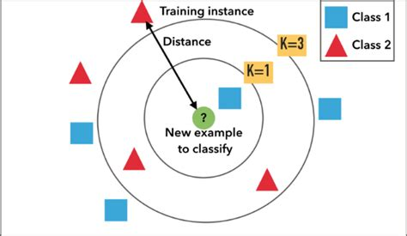
Figure 1: K Nearest Neighbour

Bayesian Clustering

Bayesian Clustering is a type of hierarchical clustering algorithm, these algorithms are one of the most commonly used approaches to an unsupervised machine learning model. These algorithms output binary trees whose leaves are data points and whose internal nodes represent the nested clusters of items. Bayesian Clustering assumes that similar users will rate the same type of item in a similar way. This allows for users to be grouped together into clusters according to the ratings they give for these items. Given a user class ‘z’, the preferences for different items expressed as ratings are independent, and the joint probability of user class ‘z’ and the ratings of items can be written as the standard naïve Bayes formulation. (Jin, n.d.)

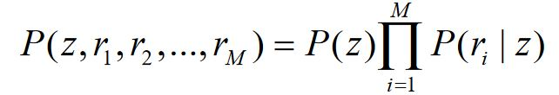
Figure 2: Naive Bayesian Formula

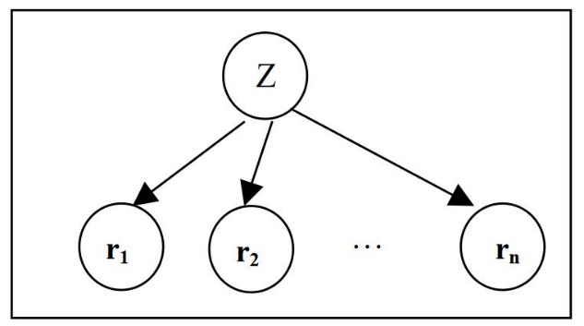
Figure 3: Bayesian Clustering

Matrix Factorization

Matrix factorization also known as Matrix Decomposition is a discipline of linear algebra that is used to factorize a matrix into a product of matrices. (“Matrix decomposition,” 2018) In other words it factorizes a large complex matrix into sub matrices which can be resolved to the original matrix using the dot product of two or more of the sub-matrices. There are two common methods when implementing matrix factorization LU and QR factorization. LU is used to factorize a square matrix into L a lower triangle matrix and U and upper triangle matrix. QR is used to factorize an X x Y matrix into Q a square matrix and R an upper triangle matrix. Matrix factorization is extremely useful when dealing with a very large sparse matrix like the type required by a collaborative filtering system, helping to greatly reduces computation time and reveal hidden information about the relationship between the users and items in the matrix.

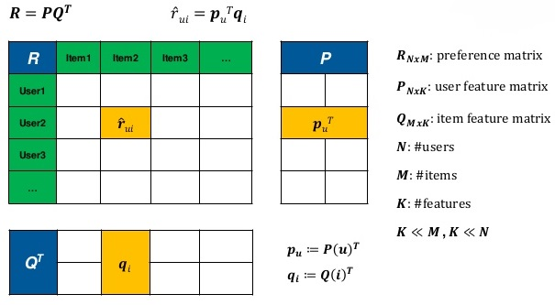
Figure 4: Matrix Factorization

Singular Value Decomposition

Singular value decomposition is a form of matrix factorization, it takes a rectangular matrix of gene expression data (defined as A, where A is a n x p matrix) in which the n rows represents the genes, and the p columns represents the experimental conditions. The SVD theorem states:

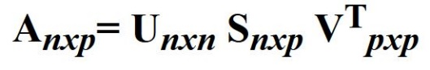 Where 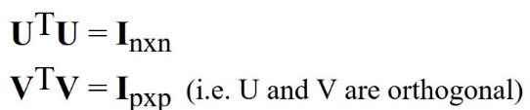

Where the columns of U are the left singular vectors (gene coefficient vectors); S (the same dimensions as A) has singular values and is diagonal (mode amplitudes); and VT has rows that are the right singular vectors (expression level vectors). The SVD represents an expansion of the original data in a coordinate system where the covariance matrix is diagonal. (“Singular Value Decomposition (SVD),” n.d.) Singular value decomposition is a complex approach to collaborative filtering, but it can produce very good results. It helps to identify latent features from the dataset in order to represent users and items as vectors in an N dimensional space. It helps to extract the most useful information form the dataset and quantify it so that accurate predictions can be made from it.

Development Technologies

Python

Python was released in 1991 and is one of the most popular and fastest growing programming languages today. It is an open-source, high-level, object-oriented, interpreted programming language that enforces indentation to ensure code readability. It is ideal for rapid development, it takes a high-level approach to data structures and it has an abundance of useful open-source libraries. Thanks to the wide variety and abundance of libraries Python is one of the top languages of choice for data science and machine learning. It has a great built in debugger which is also written in Python.

Java

Java was released in 1995, it is a widely applicable computer programming language, it is concurrent, object-oriented, class based and designed to have a minimal amount of implementation dependencies. Java was designed to allow developers to develop once and run anywhere because of this compiled Java code is capable of running on all platforms that support Java without requiring recompilation. Java is generally compiled to byte code and run on a JVM (Java Virtual Machine).

R

R was released in 1993, it was written primarily in C, Fortran and R, it is an implementation of the S programming language with the addition of lexical scoping semantics. It is a free programming language that is mainly used for statistical computing and graphics. It is a very popular language among data scientists, statistician and data miners.

Spring Boot

Spring Boot is a project that has been developed on top of the Java Spring framework. It helps the developer to create a stand-alone MVC (Model View Controller) application with minimal configurations. It provides the developer with default code annotations and configurations to allow for rapid development of applications. It uses either Maven or Gradle to add dependencies or libraries to the project. Spring Boot generates much of the boilerplate code involved with developing Spring applications and it has embedded HTTP servers such as Tomcat to allow developer to live test the application, it also has a wide variety of plugins available to it.

Django

Django is a web framework for the programming language Python. It is open-source and enables rapid development of web-applications. Django implements its own version of MVC called MTV (Model Template View) where the view is the controller and the template is the view from MVC, it also eliminates the development of boiler plate code. It has a built-in mechanism for dealing with database design called migrations which allow a developer to create databases in many of the popular flavours such as SQL, Postgres and MongoDB with relative ease. It is very easy to configure and has a very large community. Thanks to its large community it has a wealth of fantastic libraries that can aid in the development of REST, geolocation and many other services.

Angular

Angular is a JavaScript framework that uses TypeScript as its language for front end web applications, it combines declarative templates, dependency injection end to end tooling and integrated best practises to produce high quality applications. Angular is open-source and is developed and maintained by Google and a number of other organizations and individuals. It is used to build dashboard like applications that are geared towards optimizing user experience. Angular is feature rich with support for almost all JavaScript based libraries, it follows a single page application type design.

Ionic

Ionic is the world’s most popular cross platform mobile development framework. It is an open-source SDK (Software Development Kit) for developing hybrid mobile applications that is built on top of Angular and Apache Cordova. It has a plethora of native feeling elements for IOS and Android such as buttons, icons, themes and much more. It has a built-in webserver that allows developers to utilize the browser as a test bench for applications.

PostgreSQL

PostgreSQL in an open-source object-relational database system that implements the SQL language with many other features that provide safe storage and scalability. PostgreSQL enables the development of scalable database architectures and fault tolerant environments, it is highly extensible allowing developers to define their own data types making it very flexible. It provides many of the good features of SQL such as data integrity without the harsh rigidity associated with it.

Libraries

Pandas

Pandas is an open-source, BSD-licensed library for the Python programming language. It provides high performance and easy to use data structures as well as useful data analytics tools. The flexible data structures that Pandas offers allow developers to quickly manipulate large datasets into forms they can use to perform data analysis against. Some of the most useful data structures Pandas provides are the DataFrame and Series which represent data in a matrix format.

NumPy

NumPy is the fundamental package required for scientific computing in Python. It provides developers with tools such as N-dimensional array objects, linear algebra, Fourier transforms, and random number capabilities. The N-dimensional arrays and linear algebra capabilities are particularly useful for machine learning in the case of matrix factorization problems.

Scikit-Learn

Scikit-Learn is an open-source, BSD-licensed library for Python. It is built on top of NumPy, SciPy and Matplotlib and is aimed at providing tools for data mining and data analysis problems. Scikit-Learn has tools for dealing with Classification, Regression, Clustering and more.

Web Hosting Platforms and Deployment

Amazon Web Services

Amazon Web Services (AWS) is the largest cloud service provider in the world. AWS offers a wide variety of services, the ones that are of most use for this project are the Elastic Compute Cloud units (EC2) and the Relational Database Service (RDS). EC2 is a virtual machine that can be configured to the developers required specification including OS, storage capacity and networking capabilities. RDS is a service provided to host relational databases such as SQL, PostgreSQL and many more. For this project the EC2 instance is being used to host the Django web application and will be used to host the predictive analytic model and Angular front end while the databases will be hosted on the RDS service.

Figure 1: EC2 Dashboard Django App

Figure 2: RDS Dashboard PostgreSQL DB

Docker

Docker is an open-source tool that is used to make it easier to create, deploy and run applications using containers. Containers are essentially packages that allow developers to wrap up their application with all of its required dependencies and libraries and ship it out as one unit. This ensures that the application will work on any Linux machine so long as it has Docker installed on it. Docker works like an operating system for containers, containers work by virtualizing the operating system of a server and then run the application code on top.

Approach and Methodology

Software Development Lifecycle

The software development lifecycle that has been chosen for this project is a hybrid of two existing Agile methodologies, Agile Scrum and Agile Kanban. Neither of these methodologies are fully implemented but key aspects have been incorporated from both to form this hybrid approach, which I have outlined below as ScrumBan. This method I believe best suits the all of the software development in this project as this is not a large project undertaken by many people it is essentially a one-man operation that requires some level of planning, time keeping and co-ordination of the different aspects of the project, but there is no overseeing management divvying out tasks. On top of the ScrumBan methodology lies the CRISP-DM methodology for the development of the predictive analytics system.

Agile Scrum

Scrum is a subset of Agile and one of the most popular process frameworks for implementing Agile. It is an iterative software development model used to manage complex software and product development. Fixed-length iterations, called sprints lasting one to two weeks long, allow the team to ship software on a regular cadence. At the end of each sprint, stakeholders and team members meet to plan next steps. Scrum follows a set of roles, responsibilities, and meetings that never change. For example, Scrum calls for four ceremonies that provide structure to each sprint: sprint planning, daily stand-up, sprint demo, and sprint retrospective. During each sprint, the team will use visual artifacts like task boards or burndown charts to show progress and receive incremental feedback. (“What’s the Difference?,” 2016)

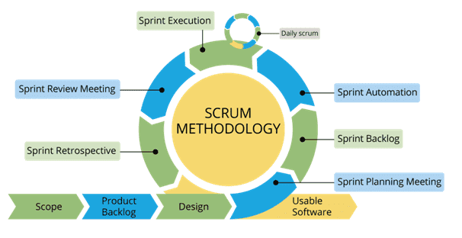
Figure 5: Agile Scrum Lifecycle

Agile Kanban

Kanban is Japanese for “visual sign” or “card.” It is a visual framework used to implement Agile that shows what to produce, when to produce it, and how much to produce. It encourages small, incremental changes to your current system and does not require a certain set up or procedure (meaning, you could overlay Kanban on top of other existing workflows). A Kanban board is a tool to implement the Kanban method for projects. A Kanban board, whether it is physical or online, is made up of different swim lanes or columns. The simplest boards have three columns: to do, in progress, and done. (“What’s the Difference?,” 2016)

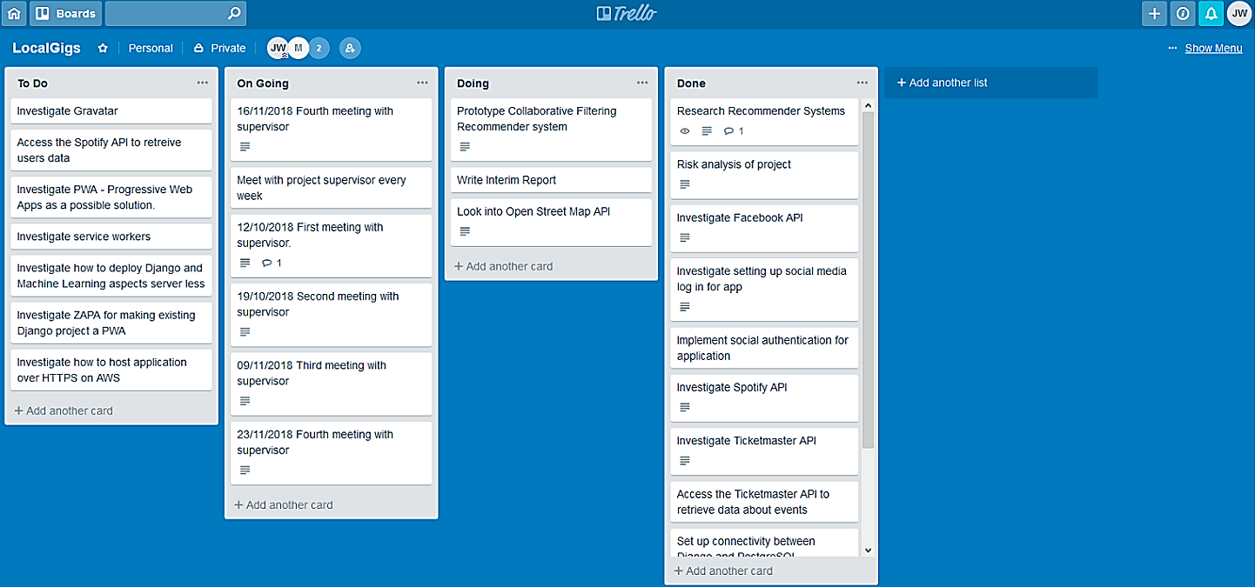
Figure 6: Agile Kanban Board (Trello)

ScrumBan

ScrumBan in the implementation of Agile Scrums cyclic sprint development pattern that also incorporates the organizational benefits of an Agile Kanban board. The development cycle for this project is one week. This coincides with the meeting of the project supervisor Mark Foley where the work and or any research that has been done in the completed scrum will be demoed. This time is being used as a stand up and a retrospective where we talk about the challenges faced in the sprint and what can be changed going forward. In addition to this the Kanban board for the project which is hosted on www.Trello.com is modified weekly to add potential features for the project and keep track of any work completed, it is also used to keep the meeting minutes.

Predictive Data Analytics Software Lifecycle

CRISP-DM

Building predictive data analytics solutions for applications involves a lot more than just choosing the right machine learning algorithm. Like any other significant project, the chances of a predictive analytics project being successful are greatly increased if a standard process is being used to manage the project through the project lifecycle. One of the most commonly used processes for predictive analytics is the Cross Industry Standard for Data Mining (CRSIP-DM) (D. Kellher et al., n.d.) The CRISP-DM Lifecyle will be used in the development of the predictive data analytics portion of this project. The key features of the CRISP-DM development lifecycle are as follows.

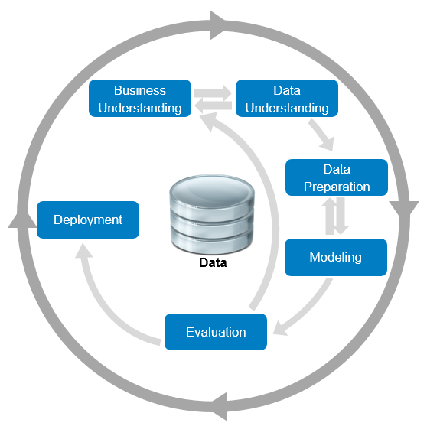
Figure 3: CRISP-DM Lifecycle

Business Understanding

Predictive analytics projects never start out with the goal of building a prediction model. Instead their focus is to gain more customers or sell more products all while improving the efficiency of their business. So, the goal in this phase of the development cycle is to fully understand the business needs so the right model can be produced.

Data Understanding

Once the manner in which the predictive data analytics will be used to address a business problem has been outlined, it is important that the data analyst then fully understands the different data source available within the organization and the different types of data within those sources.

Data Preparation

Building predictive data analytic models requires specific kinds of data, organized in a specific kind of structure known as Analytic Base Table (ABT). This phase of CRIPS-DM includes all the activities required to convert the disparate data sources that are available into a well-formed ABT.

Modelling

The modelling phase of the CRISP-DM process is when the machine learning algorithms are used to build a range of predictive models from which the best model will be selected.

Evaluation

Before a model is deployed it is essential that the model is tested to ensure it is making accurate predictions. This phase of CRISP-DM covers all the relevant evaluation tasks required to prove the effectiveness of the model.

Deployment

This section of the CRSIP-DM lifecycle covers all of the work that is necessary to successfully integrate the predictive data analytics model into the process within the organization.

Design

Front End

Website

The website for the application at the moment is built using the Django frameworks templates, which have been a successful method of prototyping the website aspect of this project. As the project moves forward, I will be building the front end of the application in the Angular framework. I have chosen Angular as it is well known for being very fast and great for developing responsive websites that can provide a memorable user experience. I also like the fact that Angular implements a modularized approach to development with great separation of concerns. I have been using Angular for the last few months while developing an application for a module and so should not have much trouble transposing a lot of what I have done in the Django templates over to the Angular application.

Mobile Application

The mobile application I have begun to develop using the Ionic framework. I have chosen Ionic as the other options, develop a native app using Android Studio or use Apache Cordova felt a little out dated and somewhat wasteful. Android Studio is slow and cumbersome and of course it means the application can only ever function on an Android and Apache Cordova would have been a solid solution but just lacks some of the features and modularization of Ionic and doesn’t really make full use of the technologies that are available.

Ionic makes use of Angular for its development and front end and Apache Cordova for configuration and deployment so it has the separation of concerns that Angular provides along with all of the libraries and the rendering speed for the different pages and the faster API calls, but it still retains all of the configuration benefits of Cordova. Ionic also has a wide variety of components that look and feel native to the desired platform, it has some handy theming capabilities that will allow a developer to apply a general theme of their own choosing throughout the app and has a lot of icons that again look native to the device’s platform.

Back End

Django

The business logic of the web application is being developed using the Python framework Django. I had initially planned to develop the backend using Java Spring Boot but after some deliberating, I decided it would be a prudent move to develop the back end in Python. This was mainly because I would be building my predictive analytics model in Python. This helped me keep the number of programming languages to a minimum and remove any possible doubt of conflicts between the two sections of the project. This left me with two options in my mind Flask and Django, my initial inclination was towards Flask as it seemed to be a bit simpler to get going with over Django but after taking a module this semester that utilized Django I am now comfortable with the framework and pleased with my decision. At the moment Django makes up the bulk of the application but as I move forward sections will be trimmed off until it is essentially just a controller for the project. Its primary role will be to provide functionality over API endpoints to the front end, send and receive data from the predictive analytics model and to perform CRUD operations on the database.

Predictive Analytics Model

The predictive analytics model for this application will be developed in Python. I had initially considered using R as through much research I had discovered it was more efficient than Python in terms of memory consumption and speed. But, like with the web application, I thought there would be too many technologies and languages in the project which was going to further increase the risk of problems when integrating all of the different components later in the development cycle. In order to mitigate against the lost performance using Python I am going to implement the predictive analytics model as a microservice, a stand-alone block of code that will run serverless in AWS.

One area of concern for this project was finding a quality dataset that could be used to train the model, I have found a dataset called the #nowplaying playlists dataset. This dataset stores extracted data on Spotify users listening habits through the Twitter handle #nowplaying. A hashed version of the username the artists, tracks and playlist name are all extracted from the tweet. This dataset contained over 12 million entries, I have cleaned and filtered the data from approximately 12 million entries down to approximately 3 million and have begun minor attempts at building the predictive analytics system.

The form of predictive analytics I will be using for this project is a Recommender System, specifically a Collaborative Filtering Recommender System. This type of recommendation system is the most popular and well researched and it is implemented by most of the big media distributions companies such as Spotify and Netflix. I have been researching the best approaches to take for a collaborative filtering model and one method that was of particular interest to me was the Netflix prize winners’ model BellKor’s Pragmatic Chaos. There method was to combine Singular Value Decomposition (SVD++) with a Neighbourhood model and a Restricted Boltzmann Machine to create a 10% improvement over Netflix’s current system. I am going to attempt a similar approach to my model although it will probably lack some of the complexity of their solution.

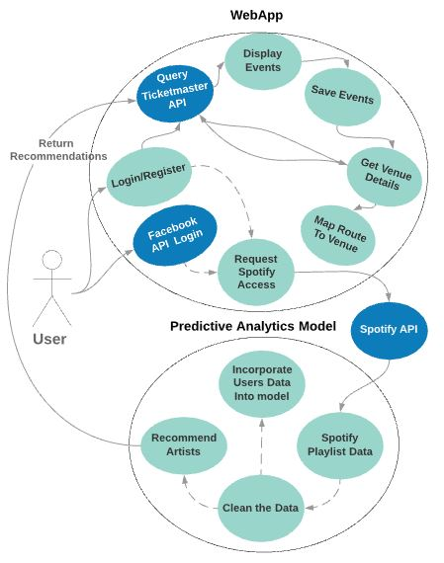
Figure 1: Use Case Diagram

Database

PostgreSQL

The database type I will be using for the web application and the predictive analytics model for this project is PostgreSQL. I have chosen PostgreSQL as it allows developers to easily store different types of data from text to JSON to arrays to spatial data and even custom data types with relative ease. Also, it provides SQL type relationships making storing and querying data for users and related tables fairly straight forward. I will however be using separate databases for the web and analytics apps to keep querying times to a minimum.

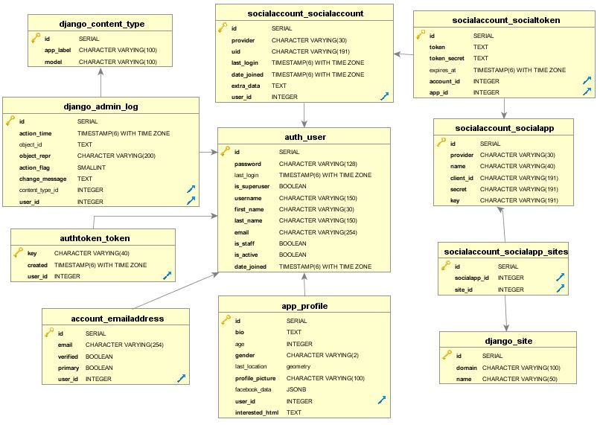
Figure 2: ERD For Django Application

Deployment

Docker

Docker will be used to package up the Django application and deploy it to the AWS EC2 instance. Using Docker for deploying to AWS makes it a hassle-free experience. It involves creating a Docker file setting the dependencies for the project installing the required libraries and setting the RUN command. The container image is then pushed up to a Docker repository, similar to GitHub where it can be pulled down onto an EC2 instance that has Docker installed and from there the server can be run.

AWS

Amazon Web Service (AWS) will be used to host the entire project. Relational Database Service (RDS) will be used to host the two separate databases, the Django web application and the Angular front end will be running on two separate Elastic Compute Cloud (EC2) units and the serverless predictive analytics model will be deployed in the AWS Serverless Application Repository.

App Store & Google Play Store

The Ionic mobile application will be deployed through the Google Play Store and Apples App Store. My plan is to make it available to both Android and IOS if I have the time. If there is not enough time the mobile app will be deployed as an Android only application. Google Play Store is the most popular mobile Android application store hence why it has been chosen over others such as Samsung’s or Windows app stores.
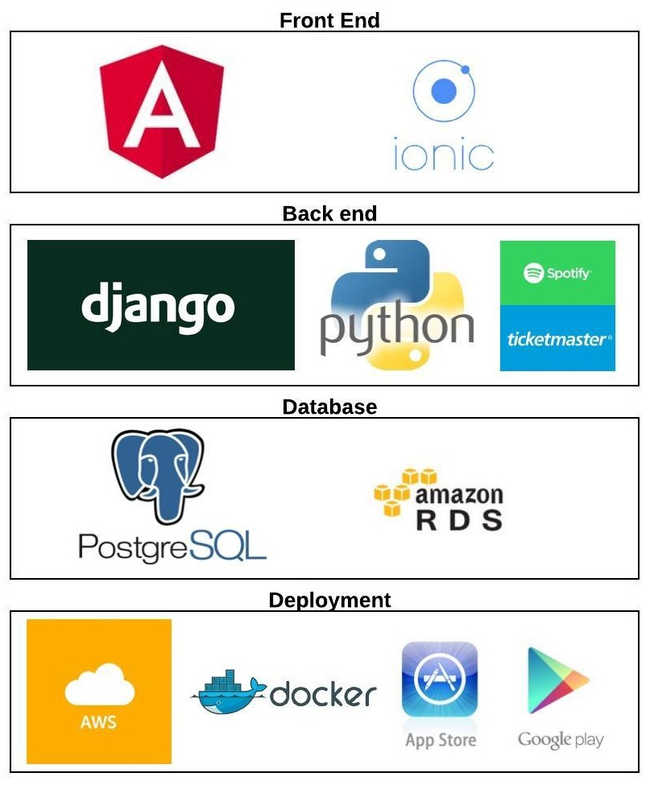
Figure 3: Project Stack

Prototyping and Development

In this section I will present the sections of the project that have been completed thus far. I will use pictures of the application and snippets of code to demonstrate the functionality of the application. I will not be able to provide examples for all of the functionality that has been developed but will try to highlight the aspects of the use case diagram that I have completed.

Website

The front-end website is currently built using Django templates which use HTML, CSS, JavaScript and Django specific sections of code such as forms. Django forms make it easy to pass data from the templates to the views where CRUD operations on the database, or other business logic such as querying API’s can be performed. Django’s templates operate as a single page application where the Base.html file is loaded up with most of the external libraries and CDN’s that the site needs to function. Every other page is then injected between {% block content %} {% endblock %} tags in the body of the Base.html as the user navigates around the website.

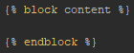
Figure 1: Block Content Tags
Aspects of the website that are common to all pages such as the navigation bar and footer are built once in the Base.html file and used throughout the project with conditionals and authorization tags being implemented to control what links are displayed in the navigation bar.

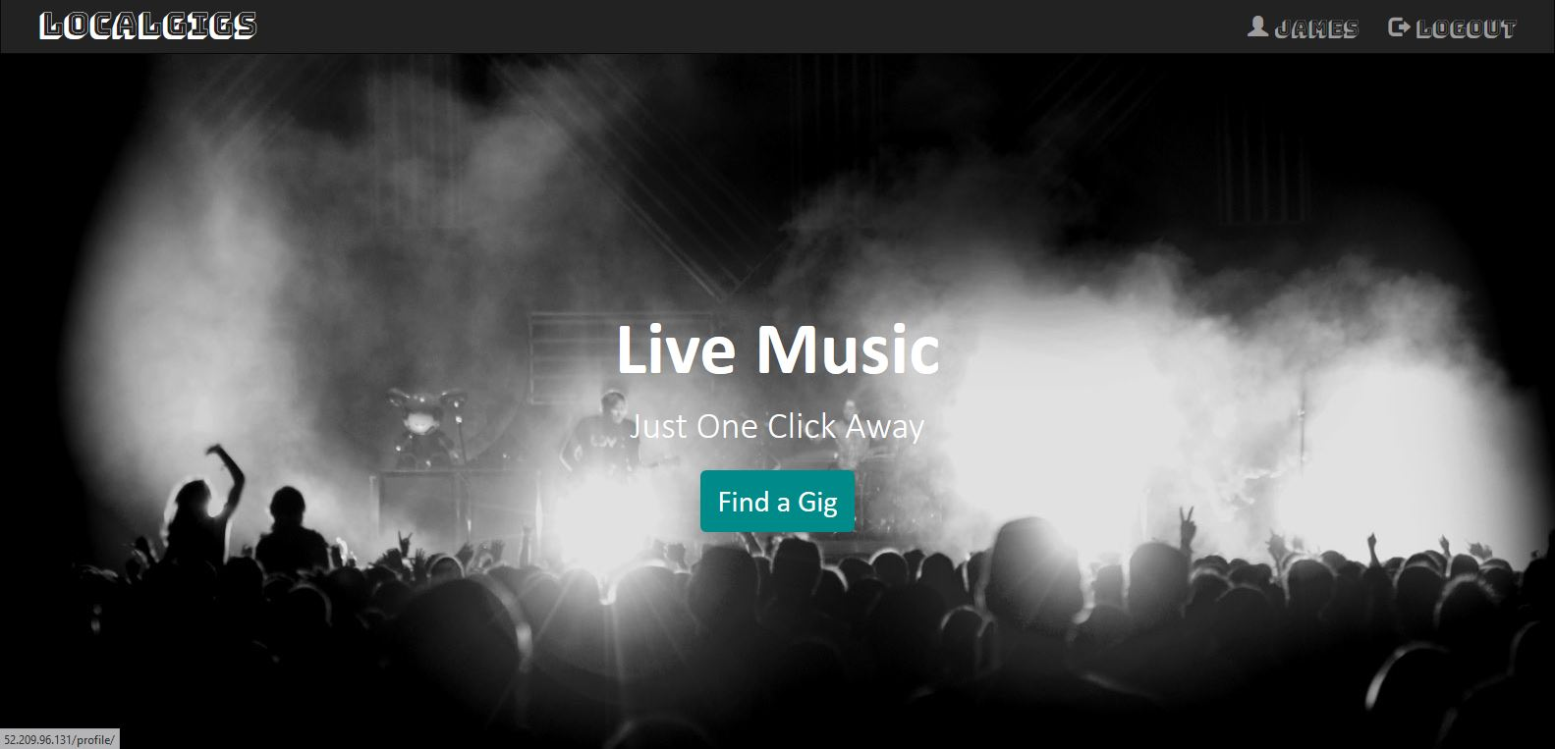
Figure 4: Website Landing Page
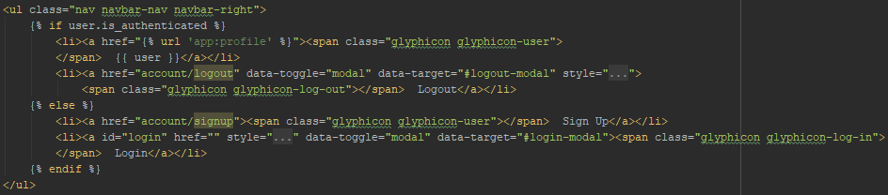
Figure 2: NavBar Code

For the login, registering and social authentication aspect of the project I am making use of the Django all-auth and rest-auth libraries. These libraries provide some boiler plate code and URL’s that can be used to remove some of the grunt work associated with setting up authentication. I have extended and customized some of these boiler plate views however to better suits the need of this project. Among other things the signup view has been changed to require the user to enter their first and last name and I am not using any of the boiler plate templates.

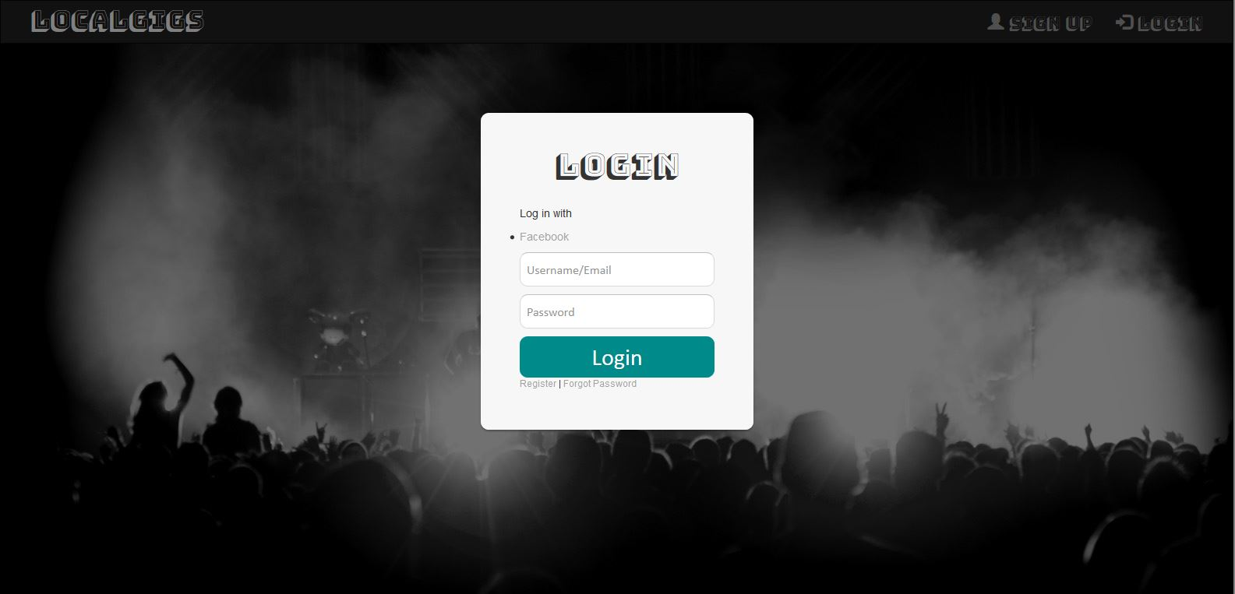
Figure 5: Landing Page Modal Login

The profile page comprises of three different sections, the user information section, the event searching section and the map section. The user information section is completely customizable, apart from the username and email as they are specific to the account. The user can upload their own profile picture and connect their account to their Facebook account for ease of access in future if they sign out of their account otherwise the website will remember their session and automatically log them back in.
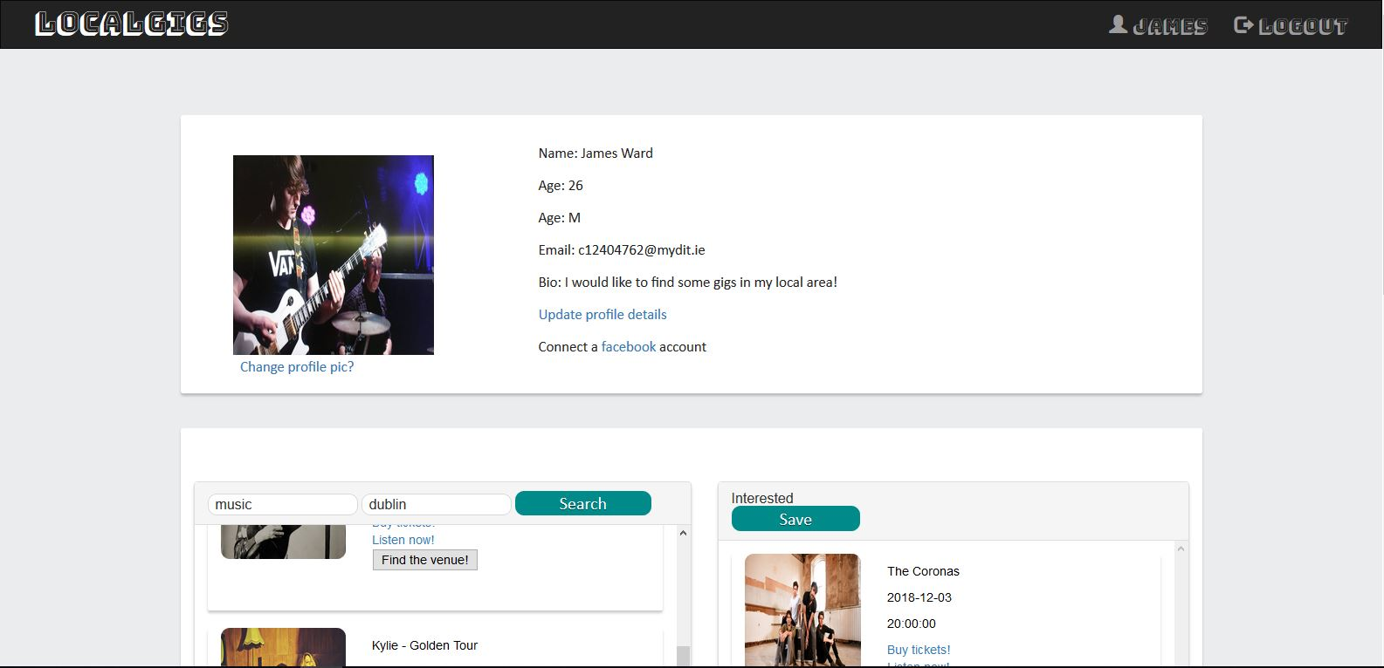
Figure 6: Profile Page User Info

The event searching section of the website requires the user to enter what type of events they are looking for and the city they want to see these events in. This makes a GET request to a REST API endpoint in the Django app which is handled by a view in the api section of the application this view then makes a GET request to Ticketmaster API to fetch the desired data. The relevant data is extracted from the response and placed into an array of dictionaries that is returned is to the template.

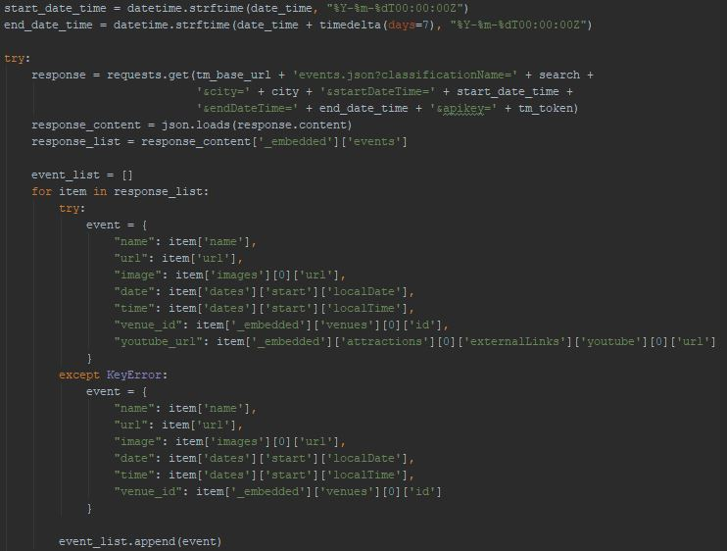
Figure 3: Query to Ticketmaster API
At the template the data is passed into a JavaScript function that programmatically creates the div elements and its contents, assigning incremented id’s and classes to each element which can then be used for styling purposes, each div element created is representative of each object that has been returned. Each element displays a picture of the artist, their name, the date and time they are playing, a link to the section of the Ticketmaster website for that event and if the artist has a YouTube profile a link is provided so the user can go and listen to them. The user can drag these items into the interested list and save them for later.

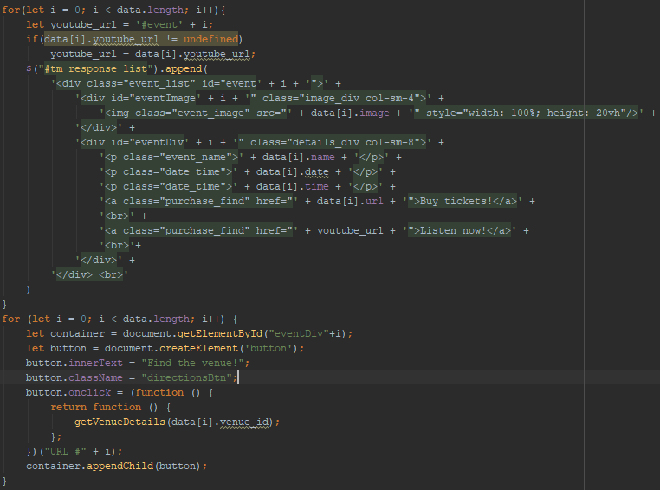
Figure 4: Creating Event Div Elements
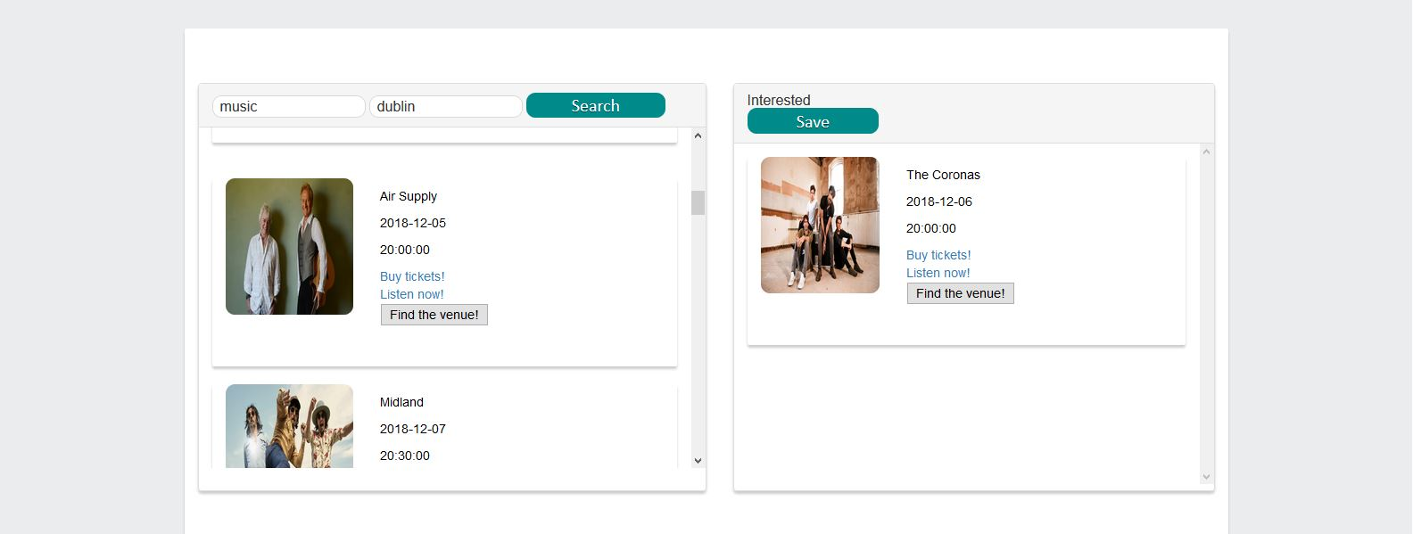
Figure 7: Profile Page Ticketmaster API Query
The Find The Venue! button follows a similar REST procedure as above. Each button has a call to a JavaScript function that has the venue ID as a parameter that was added when programmatically creating the div elements with the data from the GET response. The venue ID is sent to the Ticketmaster API in another query which return details about the venue such as its name, address, longitude and latitude and an image if one is available. This response is used to add a marker to the leaflet map with the returned information about the venue.

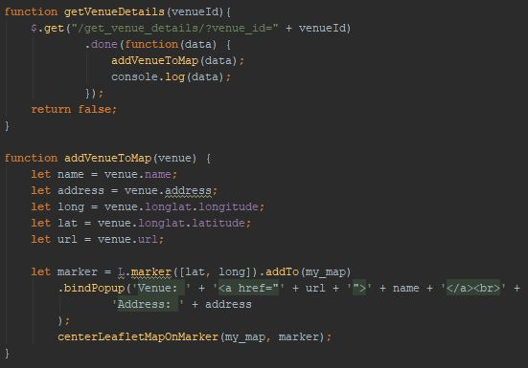
Figure 5: Get Venue & Place Marker on the Map
An addition that I will make to this is the opening hours of the venue. I did have routing functionality from the user to the venue which works locally but does not work while running on AWS this will require further research as the application does not seem to be able to pick up the user’s location, this could be because the application is currently being provided over HTTP and not HTTPS.
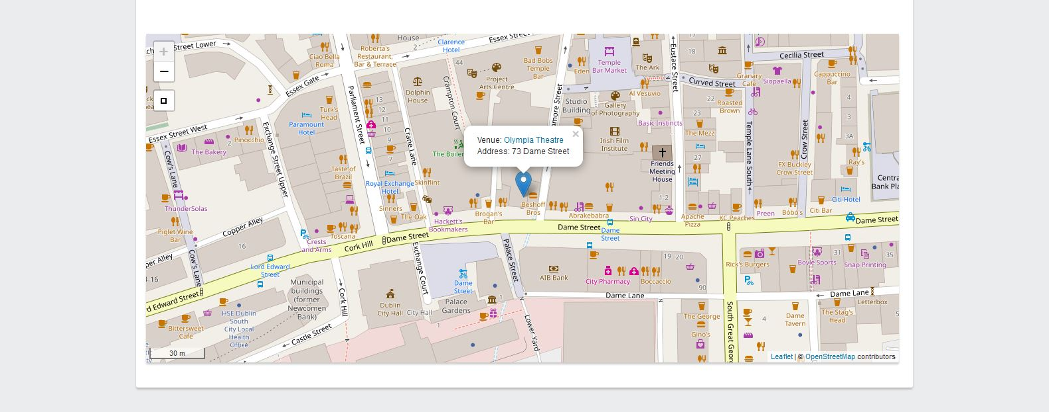
Figure 8: Profile Page Venue Located

Ionic App

The first page the user sees when opening the app is the login page. The user can enter their email address and password to sign in or they can navigate to the signup page where they can register for an account. Both actions make calls to the Django Rest API, login is a GET request that passes the email and password and returns the users information and an access token and signup is a POST request that creates a new user which fires the triggers in the Django model class creating a profile and token for the user.

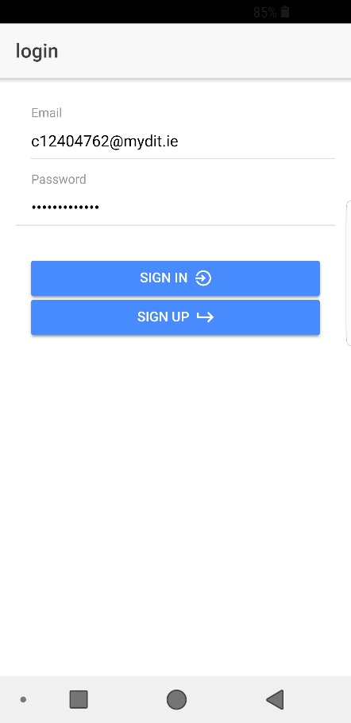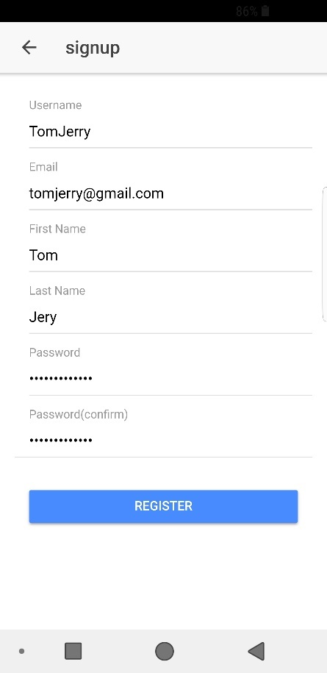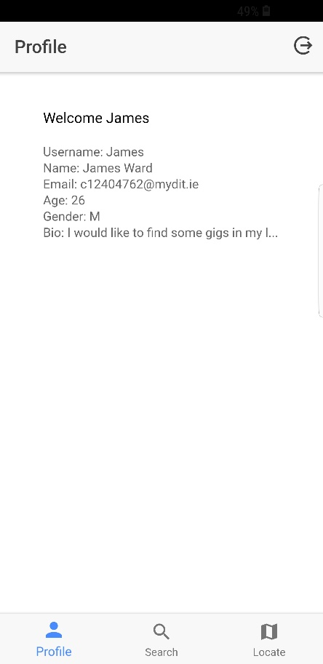
Figure 6: Login Screen Figure 7: Register Screen Figure 6: Profile Screen

Once the user has logged in, they are redirected to the profile page where the user’s information is displayed to them. From here the user can navigate to the different pages using the tabs at the bottom of the screen. The search tab redirects the user to a screen where they can perform the same API request as mentioned in the website, querying the Ticketmaster API for event and returning them, and displaying them as div elements in a list. Clicking the find venue button will again place a marker on the map with the details of the venue and the user’s location is also displayed. The routing was working on the phone up until a few days ago where I found a small bug and have not had time yet to go back and fix it so for now it is de-activated. The links for each one of the events function in the same way the website links do, opening up the respective Ticketmaster and YouTube pages.
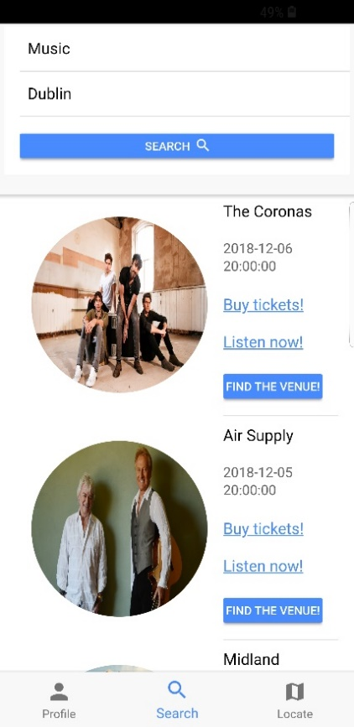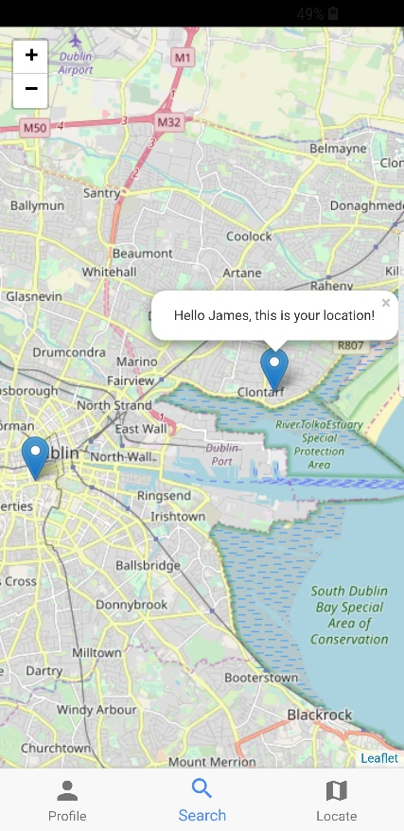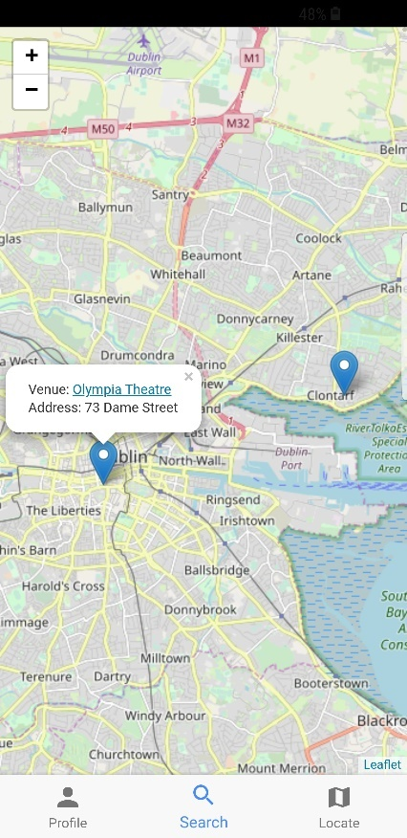
Figure 7: Event Search Screen Figure 8: User Location Figure 9: Event Location

Predictive Analytics Model

As of now I have not started development of the model, I have been working on prototypes for a couple of different approaches, once I have decided on the best approach I will begin work on the actual model. I have however attained a dataset and cleaned up the dataset. I have reduced the total number of entries from over twelve million to just over three million. I accomplished this by aggregating the dataset based on the user and the artist, this removed multiple entries, condensing the number of songs a user has from a single artist down to a count. This count is what will act as the rating system for this model. The higher the count, the more songs of a particular artist the user has in their playlist, the more they like that artist. It is a fairly simple rating system, but I believe it should be accurate enough for this project.

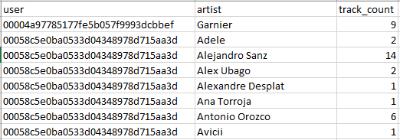
Figure 10: Extract From Clean Dataset

Deployment

I have deployed the Django application prototype to Docker hub and pulled it down on to an EC2 instance where it is currently hosted. The website can be accessed at the following web address http://52.209.96.131/ . The database is currently hosted on a separate RDS instance.

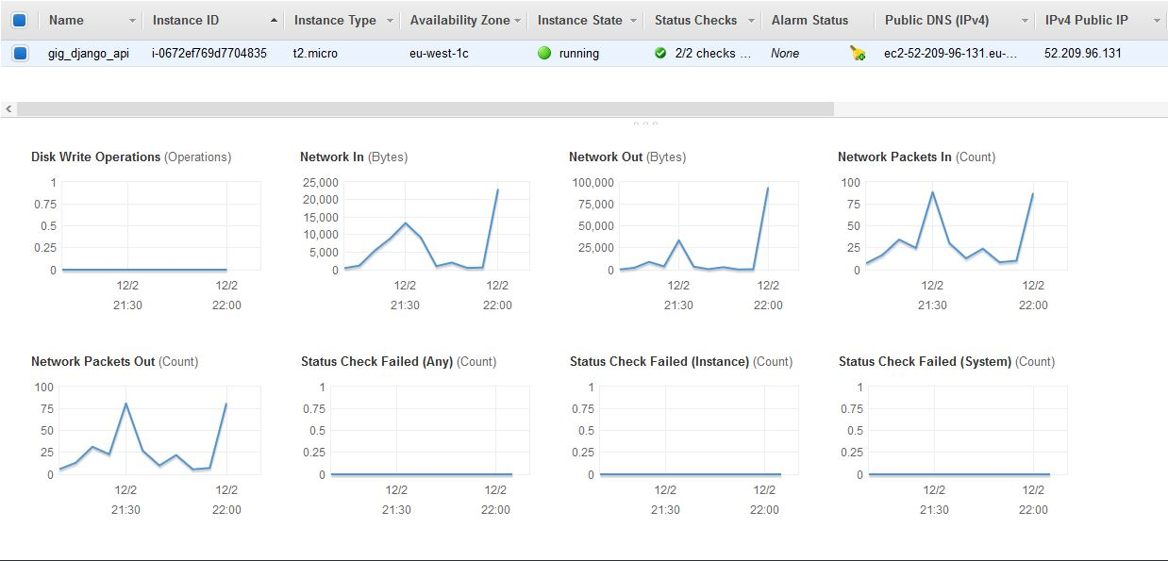
Figure 11: Django App Hosted on EC2

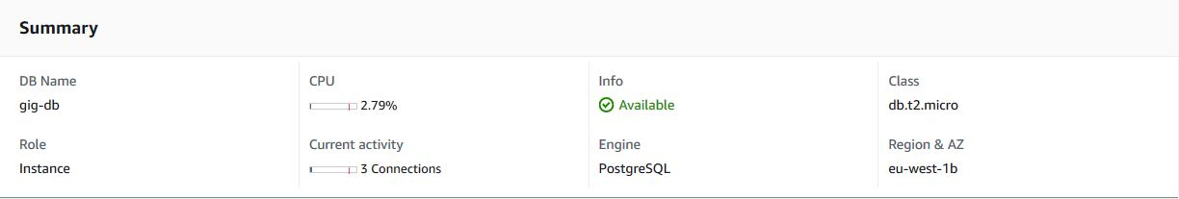
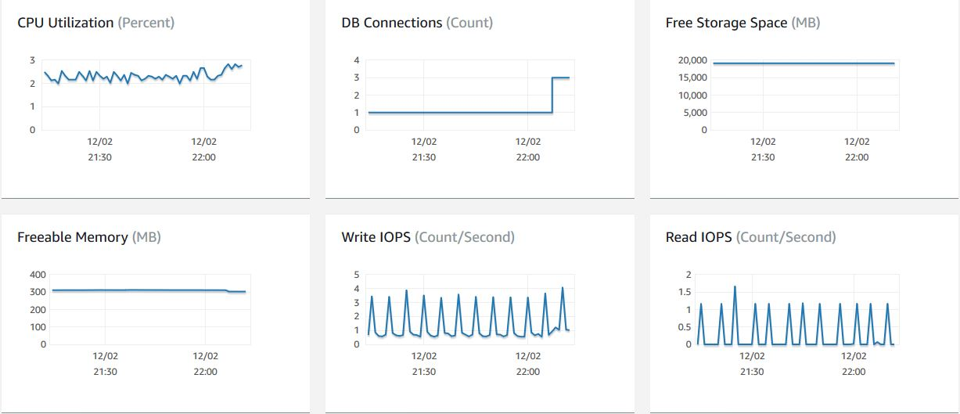
Figure 12: PostgreSQL Database Hosted on RDS

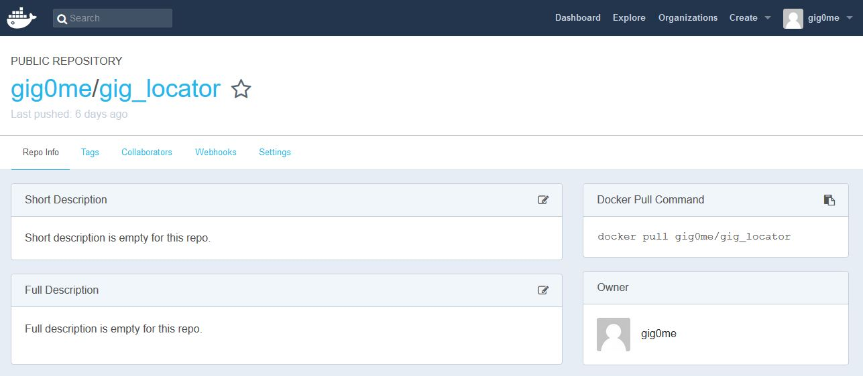
Figure 13: Django App Deployed on Docker Hub

Testing

As explained above I have deployed the application and have put together a basic proof of concept of querying the Ticketmaster API and returning the events and then displaying these events to the user. The project is not far along enough yet to have accomplished any real-world user testing. In relation to test code, I have not written any test code as of now as I have not had the time. I thought it a better use of my time to get a prototype built and deployed so that it is demonstratable rather than constructing test cases.

Issues and Risks

In this section the areas of the project that may prove to be the most challenging will be outlined. The reason some these areas may prove to be challenging will be explained and a possible solution to these challenges will be provided.

Attaining and Processing Quality Data

This is the aspect of the project that needed to be addressed first. If adequate data could not have been found to train the model, the project would have become completely infeasible. The data that was obtained needed to be of adequate quality and quantity in order to train the model effectively. I have acquired a dataset that has been monitoring the activity of Spotify users listening behaviours and the user’s playlist composition since 2014. It has been using the Twitter handle #nowplaying to gather information from users post. (Zangerle et al., 2014) I have filtered and cleaned this data from approximately 12 million entries down to 3 million. Further pre-processing may be required but this dataset should be more than adequate for training the model.

Picking the right model

Picking the right model is essential to producing accurate predictions and because of this it can be seen as equally important as the quality of the data set attained. The approach I am taking is a Collaborative Filtering model, this type of model incorporates the opinions of all its users, or at least similar users when it is making its predictions. Had this type of recommendation system been attempted even five to ten years ago this would have been a task on a much higher level of difficulty and would probably be bordering research masters. Thankfully in recent years there has been huge progression in this field of machine learning. This is in part because of companies such as Spotify, Netflix and YouTube assigning large amount of resources into the development of these technologies. Also, the input of master’s and PhD students cannot be understated in this regard as much of the information that is readily available on this subject comes from them.

Processing power

Due to the large volumes of data that needs to be processed in this type of machine learning model the physical capabilities of the hardware being used come into play. If I were to attempt to complete this project on my own machine it would be disastrous. Therefore, once I have accessed the model effectively on a small-scale dataset and I am happy with its performance all further testing, and training of the model will be performed in one of the cloud service providers who can provide the processing power require to handle the large quantity of data.

Overfitting and Underfitting the model

Fitting the model refers to how accurately the model approximates the target features value. The goal is to develop a model that can accurately model the training data and make precise predictions for the testing data. If this can be achieved the model should make accurate predictions on future data. This in practise is very difficult to achieve and such as model has not yet been perfected. Underfitting refers to a model that can neither model the training data nor generalize to new data (Brownlee, 2016) in essence the model does not have a comprehensive enough understanding of the data and or may be using the wrong approach to the given data for it to make accurate predictions. Overfitting refers to a model that models the training data too well. This occurs when a model has over analysed the data and incorporates even the noise in the data into its predictions. The solution to this challenge will be continuous research throughout the lifecycle of the project and learning what is required of the model as it is developed.

Integrating every user with the model

For this approach to take full advantage of the Collaborative Filtering model each user will need to be incorporated in to model. This will require cleaning and processing each user’s data and asynchronously retraining the model with the new data. This may prove to be a resource intensive aspect of the project as training the model with such large amounts of data requires a lot of processing power. This also brings in the question of when and how the model should be updated with the new dataset. A possible solution to this is to perform all updates to the dataset at night, this means the users own preferences will not be incorporated into the dataset for the initial predictions, but this is the limitation of this model and the resources available.

Request limits on free API’s

With much of the data for this project relying on querying Spotify’s and Ticketmaster’s API’s the request limits they put on the number of times their service can be hit for free in a day may be a factor. The current limit for the number of requests that can be made to the Ticketmaster API per day is 5000, Spotify operates slightly differently in that if too many requests are made they will return an error and force a timeout for the service, the length of the timeout and how many requests will cause the timeout does not seem to be available in their documentation. A possible to solution to this and the most obvious one is to retrieve as much relevant data as possible in a single request keeping the quota low. Another possible solution may be to contact Spotify and Ticketmaster directly and ask for a possible increase in the number of allowable requests from my application. The best solution to this possible challenge would be a combination of both of these tactics if possible.

Deployment cost

It would not be unreasonable to assume the cost of hosting an operating this project could increase quite rapidly, especially the machine learning aspect of the project. A possible solution to this is to host the machine learning part and the Django controller serverless and provide them as a service as code. This would be the best possible way to keep the running time of the application to a minimum.

Learning new languages and frameworks

The final aspect of this project that will prove to be a challenge is learning new frameworks and languages. I transitioned from electronics engineering into computer science in third year and had no exposure to any of the programming languages that had been taught in the previous two years (Java, Python, HTML, CSS, Bash, JavaScript, SQL). The last year and six months have been a massive learning curve for me, to get a firm grasp of all these languages, and the frameworks that go along with them in such a short time frame has been one of the biggest intellectual challenges I have faced to date. I first began programming in Python at the beginning of this academic year and plan to use the language to develop much of my project. All the frameworks used will be ones that I have learned this year in college or by myself. The only solution to this challenge will be hard work and determination as it has been for the last year and six months.

Plan and Future Work

My immediate plan is to finish evaluating the different algorithms and approaches to the predictive analytics section of this project, and to begin development of the predictive analytics model. I have all the data ready so, I plan to build the bones of the predictive model over the Christmas holidays, deploy it to AWS and piece it together with the Django web application via my API.

Regarding the Django web application, I want to implement the functionality that will connect a user’s Spotify account to their LocalGigs account allowing access to their playlist data. Once these two pieces of functionality have been completed, I will move onto the problem of adding the new users profile data to the existing model. These are the main blocks of functionality left that are required to take this prototype to a proof of concept. From then on it will be a matter of cleaning up the application styling all of the different aspects and getting users onto the system to perform some real-world testing.

I plan to post on my social media accounts religiously about the application to get as many of my friends, family, acquaintances and others to sign up and start using the application. I will ask them all to provide me will some form of feedback where ever possible and use this feedback to weed out any functionality problems.

Bibliography

Brownlee, J., 2016. Overfitting and Underfitting With Machine Learning Algorithms. Mach. Learn. Mastery.

D. Kellher, J., Mac Namee, B., D’Arcy, A., n.d. Fundamentals of Machine Learning for Predictive Analytics. The MIT Press, Cambridge Massachusetts, London, England.
Jin, R., n.d. A Study of Mixture Models for Collaborative Filtering 33.

Lops, P., de Gemmis, M., Semeraro, G., 2011. Content-based Recommender Systems: State of the Art and Trends, in: Ricci, F., Rokach, L., Shapira, B., Kantor, P.B. (Eds.), Recommender Systems Handbook. Springer US, Boston, MA, pp. 73–105. https://doi.org/10.1007/978-0-387-85820-3_3

Matrix decomposition, 2018. . Wikipedia.

Pazzani, M.J., Billsus, D., 2007. Content-Based Recommendation Systems, in: Brusilovsky, P., Kobsa, A., Nejdl, W. (Eds.), The Adaptive Web. Springer Berlin Heidelberg, Berlin, Heidelberg, pp. 325–341. https://doi.org/10.1007/978-3-540-72079-9_10

Sander Dieleman, n.d. Recommending music on Spotify with deep learning [WWW Document]. Sander Dieleman. URL http://benanne.github.io/2014/08/05/spotify-cnns.html (accessed 11.30.18).

Singular Value Decomposition (SVD) [WWW Document], n.d. URL https://web.mit.edu/be.400/www/SVD/Singular_Value_Decomposition.htm (accessed 12.1.18).

What’s the Difference? Agile vs Scrum vs Waterfall vs Kanban [WWW Document], 2016. . Smartsheet. URL https://www.smartsheet.com/agile-vs-scrum-vs-waterfall-vs-kanban (accessed 11.24.18).

Zangerle, E., Pichl, M., Gassler, W., Specht, G., 2014. #Nowplaying Music Dataset: Extracting Listening Behavior from Twitter, in: Proceedings of the First International Workshop on Internet-Scale Multimedia Management, WISMM ’14. ACM, New York, NY, USA, pp. 21–26. https://doi.org/10.1145/2661714.2661719

