

**ADDIS ABABA UNIVERSITY**

**INSTITUTE OF TECHNOLOGY**

**COMPUTER ORGANIZATION AND ARCHITECTURE (COA)**

**SEMESTER PROJECT**

**CPU DESIGN**

**GROUP STUDENT NAME ID NO**

1. **Peniel Yohannes UGR/6315/14**
2. **Semalign Markos UGR/6401/14**
3. **Walelign Tagesse UGR/3698/14**

**INSTUCTOR: Mr. Daniel D.**

**SUBMITTION DATE: 2/01/2025**

**Introduction**

The purpose of the project is to design a complete processor which can handle 4 bit instruction set. Thus we have designed the processor each part from scratch and connected them together. The processor begins the execution from the given memory location and transfers the data in PC to MAR and then to memory. Then the control unit issues to access the required memory location and fetches the data and instruction which is contained in a given memory location. The instruction is moved to instruction register and decoded for further execution. The data in given memory location is transferred to MBR and AC at the same time for execution in ALU. The output of ALU is displayed using seven segment display.

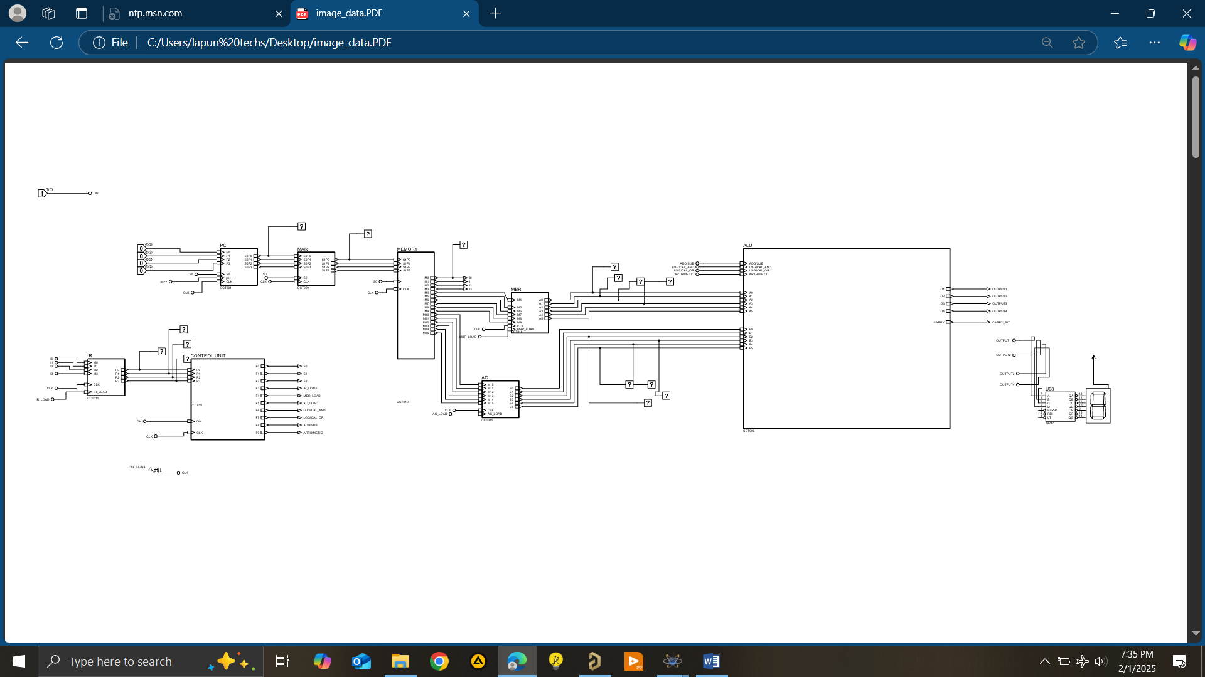

If we try to look at each stage in deep

PC stores the beginning of instruction and holds the memory address where the instruction is stored and incremented at the time the control unit generated the increment signal.

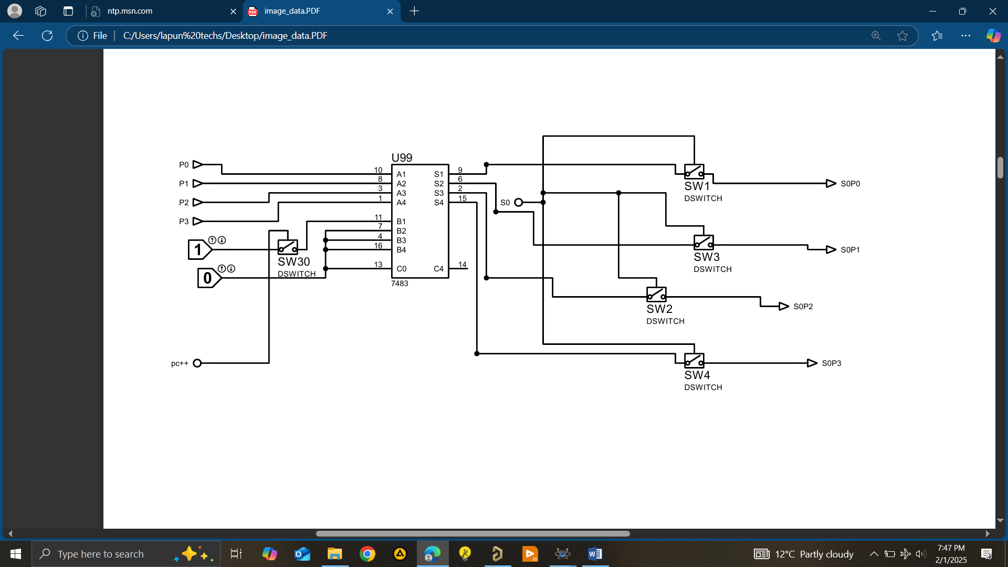

**MAR , MBR AND AC**

This registers are used to hold temporary data for the time of execution and to store in memory.

They have almost similar internal structure, they take data and control signal as input and they have switches used to allow control signal to control the execution of instruction in a sequence.

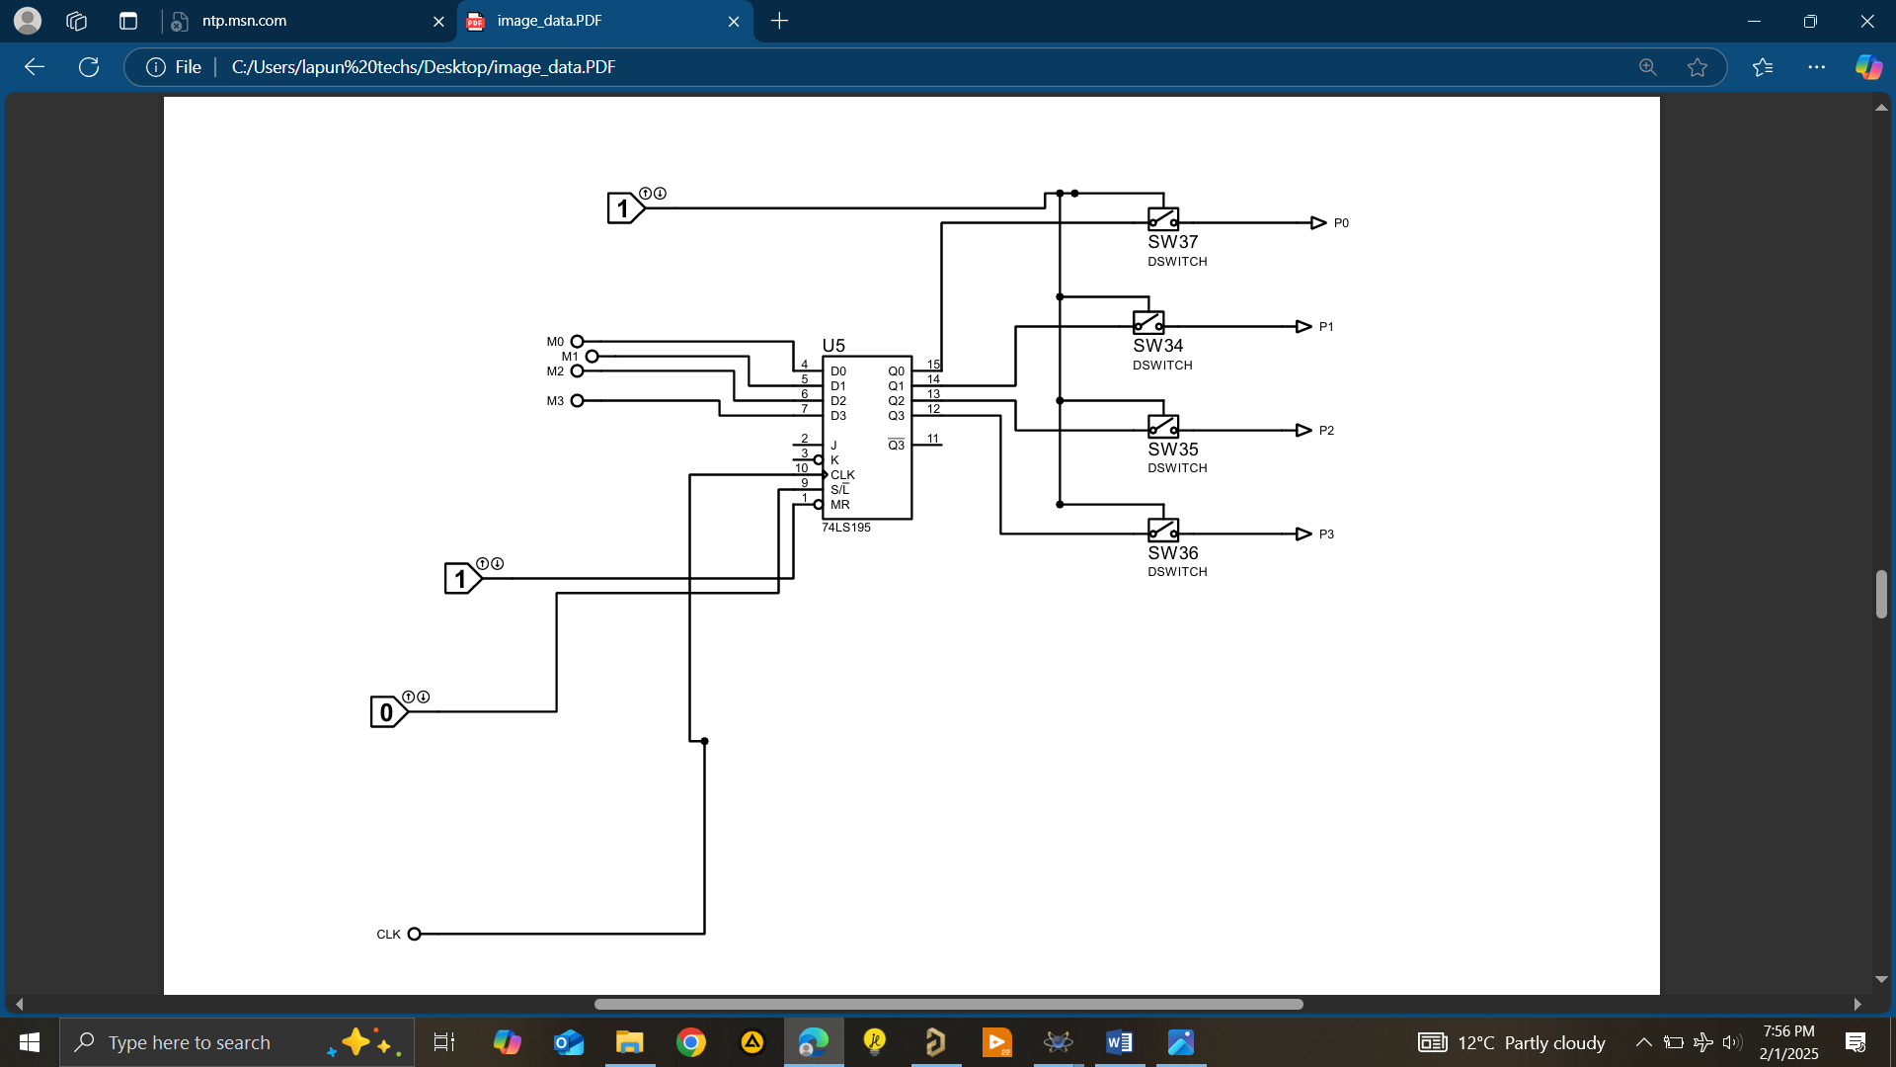

**Memory**

It is the part which contain the data of 16 bits in 4 locations in our design. We allowed it to be loaded directly by adding logic states inside memory. Since the system is hardwired we can say it ROM memory which contains 16 bit with 4 bits as instruction and 12 bits for data. We followed structure in our textbook and allowed 4 bit operation. And as input there are also control signals and digital switches to control the instruction sequence based on signal generated by control signal.

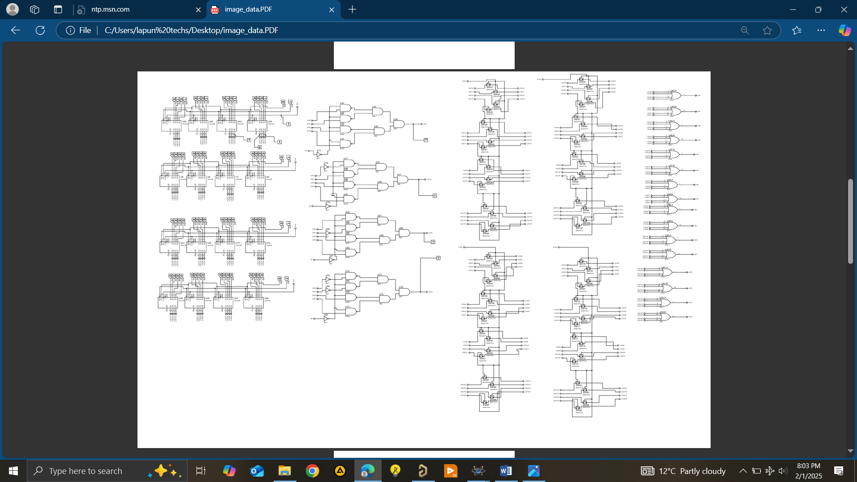

**Control Unit**

**This we call brain of the CPU. Which generates control signals based on instruction to be executed and used as sequencer.**

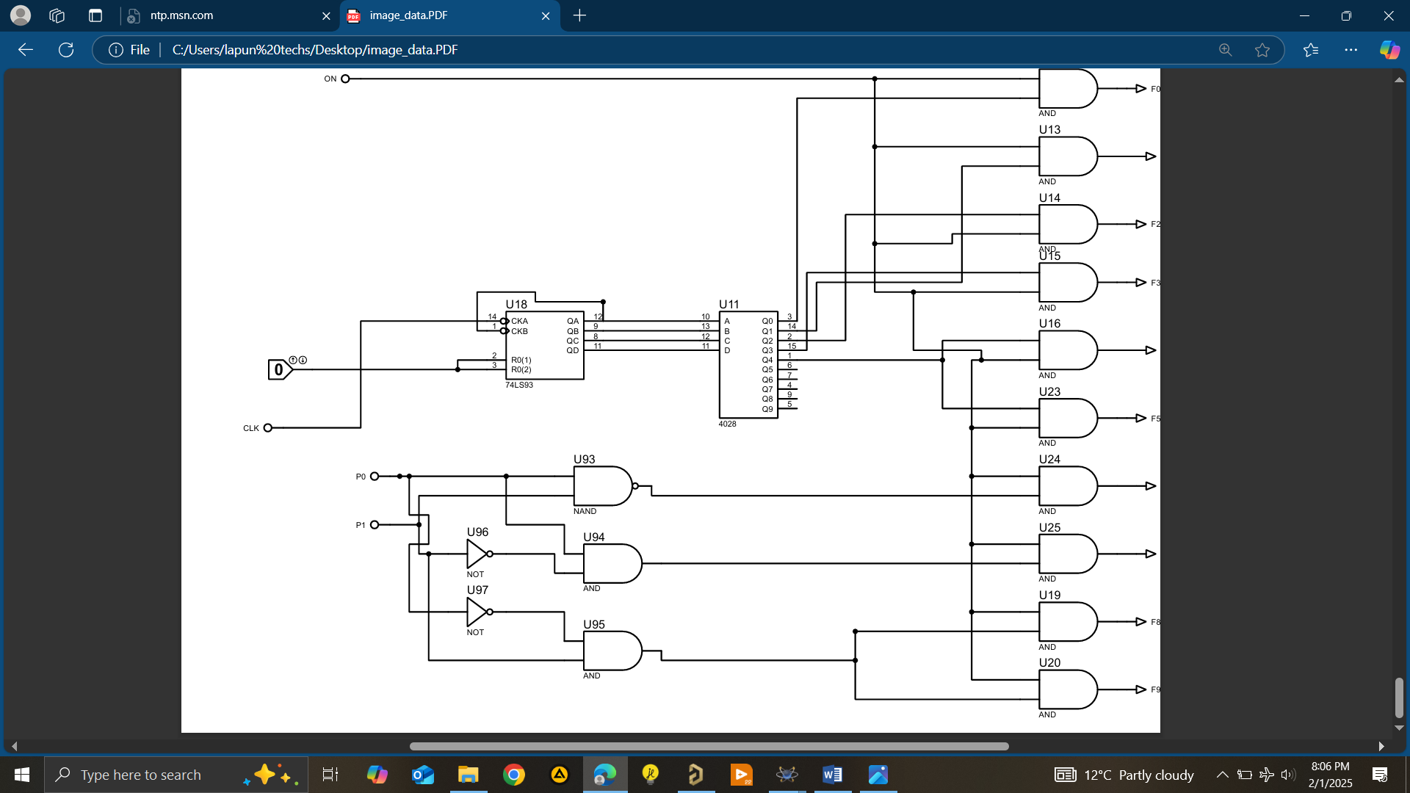

**ALU**

**The unit which performs mathematical and logical function of computer. Built mostly of adders and logical gates. Which computes the given instruction and uses the bits of AC and MBR.**

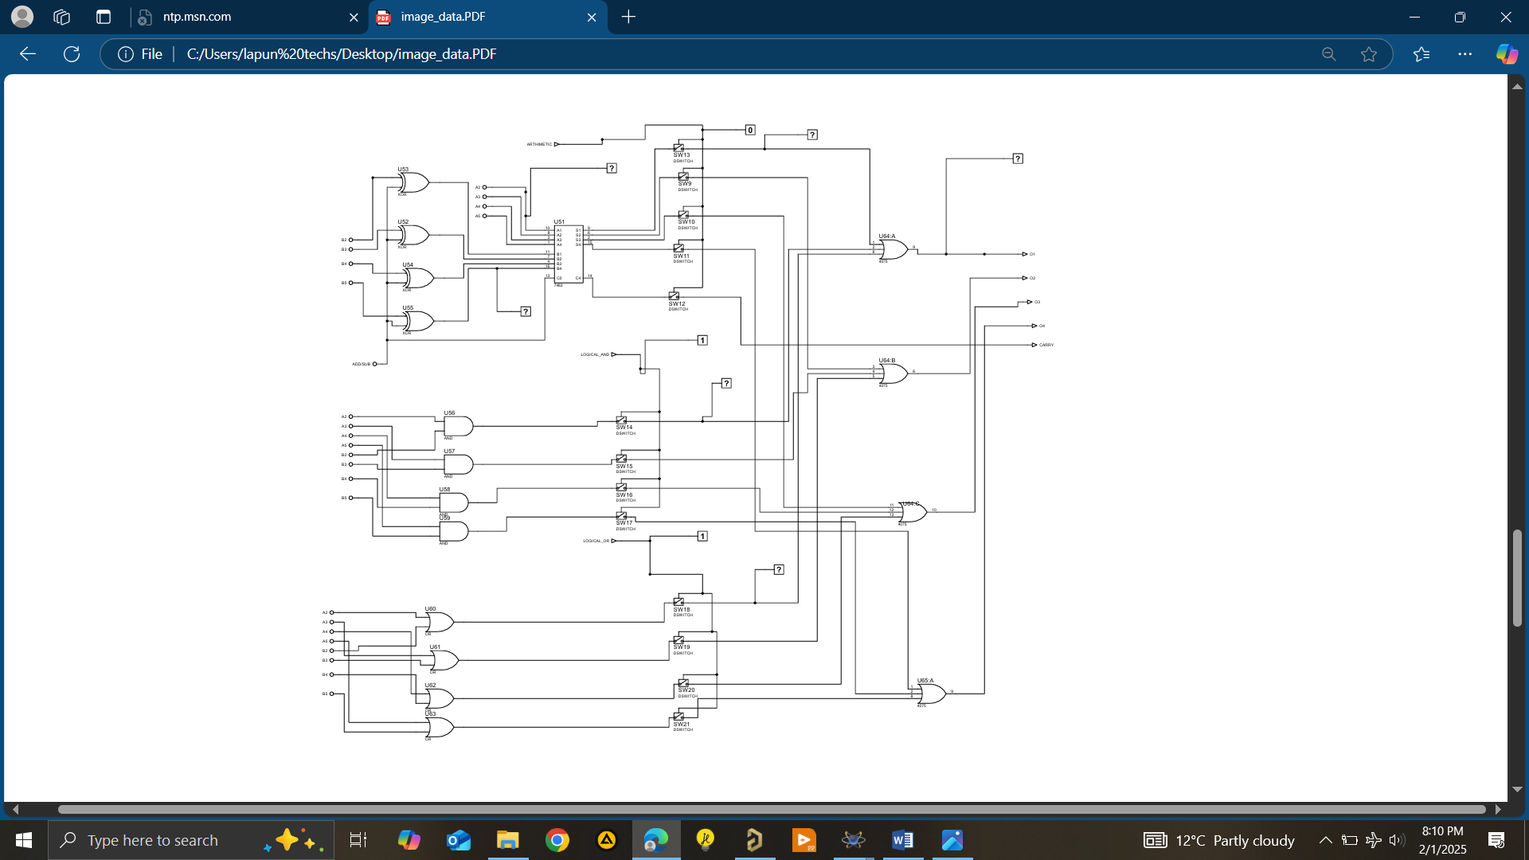

This finally we can say our CPU executes hardwired logic and can be used to any type of instruction by rebuilding some of the logic or by using different combination of control unit operation. We have limited ourselves in hardwired control unit due to time limitation. It is simple 4 bit computer can be extended to any number of bits using cascaded form in all the components.

**ACKNOWLEDGEMENT**

Instructor; Mr. Daniel D. for motivating us to build our first computer and giving comprehensive theoretical foundations.