Roxana Ohriniuc  
Collaboration with: Ohm Trivedi  
COP5850 summer 2015  
Prof. Ravi Shankar

**Smart on FHIR—using technology to revolutionize Health Data Information**

The era of big data knowledge has brought many improvements in our day to day life. Even so, one of the most important area of our well-being, health, is still lacking operational efficiency because of not enough focus on how health is influenced at a greater scale. Nowadays, health software moves slowly and is very unorganized. Currently, most hospitals and doctors use **EHRs** (electronic healthcare records) to collect data and coordinate care. Hospitals, insurance companies, laboratories, physicians, providers, etc., are all gathering information on patients, cost, procedures, medication which is stored in databases. And with all these efforts, analysis of data at greater levels is not being performed. Learning about health patterns and trends can help the community improve our overall healthcare and standard of living. Learning from data can be tremendously helpful in analyzing our society, uncover trends and relationships that were not seen or thought of before, such as unknown precursors for diseases, hidden public health risks and medication efficacy rates for segments within the patient population.(theatlantic.com)

Given the facts I have talked about so far, I have taken on a project on analyzing, sorting and displaying health data with the purpose of maybe showing how data can be analyzed, and its results used to draw certain conclusions. For this project I used the Python programming language (Through Anaconda Launcher and Spyder, the Scientific Python Development EnviRonment) and some online resources which i will be explaining to my best ability among which SMART on FHIR, a set of open specifications to integrate apps with Electronic Health Records, portals, Health Information Ex- changes, and other Health IT systems.

**Overview of new SMART on FHIR concept**

Before I present how exactly I analyzed the data with Python, I would like to make a short introduction to some of the terms and the technologies that I would like to focus on. The most important emerging concept in healthcare data analysis is **SMART** (Substitutable Medical Apps & Reusable Technology). SMART is mostly defined as a new model for Health Information Technology that is based on substitutable apps—apps that can be added to or deleted from EHRs. This model follows closely the SMART phone model, where everyone can download and upload apps for very specific needs. This new model of health information is about to connect EHRs on a very wide scale. The EHRs will be connected to applications running on the web, local intranets, or mo- bile devices. These new apps that are created using SMART on FHIR technology will be able to give the user the ability to better visualize and analyze health data by organizing and fluidizing the way data is collected and stored. The SMART platform architecture is achieving two goals: first, they are providing a user interface for medical apps based

upon shared basic components, secondly, they are providing a set of services that en- ables data capture, storage and data retrieval and analytics.(smarthhealthit.org)

**FHIR** -Fast Healthcare Interoperability Resources, is a framework created by HL7(Health Level 7). HL7 is a set of international standards or transfer of clinical and administrative data between software applications used by various healthcare providers. These standards focus on the application layer. FHIR solution are built from “Re- sources” which represent a set of modular components. These resources can be assembled into systems that resolve real world clinical and administrative problems. FHIR can be used in many context such as: mobile phone apps, cloud communications, EHR data sharing, server communications in large databases for healthcare providers, and more. (hl7.org). An example of a standardized patient record you can observe in fig.2 below.

**Issues**

The major issue with analyzing health data that I have came across was the actual lack of data available to the public. Health data is many times inaccessible and considered confidential. It is very difficult to find records of patients on the internet. An- other big issue with data online is that each organization stores and organizes their data totally different the the other ones. These aforementioned inconsistencies makes it difficult for everyone who could use this data to be able to do so. For our project here, we will be using some sample data that smarthealth.it website makes available so that developers can create and test apps based on SMART on FHIR.

**Description of project goal Python**

In order to analyze the health data related to the patients i will be using, as previously mentioned, Python through Spyder. Through Python, we will initially obtain data from a folder where we previously saved patient records. When creating an app, the data will come from either EHRs or some particular database. The purpose of this project is to show that data analyzed at a large scale level, for specific regions, cities, or even countries is very useful for drawing conclusion that can answer particular important questions. Given our defined purpose we will analyze the large sets of data by first importing the records one by one in our program, isolating the particular data that we are interested in, save it in a local variable that we later on manipulate or display to our specific purpose and intention. A good example, if we want to display the weight change of people over a period of a couple of years, we analyze all the records we have for the specified time period, we than can plot the information in a graph that will depict the change in weight of that particular patient or for a give population sample. Most of our data analysis will be based on the average of a given population as extreme cases do not make for good analysis.

**Integration with SMART**

Since SMART on FHIR is a set of protocols, we have used the given specifications to know exactly what semantics have been used, making it easier to analyze our given data. SMART on FHIR is the new standard for data collection, therefore we know that if we write a particular Python script, even though the name of patients and the location of where the data was collected will be different, all the other fields have been completed in the same order and with the same nomenclature. The fact that the data will be saved in the same format will make data large scale data analysis easier and more accessible. When we will create an app that will have the SMART on FHIR integration, we will have automatic integration with the SMART platform and also HL7 standards. The automatic integration will take place through some accreditation method (OAuth as most web apps). For our current project though, We have downloaded the files from the SMART website and will be processing locally through Python.

**Conclusions:**

After analyzing the data, we have made graphs of the mean and standard deviation for the respiratory rate, BMI, Oxygen Saturation and Blood Pressure. An example of the code we have in the GitHub link provided below. As it relates to our cases, we can see the following:

**For the Mean and Standard Deviation BMI**, 37 patients have had their BMI registered. We can draw the conclusion from our graph below that most patients that had their BMI recorded are somewhere in the normal range. We can see how dispersed the data in our sample is from the mean by analyzing the standard deviation histogram.

**For the Mean and Standard Deviation for Respiratory Rate,** 36 patients have been found to have registered the respiratory rate. As we can see from the mean histogram, the mean respiratory rate is somewhere around 15-16 breaths per minute. From the standard deviation histogram we can very easily see that the recordings are very close to the mean with less than a quarter of the population being outside of the normal range.

**For the Mean and Standard Deviation for the Oxygen Saturation**, 36 patients have been found to have registered their oxygen saturation, most of which are very close to 100%. The deviation from the norm is very little as it can be seen in the histogram for the standard deviation.

Appendix: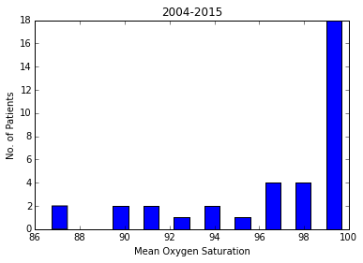

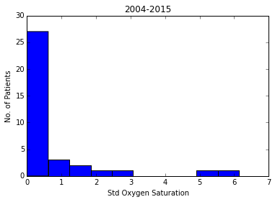

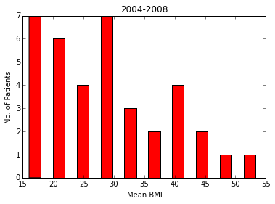

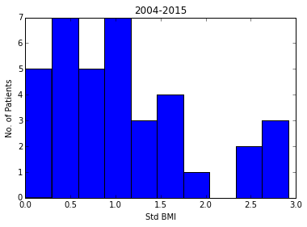

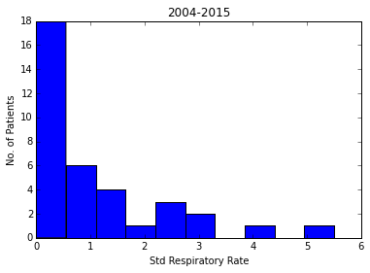

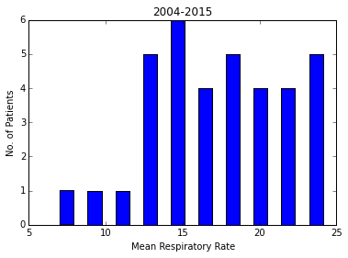

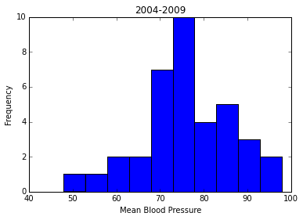

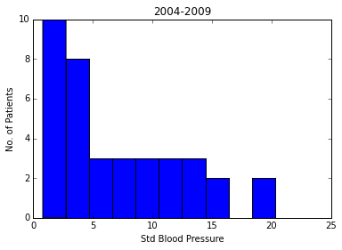

Links to code and graphs:

https://github.com/Semantic-Web/Roxana-O/tree/master/Project

References:

http://www.hl7.org/about/FAQs/index.cfm?ref=nav  
http://smarthealthit.org  
http://docs.smarthealthit.org/profiles/  
Susan Buie, Jan 29, 2014 http://www.theatlantic.com/sponsored/cvs-innovation-care/ big-data-better-health/96/