Assignment4

I chose to grab data from chicago’s data site. The city of Chicago has most data available that they are collecting in RDF format. I took the socioeconomic dataset which has the field community_area by number. I used the available information on Wikipedia to match up the community areas with their number. This allowed me to have a community number that I could join the second dataset of crime statistics to. The second dataset provided a collection of crimes that occurred throughout Chicago. I tallied the numbers for each community area in a dataframe with the community name and poverty level. This presents an interesting graph, I ran a bar chart of poverty level against crime statistics.

The question: Is poverty level directly tied to crime?

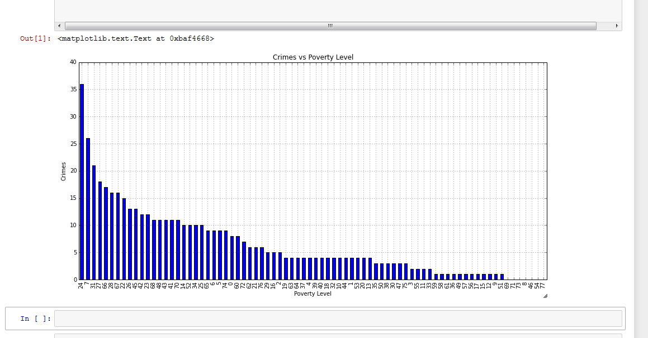

The chart proves that they are not consistently related. There are too many variations to say that a high poverty rate would make an area more susceptible to crime.