United States Department of Agriculture

National Agricultural Library

**NALT Deployment Guide Document**

**Deployment Guide Document**

Document Version Number: 1.0

Document Version Date: 10/23/18

**VERSION HISTORY**

|  |  |  |  |  |  |
| --- | --- | --- | --- | --- | --- |
| **Version Number** | **Implemented by** | **Revision Date** | **Approved by** | **Approval Date** | **Description of Change** |
| 1.0 | Sujata Suri | 9/13/2018 |  |  | Initial Revision |
|  |  |  |  |  |  |
|  |  |  |  |  |  |
|  |  |  |  |  |  |

**TABLE OF CONTENTS**

1. INTRODUCTION 4

1.1 Points of Contact 4

1.2 Application Servers in Scope 4

1.3 Software Media Required 5

2. Pre-installation 6

2.1 Technical Assumptions 6

2.2 Technical Dependencies 6

2.3 Technical Risks 6

2.4 Terminology and Acronyms 7

2.5 Pre-work 7

2.6.1 Preparing for Backout 7

3. Installation Instructions 8

3.1 STEPS TO BUILD NAL.war 8

3.2 STEPS TO DEPLOy OF NAL.war 9

4. Verification Plan 10

5. Backout Plan 11

5.1 Backout Plan 11

6. Known Problems 12

APPENDIX A: KEY TERMS 1

**List of Tables**

Table 1‑1: Points of Contact 4

Table 1‑2: Application Servers in Scope 5

Table 1.3‑1: Application Identification Information 5

Table 1.3‑2: Software Required for Build 5

Table 1.3‑3: Software Released 5

Table 1.3‑4: Database Scripts Affecting the Current Release Only 5

Table 1.3‑5: Required Software License 5

Table 2.4‑1: Terminology and Acronyms 7

Table 3‑1: Steps to Build WAR file 8

Table 3‑2: Steps for Deployment in Tomcat 9

# INTRODUCTION

This section provides a brief overview of the system and this document is available on the NAL shared drive

[S:\NAL\ISD\O&M_Documents\MultiTes\NAL MulTiTes_Deployment_Guide_Document_V1.0.docx ]

The Agricultural Thesaurus and Glossary were first released by the National Agricultural Library in 2002. In 2007, NAL and the Inter-American Institute for Cooperation on Agriculture (IICA) collaborated to develop the Spanish version of the NAL Agricultural Thesaurus and Glossary, named Tesauro Agrícola y Glosario

Multites is a software used to build and maintain NAL Thesaurus. A th2 file of NALT is generated through MultiTes and it is converted to SKOS file by using in-house program developed by Ying, Li (https://programs.nal.usda.gov/).

## Points of Contact

[This subsection of the DGD presents the names, roles, and contact information for all key personnel involved in the management, design, implementation, and testing of the current software release. The table below should contain at a minimum:

* Project Managers
* IT Tech Leads
* Any SMEs or other resources that will be supporting the development or deployment of this DGD

Table 1‑1: Points of Contact

| Name | Email | Phone | Contact for: |
| --- | --- | --- | --- |
| Jennifer, Woodward-Greene | Jennifer.Woodward@ARS.USDA.GOV | 301-504- | Chief, Indexing & Infoormatics Branch (I&I) |
| Sujata Suri | Sujata.suri@ars.usda.gov | 301-504-5058 | Thesaurus Coordinator |
| Sue, Phelps | Sue.Phelps@ARS.USDA.GOV> | 301-504 | IT |
| Truong Nguyen | Truong.Nguyen@ars.usda.gov | 703-622-1646 | Contractor |

## Application Servers in Scope

*[The following table contains the list of server instances that are the target for this Release Package DGD. This document may be applied to one specific server, or many, if each server receives an identical application build.*

Table 1‑2: Application Servers in Scope

| Application Name | Hostname | Environment |
| --- | --- | --- |
| NALT | nalt-prod.nal.usda.gov | Production |
|  |  |  |

## Software Media Required

Table 1.3‑1: Application Identification Information

|  |  |
| --- | --- |
| Application Name | MultiTes Pro WDK |
| Application Acronym | MultiTes Pro |
| Release Number | v2018.04.01 |
| GitHub Location | N/A |

Table 1.3‑2: Software Required for Build

|  |  |
| --- | --- |
| Name | Version |
| IIS | 7 |
|  |  |
|  |  |

Table 1.3‑3: Software Released

| Name | Description |
| --- | --- |
| ? | Web deployment file for NALT |

Table 1.3‑4: Database Scripts Affecting the Current Release Only

| Name | Description |
| --- | --- |
| None |  |

Table 1.3‑5: Required Software License

| Name | Description |
| --- | --- |
| None |  |

# 

# Pre-installation

## Technical Assumptions

[This section contains all relevant assumptions regarding the installation of this application, such as availability of support personnel or skill set required. Include any security support requirements, or support from any other organization or vendor.]

* The primary deployment file is a th.2 file that is automatically generated through the software. Creating the th2 file requires good working knowledge of Multites, creating reports and structuring data.

## Technical Dependencies

[This section lists all key dependencies that are required for a successful installation. Examples are infrastructure services, such as DNS, WINS, etc, or other applications that must be available prior to beginning this application installation.

This section also contains any required sequencing of applications installations, identifying predecessors and successors, if a particular sequence of installations is required for bringing a complete system online (i.e. App A needs to be operational before App B can begin installation).

Identify any upstream or downstream applications that are directly affected by this application.

Determine whether any of the previous versions of the software will need to be uninstalled before installing the new items.

Ensure that installation scripts generate meaningful status information as they run or that an installation log is created.

## Technical Risks

[This section identifies any significant technical risks (associated with this particular release only) to the successful completion of this installation. Ensure that any support or application knowledge shortcomings (i.e. the original developer is no longer available) are identified.]

* The build process requires a working knowledge of MultiTes, understanding of data structure and configurations.

## Terminology and Acronyms

This table defines the client-specific terminology and acronyms used in this document.

Table 2.4‑1: Terminology and Acronyms

| **Term** | **Definition** |
| --- | --- |
| NAL | National Agriculture Library |
| NALT | National Agricultural Library Thesaurus |

#### 

## Pre-work

[This section contains all pre-work items that must be completed before following the installation instructions, such as creating backup copies of critical files, locating IDs/passwords, converting data, or verifying any server settings.]

The installation staff shall have the linux admin privilege on the deployment server.

## Preparing for Backout

[This section provides details on what will need to be done should a backout be necessary. For example, perform special backup of specified files or folders prior to the update, perform archiving, etc.]

Back up the current deployment file “nal.war” using the simple command

$ sudo cp /opt/tomcat/webapps/nal.war /opt/tomcat/webapps/nal.war.bk

# 

# 

# Installation Instructions

This section provides the detailed instructions which would allow a systems administrator to use the Software media posted to GitHub repositories it by the Application Teams to successfully install the application on the target server.

**Note:** The installation instructions should not include the following:

* Windows operating system
* Unix operating system
* Middleware products: IIS, Oracle AS, Apache Tomcat, Oracle DB, SQL Server, Coldfusion, Business Objects, Documentum

A standard installation procedure will be followed for these products.

## Multites Deployment

### Multites – Generating web file

A clean NALT th.2 web file (NALT20XXweb.th2) and a glossary (GLOS20XX.th2) file is generated from the Multites. The instructions for generating web files for NALT and Glossary can be found in S:\NAL\DPD\Indexing & Informatics\NAL Thesaurus\NALT Manual-Procedures for publishing a new edition of Thesaurus and Glossary Revised 2018.

### Multites – Move .th2 file to deployment server

Copy NALT20XXweb.th2 and GLOSS20XX.th2 files and paste it into mt2007/data on production server.

### Multites – Site Configuration Tool

Configuration for NALT and glossary can be set as shown in the screenshots below:

Go to mt2007/WDK/ WDKConfig and select different options from drop down “Web Site” for NAL Thesaurus and glossary in English and Spanish as shown below

Web Site: default (For NALT in English)

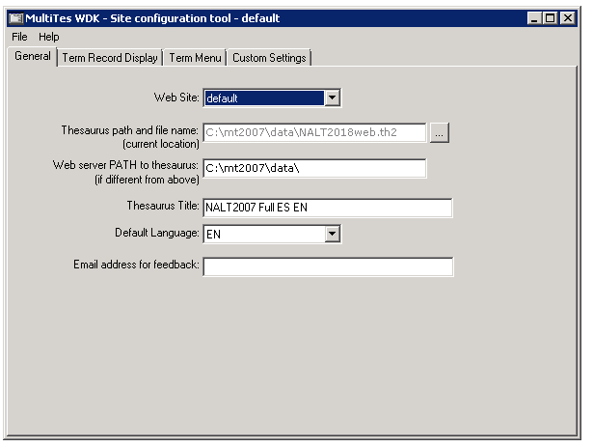 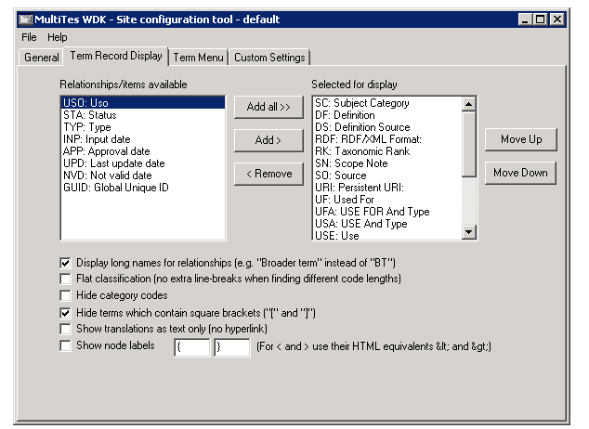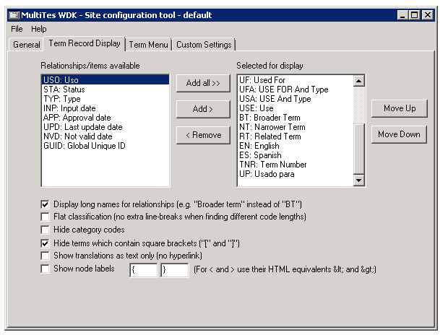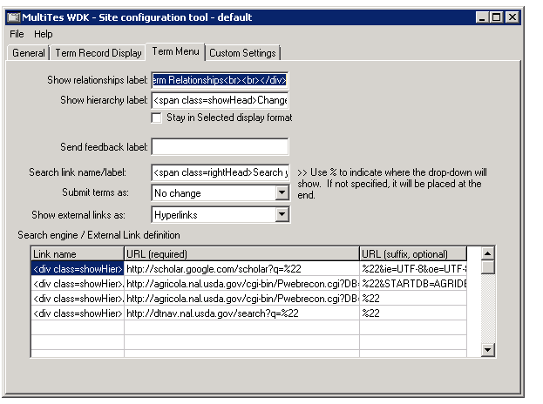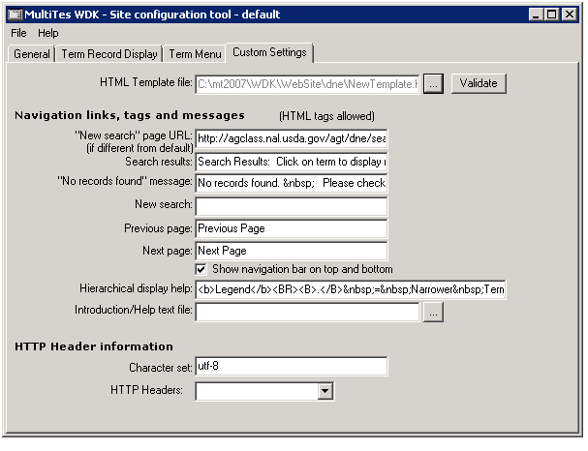

Web Site: 2007es (For NALT in Spanish)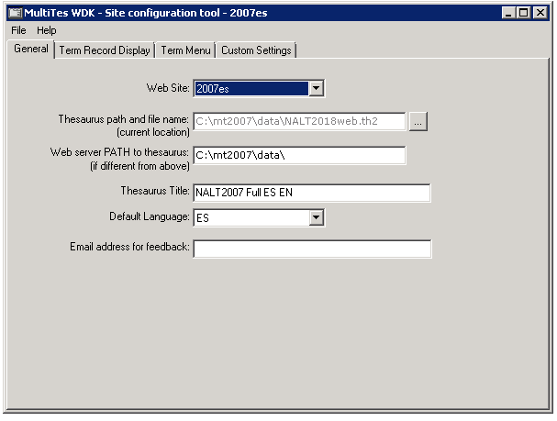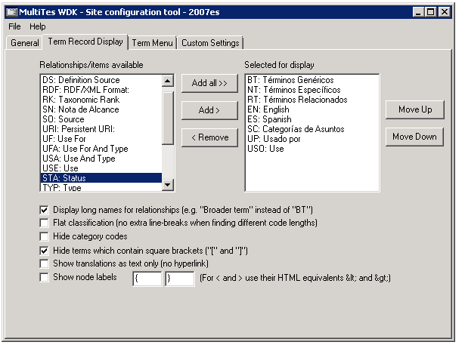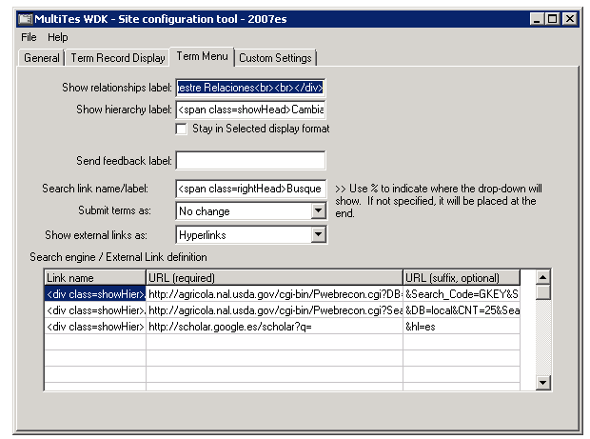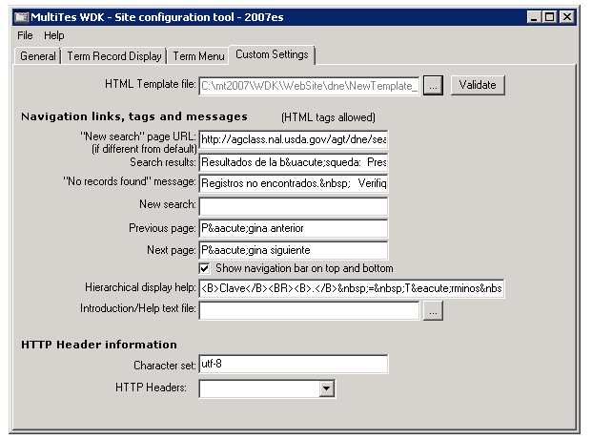

Web Site: glossary (For NAL glossary in English)

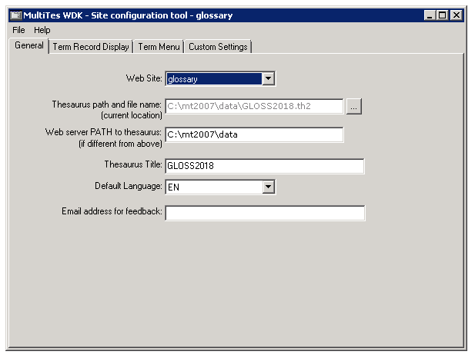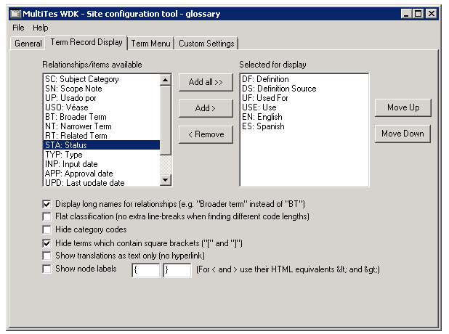

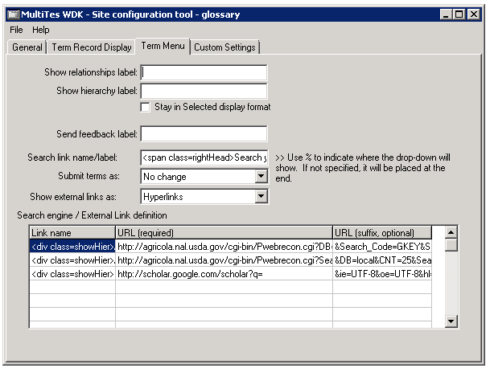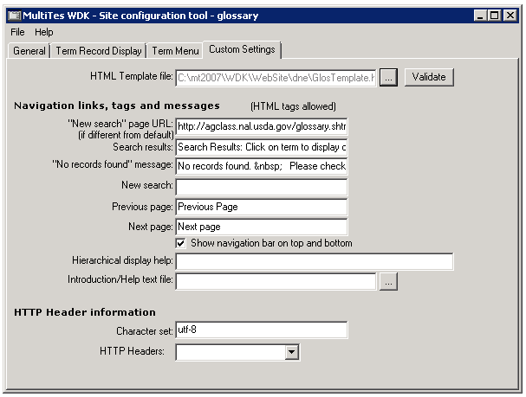

Web Site: glosses (For NAL glossary in Spanish)

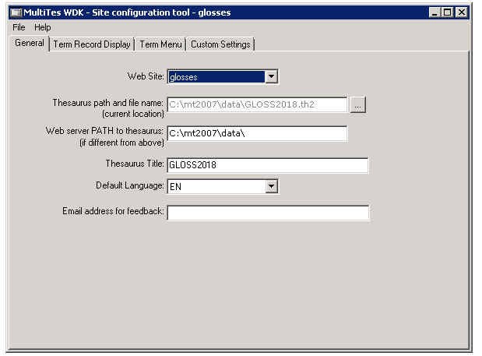

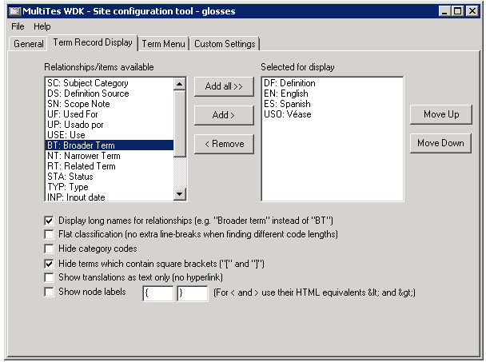

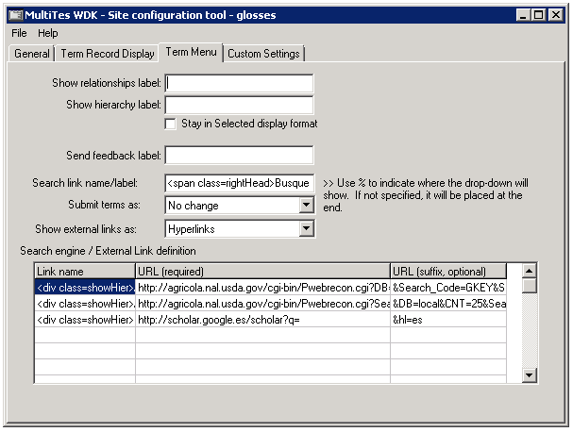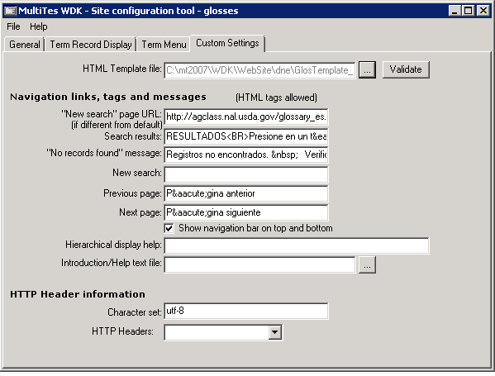

## 3.2 STEPS TO iis

Table 3‑2: Steps for Deployment in Tomcat

|  |  |  |  |  |  |  |
| --- | --- | --- | --- | --- | --- | --- |
| |  |  | | --- | --- | | Stage/Phase (Target Environment): | Build machine/ build phase | | | |  |  | | --- | --- | | Duration: |  | |
| Step | Task/Description | Comments |
| 1 | $ sudo systemctl stop tomcat | Stop the tomcat instance |
| 2 | $ sudo -rf /opt/tomcat/webapps/nal.war  $ sudo -rf /opt/tomcat/webapps/nal | Delete the current deployment war file and folder |
| 3 | $ sudo cp dist/nal.war /opt/tomcat/webapps/nal.war | Copy the deployment nal.war file |
| 4 | $ sudo systemctl start tomcat | Start the tomcat instance |

# 

# Verification Plan

[This section describes the criteria and verification tests that the NAL Systems Administrator should perform after completing the installation, to confirm successful completion. This is usually a short list of simple checks, such as communication to target devices, status on consoles, interface of the application through a web browser, etc. These checks will be conducted prior to turning the application over for full system testing.

**Note:** This section should include basic system verification steps, not a full blown system test plan. The system test plan is maintained independently from this document. Upon successful completion of the Verification Plan, the system will be turned over for formal and complete system testing.]

|  |  |  |  |  |
| --- | --- | --- | --- | --- |
| |  |  | | --- | --- | | Target Environment: |  | | | |
| Step (Task) | Expected Outcome | Comments |
| 1 | Navigate to the lca collaboration server portal   * Dev: http://annotator-dev:8080/nal/ * Staging:TBD * Production: TBD | The landing page should be rendered without any errors |

# 

# Backout Plan

## Backout Plan

[This section describes any steps necessary to backout an unsuccessful installation. This does not need to include steps to uninstall the software on the target server, but rather to reset any links, DNS entries, or other external dependencies that may have been established assuming the new server coming online. Steps taken under Section 2.6.1 Preparing for a Backout should be referenced here, for example: “restore the back up that was performed under Section 2.6.1. This section should also include any dependant applications and/or components that may need to be reset if this installation fails.]

| Environment: | | Duration: |
| --- | --- | --- |
| Step | Task/Description | Comments: |
| 1 | sudo systemctl stop tomcat | Stop tomcat |
| 2 | sudo rm –rf /opt/tomcat/webapps/nal/  sudo rm –rf /opt/tomcat/webapps/nal.war | Delete the current web folder and war file |
| 3 | sudo mv /opt/tomcat/webapps/nal.bak opt/tomcat/webapps/nal.war | Restore the previous deployment war file |
| 4 | sudo systemctl start tomcat | Start tomcat |

**Note:** If the system fails in PROD, then any special steps to be taken should be detailed in a “Backout From PROD SOP” to be added as an Appendix to this document.

# Known Problems

[This section contains all known problems with the application installation or ongoing operational issues, such as known bugs or unusual behavior.]

None

1. KEY TERMS

The following table provides definitions and explanations for terms and acronyms relevant to the content presented within this document.

| **Acronym** | **Definition** |
| --- | --- |
| DNS | Domain Name System |
| ISD | Information Systems Division |
| NAL | National Agriculture Library |
| NALT | National Agricultural Library Thesaurus |
| SOP | Standard Operating Procedure |
| WDK | Web Deployment Kit |
|  |  |
|  |  |
|  |  |
|  |  |
|  |  |
|  |  |
|  |  |
|  |  |
|  |  |
|  |  |
|  |  |
|  |  |
|  |  |
|  |  |
|  |  |
|  |  |
|  |  |