**MultiTes Pro** v2019.05.19u (soft wear to maintain Thesaurus): Thesaurus maintaining Soft wear I use to develop Thesaurus / data (edit, update or add terms). It looks like the icon as in the image below

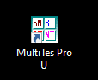

Once we open this Multites, I select file saved on my desktop (or on S drive/ S:\NAL\DPD\Indexing&Informatics\mtm\2021). File name is NALT2021.th2. You will see as below

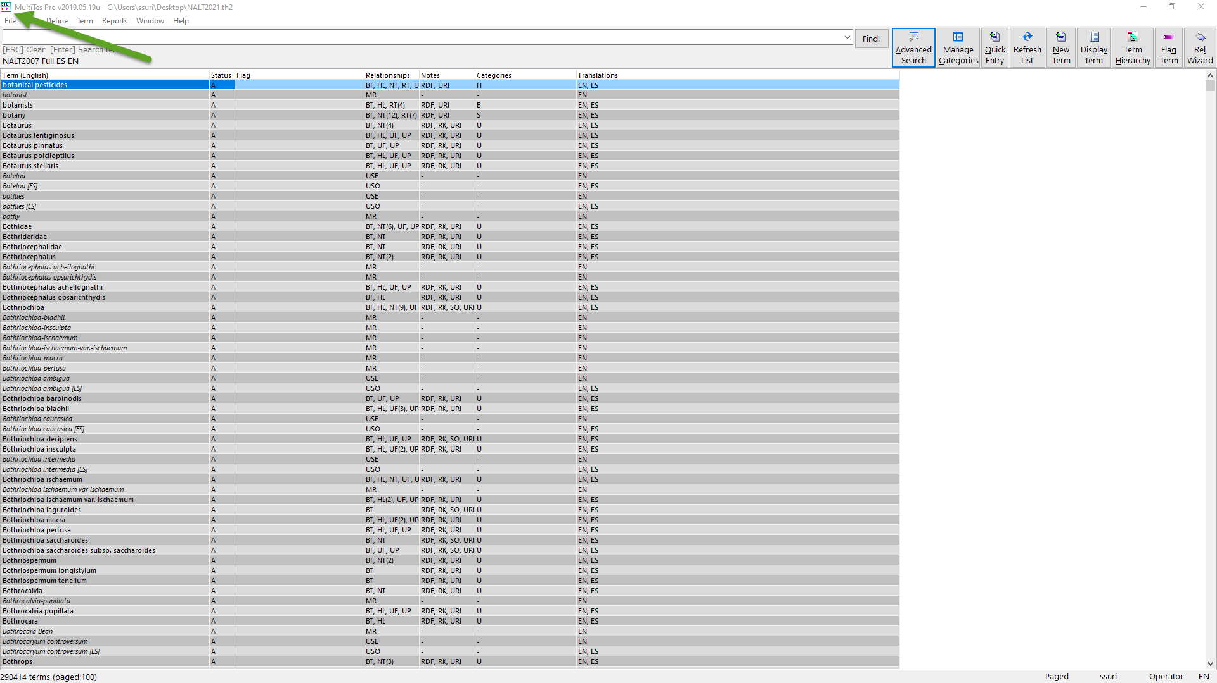

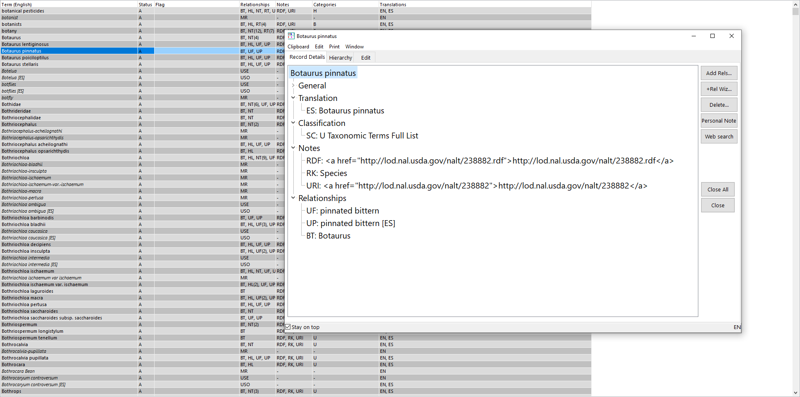

Data is stored in it in th2 format as shown below



2. Files for website:

a. NALT2021.th2 file backed up on production/website server on regular basis (10.11.217.125).

1. At the end of year when we publish Thesaurus, we generate

NALT2020web.th2 and NALT2020 Glossary.th2 from the above Multites thesaurus tool and these files go in data folder of (mt2007) for production server (10.11.217.125).

1. mt2007 folder (I will say web display folder as it contains all the files related to website) is on production server where we store all shtml files and web templates. These files are generated per the “***Procedures for publishing a new edition of Thesaurus and Glossary***”, (Guide) (S:\NAL\DPD\Indexing&Informatics\NAL THESAURUS\NALT Manual). The guide also includes instructions for creating the RDF/URI links to NAL terms (Section III).
2. Production server looks as below
3. 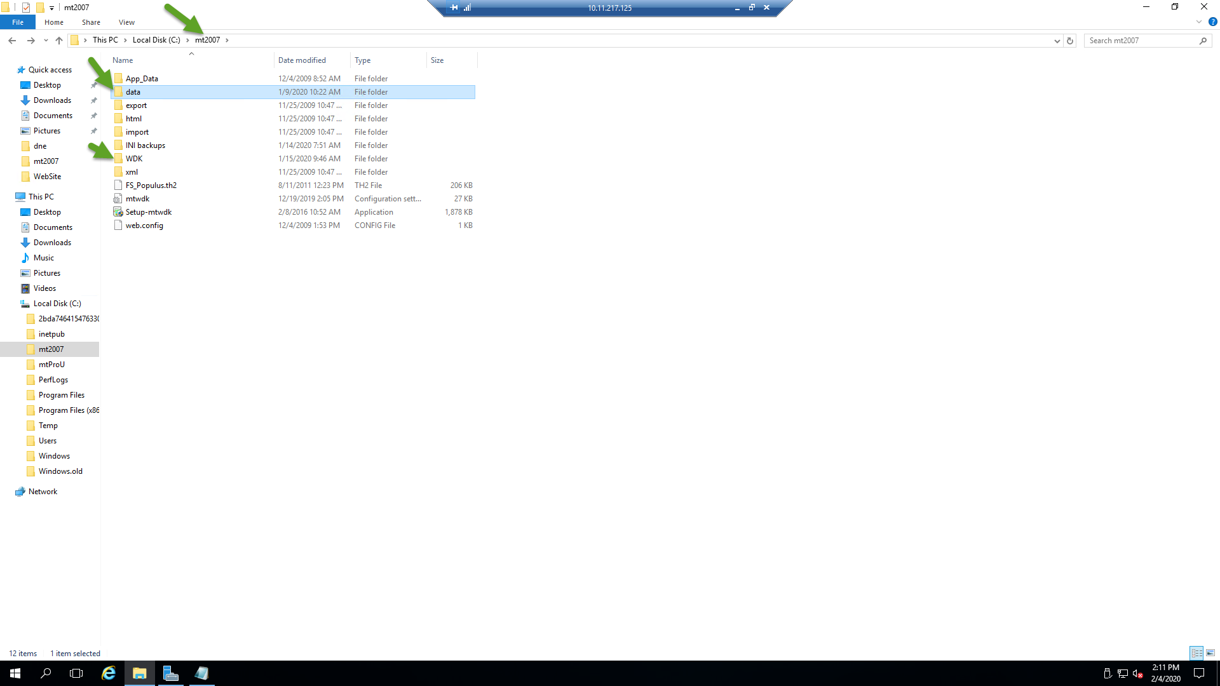
4. 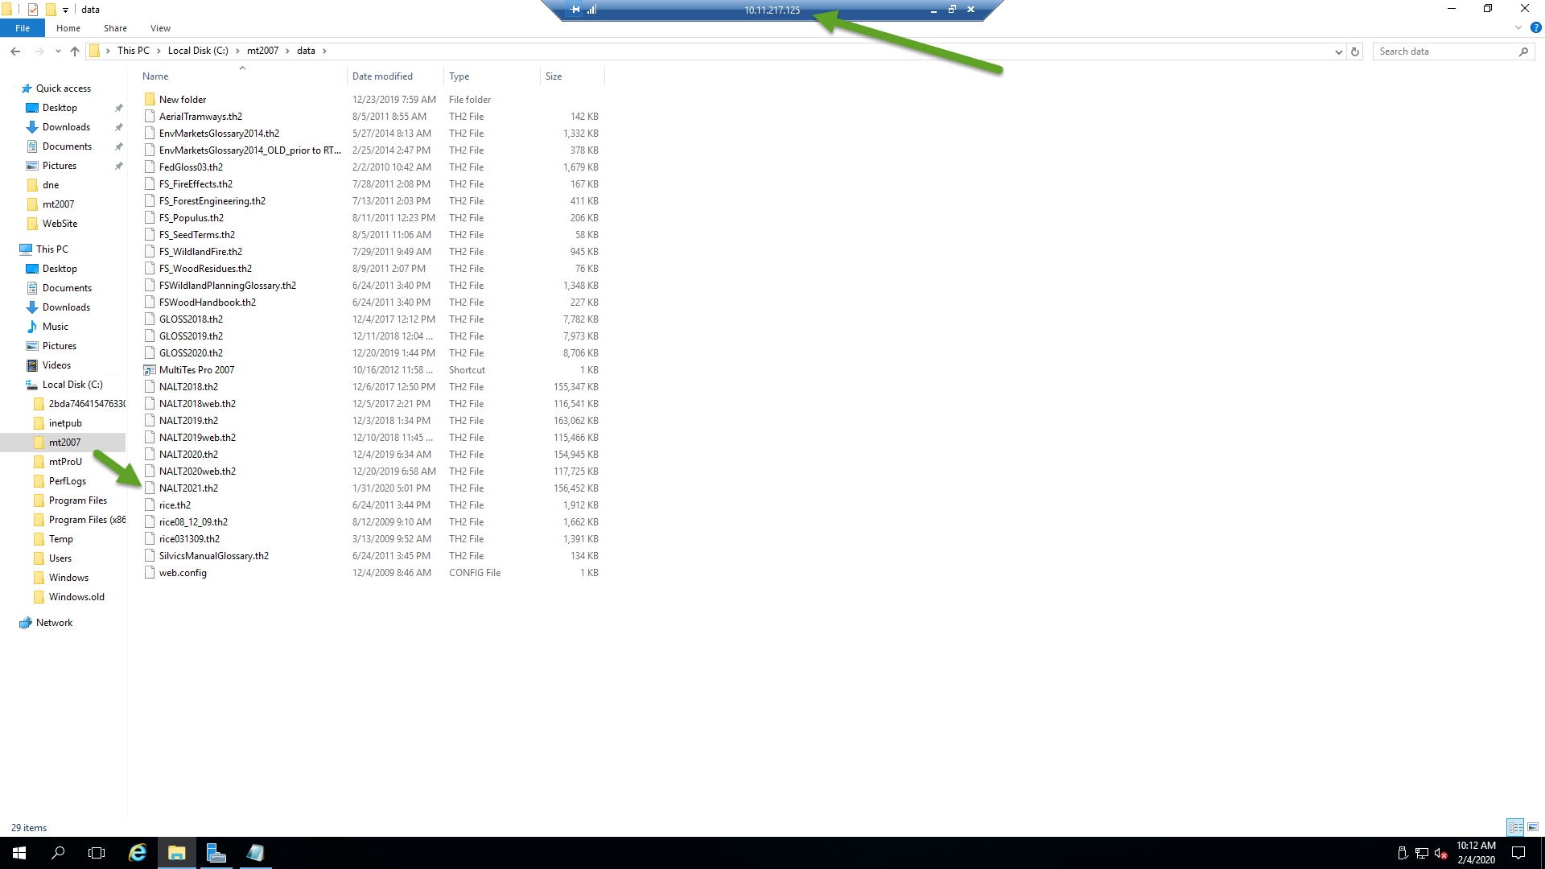

2. Create STF for NALT use in Cogito for the Annotation Plan (includes hidden labels i.e. full file). Detailed instructions are found in the Guide, (Q:\Documentation\Instructions\Instructions on creating new STF_for WebStudio_Updated 13_june_2019)

After 3 months, I generate xml file from Thesaurus Software. For example NALT2019_Oct5_2018.xml and I use <http://programs.nal.usda.gov/> (in-house program for converting xml file into SKOS or Misha’s program). Once SKOS file (now STF) is generated, it is given to Misha. Misha loads in Cogito for indexing.

Below is the **Proposal Database** (maintained by Misha) where indexers or others (AWIC, etc.) suggest terms (new terms, hidden labels, or other suggestions)

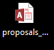

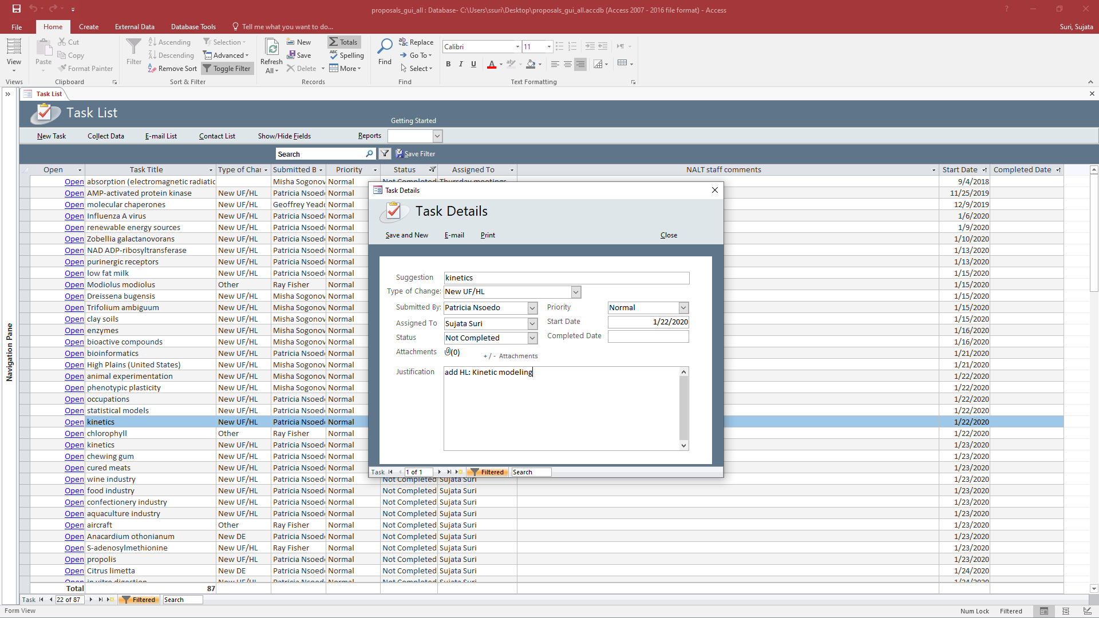

How to propose terms: Please see “Instructions for using proposal form August, 2018”. It is in drive S:\NAL\DPD\Indexing&Informatics\NAL THESAURUS\NALT Manual.