Striped magnetic fields and the Richtmyer-Meshkov instability: a trade-off between suppression and collimation
Abdelrahman Shaltout
Independent researcher

Abstract
We examine whether a spatially striped magnetic field can suppress the Richtmyer-Meshkov instability (RMI) of a shocked density interface while channelling the post-shock flow through the weak-field gaps between the stripes, a configuration we refer to as a magnetic sieve. The study uses a two-dimensional, GPU-based finite-volume MHD solver with an HLLD Riemann solver, MUSCL reconstruction, SSP-RK3 time integration and GLM divergence cleaning. An audit of the first implementation found a non-solenoidal initial field, an upstream state that was not in pressure balance, a resistive energy source that created energy, and an energy diagnostic that confused boundary inflow with conservation error. After correction, the discrete energy budget closes to round-off, and initial states are restricted to the fast-shock regime, which for a shock-parallel field at Mach 10 requires B₀ < 6.55√p̅. A uniform shock-parallel field of strength B ≥ 2 reduces the mixing-layer enstrophy to 0.03 of the hydrodynamic value. Striped fields meet the same criterion only when the bar-to-gap field contrast is about 10% or less. Larger contrast produces a steady, field-aligned shear behind the shock, because the shock compresses the gas but not a shock-parallel field; magnetic tension does not oppose this shear, and it deforms the interface at the stripe scale. The contrast needed to steer flow into the gaps therefore prevents suppression. When the stripe wavenumber is half the interface wavenumber, the stripe-induced displacement interferes with the RMI mode with the phase dependence predicted from the jump conditions, producing a zero crossing of the mode followed by inverted growth rather than a sustained lock. This zero crossing is the magnetic counterpart of the phase-dependent interaction between non-uniform shocks and interface perturbations known from hydrodynamic studies; we report it as an observation.
Keywords: Richtmyer-Meshkov instability; magnetohydrodynamics; magnetic suppression; HLLD; divergence cleaning; shock admissibility

1. Introduction
When a shock crosses a perturbed interface between fluids of different density, baroclinic vorticity deposited on the interface drives the growth of the perturbation: the Richtmyer-Meshkov instability [1, 2]. The instability matters in inertial confinement fusion, where it seeds mixing between capsule layers, and in astrophysical shocks, where it can amplify magnetic fields. A magnetic field can suppress it (Section 2).
This work asks what happens when the field is structured on the scale of the perturbation on purpose. The hypothesis was that a field organised in stripes, with strong-field bars separated by weak-field gaps, would act as a sieve: the bars would hold the interface in place, while the gaps would admit the post-shock flow as collimated jets. The critical field would then follow a scaling B_{crit} = Ψ√ρ̅ V_{hydro}, with V_{hydro} the linear Richtmyer growth rate and Ψ a geometric factor.
The first implementation of the solver reported a total energy change of 329% over a run and a maximum |∇·B| of 241, figures incompatible with a reliable calculation. Tracing them to their causes changed both the numerical method and the physical set-up (Sections 3 and 4.1). With a pressure-balanced, admissible configuration and interface-local diagnostics, the study then tests the hypothesis over the field strength, the bar-gap contrast, and the wavenumber and phase of the stripes (Section 4). Section 5 relates the results to previous work and states their limits.

2. Literature Review

2.1 Magnetic suppression of the RMI
In ideal MHD a magnetic field can suppress the RMI. For a field aligned with the shock normal, Samtaney [3] showed numerically that the interface remains stable. Wheatley, Pullin and Samtaney [4] solved the linearised initial-value problem and showed that the interface amplitude stays bounded, because the vorticity deposited by the shock is carried away from the interface along field lines. Sano, Inoue and Nishihara [5] derived the field strength required for suppression in plasmas and found that it depends mainly on the shock Mach number.
Fields with spatial structure have been studied mainly in converging geometry. Mostert et al. [6] applied seed fields of prescribed shape to spherical implosions; the suppression varied over the interface, and an octahedrally symmetric field gave a nearly uniform suppression pattern. In these studies the field structure is a consequence of the geometry or is chosen for symmetry; it is not used to steer the flow.

2.2 Phase-dependent interaction and freeze-out
In hydrodynamics, perturbation growth depends on the relative phase of a non-uniform drive and the interface. Ishizaki et al. [7] showed that a flat contact surface becomes unstable behind a rippled shock, with a growth rate that depends on the phase of the shock oscillation at impact. Zou et al. [8] studied flat interfaces impacted by rippled shocks in a shock tube. Freeze-out, the vanishing of the asymptotic normal velocity of the interface, results from the interaction of the interface with rippled wave fronts [9]. Recent work designs targets so that such interactions cancel growth, by optimising the target geometry [10] or by placing sub-surface voids that split the shock into a sequence of weaker waves [11].

2.3 Gap addressed
We did not find studies of a magnetic field that is striped across a planar interface, nor of how such a field behaves when it must be in pressure balance with the gas ahead of the shock. The present work examines that configuration, and Section 5.1 compares its findings with the work above.

3. Methodology

3.1 Equations and discretisation
We solve the two-dimensional compressible MHD equations for an ideal gas (γ = 5/3) with a passive scalar C marking the heavy fluid and an optional constant resistivity η. Variables are cell-centred. Interface states are reconstructed with MUSCL and the van Leer limiter [12], fluxes use the HLLD solver of Miyoshi and Kusano [13] in a CUDA kernel (one thread per face), and time integration uses three-stage SSP Runge-Kutta [14]. The divergence constraint is controlled by GLM cleaning [15] with Powell source terms [16].
The GLM speed c_{h} is set to the largest MHD signal speed; the earlier choice of 1.5 times the sum of fast speed and |v| reduced the time step by a factor of two to three without improving the cleaning. The damping parameter was reduced from α = 1.5 to 0.4: in a test with a striped field, h max|∇·B|/max|B| was 0.050, 0.042 and 0.038 for α = 1.5, 0.4 and 0, consistent with [17].

3.2 Striped field, pressure balance and admissibility
The field is aligned with the shock normal and modulated across the interface,
B_{x} = B₀√[ε² + (1 − ε²)cos²(k_{m} y + φ)], B_{y} = B_{z} = 0 (1)
which is solenoidal for any profile in y. Bars (B_{x} = B₀) alternate with gaps (B_{x} = εB₀); ε = 0 gives field-free gaps and ε → 1 a uniform field. The upstream gas is in pressure balance,
p(y) = P_{tot} − B_{x}²/2, P_{tot} = p̅ + B₀²/2 (2)
so the bar centres keep the reference state ρ = 1, p = p̅ = 1 (Fig. 1). With uniform upstream density, a planar shock of speed v_{s} = M c_{s}(bar) is imposed and each row receives the hydrodynamic jump at its local Mach number, since the normal field is continuous across the shock.

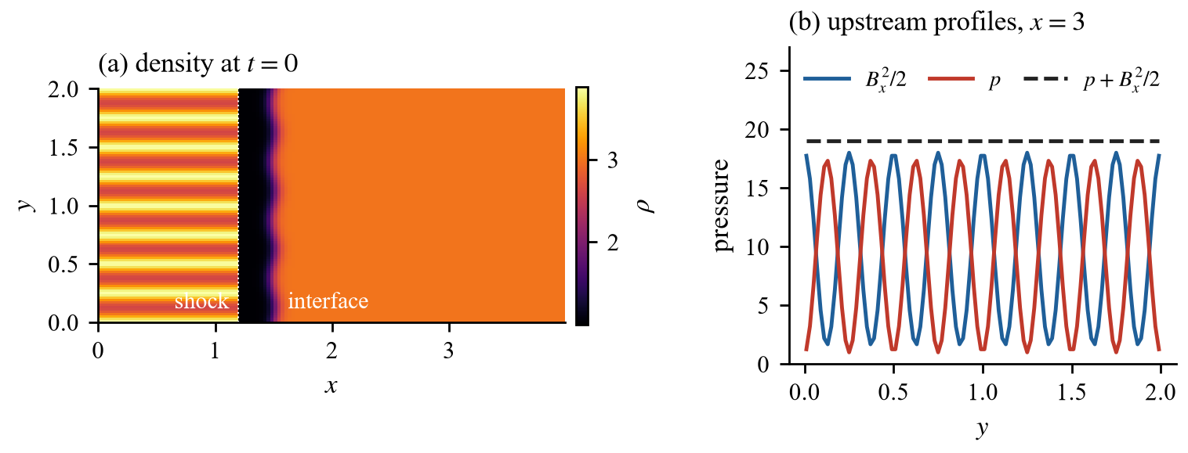
Figure 1. Initial condition for B₀ = 6, ε = 0.3. (a) Density at t = 0: post-shock gas to the left of the shock at x = 1.2, the rippled interface at x = 1.5, and uniform heavy gas beyond it. (b) Upstream profiles across the stripes: gas and magnetic pressure vary, their sum does not.

The hydrodynamic jump is an admissible fast MHD shock only if the downstream flow stays super-Alfvénic in the shock frame, u₂ = v_{s}/r > v_{A2}. At the bar centres this gives
B₀ < v_{s}√(ρ/r) = 6.55√p̅ (M = 10, r = 3.88) (3)
Beyond this limit the shock would be of switch-on type. With uniform density the hotter gaps must also stay supersonic, B₀ < √[2p̅(M² − 1)] = 14.1√p̅ (Fig. 2b). The solver rejects inadmissible states; only B₀/√p̅ matters, so raising the reference pressure does not extend the range. The pressure balance is exact in the initial data but only second-order in the scheme, because p and B_{x} are reconstructed separately (Fig. 2a).

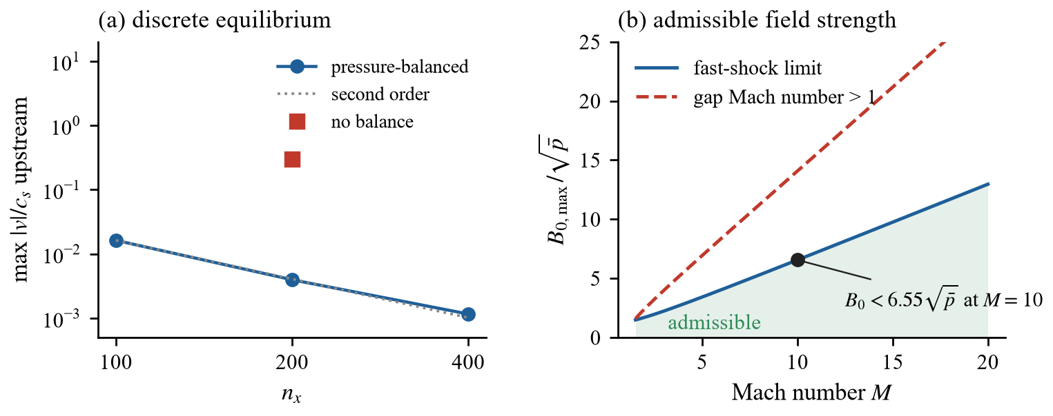
Figure 2. (a) Residual flow far upstream of the shock at t = 0.05 for B₀ = 5, against resolution; the square is the same case without pressure balance. (b) Admissible field strength against Mach number: the fast-shock limit of Eq. (3) and the gap Mach-number limit. The point marks the configuration of this study.

3.3 Energy accounting
In a domain with driven inflow, the change of total energy is not a measure of conservation. We accumulate the energy flux through the domain faces from the same HLLD fluxes that update the energy, weighted by the SSP-RK3 stage coefficients (1/6, 1/6, 2/3), and the integral of the Powell energy source. The conservation error is
ε_{E} = [E(t) − E(0) − ∫F_{E} dA dt − ∫S_{P} dV dt]/E(0) (4)
It stays below 10⁻¹¹ in all runs and near 10⁻¹² in the sweeps of Section 4 (Fig. 3). The resistive terms are written in conservative form: −∇×(ηJ) in the induction equation with all three current components, and the divergence of the face-centred resistive Poynting flux ηJ×B in the energy equation, so Ohmic heating is not counted twice. A parabolic limit Δt ≤ [2η(Δx⁻² + Δy⁻²)]⁻¹ applies when η > 0.

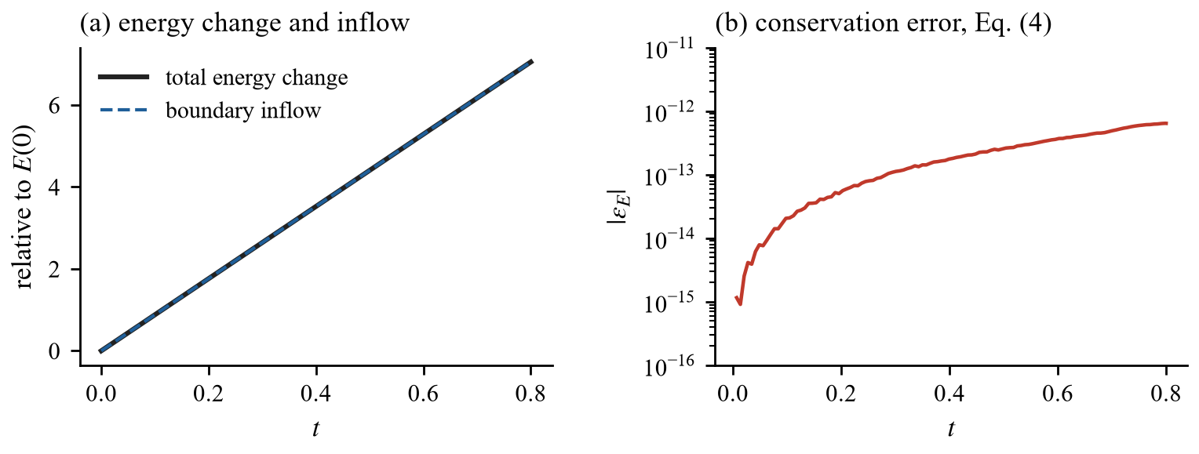
Figure 3. Energy budget for B₀ = 3.5, ε = 0.9. (a) The total energy grows to several times its initial value, and the boundary inflow accounts for all of it. (b) The conservation error of Eq. (4).

3.4 Boundary conditions
The post-shock state is held fixed in the ghost cells at x_{min}. For a super-fast inflow all seven characteristics enter the domain, so this is the characteristic boundary condition, and the solver checks it at start-up. The outflow is transmissive with ψ extrapolated, and y is periodic. Small fast and Alfvén pulses passed through the outflow leave residuals of 3.5×10⁻⁵ and 6.9×10⁻¹⁰ of the incident amplitude.

3.5 Diagnostics and lock criterion
Enstrophy over a fixed window around the interface, the metric used initially, is unsuitable for MHD: the Alfvénic waves that remove vorticity from the interface stay inside the window for some time. A uniform field gives a window enstrophy well above the hydrodynamic value while the mixing-layer enstrophy is far below it (Fig. 4). We therefore use the enstrophy in the mixing layer, 0.05 < C < 0.95, and the interface circulation per half wavelength. The interface position in each row follows from the gradient of C; its Fourier transform in y gives the seeded-mode amplitude a₄ and the rms roughness over all modes.

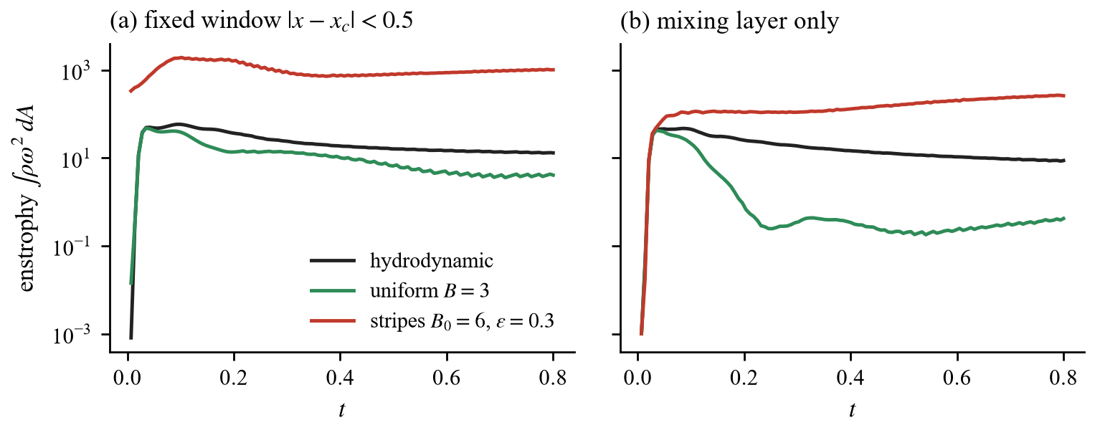
Figure 4. Enstrophy (a) in a fixed window around the interface and (b) in the mixing layer only, for the hydrodynamic run, a uniform field and deep stripes.

A case is locked if, relative to the hydrodynamic run with identical settings, the late-time mixing-layer enstrophy is below 0.2 and the interface growth is below 0.5. Sweeps A-D measure growth as a₄(t_{end})/a₄(0.05); from sweep E onwards the roughness over all modes is used, so that stripe-scale deformation cannot hide outside the seeded mode.

3.6 Configuration and verification
The domain is 12 × 2 with 400 × 100 cells. A Mach-10 shock starts at x = 1.2; the interface at x = 1.5 separates ρ = 1 from ρ = 3 with a perturbation a₀ sin(ky), k = 4π, a₀ = 0.02 (ka₀ = 0.25). Runs end at t = 0.8 with CFL number 0.3. Table 1 lists the verification suite, which is run before each study.

Table 1. Verification tests, run before each study.
Test | Quantity | Result
Brio-Wu shock tube [18] | wave structure | pass
Alfvén wave | convergence order | 1.96
Outflow reflection | residual of fast / Alfvén pulse | 3.5×10⁻⁵ / 6.9×10⁻¹⁰
Energy budget | conservation error ε_{E} | ≤ 1.2×10⁻¹⁴
Divergence | h max|∇·B|/max|B| | 0 to 0.025
Upstream equilibrium | max|v|/c_{s} ahead of the shock | 3.9×10⁻³

4. Results

4.1 Consequences of the corrected set-up
The original stripes B = B₀cos(k_{m} y)ŷ have ∇·B = −B₀k_{m} sin(k_{m} y), so the initial field violated the solenoidal constraint, by more behind the shock where B_{y} is compressed (Fig. 5). For B₀ = 85.4 the initial max|∇·B| was 3064, larger than the final 241: GLM was reducing an error imposed by the initial and inflow conditions. The Powell source, which acts only where ∇·B ≠ 0, removed 22% of the initial energy at B₀ = 20, so earlier estimates of the critical field were influenced by forces with no physical counterpart. The reported 329% energy change was boundary inflow: a run without field showed a 263% change and 0.00% after correcting for the boundary flux.

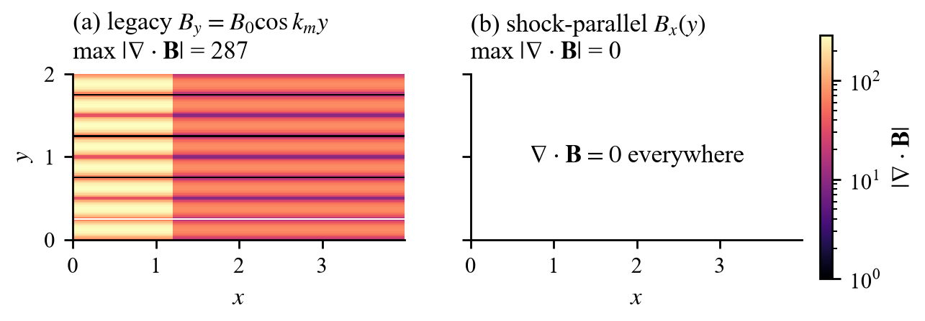
Figure 5. |∇·B| at t = 0 for B₀ = 6: (a) the original B_{y} stripes and (b) the shock-parallel stripes used in this study.

A first probe with the corrected set-up and the original perturbation (ka₀ ≈ 1.9, outside the linear regime assumed by V_{hydro}) met the original momentum criterion at B₀ = 6 (gap-to-bar momentum flux 0.763 < 0.8). The imposed inflow alone gives 0.593, because the hotter gaps receive a weaker shock; relative to it, the flow moved momentum into the gaps. Momentum ratios below are normalised by their inflow value.

4.2 Field-free gaps and choice of closure
With field-free gaps (ε = 0, sweep A) the late-time growth rate of a₄ falls from 0.121 (hydrodynamic) to 0.018 at B₀ = 3 and 0.016 at B₀ = 6 (Fig. 6), but the mixing-layer enstrophy at t = 0.8 rises from 8.7 to 340 at B₀ = 6. A uniform-temperature closure keeps the Mach number equal in every row but leaves the dense gaps with about five times the post-shock pressure of the bars; the amplitude then grew 93-fold (sweep B). With uniform density the strong-shock pressure barely depends on the upstream pressure, and this closure is used throughout.

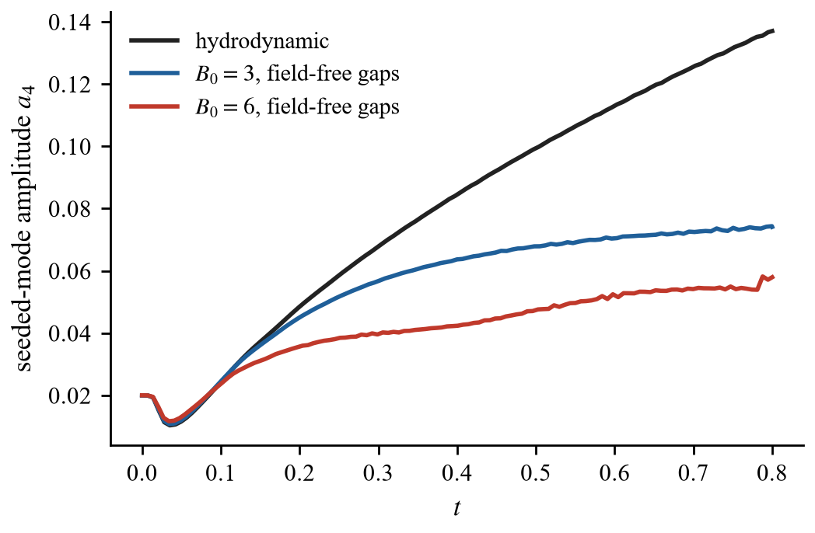
Figure 6. Seeded-mode amplitude for the hydrodynamic run and for stripes with field-free gaps (sweep A).

4.3 Suppression and collimation
A uniform field locks the interface: at B = 2 and B = 3 the mixing-layer enstrophy is 0.03 of the hydrodynamic value, while at B = 1 the growth criterion fails (0.73). Figure 7 shows sweeps C and D against the bar-gap magnetic-pressure contrast ΔP_{B} = B₀²(1 − ε²)/2. Every striped field reduces seeded-mode growth to 0.21-0.32 of the hydrodynamic value, but the mixing-layer enstrophy rises monotonically with ΔP_{B}; the criterion is met only for ΔP_{B} ≲ 1.2, a field contrast of about 10% at B₀ = 3-3.5 (Table 2).

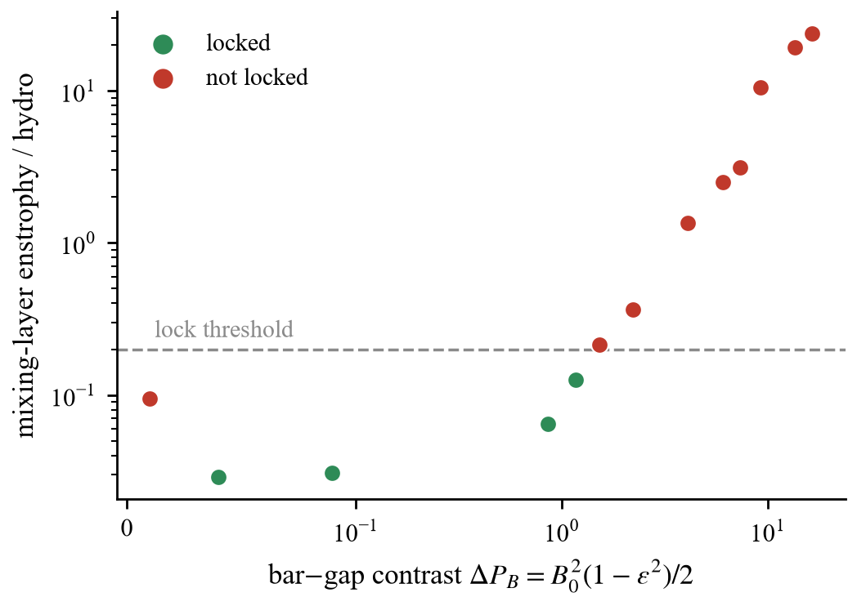
Figure 7. Late-time mixing-layer enstrophy relative to the hydrodynamic run, against the bar-gap magnetic-pressure contrast (sweeps C and D). Green: locked. The red point at the smallest contrast is a uniform field B = 1, which meets the enstrophy criterion but not the growth criterion.

The interface spectrum shows where the excess vorticity goes (Fig. 8). At t = 0.8 the hydrodynamic run has a₄ = 0.137 and roughness 0.098; a uniform field B = 3 gives 0.038 and 0.027, and the 10% stripes 0.035 and 0.029. Deep stripes (B₀ = 6, ε = 0.3) also give a₄ = 0.035, but the stripe-scale mode a₈ grows to 0.255 and the roughness to 0.200, twice the hydrodynamic value.

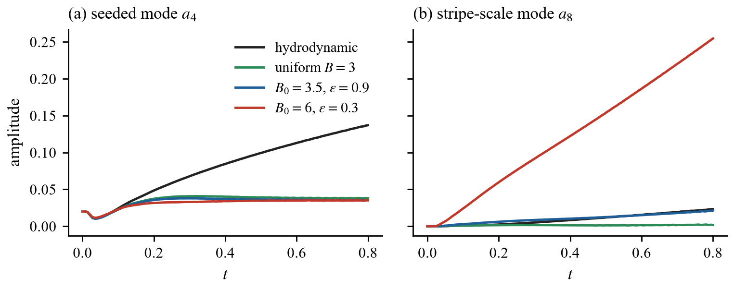
Figure 8. Interface spectrum: (a) seeded mode a₄ and (b) stripe-scale mode a₈.

Table 2. Selected cases at t = 0.8, relative to the hydrodynamic run. Contrast is (B₀ - εB₀)/B₀.
Field | Contrast | Mixing-layer enstrophy | Growth of a₄ | Locked
uniform, B = 2 | 0 | 0.029 | 0.40 | yes
uniform, B = 3 | 0 | 0.031 | 0.28 | yes
B₀ = 3, ε = 0.9 | 10% | 0.064 | 0.29 | yes
B₀ = 3.5, ε = 0.9 | 10% | 0.126 | 0.26 | yes
B₀ = 4, ε = 0.9 | 10% | 0.213 | 0.24 | no
B₀ = 3.5, ε = 0.8 | 20% | 0.367 | 0.27 | no
B₀ = 4, ε = 0.7 | 30% | 1.35 | 0.26 | no
B₀ = 6, ε = 0.3 | 70% | 23.6 | 0.24 | no

4.4 Mechanism
The shock raises the gas pressure about 125-fold at Mach 10, while a shock-parallel field passes through unchanged. A striped field balanced upstream therefore cannot stay balanced downstream. With uniform density the gaps hold more gas pressure, receive a weaker shock (Mach 2.4 against 10 in the bars at B₀ = 6) and acquire a lower post-shock velocity, so the bars advance faster than the gaps (Fig. 9). The shear is aligned with the field, and tension resists only displacements across field lines, so nothing opposes it. Its vorticity enters the mixing layer continuously and scales with ΔP_{B}.

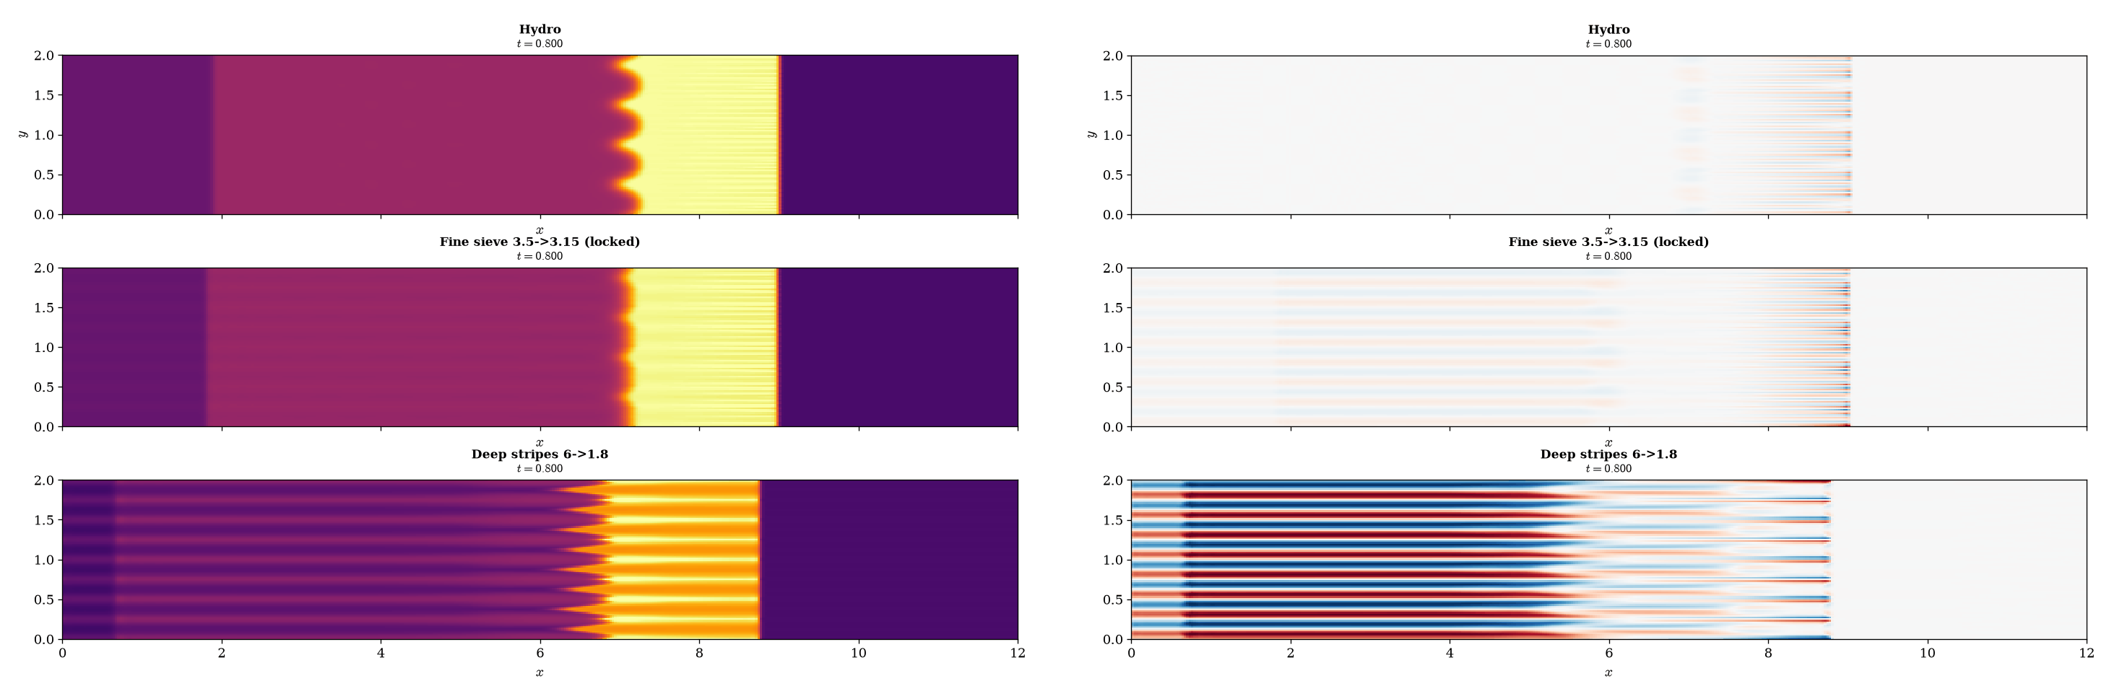
Figure 9. Density (left) and vorticity (right) at t = 0.8 for the hydrodynamic run (top), 10% stripes B₀ = 3.5, ε = 0.9 (middle) and deep stripes B₀ = 6, ε = 0.3 (bottom). The bands in the bottom-right panel are field-aligned shear layers between bars and gaps.

The same contrast produces collimation. The normalised gap-to-bar momentum flux increases with field strength (1.02, 1.08 and 1.29 for B₀ = 0, 3 and 6 in the first probe; 1.12 for B₀ = 6, ε = 0.3 in sweep C) and is indistinguishable from 1 in the locked cases. Suppression and collimation are therefore mutually exclusive in this regime.

4.5 Phase-tuned interference and zero crossing
With faster bar flow, the stripe-induced displacement follows B_{x}² ∝ cos(2k_{m} y + 2φ). It projects onto the seeded mode sin(ky) only if k_{m}/k = 0.5, and then opposes RMI growth for φ = π/4 and reinforces it for φ = 3π/4. Sweep E (B₀ = 6, ε = 0.3) confirms the phase dependence, with minimum roughness at φ = π/4 and maximum at 3π/4 (Fig. 10), but all phases are 2.5-3.0 times rougher than the hydrodynamic run. Writing the final seeded amplitude as |S ± R|, the extremes (0.347 and 0.407) give a stripe component S ≈ 0.38 and a residual RMI component R ≈ 0.03.

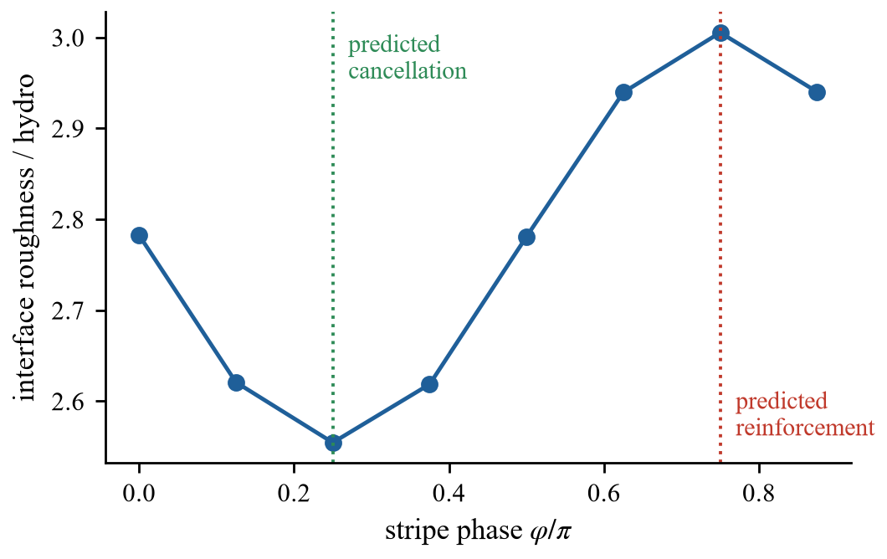
Figure 10. Final interface roughness against stripe phase for k_{m}/k = 0.5, B₀ = 6, ε = 0.3 (sweep E). Dotted lines mark the predicted phases of cancellation and reinforcement.

Sweep F reduced the contrast to bring S closer to R. At 20% contrast and φ = π/4 the final roughness is 0.14 of the hydrodynamic value, against 0.66 at φ = 3π/4 and 0.27 for a uniform field, but the time history shows no lock (Fig. 11): a₄ passes through zero at t ≈ 0.55 and grows again with inverted sign; at 30% the crossing occurs at t ≈ 0.31 and the subsequent growth exceeds the hydrodynamic rate. The mixing-layer enstrophy is 0.23 and 0.21 for the two phases at 20%, so the phase changes the displacement but not the injected vorticity. The RMI is an impulse that the field saturates, whereas the shear is a steady drive; the two cancel at one instant, not for all time.

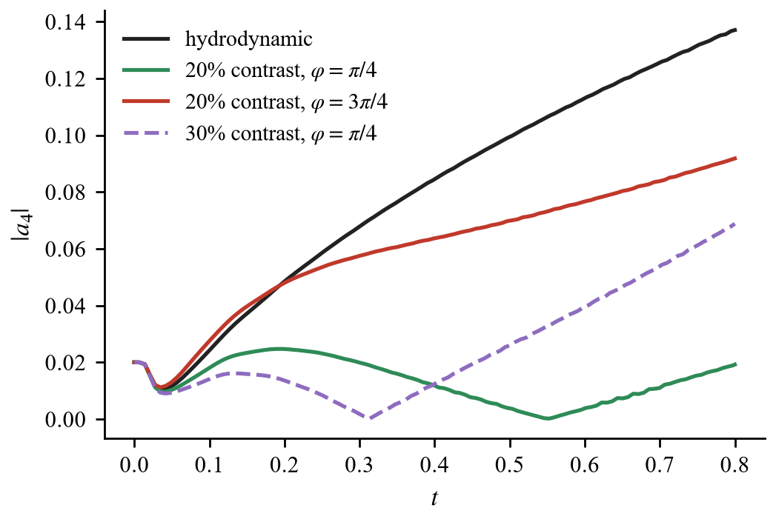
Figure 11. Seeded-mode amplitude for phase-aligned (φ = π/4) and anti-aligned (φ = 3π/4) stripes with k_{m}/k = 0.5 (sweep F). The aligned cases pass through zero and then grow with inverted sign.

4.6 Resolution sensitivity
The hydrodynamic reference is converged: doubling the cells in y changes a₄(0.8) from 0.137 to 0.143. Deep-stripe cases are not (Fig. 12). For k_{m}/k = 2 the stripe pattern has about six cells per wavelength; at twice the resolution the roughness rose from 0.62 to 1.87 times the hydrodynamic value and the mixing-layer enstrophy from about 10 to 212 times. The apparent benefit of k_{m}/k = 2 in sweep E was numerical smoothing. Higher resolution sharpens the shear layers and strengthens the conclusion that deep stripes do not lock.

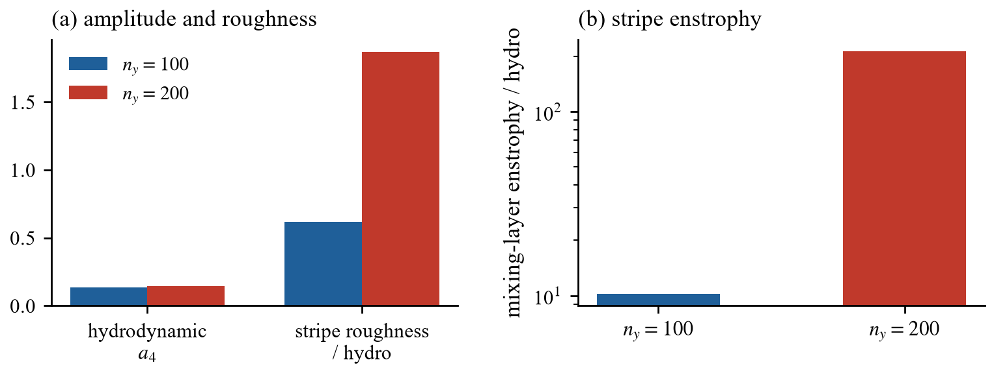
Figure 12. Resolution check for k_{m}/k = 2, B₀ = 6, ε = 0.3 at n_{y} = 100 and 200. (a) Hydrodynamic a₄ and stripe roughness relative to hydrodynamic. (b) Stripe mixing-layer enstrophy relative to hydrodynamic.

5. Discussion

5.1 Relation to previous work and novelty
The suppression by a uniform shock-parallel field agrees with [3-5] and serves as a check of the solver. The phase-dependent zero crossing of Section 4.5 is not a new phenomenon: it is the magnetic counterpart of the dependence of RMI growth on the phase between a non-uniform drive and the interface [7-9], which has also been used deliberately to reduce growth [10, 11]. What differs here is the origin of the non-uniform drive, which is the stripe-induced shear rather than a rippled shock or a shaped target. We therefore report the zero crossing as an observation.
We found no previous report of the mechanism of Section 4.4, in which a pressure-balanced shock-parallel field structure is converted by the shock into a field-aligned shear that magnetic tension cannot oppose, nor of the resulting conflict between suppression and collimation. Studies of structured fields [6] concern implosion symmetry rather than flow steering. This statement is based on a search of the open literature and the indexes available to us; it should be read as “not found” rather than “shown to be absent”.

5.2 Implications for the sieve concept
The trade-off follows from two properties that do not depend on the numerical details: a shock-parallel field is not compressed by the shock, and magnetic tension does not resist shear along the field. Any stripe pattern strong enough to redirect the post-shock flow therefore also drives the shear that deforms the interface. A field that locks the interface must be nearly uniform, and a field that collimates the flow cannot lock it. Phase alignment can choose the time at which the seeded mode is flat but cannot hold it there.

5.3 Limitations
The results apply to two-dimensional ideal MHD with shock-parallel stripes, uniform upstream density, Mach 10, density ratio 3 and the fast-shock regime of Eq. (3). Stronger fields with switch-on shocks, three-dimensional flow, other closures and oblique fields were not examined. Most sweeps used one resolution and one realisation, and Section 4.6 shows that deep-stripe metrics depend on resolution; the 10% lock boundary and the zero-crossing times need a convergence study before quantitative use. Divergence errors of a few percent remain at shocks because the scheme does not use constrained transport.

6. Conclusion
Deep magnetic stripes cannot both hold a shocked interface and channel the flow through their gaps when the field is shock-parallel and the shock is in the fast regime. Reaching this result required correcting the initial field, the upstream equilibrium, the resistive energy term and the energy diagnostic, and restricting initial states to admissible shocks. A uniform field locks the interface; stripes lock only at about 10% contrast; larger contrast creates a field-aligned shear that tension cannot oppose, so suppression and collimation compete. Phase-aligned stripes produce a zero crossing of the seeded mode at a time set by the contrast, the magnetic analogue of known hydrodynamic phase interference, but no sustained lock.

Code and data availability
The solver, sweeps A-H, saved time series and the scripts that generate the figures and this document are available at [repository URL].

Acknowledgements
[Computing resources, and any disclosure of tools used, as required by the target venue.]

References
[1] R. D. Richtmyer, Taylor instability in shock acceleration of compressible fluids, Commun. Pure Appl. Math. 13, 297-319 (1960).
[2] E. E. Meshkov, Instability of the interface of two gases accelerated by a shock wave, Fluid Dyn. 4, 101-104 (1969).
[3] R. Samtaney, Suppression of the Richtmyer-Meshkov instability in the presence of a magnetic field, Phys. Fluids 15, L53-L56 (2003).
[4] V. Wheatley, D. I. Pullin and R. Samtaney, Stability of an impulsively accelerated density interface in magnetohydrodynamics, Phys. Rev. Lett. 95, 125002 (2005).
[5] T. Sano, T. Inoue and K. Nishihara, Critical magnetic field strength for suppression of the Richtmyer-Meshkov instability in plasmas, Phys. Rev. Lett. 111, 205001 (2013).
[6] W. Mostert, D. I. Pullin, V. Wheatley and R. Samtaney, Magnetohydrodynamic implosion symmetry and suppression of Richtmyer-Meshkov instability in an octahedrally symmetric field, Phys. Rev. Fluids 2, 013701 (2017).
[7] R. Ishizaki, K. Nishihara, H. Sakagami and Y. Ueshima, Instability of a contact surface driven by a nonuniform shock wave, Phys. Rev. E 53, R5592 (1996).
[8] L. Zou, J. Liu, S. Liao, X. Zheng, Z. Zhai and X. Luo, Richtmyer-Meshkov instability of a flat interface subjected to a rippled shock wave, Phys. Rev. E 95, 013107 (2017).
[9] J. G. Wouchuk and T. Sano, Normal velocity freeze-out of the Richtmyer-Meshkov instability when a rarefaction is reflected, Phys. Rev. E 91, 023005 (2015).
[10] D. M. Sterbentz, C. F. Jekel, D. White, S. Aubry and J. L. Belof, Design optimization for Richtmyer-Meshkov instability suppression at shock-compressed material interfaces, Phys. Fluids 34, 082109 (2022).
[11] J. Strucka, D. M. Sterbentz, B. Lukic et al., Passive freeze-out of the Richtmyer-Meshkov instability, arXiv:2602.21375 (2026).
[12] B. van Leer, Towards the ultimate conservative difference scheme. II. Monotonicity and conservation combined in a second-order scheme, J. Comput. Phys. 14, 361-370 (1974).
[13] T. Miyoshi and K. Kusano, A multi-state HLL approximate Riemann solver for ideal magnetohydrodynamics, J. Comput. Phys. 208, 315-344 (2005).
[14] S. Gottlieb and C.-W. Shu, Total variation diminishing Runge-Kutta schemes, Math. Comp. 67, 73-85 (1998).
[15] A. Dedner, F. Kemm, D. Kröner, C.-D. Munz, T. Schnitzer and M. Wesenberg, Hyperbolic divergence cleaning for the MHD equations, J. Comput. Phys. 175, 645-673 (2002).
[16] K. G. Powell, P. L. Roe, T. J. Linde, T. I. Gombosi and D. L. De Zeeuw, A solution-adaptive upwind scheme for ideal magnetohydrodynamics, J. Comput. Phys. 154, 284-309 (1999).
[17] A. Mignone and P. Tzeferacos, A second-order unsplit Godunov scheme for cell-centered MHD: the CTU-GLM scheme, J. Comput. Phys. 229, 2117-2138 (2010).
[18] M. Brio and C. C. Wu, An upwind differencing scheme for the equations of ideal magnetohydrodynamics, J. Comput. Phys. 75, 400-422 (1988).

