Model architecture
Initial idea of used CNN has been taken from NVIDIA paper (https://images.nvidia.com/content/tegra/automotive/images/2016/solutions/pdf/end-to-end-dl-using-px.pdf)
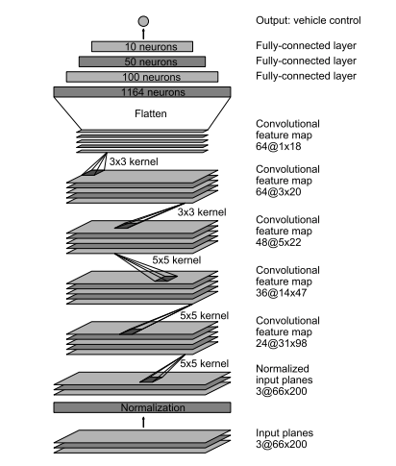
NVIDIA team in the original article used those network architecture by try and error method and quite inspiring results were achieved for similar task. This is the main reason to stick to the CNN architecture described above.

Architecture characteristics
The same structure of CNN was used with following detailed layering:
- Convolutional layer 32x32x24.
- Convolutional layer 16x16x36. Dropout (0.3) and Pooling was used for regularization.
- Convolutional layer 6x6x48. Dropout (0.3) was used for regularization.
- Convolutional layer 4x4x64. Dropout (0.2) was used for regularization.
- Flattering layer
- Dense layer 1164
- Dense layer 100
- Dense layer 50
- Dense layer 1
Adam optimizer was used (inspired by Traffic Sign Classification Project). Reasons behind selection of Adam optimizer are explained in details in previous project report.

Data Preprocessing
Dataset consist of 77530 images with different images from different cameras (center, left, right). Augmentation of brightness, crop, adjustment in case of left/right camera and resizing to 64*64 size was applied. Initially I've started train the model from initial 8000 images from 3 cameras, but only after increase of dataset size I've reached the proper self-driving ability.

The training dataset was gradually increased from 8000 to 77530 images till the moment, when all complex part on the track could be handled by car. For example, on the image below there is a junction:
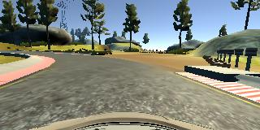

Initially I’ve tried to learn the car to turn left but due to the high curvature on the road, the way to the right was easy to learn. By gradually turning to the right (off-road zone) I’ve managed to learn car to chose the way on the right. But on the off-road part there are many obstacles. In order to learn car to steer out of obstacles, I’ve come closer to the borders (right and left) and then move steering wheel. For example:
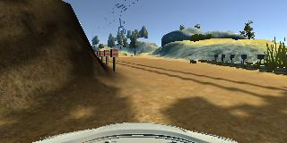
On the picture I’ve intentionally come close to the left part, and move wheel to the right to escape the right border. The same technique was used to teach car to steer out of the borders on other parts of the track (ordinary road).
Especially difficult was to teach car to come back again to the track from the off-road part:
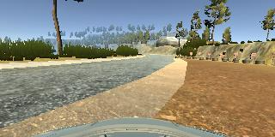
In this case I’ve come close to the signs in front and steer left many times until car model have learned the technique.

Model training
Data were divided to training/testing data set with ration 0.75 (0.6-0.8 ratios were investigated). Training batch size 256 was used for final model (32,64,128,512 were tried). 5 epochs were used for final model (I've increased the number of epochs up to 50 but it causes over optimization after 30). Initially I've tried to use 2 outputs from the model: steering angle and throttle size. But the accuracy was not comparable with steering angle only output. Difficult situation for the model could happen on the off-road part of the track (the model was intentionally trained to choice this path), in case of touching tires (considered not dangerous for passenger), you could push revers and model will manage to find the way out.
Final model training log with details is below:
____________________________________________________________________________________________________
Layer (type) Output Shape Param # Connected to
====================================================================================================
convolution2d_1 (Convolution2D) (None, 32, 32, 24) 1824 convolution2d_input_1[0][0]
____________________________________________________________________________________________________
elu_1 (ELU) (None, 32, 32, 24) 0 convolution2d_1[0][0]
____________________________________________________________________________________________________
convolution2d_2 (Convolution2D) (None, 16, 16, 36) 21636 elu_1[0][0]
____________________________________________________________________________________________________
elu_2 (ELU) (None, 16, 16, 36) 0 convolution2d_2[0][0]
____________________________________________________________________________________________________
dropout_1 (Dropout) (None, 16, 16, 36) 0 elu_2[0][0]
____________________________________________________________________________________________________
maxpooling2d_1 (MaxPooling2D) (None, 8, 8, 36) 0 dropout_1[0][0]
____________________________________________________________________________________________________
convolution2d_3 (Convolution2D) (None, 6, 6, 48) 15600 maxpooling2d_1[0][0]
____________________________________________________________________________________________________
elu_3 (ELU) (None, 6, 6, 48) 0 convolution2d_3[0][0]
____________________________________________________________________________________________________
dropout_2 (Dropout) (None, 6, 6, 48) 0 elu_3[0][0]
____________________________________________________________________________________________________
convolution2d_4 (Convolution2D) (None, 4, 4, 64) 27712 dropout_2[0][0]
____________________________________________________________________________________________________
elu_4 (ELU) (None, 4, 4, 64) 0 convolution2d_4[0][0]
____________________________________________________________________________________________________
dropout_3 (Dropout) (None, 4, 4, 64) 0 elu_4[0][0]
____________________________________________________________________________________________________
flatten_1 (Flatten) (None, 1024) 0 dropout_3[0][0]
____________________________________________________________________________________________________
dense_1 (Dense) (None, 1164) 1193100 flatten_1[0][0]
____________________________________________________________________________________________________
elu_5 (ELU) (None, 1164) 0 dense_1[0][0]
____________________________________________________________________________________________________
dense_2 (Dense) (None, 100) 116500 elu_5[0][0]
____________________________________________________________________________________________________
elu_6 (ELU) (None, 100) 0 dense_2[0][0]
____________________________________________________________________________________________________
dense_3 (Dense) (None, 50) 5050 elu_6[0][0]
____________________________________________________________________________________________________
elu_7 (ELU) (None, 50) 0 dense_3[0][0]
____________________________________________________________________________________________________
dense_4 (Dense) (None, 1) 51 elu_7[0][0]
====================================================================================================
Total params: 1,381,473
Trainable params: 1,381,473
Non-trainable params: 0
____________________________________________________________________________________________________
Epoch 1/5
77312/77312 [==============================] - 799s - loss: 0.0339 - val_loss: 2.8290e-05
Epoch 2/5
77312/77312 [==============================] - 753s - loss: 0.0172 - val_loss: 8.5836e-05
Epoch 3/5
77312/77312 [==============================] - 794s - loss: 0.0157 - val_loss: 2.8790e-04
Epoch 4/5
77312/77312 [==============================] - 797s - loss: 0.0145 - val_loss: 6.6669e-04
Epoch 5/5
77312/77312 [==============================] - 788s - loss: 0.0138 - val_loss: 1.3098e-04
Saving model weights and configuration file.

