E21CSEU0962  
Lab 2__Cloud  
EB08.  
  
Step 1: Sign into AWS Console using Learner Lab • Open the AWS Management Console.  
  
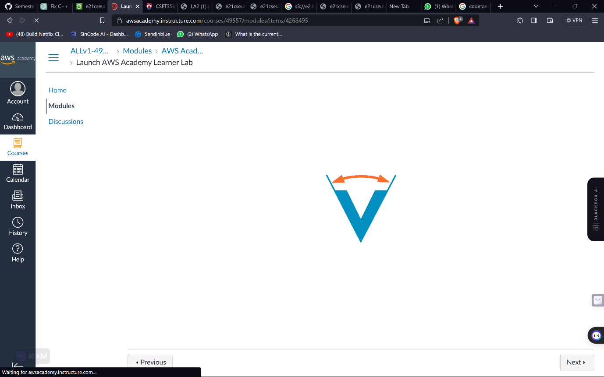

Step 2: Navigate to EC2 Dashboard

Once logged in, go to the EC2 Dashboard. You can do this by searching for "EC2" in the AWS services search bar or by selecting "Services" and then choosing "EC2" under the "Compute" section.  
  
  
  
  
Step 3: Launch Instance

Click the "Launch Instance" button on the EC2 Dashboard to initiate the process of creating a new EC2 instance.  
  
  
Step 4: Choose an Amazon Machine Image (AMI)

Select an AMI from the list. An AMI is a pre-configured template containing the software configuration for your instance. Choose one that matches your requirements, such as Amazon Linux, Ubuntu, Windows Server, etc.  
  
  
  
  
Launched Instance successfully:  
  
  
  
