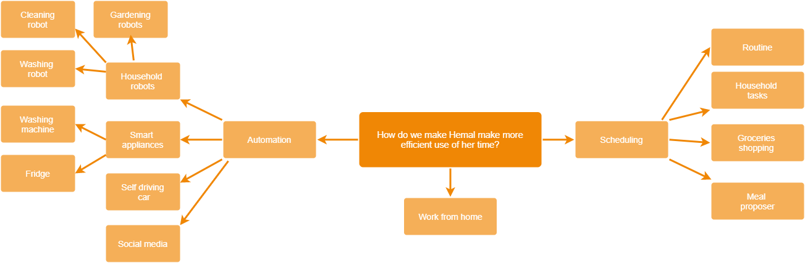

**Dark Side**

How do we make Hemal waste as much time as possible?

Social Media :)

Make her chores more tedious

Make her work really far from home

Invisible items(like keys or mobile phones)

Make her do a lot of things at the same time

Features:

**Must**

I should be able to see all tasks in a list.

I should be able to add/remove a task to/from the schedule.

I should be able to add other people to my schedule.

I should be able to get notifications on my phone when Tasks are due (or new tasks are assigned to me).

**Should**

I should be able to see all tasks on a monthly view (calendar).

I should be able to see all tasks on a weekly view (List with days included, this could also be integrated into).

I should be able to see all tasks on a daily view

I should be able to add a new Task Category (Useful for colors)

I should be able to create recurring tasks. (Automatic assignment should work here)

I should be able to automatically assign tasks to eligible people.

**Could**

I should be able to assign privileges to people added to my schedule (adding/removing tasks, add people to schedule)

I should be able to login/register.

I should be able to see a leaderboard of stats

I should be able to add subtasks to tasks to allow for finer control over the contents.

I should be able to see a summary of my tasks. (Good homepage material)

**Wont**

I should be able to customize when notifications notify me (based on category or individual task)