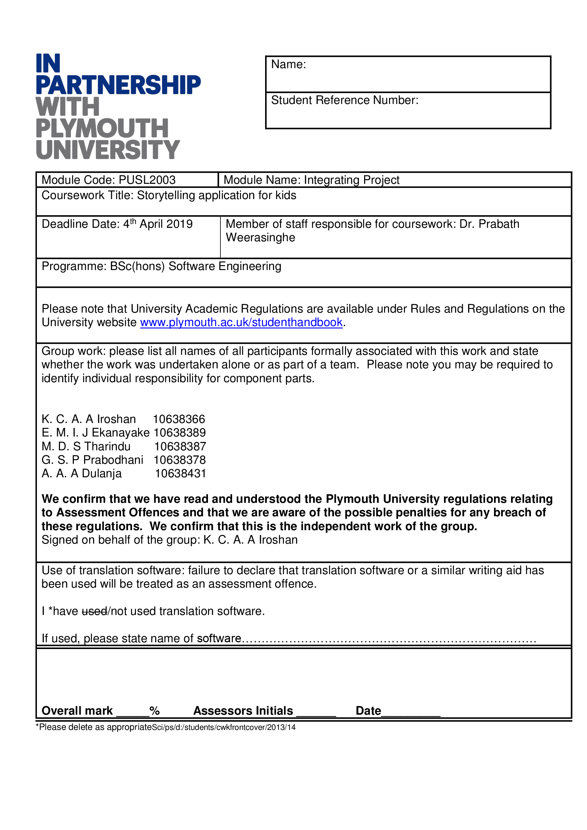

H

10638366

K. C. A. A Iroshan

# Acknowledgement

We would like to say our gratefulness to some special people those who helped and guided us to make our project successful. It was a great pleasure for us to complete this project in time and successfully. We would like to expresss our Dr. Prabath Weerasinghe who is our lecturer and the module leader of Integrating Project module for giving us guidance for assignment throughout various consolations. We’d additionally wish to express our gratitude to all people who have directly or indirectly guided us throughout this assignment.

# Table of Contents

Acknowledgement 2

Table of Contents 3

1. How we collaborated 4

2. Folio 5

2.1. Used Technologies 5

I. Java (MVC Architecture) 5

II. Firebase 6

2.2. Non-Functional Requirements 6

3. Analysis of the system 6

3.1. Functional Specification 6

3.2. Benefits of The Proposed System 7

4. System Design 8

4.1. User Flow Diagram 8

4.2. Use Case 9

5. Implementation 10

6. Testing 11

6.1. Test Run (01) 11

7. Future Implementation 12

8. Bibliography 12

9. Our Contribution 13

10. Turnitin Report 14

# How we collaborated

We used git version control system with the GitHub platform and collaborated virtually as well as physically.

<https://github.com/GHPPrabodhani/folio>

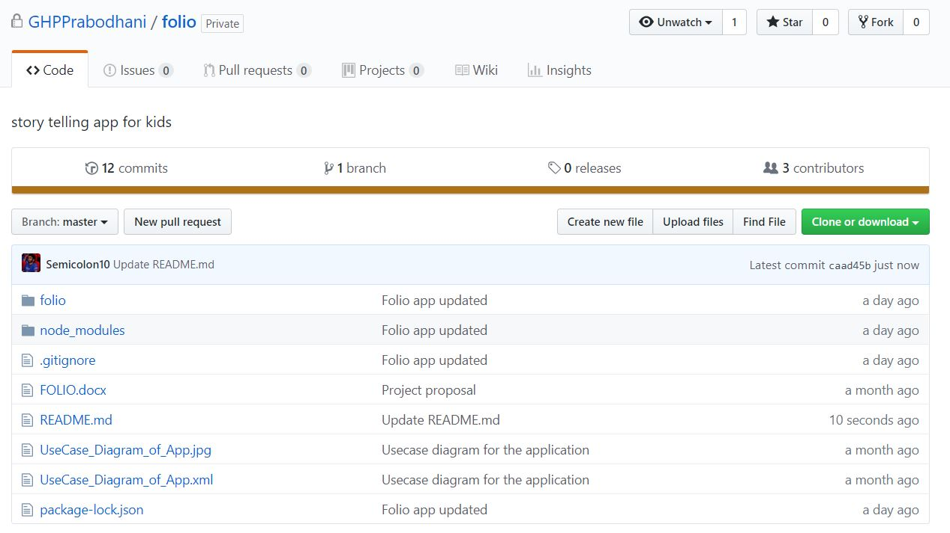

# Folio

Physiologists say, “You can always get a view from a hill and being 4 is like the first developmental hill from which your child can get a view of a bigger world.”[1] Age 3-5 is the period which the brain develops the most. As a parent they have huge responsibility for interacting with their child and do the things what they have to, but today there is a problem with that. Parents are busy with their schedules and they have a little time to interact with their kids. That’s why day-cares and nannies are common in Sri Lanka. This is not a good sign. Folio will overcome the problem of having less interaction and provide the hands-on strategies that the kids need. Its not distancing the relationship between parents and children nut simplifies the relationship and makes it easy for parents.

With Folio, a child can learn on his own without any support of others. He can either listen to story or colour the pictures according to the coloured picture which is showing in the mobile or tablet screen. Specially for under four-year-old we are recommending phone holder which holds the device over the folio-book which makes it easier.

## Used Technologies



1. Java (MVC Architecture)
2. Firebase

(Additionally, we used Android Studio IDE to develop the native application.)

## Non-Functional Requirements

1. Interfaces should be simple.

Since this app design to kids and children it should be simple application which can be easy to use.

1. Interfaces should be colourful and attractive

Interfaces should be more colourful and attractive to grab the attention of the children.

1. Minimum navigation

Only essential options should be there

1. App should be light weight

App should be light weight and quick.

# Analysis of the system

## Functional Specification

In this project when it come up with the functional specification, below there are some important facts we highly concern about.

* Ability of reading QR code

when a kid selects any image (blank sketch) he/she should have to scan for the QR code for the coloured image and audio track. There for this app should have the ability of reading QR code.

* Ability of recognize the similar image to each QR code

Each image has its own QR code which identically recognized its coloured image and audio track. When user scan the QR code it should be able to recognize its similar coloured image.

* Ability of sending coloured images from database that matches to blank image

When it recognized the similar coloured image, it should be able to retrieve that coloured image from database and display it through the application.

* Capability of recognizing and retrieving the matching audio to the each QR code

Each image has its own QR code which identically recognized its audio track. When someone scan the QR code it should be able to recognize the relevant audio track and retrieve it from database and make it playable on the app.

* Capability of pause, replay, stop the audio

The audio track should be able to pause, replay and stop according to the user preferences.

* Ability of mute, increase and decrease the volume

The audio track should be able to perform the tasks of mute, increase and decrease the volume according to the user preferences.

## Benefits of The Proposed System

* Practice child to do things on his own, from the earlier stage.

In Sri Lanka teachers have to spoon-feed everything to the students because on the earlier stage parents did not teaches them to do things on its own. But in European countries things happen much different. With folio parent only need to give proper guidance and child practice to learn on its own without spoon-feeding.

* Fit for parents’ busy schedules

Since parents only need to give guidance parents can do multiple things while child is learning new things. For example, mother can cook meals while child interacting with application on the near desk. This saves the money which spend for nannies or babysitters.

* Child development

Folio is a hybrid solution which is capable for improve many areas of the child.

handwriting

Hand and eye coordination

Relaxation and patience

Focus

Knowledge

Confidence

Motor Skill

Stimulates creativity

Self-expression

Colour recognition

Therapeutic

Grip

Language Development

Development of imagination

Etc.

# System Design

## User Flow Diagram



## Use Case

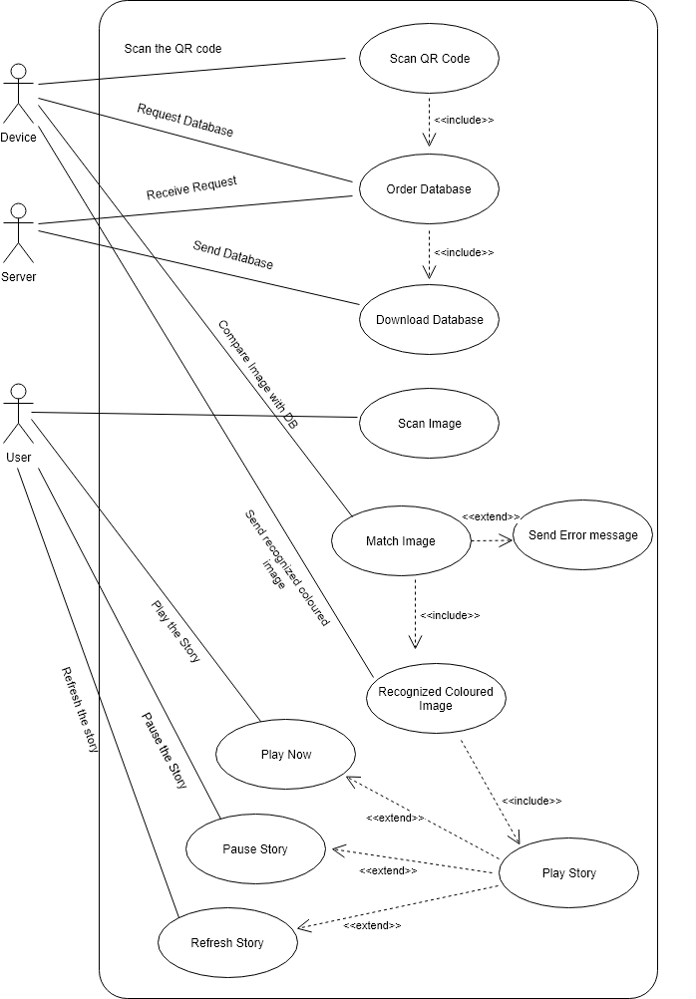

# Implementation

As normal application folio can install into our android device.

We need mobile hardware access since we need to use mobile camera to scan images.

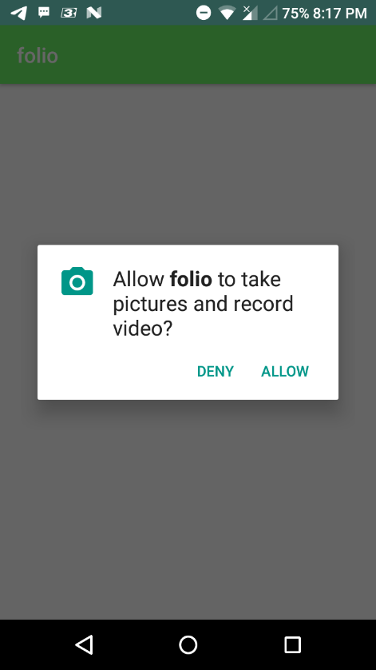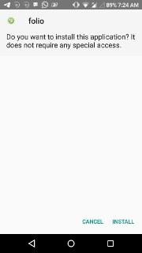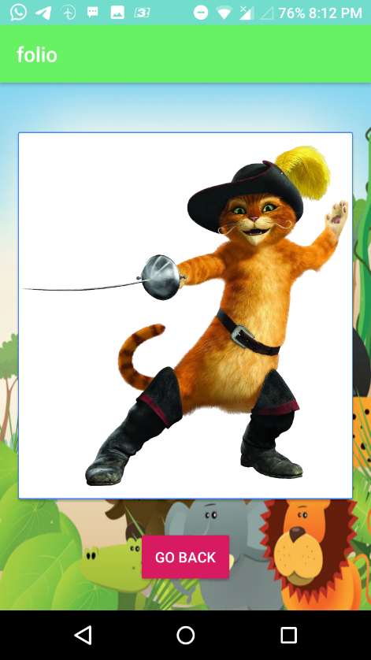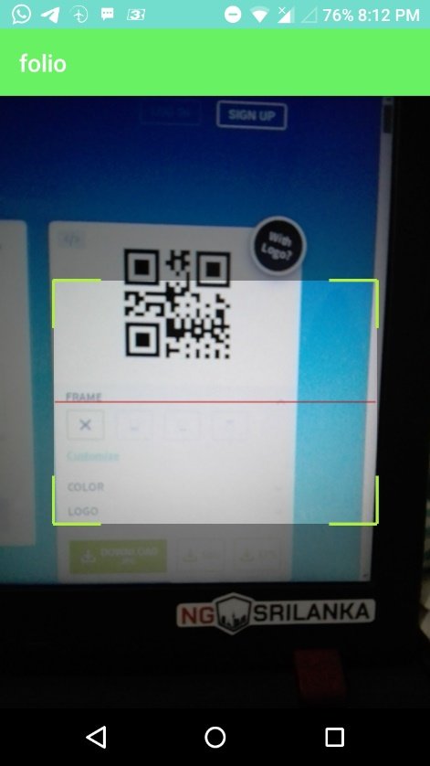

Outcome

Scanning process

# Testing

After implementing the application, we are going through test run on the Gradle to confirm that the application is working properly without any irritations.

## Test Run (01)

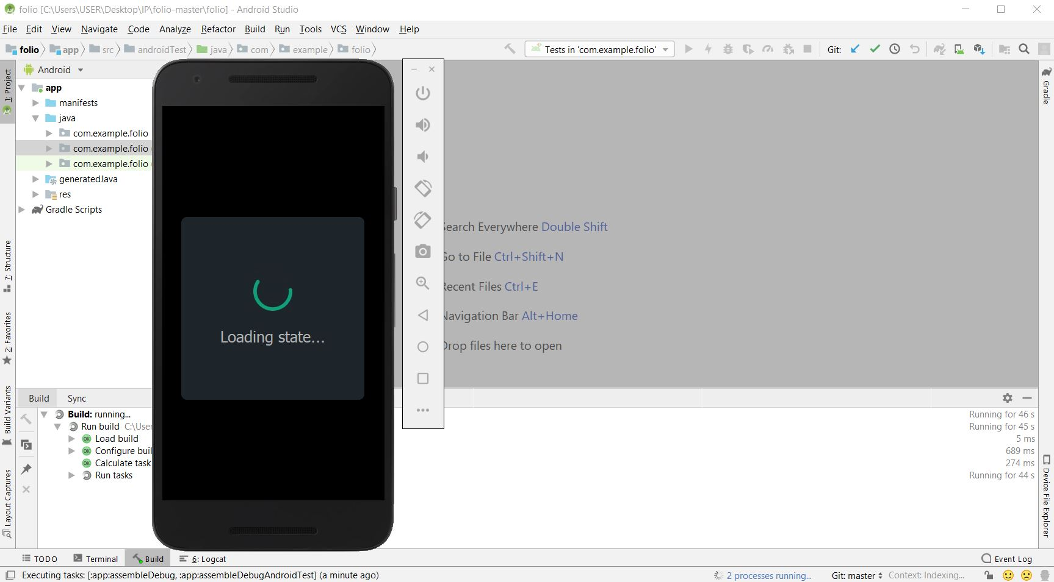

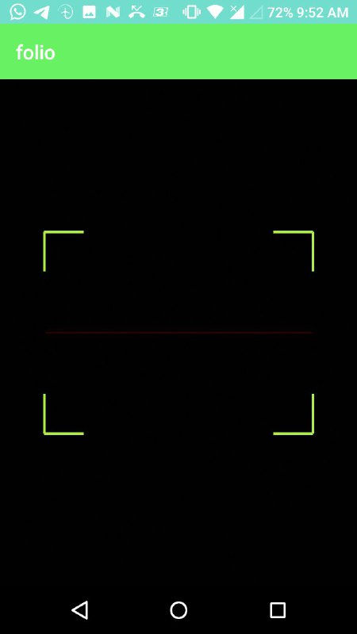

# Future Implementation

Additional interactions with the kids such as, touching the picture which then will play short enjoyable animations will be added.

Sketch recognition will be implemented with AR(Augmented Reality) to demonstrate the colouring process with animations.

Voice recognition which will trigger various audio responses related to the cartoon character will be implemented.

# Bibliography

Network, W. a. C. H., 2019. Child development 4–5 years. *HealthyWA.*

# Our Contribution

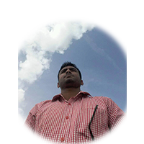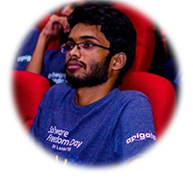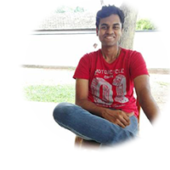

*G.H.P.Prabodhani*

*M.D.S.Tharindu*

*A.A.A.Dulanja*

*E.M.I.J Ekanayake*

*K C A A Iroshan*



|  |  |  |  |  |  |
| --- | --- | --- | --- | --- | --- |
| Member / Activity | Member 01  ID:10638366 | Member 02  ID:10638389 | Member 03 ID:10638387 | Member 04  ID:10638378 | Member 05  ID:10638431 |
| Image Processing  Backend development | Checkmark |  |  |  |  |
| Image processing Backend development |  |  |  |  |  |
| Backend Development |  |  |  |  |  |
| Database development & UI |  |  |  |  |  |
| UI |  |  |  |  |  |
|  |  |  |  |  |  |
| Total Contribution | 20% | 20% | 20% | 20% | 20% |

# Turnitin Report

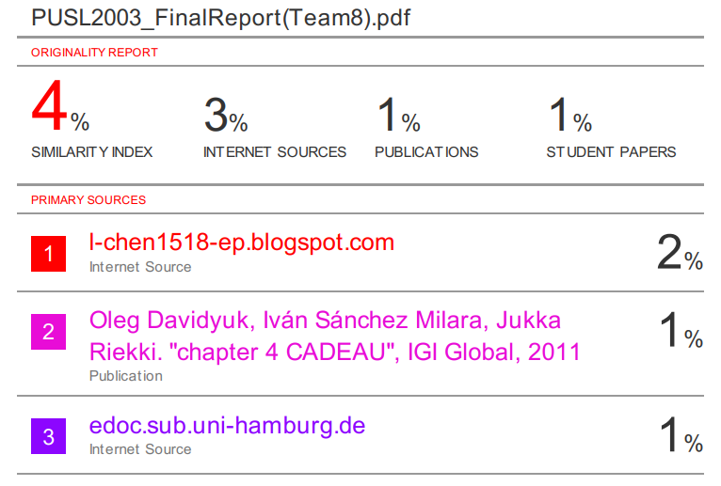

1. (Network, 2019)