**Project Proposal**

***System name***

folio

***Module***

Integrating Project

***Batch & Group***

17.1 - Plymouth -Software Engineering

**Group Members**

|  |  |
| --- | --- |
| **Name** | **Student ID** |
|  |  |
| K C A A Iroshan: | 10638366 |
| E.M.I.J Ekanayake: | 10638389 |
| A.A.A.Dulanja: | 10638431 |
| M.D.S.Tharindu: | 10638387 |
| G.H.P.Prabodhani: | 10638378 |

# Table of Content

Table of Content 2

List of Figures 2

1. Project Overview 3

2. “FOLIO” 4

2.1. Expected benefits of the proposed system 4

3. Constraints 6

3.1. Scope 6

3.2. Timeline 7

3.3. Cost Analysis 7

3.4. Competition with similar products 7

4. Resource requirements 8

Bibliography 9

About Us 9

# List of Figures

Figure 1 6

Figure 2 7

## Project Overview

“Folio” is our product for next generation kids which facilitates story telling by simply recognition of images. We introduce a “folio-book” which contains black and white images which kindergartens can color as well as listening to the story with the app.

We expect to develop an android app with the intention to deploy an iOS app later. We are using Android Studio IDE and java language for the development of the app.

## “FOLIO”

Physiologists say, “You can always get a view from a hill and being 4 is like the first developmental hill from which your child can get a view of a bigger world.”[1] Age 3-5 is the period which the brain develops the most. As a parent they have huge responsibility for interacting with their child and do the things what they have to, but today there is a problem with that. Parents are busy with their schedules and they have a little time to interact with their kids. That’s why daycares and nannies are common in Sri Lanka. This is not a good sign. Folio will overcome the problem of having less interaction and provide the hands-on strategies that the kids need. Its not distancing the relationship between parents and children nut simplifies the relationship and makes it easy for parents.

With Folio, a child can learn on his own without any support of others. He can either listen to story or color the pictures according to the colored picture which is showing in the mobile or tablet screen. Specially for under four-year-old we recommending phone holder which holds the device over the folio-book which makes it easier.

### Expected benefits of the proposed system

* Practice child to do things on his own, from the earlier stage.

In Sri Lanka teachers have to spoon-feed everything to the students because on the earlier stage parents did not teached them to do things on its own. But in European countries things happen much different. With folio parent only need to give proper guidance and child practice to learn on its own without spoon-feeding.

* Fit for parents’ busy schedules

Since parents only need to give guidance parents can do multiple things while child is learning new things. For example, mother can cook meals while child interacting with application on the near desk. This saves the money which spend for nannies or babysitters.

* Child development

Folio is a hybrid solution which is capable for improve many areas of the child.

handwriting

Hand and eye coordination

Relaxation and patience

Focus

Knowledge

Confidence

Motor Skill

Stimulates creativity

Self-expression

Color recognition

Therapeutic

Grip

Language Development

Development of imagination

etc.

## Constraints

### Scope

Target audience: Kids age between 3-7.

Target market: Parents of the above kids.1.9Bilion approximately

According to statistics portal[2] (Statista, 2019) child population of Asia region and world as follows,

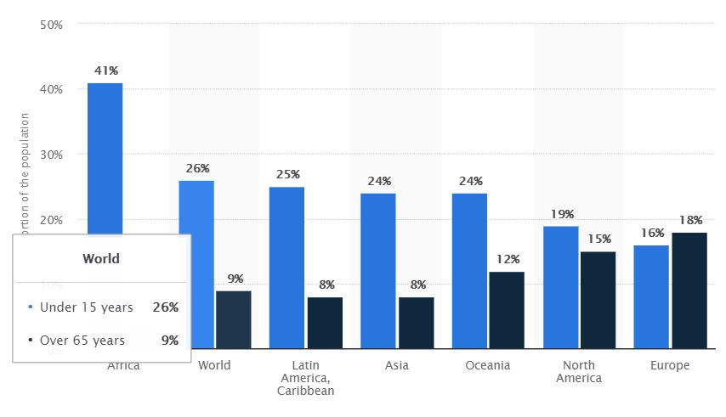

Figure 1

### Timeline

Since still we are on implementation stage we must follow up very strict timeline.

March

February

January

1

4

4

3

3

2

2

1

2

4

3

1

Problem identification

Feasibility study

System analysis

System development

System design

System testing

System implementation

Figure 2

### Cost Analysis

Since this is a real-world project implementation our estimated budget is 6000LKR.

### Competition with similar products

Folio is totally new concept for world. We have not any local competitors. But there are similar products internationally,

Noveleffect

Storytime for Kids

## Resource requirements

Hardware

Software

People

Finance resources

Infrastructure

# Bibliography

Network, W. a. C. H., 2019. Child development 4–5 years. *HealthyWA.*

Statista, 2019. Proportion of selected age groups of world population in 2018, by region. *Statictica.*

# About Us





*G.H.P.Prabodhani*

*(Co-Founder)*

*M.D.S.Tharindu*

*(Co-Founder)*

*A.A.A.Dulanja*

*(Co-Founder)*

*E.M.I.J Ekanayake*

*(Co-Founder)*

*K C A A Iroshan*

*(Co-Founder)*

1. (Network, 2019)
2. (Statista, 2019)