

SRM Institute of Science and Technology
College of Engineering and Technology
Department of Electronics and Communication Engineering
21IPE314P / RTOS Programming
Review – 3 Report (Final Evaluation)
Submission Date: 27.4.2026

Title of the project: Hardware-in-the-Loop infusion pump controller prototype using QNX Neutrino RTOS
Student 1 Reg no. and Name and Dept: Naga Praneeth Reddy, RA2311004010473, ECE-H
Student 2 Reg no. and Name and Dept: Rudra Shukla, RA2311004010482, ECE-H

Demo Evaluation (7.5 Marks)
S.No. | Criteria | Description | Marks | Reg.No 473 | Reg.No 482
1 | Functionality | Complete system working | 2
2 | Integration | Module integration | 1
3 | Results | Accuracy of output | 1.5
4 | Innovation | Key features | 2
5 | Presentation | Demo explanation | 1

B. Viva Evaluation (5 Marks)
S.No. | Criteria | Description | Marks | Reg.No 473 | Reg.No 482
1 | Concepts | Core understanding | 2
2 | Technical | Tools/algorithms | 1
3 | Contribution | Individual role | 1
4 | Problem Solving | Application | 1

C. Report Evaluation (7.5 Marks)
S.No. | Criteria | Description | Marks | Reg.No 473 | Reg.No 482
1 | Structure | Organization | 1
2 | Methodology | Implementation clarity | 1.5
3 | Results | Analysis | 2
4 | Diagrams | Figures/Flowcharts | 1
5 | Conclusion | Future scope | 1
6 | Quality | Grammar/completeness | 1
Total Marks |  |  | 20

Course Teachers: Dr. S. Dhanalakshmi and Dr. Jaba Deva Krupa A


COLLEGE OF ENGINEERING & TECHNOLOGY
SRM INSTITUTE OF SCIENCE & TECHNOLOGY
S.R.M. Nagar, Kattankulathur – 603203, Chengalpattu District

BONAFIDE CERTIFICATE

Certified that this project report titled “Hardware-in-the-Loop infusion pump controller prototype using QNX Neutrino RTOS” is the bonafide work of “Rudra Shukla( RA2311004010482), Naga Praneeth Reddy(RA2311004010472)”, who carried out the project work under my supervision, as a part of the course “21IPE314P / RTOS Programming”, during the academic year 2025-26 (EVEN) in the Department of ECE, SRM Institute of Science & Technology, Kattankulathur.

SIGNATURE SIGNATURE
Dr. S. Dhanalakshmi Dr. Jaba Deva Krupa A
Profesor Assistant Professor
Dept. of Electronics and Dept. of Electronics and
Communication Engineering Communication Engineering

DECLARATION

We hereby declare that the Project entitled “ Hardware-in-the-Loop infusion pump controller prototype using QNX Neutrino RTOS ” to be submitted for the course “21IPE314P / RTOS Programming”, is our original work as a team

Place:
Date:
Rudra Shukla( RA2311004010482)

Naga Praneeth Reddy(RA2311004010472)

ACKNOWLEDGEMENT
We would like to express our sincere gratitude to Dr. S. Dhanalakshmi and Dr. Jaba Deva Krupa A for their guidance and support throughout this project. Their feedback during the review process helped shape both the technical direction and the scope of the work.
We thank the Department of Electronics and Communication Engineering at SRM Institute of Science and Technology for providing the resources and environment that made this project possible.
We are grateful to the broader QNX and embedded systems community whose publicly available documentation, technical references, and published research informed many of the design decisions made in this project.
Finally, we thank our families for their patience and encouragement during the course of this work.

Abstract

This report covers the design, implementation and hardware validation of a Hardware-in-the-Loop infusion pump controller prototype. The system runs QNX Neutrino RTOS 8.0.0 on a Raspberry Pi 4B as the real-time controller, with an STM32 Nucleo-F401RE microcontroller acting as the plant simulator. The two platforms communicate over a direct 3.3V UART link at 115200 baud using a fixed binary framing protocol with CRC8-MAXIM integrity checking. On the QNX side, three processes handle the system: motor_ctrl owns the UART and acts as the control server, demo_client sends commands using MsgSend and MsgReply, and alarm_mgr receives fault notifications through MsgSendPulse. Development was split into four incremental stages, each validated on hardware before the next stage began. The four stages cover the protocol layer, the message-passing server, asynchronous fault notification, and continuous heartbeat monitoring. All four stages passed hardware validation on 2026-04-14. The project is scoped as a safety-informed classroom prototype and draws on design principles from mixed-criticality embedded systems, implemented on a real RTOS with real hardware interaction.

TABLE OF CONTENTS

CHAPTER NO. | TITLE |  | PAGE NO.
 | ACKNOWLEDGEMENT |  | iii
 | ABSTRACT |  | iv
1 | Project Overview |  | 1
2 | System Architecture |  | 2
3 | Protocol Design and Methodology |  | 3
4 | Module Development |  | 5
5 | Tools and Technology |  | 6
6 | Results and Testing |  | 7
7 | Problem Solving and Debugging |  | 14
8 | Conclusion and Future Work |  | 15
 |  | REFERENCES | 16

1. Project Overview
This project implements a Hardware-in-the-Loop infusion pump controller prototype using QNX Neutrino RTOS on a Raspberry Pi 4B as the real-time controller, with an STM32 Nucleo-F401RE microcontroller acting as the hardware-side plant simulator. The two platforms communicate over a direct 3.3V UART link at 115200 baud, and all inter-process coordination within QNX is handled through the operating system's native message-passing mechanisms.
The motivation for choosing QNX as the target platform comes from its microkernel architecture and its suitability for mixed-criticality embedded applications. Rather than attempting to build a fully IEC 62304-certified implementation, this project is deliberately scoped as a safety-informed classroom prototype. The design priorities are a reliable hardware-validated communication path, a cleanly separated QNX process architecture, and demonstrable fault detection behaviour. These goals have been fully achieved through a sequence of incrementally validated implementation stages.

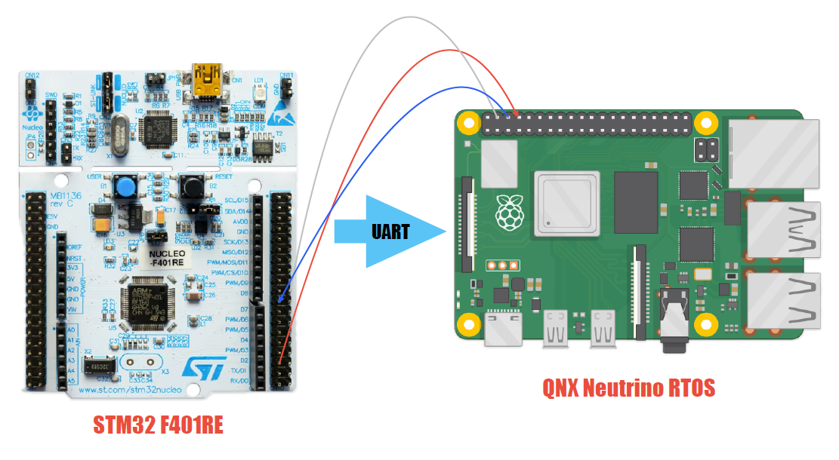

2. System Architecture
The system is structured around three QNX processes and one STM32 firmware component. On the QNX side, motor_ctrl acts as the central control server. It exclusively owns the /dev/ser1 serial device and is the only process that communicates directly with the STM32. A small client application called demo_client sends START, STOP, and STATUS commands to motor_ctrl using MsgSend, and receives synchronous replies via MsgReply. A separate alarm_mgr process runs independently, waiting on its own channel for fault pulses that motor_ctrl delivers asynchronously using MsgSendPulse.
This design deliberately avoids implementing a custom QNX resource manager. A resource manager would have required significantly more development time for POSIX-interface boilerplate that adds no visible demo value. The message-passing server approach chosen here achieves the same goal of centralised UART ownership with a much simpler implementation, while still exercising the core QNX IPC primitives. The separation between synchronous command control and asynchronous fault notification is a key architectural feature: demo_client is never blocked waiting for an alarm, and alarm_mgr receives fault notifications independently of whether any client command is in flight.
The STM32 firmware runs a simple four-state machine covering IDLE, RUNNING, FAULT, and EMERGENCY_STOP transitions. The onboard LED provides continuous visual feedback of the current state: off for IDLE, solid on for RUNNING, and blinking for FAULT. The user button on the Nucleo board serves as a manual fault injection source for demonstration purposes.
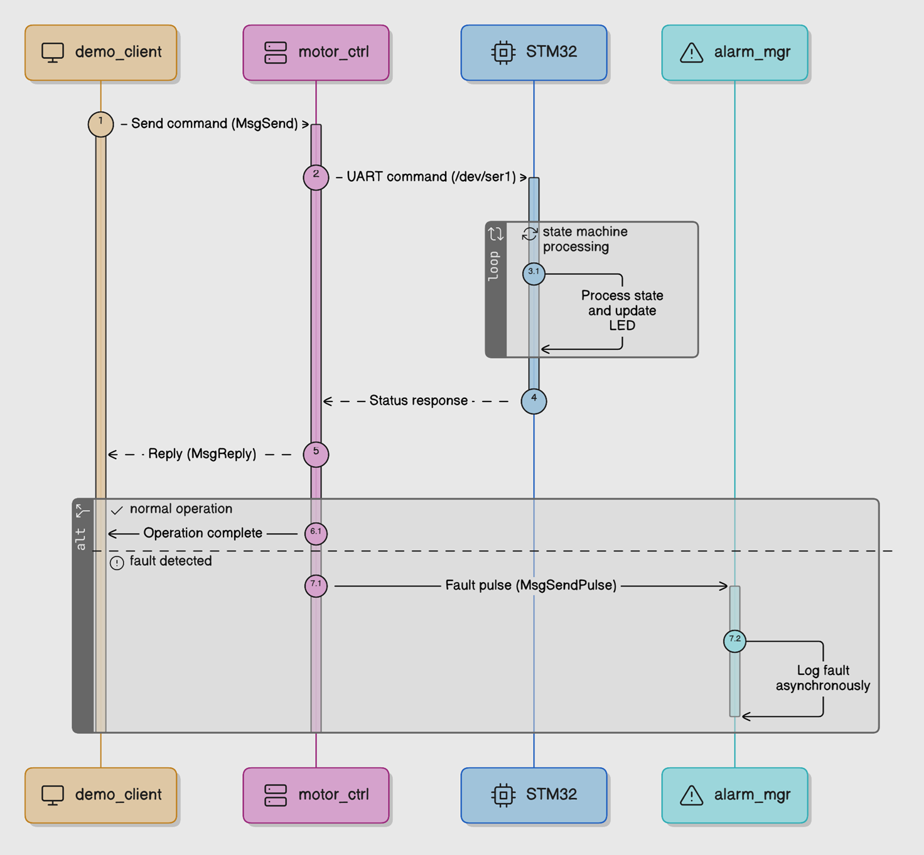

3. Protocol Design and Methodology
All UART communication between QNX and the STM32 uses a fixed binary framing structure. Each packet consists of a sync byte (0xAA), a one-byte command ID, a one-byte payload length, an optional payload of up to 16 bytes, and a trailing CRC8 checksum. The CRC is computed over the command, length and payload bytes using the CRC8-MAXIM (Dallas) algorithm in its LSB-first reflected form with polynomial 0x8C. The same CRC function is compiled into both the QNX and STM32 codebases, so any byte corruption or framing error is caught at the receiver before a command is acted on.
Packet parsing is handled by a byte-level state machine rather than a single blocking read call. This is necessary because the QNX serial driver does not guarantee that a read() call returns all requested bytes in one shot. The parser moves through five states sequentially:
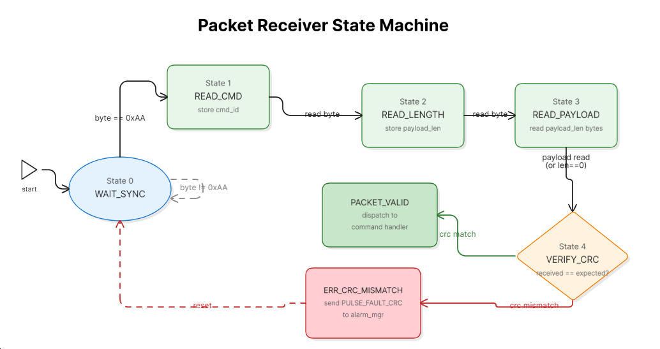
A CRC mismatch at State 4 resets the parser to State 0 and sends a fault pulse to alarm_mgr via MsgSendPulse. On the write side, a write_full() helper loops over write() until all bytes of the packet are confirmed transmitted, which was added after partial-write issues were observed on the QNX serial driver during bring-up (see Section 7).

The command set used we defined consists :-
- MOTOR_START (0x01)
- MOTOR_STOP (0x02)
- STATUS_REQ (0x03)
- HEARTBEAT (0x04)
- ACK (0x05)
- FAULT (0x06)
- STATUS_RSP (0x07).
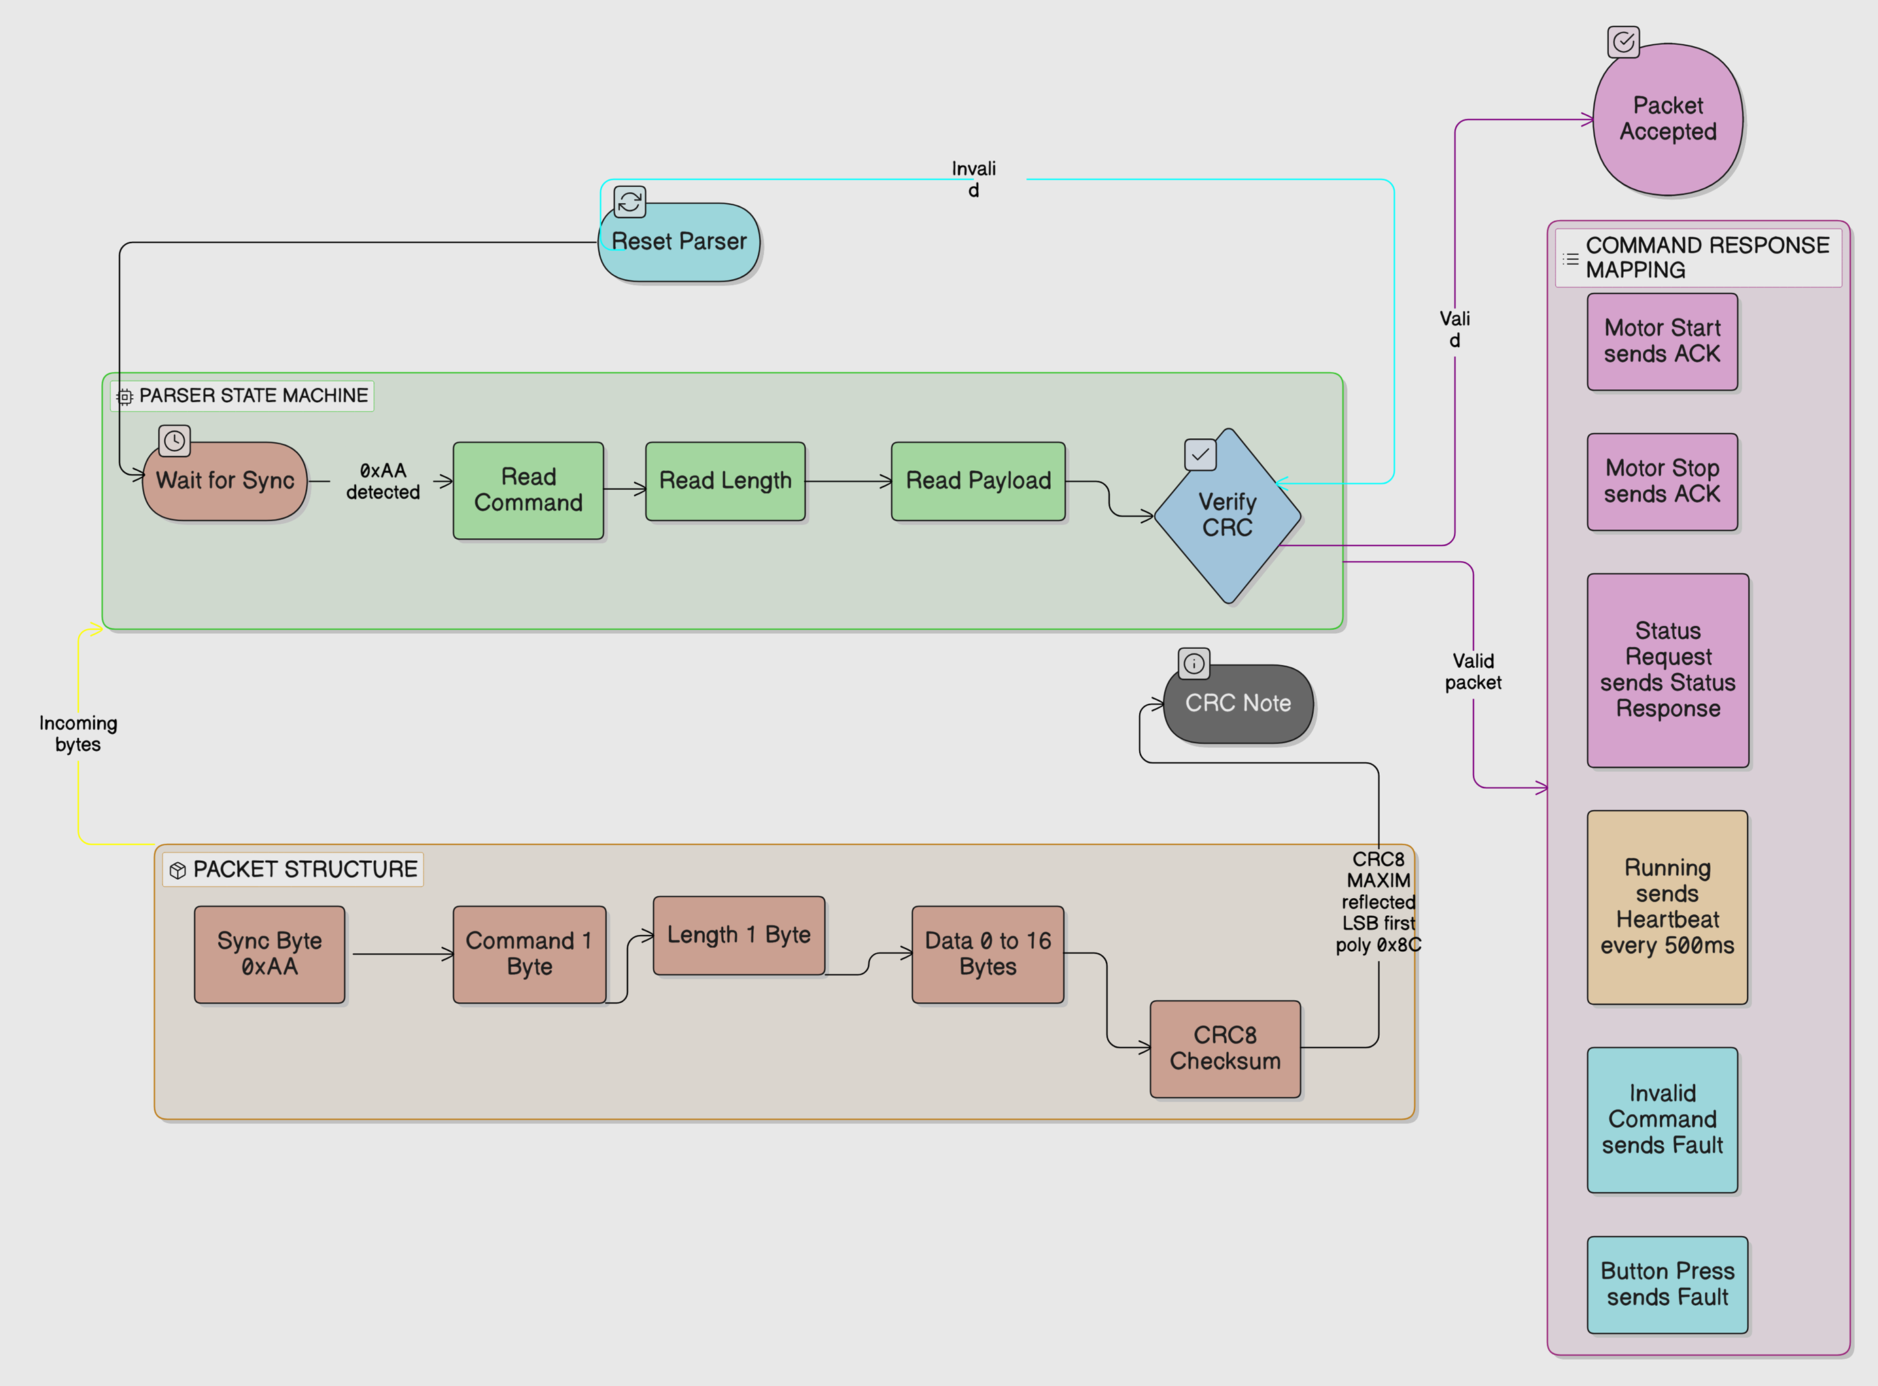
The STM32 responds to START and STOP with an ACK packet, answers STATUS_REQ with a STATUS_RSP packet carrying a one-byte motor state value, sends HEARTBEAT packets at 500ms intervals while in RUNNING state, and sends a FAULT packet either in response to an invalid command or when the user button is pressed.

4. Module Development
Development was organised into discrete implementation stages, each producing a fully tested and hardware-validated snapshot before the next stage began. This approach kept debugging tractable and ensured that a working fallback always existed.
The first functional stage established the framed protocol layer. A standalone QNX test program sent START, STOP, and STATUS commands as framed packets and validated the STM32 responses against expected reply types. This stage confirmed that CRC calculation matched across both platforms and that the parser handled all three request/reply flows correctly under real hardware conditions.
The second stage introduced the message-passing motor_ctrl server. UART ownership was moved inside motor_ctrl, and a demo_client was built to interact with it through MsgSend and MsgReply. This stage validated the complete synchronous control path: demo_client sends a typed request structure, motor_ctrl translates it into a UART packet, waits for the STM32 response, and returns a structured reply to the client. The client never accesses /dev/ser1 directly.
The third stage added alarm_mgr and introduced asynchronous fault notification. When motor_ctrl detects a fault condition, it sends a pulse to alarm_mgr using MsgSendPulse. Three fault conditions are handled: UART timeout, CRC or protocol mismatch, and an explicit FAULT packet from the STM32. alarm_mgr receives these pulses independently of any pending client request and logs the fault code and value to the terminal.
The fourth and most complex stage added continuous heartbeat monitoring. motor_ctrl now runs two background threads in addition to its main MsgReceive dispatch loop. A dedicated UART RX thread reads incoming bytes continuously and feeds them to the packet parser, updating a shared heartbeat timestamp each time a valid HEARTBEAT packet arrives. A separate heartbeat monitor thread wakes every 200ms, checks the elapsed time since the last heartbeat, and sends a PULSE_FAULT_HEARTBEAT_MISS to alarm_mgr if no heartbeat has been seen for more than two seconds. Client requests issued after a heartbeat miss are rejected with a HEARTBEAT_MISS status code rather than attempting a UART transaction against a disconnected or faulted device.

5. Tools and Technology
Component | Specification / Version | Role
Raspberry Pi 4B | 4GB RAM, AArch64, QNX Neutrino 8.0.0 | QNX RTOS controller
STM32 Nucleo-F401RE | ARM Cortex-M4, 84MHz, USART1 | HIL plant simulator
QNX SDP 8.0 | Momentics IDE, GCC cross-compiler | Build and deploy toolchain
STM32CubeIDE 1.14+ | HAL, USART1 interrupt driver | STM32 firmware development
UART Link | 115200 baud, 3.3V, PA9/PA10 | Physical communication layer
QNX IPC APIs | name_attach, MsgSend, MsgSendPulse | Inter-process communication
CRC8-MAXIM | Polynomial 0x8C, reflected LSB-first | Packet integrity verification

Cross-compilation for the QNX AArch64 target was handled entirely within QNX Momentics IDE. Binaries were deployed to the Raspberry Pi using SCP over SSH, with the Pi's network interface configured manually after each boot using a fixed IP address of 192.168.1.50. The QNX filesystem is read-only at the root level, so all runtime binaries and writable state were placed in the /var RAM filesystem.

6. Results and Testing
All four implementation stages were hardware-validated on the actual QNX and STM32 setup on 2026-04-14. The table below lists each test case, the expected behaviour based on the protocol and architecture design, the observed output from terminal logs, and the result.
# | Test Case | Expected Behaviour | Observed Output | Result
1 | START command, protocol layer | TX: AA 01 00 C4, RX: AA 05 00 FF (ACK) | TX AA 01 00 C4 / RX AA 05 00 FF [VALID] / Response CMD: 0x05 | PASS
2 | STATUS_REQ, protocol layer | RX: AA 07 01 01 E0, data byte = RUNNING (0x01) | AA 07 01 01 E0 received, data byte decoded as RUNNING | PASS
3 | STOP command, protocol layer | TX: AA 02 00 91, RX: ACK, LED turns off | Clean ACK received, STM32 LED turned off | PASS
4 | CRC consistency | No CRC mismatch on valid packet exchanges | No CRC mismatch observed across all valid exchanges | PASS
5 | demo_client START, message-passing layer | Reply status OK (0), Response cmd 0x05 | Reply status: OK (0) / Response cmd: 0x05 / Data len: 0 | PASS
6 | demo_client STATUS, message-passing layer | Reply status OK (0), Response cmd 0x07, motor state RUNNING | Motor state: RUNNING decoded from STATUS_RSP correctly | PASS
7 | demo_client STOP, message-passing layer | Reply status OK (0), Response cmd 0x05 | Reply status: OK (0) / Response cmd: 0x05 | PASS
8 | Fault notification, user button press | demo_client returns REMOTE_FAULT (-4), alarm_mgr independently logs the pulse | REMOTE_FAULT (-4) on client / alarm_mgr: REMOTE_FAULT (code=3 value=1) | PASS
9 | Fault pulse independence | alarm_mgr pulse arrives regardless of client request state | Pulse confirmed delivered to alarm_mgr at same time as client reply | PASS
10 | Heartbeat miss detection | alarm_mgr logs HEARTBEAT_MISS within 2000ms of UART interruption | alarm_mgr: HEARTBEAT_MISS (code=4 value=2000) within approximately 2 seconds | PASS
11 | Client rejection after heartbeat miss | All subsequent client requests rejected with status -6 | UNKNOWN (-6) returned for start, status and stop after miss | PASS

Protocol layer results
The CRC8-MAXIM implementation produced consistent checksums across both the QNX AArch64 and STM32 Cortex-M4 builds without any adjustment. The START packet checksum (AA 01 00 C4) and the STATUS_REQ checksum (AA 03 00 55) were both verified against manual calculations and matched on the first hardware test. The STOP command (AA 02 00 91) returned a clean ACK and the STM32 LED turned off, confirming that the state machine on the STM32 side transitioned correctly.

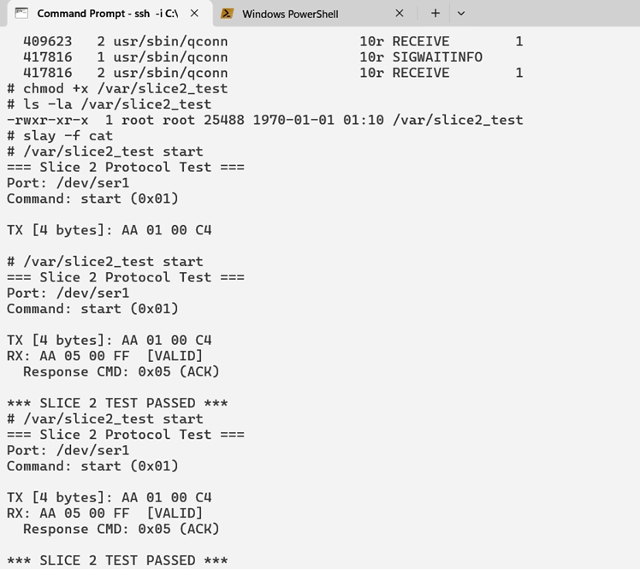

Message-passing layer results
The full command path from demo_client through motor_ctrl over UART to the STM32 and back completed correctly for all three command types. The response codes 0x05 for ACK and 0x07 for STATUS_RSP confirm that the dedicated STATUS_RSP command introduced during debugging successfully resolved the response ambiguity that existed when all replies were being sent as ACK packets. The client never accessed /dev/ser1 directly in any test, confirming that UART ownership remained exclusively inside motor_ctrl throughout.
CLIENT:-
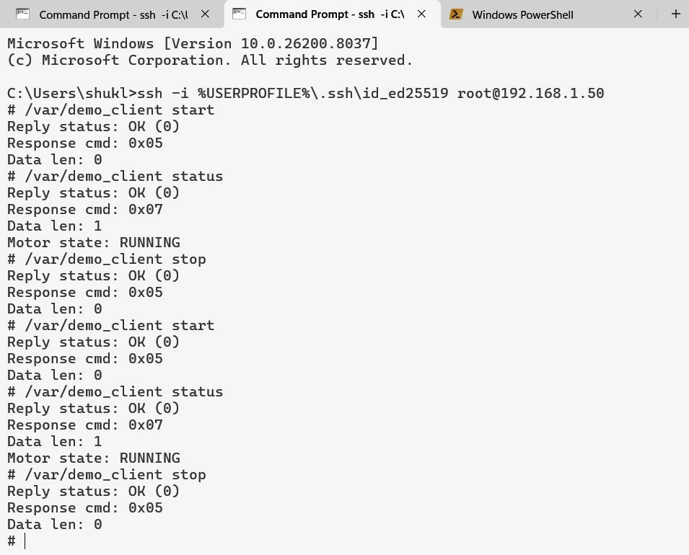

SERVER (MOTOR CONTROL):-
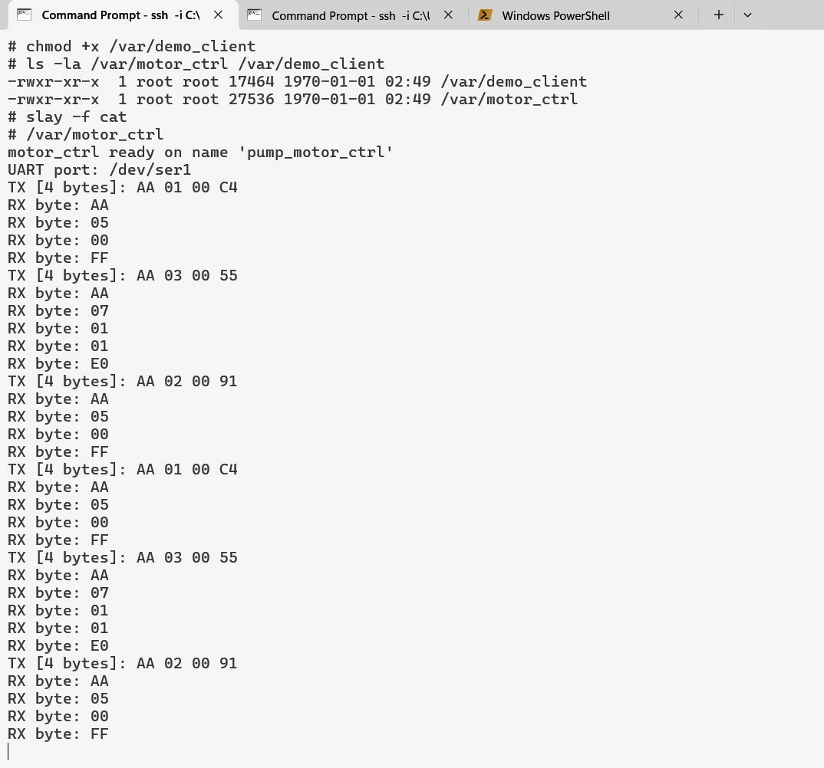
Fault notification results
Test cases 8 and 9 together confirm the key property of the three-process architecture: the fault pulse sent via MsgSendPulse reached alarm_mgr at the same time as the client received its REMOTE_FAULT (-4) reply. The client reply path and the alarm notification path operated independently, which is the main safety-relevant behaviour this architecture is designed to achieve.
ALARM MANAGER:-
SERVER (MOTOR CONTROL):-

CLIENT:-
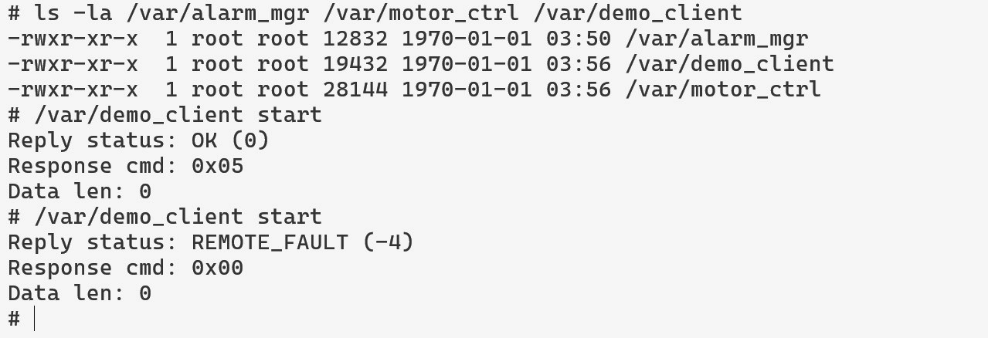

Heartbeat monitoring results
The heartbeat monitor thread is configured to poll every 200ms and declare a miss after 2000ms without a valid HEARTBEAT packet. The observed pulse value of 2000 in the HEARTBEAT_MISS notification confirms that the elapsed time measurement was working correctly. After the miss was detected, all three subsequent client operations (start, status, stop) returned UNKNOWN (-6), confirming that the heartbeat_missed flag was checked consistently across all command handlers in motor_ctrl.

ALARM MANAGER:-
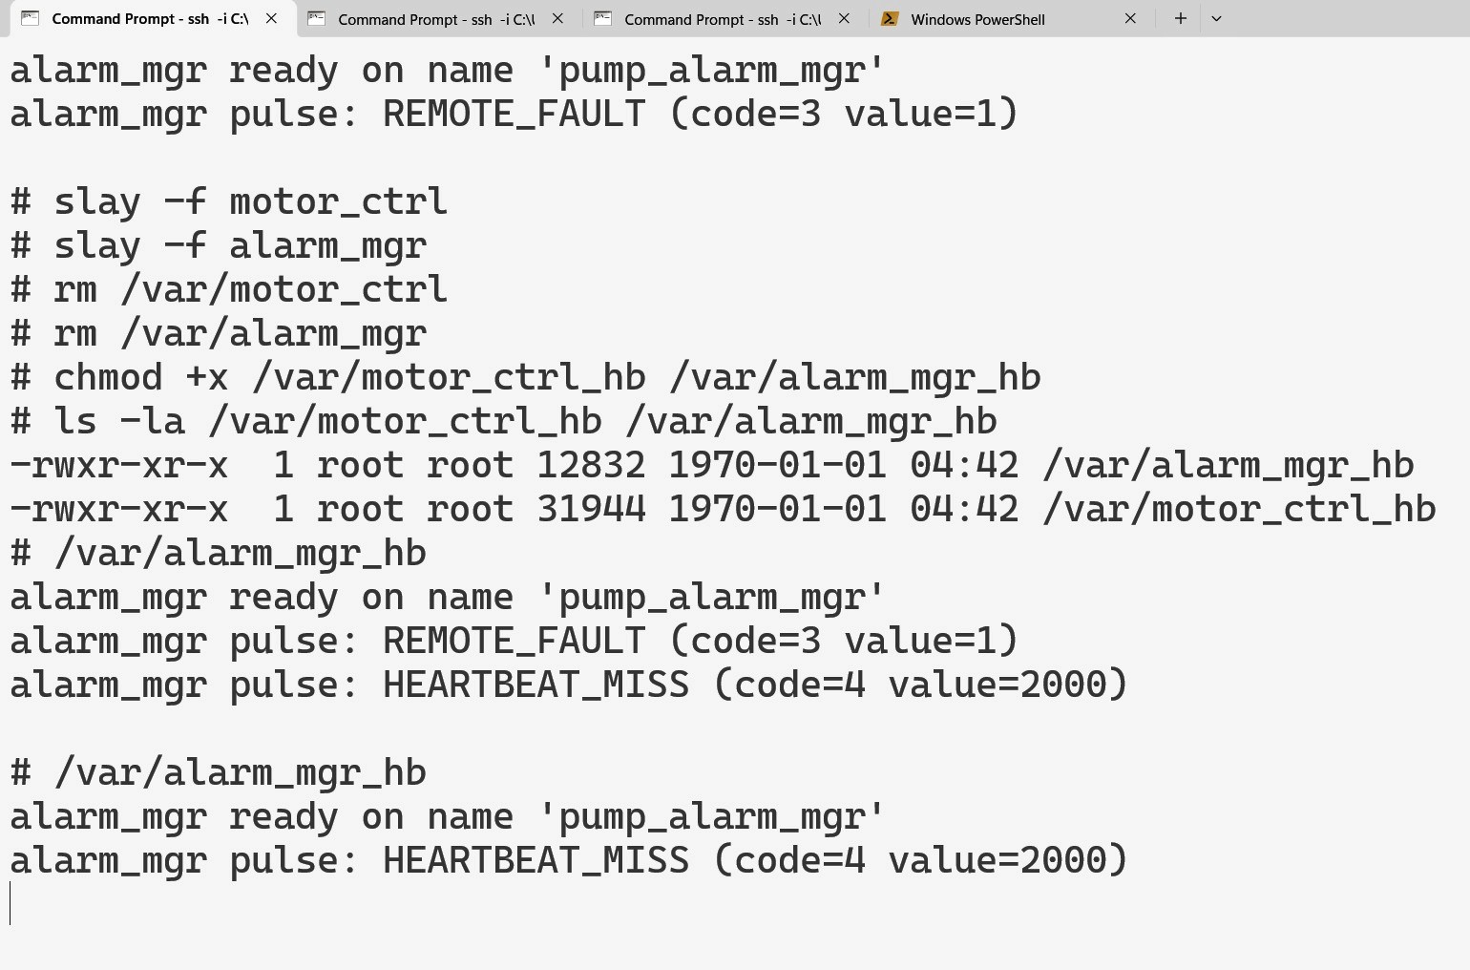

SERVER (MOTOR CONTROL):-
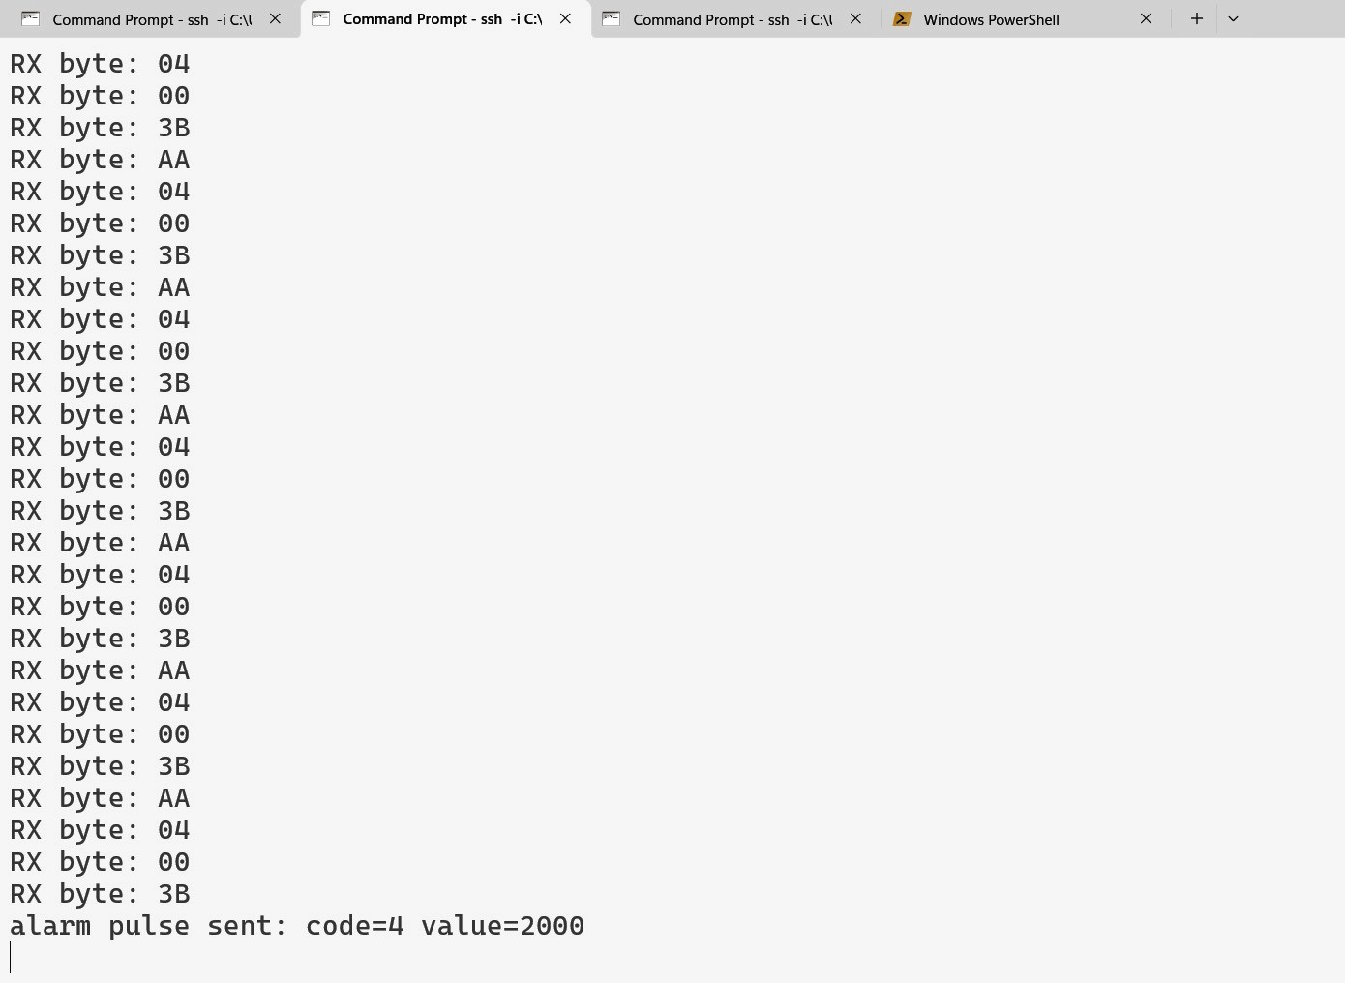
CLIENT:-
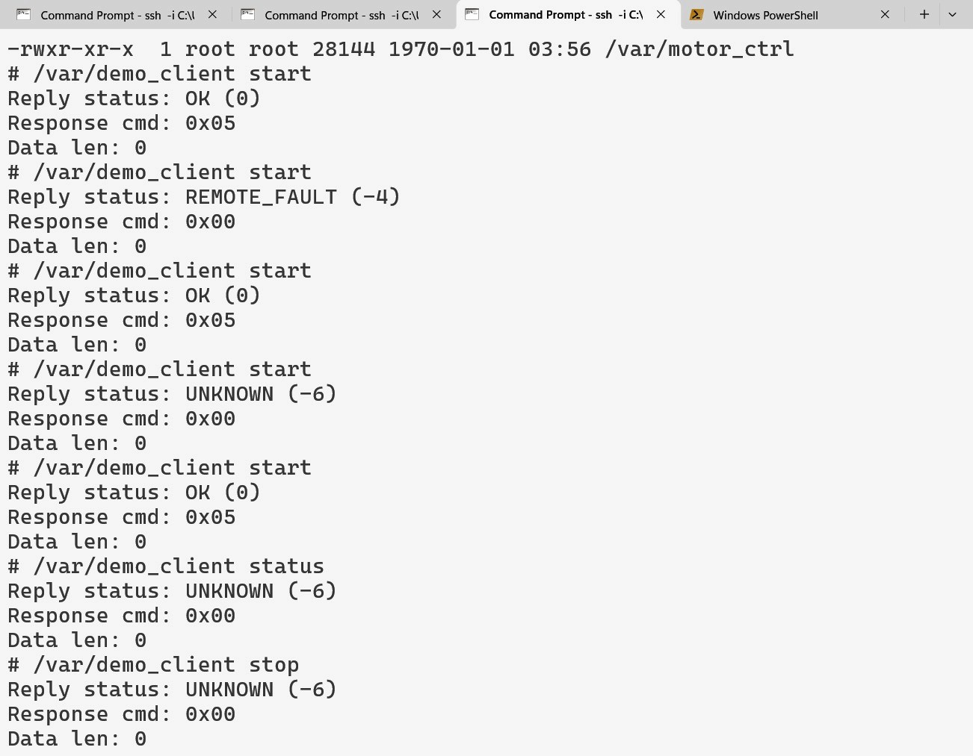

7. Problem Solving and Debugging
Several issues were encountered and resolved during hardware bring-up that are worth documenting both for their debugging value and as evidence of the iterative engineering process.
During initial protocol testing, the STM32 responded to the first START packet by entering FAULT state and blinking the LED rather than returning an ACK. The UART transmission was confirmed working because the STM32 clearly reacted. Investigation of the STM32 state machine revealed that when motor_state was already FAULT or RUNNING from a previous session, the handle_packet function for CMD_MOTOR_START returned a FAULT packet rather than proceeding to the ACK path. The fix was to reset the STM32 to IDLE state before each test, and a permanent fix was to add an explicit state check at the start of the START handler. The STATUS_RSP response was also originally ambiguous because an early design overloaded the ACK command for all responses. A dedicated CMD_STATUS_RSP command was introduced to make response matching unambiguous.
The QNX write path originally assumed that a single write() call would transmit the complete packet. On the QNX serial driver this is not guaranteed. A write_full helper function was introduced that loops until all bytes are confirmed written, which eliminated intermittent partial-packet transmission issues.
STM32 UART packet handling was originally executed directly inside the HAL_UART_RxCpltCallback interrupt handler. This caused timing issues when the callback attempted to call HAL_UART_Transmit while an ongoing receive was still in progress on the same peripheral. Moving all command execution into the main loop and keeping the interrupt handler strictly as a byte feeder into the parser resolved this interference.
During deployment, a naming inconsistency between the Momentics binary output names and the expected filenames on the Pi caused confusion where old binaries remained in place after SCP appeared to succeed. The root cause was that running processes held file locks. Explicitly running slay followed by rm before each SCP transfer resolved this reliably.
The heartbeat monitor thread required careful mutex discipline because the UART RX thread and the heartbeat monitor thread both access the last_heartbeat_ms timestamp. A shared pthread_mutex protects all reads and writes to the controller state structure. The condition variable used in the main dispatch loop allows the heartbeat monitor to signal the dispatch thread when a response arrives, avoiding busy-wait polling during UART transactions.

8. Conclusion and Future Work
This project has delivered a hardware-validated QNX-based infusion pump controller prototype across four incremental stages, all tested on physical hardware. The protocol layer, the message-passing control server, the asynchronous alarm notification system and the heartbeat monitoring mechanism have each been validated individually and shown to work correctly as an integrated system.
From the perspective of the RTOS Programming course, the project demonstrates how QNX Neutrino's IPC mechanisms can be used to separate concerns across processes: synchronous command control through MsgSend and MsgReply, asynchronous fault propagation through MsgSendPulse, and hardware ownership isolation by restricting /dev/ser1 access to motor_ctrl. These were not tested in simulation; they ran on a Raspberry Pi 4B talking to a real STM32 over a physical UART link.
The decision to use a message-passing server rather than a full QNX resource manager reduced implementation complexity without giving up the QNX-native IPC story. The incremental stage approach meant a working system existed at every point in development, which made debugging manageable and kept a fallback available at all times.
Several limitations exist in the current implementation. The system handles one client request at a time with no queuing mechanism. This is acceptable for a demo but would need to be addressed for any multi-client scenario. Once the heartbeat_missed flag is set, client requests fail indefinitely until motor_ctrl is restarted; a production system would need a recovery path involving a MOTOR_STOP command followed by a reconnection handshake. The QNX Adaptive Partitioning Scheduler was not configured in this phase, so CPU budget enforcement across motor_ctrl, alarm_mgr and any stress process has not been tested. The QNX secpol security model and the QNX Hypervisor virtualisation layer were explicitly deferred given the prototype scope and the project timeline.
The planned extensions build directly on what was validated here. APS partition configuration would give motor_ctrl a guaranteed CPU budget under system load, which matters in the infusion pump context. Tracelogger-based interrupt latency measurement would produce actual timing numbers rather than approximate observations, which is the kind of evidence IEC 62304 would require for a real medical device. A multi-client architecture with request queuing would be needed if multiple monitoring processes need concurrent access to pump status. Implementing the secpol model would enforce UART ownership at the OS level rather than relying on convention between processes.
References
[1] QNX Software Systems, QNX Neutrino RTOS System Architecture, QNX Software Development Platform 8.0, Blackberry Limited, 2023.
[2] QNX Software Systems, QNX Neutrino RTOS Programmer's Guide: Message Passing, QNX SDP 8.0, Blackberry Limited, 2023.
[3] STMicroelectronics, UM1724 User Manual: STM32 Nucleo-64 Boards (MB1136), Rev 14, STMicroelectronics, 2023.
[4] STMicroelectronics, STM32F401xB/STM32F401xC Reference Manual, RM0368, STMicroelectronics, 2023.
[5] Dallas Semiconductor, Application Note 27: Understanding and Using Cyclic Redundancy Checks with Dallas Semiconductor iButton Products, Maxim Integrated, 2001.
[6] IEC, IEC 62304:2006+AMD1:2015 Medical Device Software: Software Life Cycle Processes, International Electrotechnical Commission, 2015.

