Companies



Adams Multilingual Recruitment

Booth 30



adidas

Booth 23 + Matchmaking



Atlassian

Booth 1

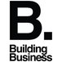

B. Building Business

Booth 2 + Pitch + Matchmaking

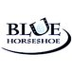

Blue Horseshoe

Booth 3



Booking.com B.V.

Booth 4



CLUB MED

Booth 5



De Gouberville for IBIS Inholland



Deskbookers

Booth 6 + Pitch



DHR International

Booth 7



Equiniti KYC Solutions

Booth 8 + Workshop



Esti

Booth 27 + Pitch



Expatica

Booth 25



FCA Netherlands B.V.

Booth 9 + Pitch



Freightex

Booth 10



HoiTalent



Information Development Co.,Ltd.

Booth 14 + Pitch



ING

Booth 11



Inholland University

Workshop



Monsanto

Booth 12



Murata Electronics Europe B.V.

Booth 13

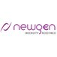

Newgen Payments

Booth 15 + Pitch + Matchmaking

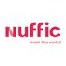

Nuffic

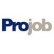

Projob

Career cafe



Pubbly B.V.

Booth 22 + Pitch + Matchmaking + Air hockey



S-Buddy

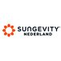

Sungevity

Booth 29



Teamleader

Booth 16 + Pitch + Matchmaking

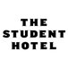

The Student Hotel

Booth 28



TIP Trailer Services

Booth 17 + Workshop

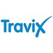

Travix

Booth 20 + Pitch



UBM EMEA

Booth 18 + Pitch



Universal Studios International B.V.

Booth 21



UvA Student Careers Centre



VenturesOne B.V.

Booth 19 + Workshop



VF International

Booth ? + Matchmaking

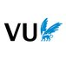

VU Amsterdam

Booth 34



VU/FEWEB Career Services



VU/FEWEB Career Services and Alumni Relations



Webster University the Netherlands

Pitch



Whirlpool Company

Booth 24

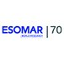

Young ESOMAR Society

Booth 26 + Pitch



Young Financials

Booth 33