T.S.E.C.

T.E. COMPUTERS

WEB TECHNOLOGY MINI PROJECT

TITLE: MOVIE-TIME


BATCH- C13

NAME- SEMIL JAIN
ROLL NO- 41

NAME- RAHUL KHATIJA
ROLL NO- 54

UNDER THE GUIDANCE OF
PROF. RUHI BAJAJ
ABSTRACT
Movie-Time is a movie information website where a logged in user can see movie details.
- User can Register and LogIn on the website.
- Watch Trailers of latest Movies.
- Search Movies by name and filter based on Genre.
- User can view Movie Information , Add Reviews and Add movies to their List.
- User can manage Account once Logged in.
- Top Rated Movies displayed based on User rating.
- In Theatre Movies can be booked via BookMyShow.

WORKING
1. A Movie Page
A single Movie page contains all the information about the movie,Watch trailer button, add review and add to my list buttons.
Designing and Layou is done by CSS.
Reviews are displayed at the end of the page.
You can’t access this page unless you are logged in.

2. Login/Register Forms
We have used Html forms to create a login/register form and Client side validation is done by javascript.
After submiting the form, values are stored in the database by PHP and MYSql using queries.
Whenever the user logins PHP is used to check if the credentials are matching with that of database.

3. Adding Reviews/Rating and Mylist updation
After user fills the review and rating form the values of form are stored in the Review table in database by sql queries.
These reviews are displayed on their respective movie pages as well as in user’s account.
On clicking ‘Add to List’ The movie gets stored in users table which can be retrieved.

4. Search and Filter(by Genre) movies
All the movies in the database are stored in a list form which gets filtered every time a key is pressed.This is done using JavaScript.
All genres are denoted by radio button.On Clicking a particular radio button filter function is called which shows and hides movie based on class value assigned to each movie.

5. Top Rated Movies
The Movie Pages are assigned id values based on the average user rating given to it which is fetched from the database.
Sorting function is called which sorts the Movie div based on id value assingned in descending order.

6.My Account
After logging in ,The user can access his account.
The Account Page contains features like Changing Username, Email Id and Password after validation.
The user can see all his reviews and the movies added to his Mylist.
A Logout Button is provided to logout of Account Page after which the user cannot access most of the features of the web site.

7. In Theatres
You will be redirected to BookMyShow after you have selected the movie currently in theatre and your city name.BookMyShow will open that movie bookings in the city selected.
Code Snippets
1. DataBase Connection
<?php
$servername="localhost";
$username="root";
$password="semiljain";
$dbname="userregistration";

$conn=mysqli_connect($servername,$username,$password,$dbname);
if(!$conn)
{
die("Connection Failed: " . mysqli_connect_error());
}
?>

Data Base connection is established by the aboove code which is the base to run all php mysql queries.

2.Sorting Based on Ratings
<script>
var main = document.getElementById( 'sortmain' );

[].map.call( main.children, Object ).sort( function ( a, b ) {
return +b.id.match( /\d+/ ) - +a.id.match( /\d+/ );
}).forEach( function ( elem ) {
main.appendChild( elem );
});
</script>

Every movie has an id which is the average of all user ratings.
The Javascipt sorts the movie based on the id values in descending order.
3.Filter Movies by Genre

filterSelection("all")
function filterSelection(c) {
var x, i;
x = document.getElementsByClassName("filterDiv");
if (c == "all") c = "";
for (i = 0; i < x.length; i++) {
w3RemoveClass(x[i], "show");
if (x[i].className.indexOf(c) > -1) w3AddClass(x[i], "show");
}
}

All Movies are assigned Genre as class values.
Initially the ‘all’ radio button is checked which shows all movies.The Movies keep on hiding and showing based on the radio button checked.Two seperate functions are used to hide and show divs of the movie.

4.Login,Session and Session variables
$sql="SELECT * FROM login WHERE Email_ID='".$user."' AND Password='".$pass."' ";
$query=mysqli_query($conn,$sql);
$numrows=mysqli_num_rows($query);
if($numrows!=0)
{
while($row=mysqli_fetch_assoc($query))
{
$dbusername=$row["Email_ID"];
$dbpassword=$row["Password"];
$name=$row["Name"];
}

if($user == $dbusername && $pass == $dbpassword)
{
session_start();
$_SESSION['sess_user']=$name;
$_SESSION['email']=$user;

Above Query checks from the user table and validates username and password.Once validated, A session is started and session variables are created.These variables are like global variables and can be used on every page of website untill the session expires or is unset.

5.Add Movie to list(Simillarly Reviews)
$movie=$_SESSION['movie'];
$user=$_SESSION['email'];
$link=$_SESSION['link'];
if(isset($_POST["wish"])) {
$sql2="INSERT INTO Mylist VALUES('$user','$movie','$link')";}

when add to list button is pressed sql query inserts the user,movie and moviepage link to database which can be retrieved back when needed.Simillarly You can add review and ratings.
Website Screenshots
1.Homepage
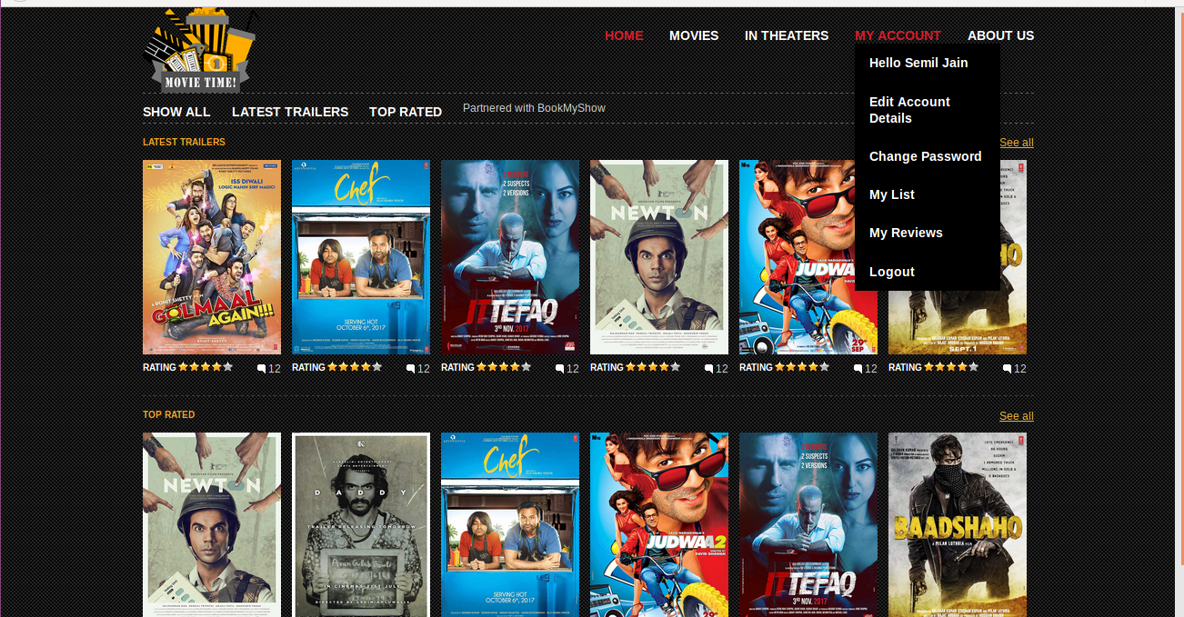
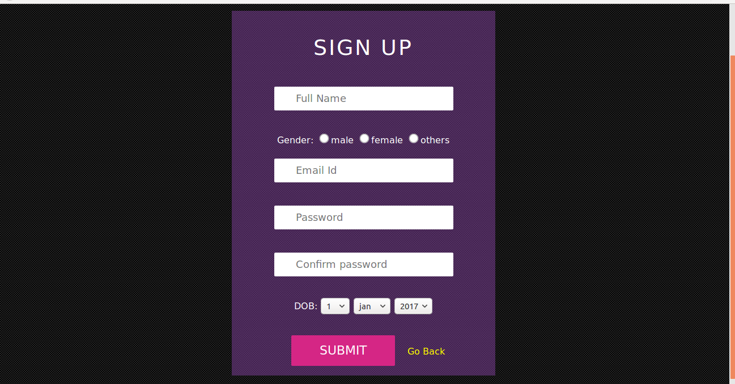
2.Register Form

3.Movie Page
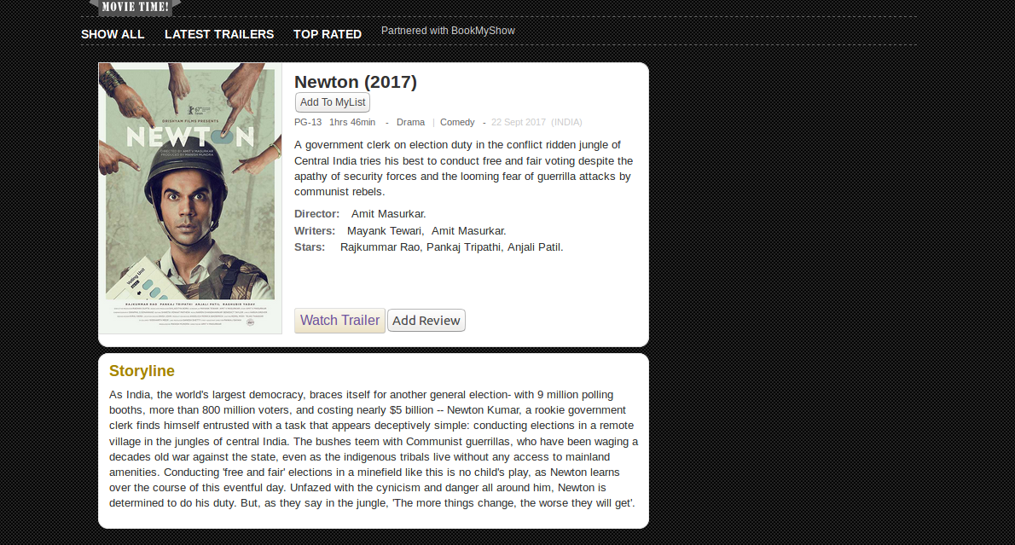

4.Sort by Genre
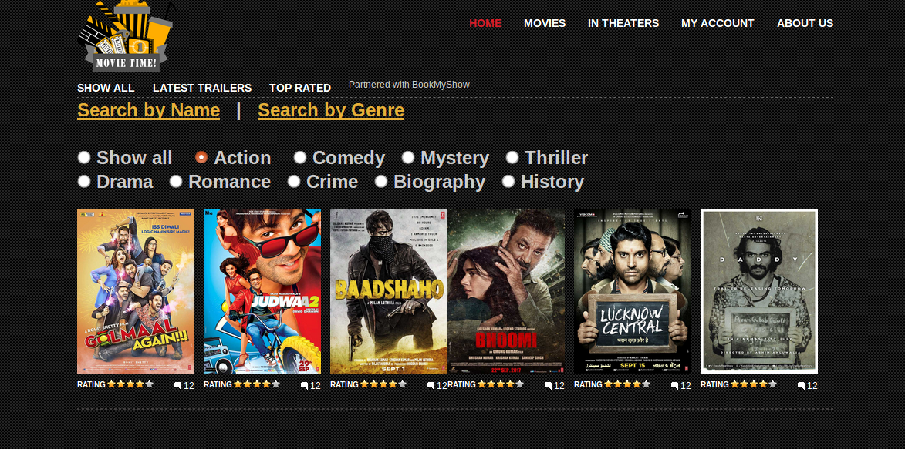

5.Top Rated Movies
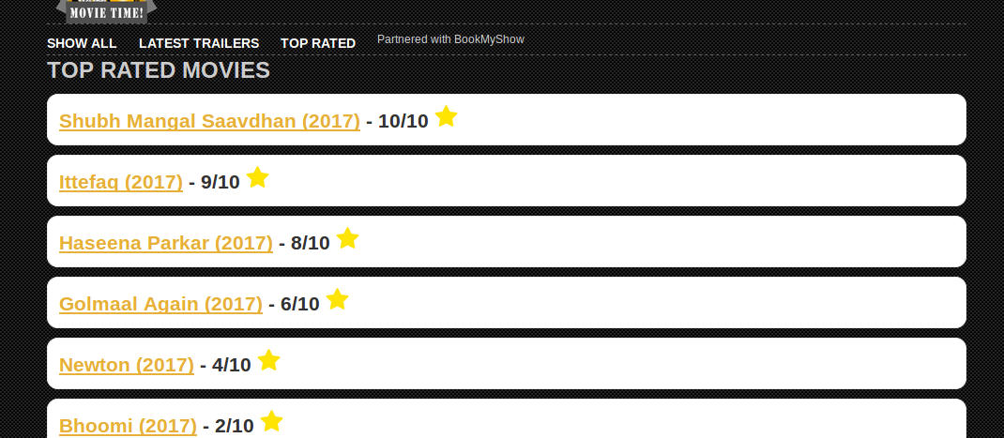

6.User Reviews
