**Report**

Name:Yuanzheng zheng ; ID:22009318

Video:

**[https://www.bilibili.com/video/BV1xu4y187Cj/?spm_id_from=333.999.0.0](https://www.bilibili.com/video/BV1Qu4y1N7QA/?spm_id_from=333.999.0.0https://www.bilibili.com/video/BV1Qu4y1N7QA/?spm_id_from=333.999.0.0)**

**Introduction:**

1. My intended audience is people who are interested in Chinese culture.
2. The students under the age of 20,especially who are in junior school.
3. The foreigners who are interested in Chinese culture and who understand English.Because the content of my page will be in English.
4. There is no gender restriction.
5. My website is to introduce the excellent traditional culture of China. I want to carry forward the excellent Chinese culture and create a learning atmosphere of traditional culture.On the one hand, let more Chinese sons and daughters understand traditional culture, pay attention to traditional culture, protect traditional culture and inherit traditional culture.On the other hand, let Chinese traditional culture to the world, let more people know about this country with a long history.
6. First,I want my website that can provide convenience and opportunity for people who want to know about traditional culture.They don't need to blindly look up the relevant content. You can learn about Chinese traditional culture from many aspects on my website.

Second, there is a question that the outstanding traditional cultures of Chinese national minorities are being lost, and many cultural heritages are in danger nowadays. Through the website, we can more effectively inherit and carry forward the excellent traditional Chinese culture, and better carry forward the excellent traditional Chinese culture in the extensive promotion, so as to win due cultural recognition and cultural respect in the world and the international community.

4.Encyclopedic knowledge base of excellent traditional Chinese culture:

<https://ctwh.cnki.net/index.html?encode=cnki>

Glossary of Chinese Ideological and cultural Terms:

<https://shuyuku.chinesethought.cn/>

5.For the first website, I like the color scheme of this page, which has a classical beauty.It is very much in line with the characteristics of Chinese culture. The animations are very fluid and it has rich content.

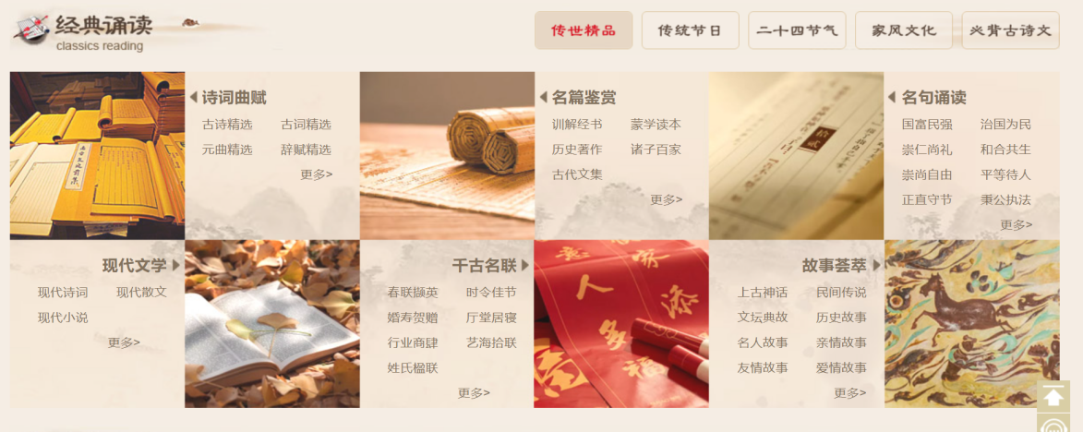

For the second website, the layout is very clean and rich in content.The use of red and gray color matching is very atmospheric simplicity, so that we browse the site is very comfortable.

**Analysis:**

1. Web Site Goal
2. .I hope my website can show Chinese traditional culture comprehensively, let more people understand, let Chinese culture to the world.
3. Call on more Chinese sons and daughters to protect and inherit traditional Chinese culture.
4. What information do I need?
5. .I will obtain the facts and text from many related pages, books and some TV shows.
6. .I will look up music and videos on the Internet alone.
7. I will organize the content of other web pages and make a graph about the relevant content.
8. How will your project use a form?

I will make the login page as a form.I will collect the gender, age and feedback of the logged-in person.I can learn about what gender and at what ages people are interested in Chinese traditional culture.

4.A Page Wireframe:

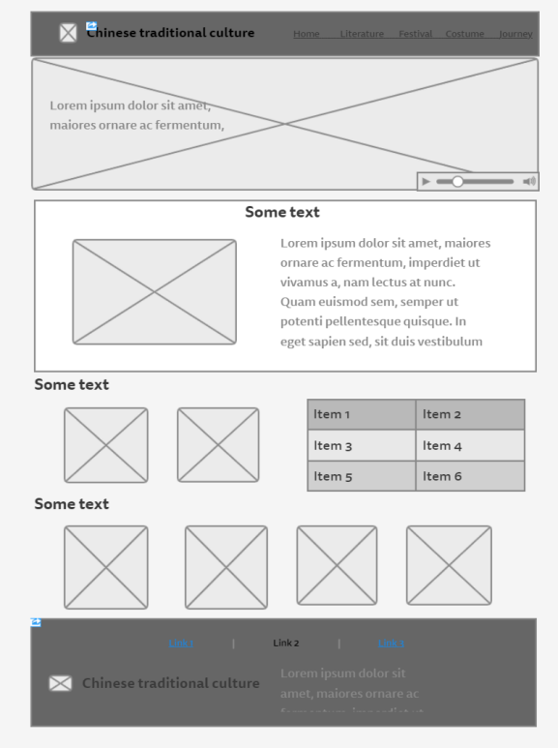

**A critique of the site:**

1. what do you think is good?
2. I think my page layout is pretty neat. Audience can clearly understand each part of the content.
3. I used a variety of animations which can make pages more vivid.
4. given more time, what would you improve?

I hope my pages have rich content and detailed introduction.

form.html

<form>

        <h1>Personnel Information</h1>

         <label for="username">Username:</label>

         <input type="text" id="username" placeholder="Enter Username">

        <br>

        <br>

         <label for="password">Password:</label>

        <input type="password" id="password" placeholder="Enter Password">

         <br>

        <br>

        <label for="password">Confirm Password:</label>

        <input type="password" id="password_again" placeholder="Please Confirm Password">

        <br>

        <br>

        <label for="gender">Gender:</label>

         <label for="male" id='malelabel'>Male</label>

         <input type="radio" name="sex" id="male" value="Male">

         <label for="female" id='femalelabel'>Female</label>

        <input type="radio" name="sex" id="female" value="Female">

         <br>

        <br>

        <label for="password">Date of Birth:</label>

        <input type="date" id="birthday">

        <br>

        <br>

         <label for="postcode">Post Code:</label>

         <input type="number" id="postcode" placeholder="Enter Post">

        <br>

        <br>

        <label for="phone">Phone Number:</label>

        <input type="tel" id="phone" placeholder="Enter Phonenumber">

        <br>

        <br>

            <label for="email">Email:</label>

            <input type="email" id="email" placeholder="Enter Email">

        <br>

        <br>

        <br>

        <br>

        <br>

        <br>

        <label for="phone">Feedback:</label>

        <textarea id="opinion" placeholder="Enter Your Feedback"></textarea>

        <br>

        <br>

        <button id= "subbmit" onclick="subbmitee()" >Subbmit</button>

       </form>

       <script src="collect.js"></script>

     <div class="suggest ">

     <a href="collected_data.html"> <span class="textsu">View information </span></a>

         </div>

form.js

function subbmitee(){

    if (localStorage.clickcount) {

     localStorage.clickcount = Number(localStorage.clickcount) + 1;

     } else {

     localStorage.clickcount = 1;

    }

     var array = new Array();

    var tmp = String(document.getElementById("username").value);

     array.push(tmp);

     var tmp1 = String(document.getElementById("password").value)

     array.push(tmp1);

     var tmp2 = String(document.getElementById("password_again").value)

     array.push(tmp2);

     var tmp3 = String($(":radio[name=sex]:checked").val());

     array.push(tmp3);

     var tmp4 = String(document.getElementById("birthday").value);

     array.push(tmp4);

     var tmp5 = String(document.getElementById("postcode").value);

     array.push(tmp5);

     var tmp6 = String(document.getElementById("phone").value);

     array.push(tmp6);

     var tmp7 = String(document.getElementById("email").value);

     array.push(tmp7);

     var tmp8 = String(document.getElementById("opinion").value);

    array.push(tmp8);

    var tmp9 = timestampToTime(new Date().valueOf());

    array.push(tmp9);

    localStorage.setItem(String(localStorage.clickcount),JSON.stringify(array));

}

function timestampToTime(time) {

      var date = new Date(time);

      var Y = date.getFullYear() + '-';

      var M = (date.getMonth() + 1 < 10 ? '0' + (date.getMonth() + 1) : date.getMonth() + 1) + '-';

      var D = (date.getDate() < 10 ? '0' + (date.getDate()) : date.getDate()) + ' ';

      var h = (date.getHours() < 10 ? '0' + (date.getHours()) : date.getHours()) + ':';

      var m = (date.getMinutes() < 10 ? '0' + (date.getMinutes()) : date.getMinutes()) + ':';

      var s = (date.getSeconds() < 10 ? '0' + (date.getSeconds()) : date.getSeconds());

      var strDate = Y + M + D + h + m + s;

      return strDate;

}