Introduction
Scoring the first goal is often seen as a decisive moment in a soccer match, shaping both the momentum and the final outcome. This project examines whether scoring the first goal significantly increases a team's chances of winning in La Liga during the 2023–2024 season. The central research question guiding this analysis is: Does scoring the first goal increase the probability of winning a match?
To explore this, the following hypotheses were formulated:
- Null Hypothesis (H₀): Scoring the first goal does not significantly increase the probability of winning.
- Alternative Hypothesis (H₁): Scoring the first goal significantly increases the probability of winning.
The objective of the study is to test these hypotheses using match data and evaluate the strength of the first-goal advantage. This report outlines the dataset and methodology used, presents key findings from the analysis, and discusses the broader implications for teams, coaches, and match strategy.

Methodology
Our methodology consisted of three main phases: data preprocessing, feature engineering, and model development.
Data Cleaning:
We began by assessing missing values in the dataset. Several entries in the first_goal column were null, typically corresponding to 0–0 draws or matches with unclear goal order. We implemented a conditional inference logic to recover first_goal in cases where only one team had scored. Matches where the first goal could not be confidently assigned were excluded from the analysis. This step reduced the dataset from 380 matches to approximately 349 usable entries.
Feature Engineering:
We constructed new variables to capture relevant match dynamics:
- first_goal_win: Binary indicator (1 if the first goal scorer won the match)
- home_scored_first: Whether the home team scored first
- high_attendance: Matches with above-median attendance
- xG_diff: Difference in expected goals between home and away teams
- goal_diff: Absolute score difference
Additional match-level metrics were created for use in exploratory visualizations and team-level comparisons, including radar charts and clustering.

Modeling & Results
To test the predictive power of early match dynamics, we built three classification models to predict whether a team would win based on features available shortly after scoring the first goal.

Models Used:
- Logistic Regression
  - Test Accuracy: 82.86%
  - ROC-AUC: 0.93
- Decision Tree Classifier
  - Test Accuracy: 90.00%
  - ROC-AUC: 0.96
- Random Forest Classifier
  - Test Accuracy: 82.86%
  - ROC-AUC: 0.95
These models were evaluated using an 80/20 train-test split and 5-fold cross-validation for robustness. ROC-AUC scores reflect high discriminative power, particularly with the Decision Tree and Random Forest models.

Exploratory Data Analysis
To understand the influence of scoring the first goal on match outcomes, we began by analyzing win rates following the first goal across all matches in the 2023–2024 La Liga season.
Key findings include:
- Overall Win Rate After Scoring First:
Teams that scored the first goal went on to win 58.45% of matches, confirming a notable advantage.
- Home Advantage:
Home teams that scored first had a remarkable 98.99% win rate (98 wins and 1 draw), suggesting a strong correlation between early goals and home victory.
- Away Team Performance:
In contrast, away teams that scored first only won 42.40% of the time, indicating that scoring first does not guarantee success when playing away.
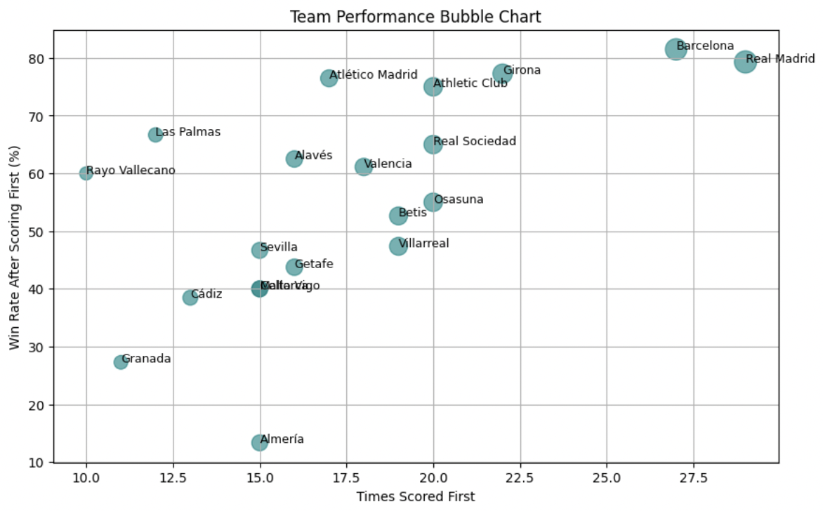
We also generated a bubble chart visualizing team performance by plotting the number of times each team scored first against their win rate after scoring first. This revealed deeper insights:
- High Volume, High Conversion:
Teams like Barcelona and Real Madrid scored the first goal most frequently and successfully converted those leads into wins at exceptionally high rates.
- High Efficiency, Low Frequency:
Teams like Girona and Atlético Madrid, while scoring first less frequently, showed very high win conversion rates (above 75%), demonstrating efficiency in capitalizing on early momentum.
These results reinforce the notion that scoring first is not just a symbolic edge, it often translates into tangible match outcomes, particularly for strong-performing or home teams.

Clustering Analysis
To uncover group-level patterns, we applied clustering to teams based on their average expected goals (xG) difference and win rate after scoring first. This revealed three distinct clusters:
- Cluster 0 included struggling teams with negative xG differentials and poor conversion after scoring first (20% win rate).
- Cluster 1 represented dominant teams like Real Madrid and Barcelona that maintained high xG and capitalized strongly on early leads (57% win rate).
- Cluster 2 featured mid-level teams with balanced stats and moderate success rates (34% win rate).
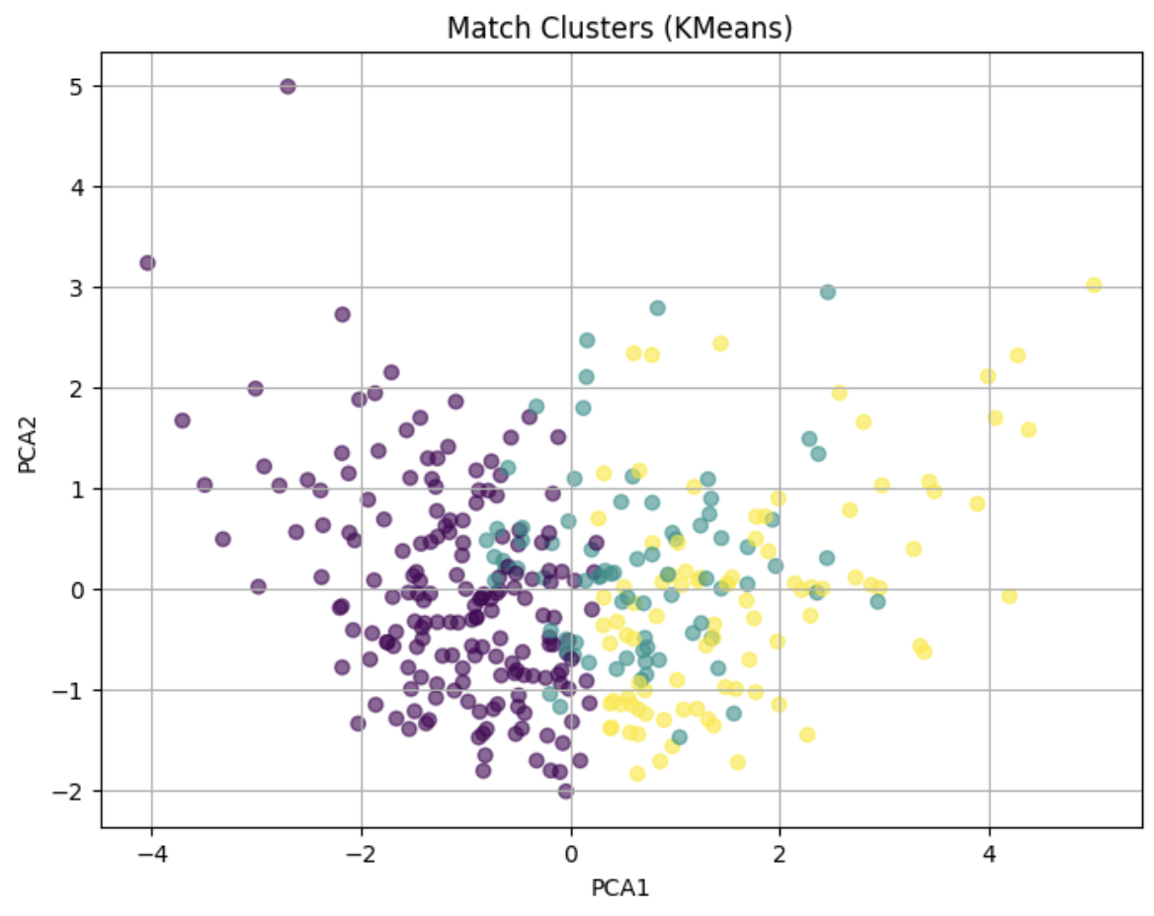
These insights suggest that not all early goals are equal, team quality and game control heavily influence the ability to secure a win after scoring first.

Discussion
Our analysis reinforces that scoring the first goal plays a pivotal role in match outcomes, but the impact is nuanced. While early goals are generally advantageous, their effect depends heavily on a team’s style of play and overall quality. Through clustering, we saw that some teams are more vulnerable despite scoring first, while others, like Real Madrid and Barcelona, capitalize consistently. Predictive models such as Decision Trees and Logistic Regression confirmed that first-goal advantage is a strong predictor of match outcome, but not the only one. Features like goal differential and expected goals were also critical. From a strategic lens, this suggests coaches should adapt tactics after taking the lead, players must remain alert regardless of the scoreline, and GMs should consider strengthening in-game control capabilities when recruiting for either dominance or stability.

Limitations and Future Work
While our findings provide strong evidence for the impact of scoring first, there are several limitations to consider. First, we did not have access to the exact timing of first goals, which limited our ability to assess how early goals influence match momentum. The dataset also excluded 0–0 draws due to missing first-goal data, which may introduce selection bias by removing low-event matches. Additionally, the analysis focused exclusively on one league (La Liga) and one season (2023–2024), which limits the generalizability of our models. It's also important to note that while our models, Logistic Regression, Decision Tree, and Random Forest, performed well on our dataset, their effectiveness may vary across leagues or in future seasons.
For future research, we recommend expanding the analysis across multiple seasons and including other major leagues like the EPL or Bundesliga. Integrating variables such as the minute of the first goal, player-level metrics, or match incidents (e.g., red cards) could improve model performance. Finally, examining drawn matches and exploring the strategic impact of early goals across team styles and coaching decisions could offer deeper tactical insights.

Conclusion
Our analysis found that scoring the first goal moderately increased a team's chance of winning, with an overall win rate of 58.45% during the 2023–2024 La Liga season. Through the use of machine learning models such as Logistic Regression, Decision Trees, and Random Forests, we confirmed that while scoring first is a strong predictor, it is not the sole factor determining match outcomes. Incorporating additional variables like expected goals (xG) and match attendance further reinforced the significance of early scoring in shaping game trajectories.
Beyond predictive accuracy, this project contributes to the growing field of sports analytics by offering timely, league-specific insights and identifying strategic patterns that differ across teams. Unlike previous research, which is often generalized across leagues or seasons, our study highlights the nuances of individual team performance and opens the door for more targeted tactical recommendations. These findings set the stage for future predictive modeling and tactical decision-making grounded in real match data.
References:
- Armatas, V., Yiannakos, A., Zaggelidis, G. (2007). The effect of scoring first on match outcomes. Sport Journal.
- StatsBomb (n.d.). The Use and Misuse of Expected Goals. https://statsbomb.com/
- Scikit-learn Documentation. https://scikit-learn.org/
- FBref.com / Kaggle datasets

