WordCount.java (Mapper Part):
java
CopyEdit
import java.io.IOException;
import java.util.StringTokenizer;

import org.apache.hadoop.conf.Configuration;
import org.apache.hadoop.fs.Path;
import org.apache.hadoop.io.IntWritable;
import org.apache.hadoop.io.Text;
import org.apache.hadoop.mapreduce.InputSplit;
import org.apache.hadoop.mapreduce.Job;
import org.apache.hadoop.mapreduce.Mapper;
import org.apache.hadoop.mapreduce.Reducer;
import org.apache.hadoop.mapreduce.filecache.DistributedCache;
import org.apache.hadoop.mapreduce.lib.input.FileSplit;
import org.apache.hadoop.mapreduce.lib.input.TextInputFormat;
import org.apache.hadoop.mapreduce.lib.output.FileOutputFormat;

public class WordCount {

public static class TokenizerMapper
extends Mapper<Object, Text, Text, IntWritable>{

private final static IntWritable one = new IntWritable(1);
private Text word = new Text();

public void map(Object key, Text value, Context context
) throws IOException, InterruptedException {
FileSplit fileSplit = (FileSplit) context.getInputSplit();
String filename = fileSplit.getPath().getName();

StringTokenizer itr = new StringTokenizer(value.toString());
while (itr.hasMoreTokens()) {
String token = itr.nextToken();
word.set(filename + "\t" + token);
context.write(word, one);
}
}
}

public static class IntSumReducer
extends Reducer<Text,IntWritable,Text,IntWritable> {
private IntWritable result = new IntWritable();

public void reduce(Text key, Iterable<IntWritable> values,
Context context
) throws IOException, InterruptedException {
int sum = 0;
for (IntWritable val : values) {
sum += val.get();
}
result.set(sum);
context.write(key, result);
}
}

public static void main(String[] args) throws Exception {
Configuration conf = new Configuration();
Job job = Job.getInstance(conf, "word count");
job.setJarByClass(WordCount.class);
job.setMapperClass(TokenizerMapper.class);
job.setCombinerClass(IntSumReducer.class);
job.setReducerClass(IntSumReducer.class);
job.setOutputKeyClass(Text.class);
job.setOutputValueClass(IntWritable.class);
TextInputFormat.addInputPath(job, new Path(args[0]));
FileOutputFormat.setOutputPath(job, new Path(args[1]));
System.exit(job.waitForCompletion(true) ? 0 : 1);
}
}

- Remove old output directory:
hdfs dfs -rm -r /user/te/output
- Create a local folder and add input files
Let’s say you have a folder called input that contains multiple .txt files.
mkdir input
echo "hello world" > input/file1.txt
echo "hadoop is awesome" > input/file2.txt
- Upload the entire folder to HDFS
Use the following command:
hdfs dfs -mkdir -p /user/te/input
hdfs dfs -put input/* /user/te/input/

- You can check them with:
hdfs dfs -ls /user/te/input/
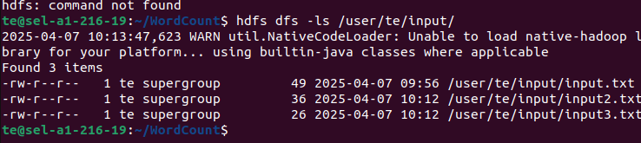
- compile:
rm -rf build wordcount.jar //if already exist
mkdir build
javac -classpath $(hadoop classpath) -d build WordCount.java
jar -cvf wordcount.jar -C build/ .
- Run the job:
hadoop jar wordcount.jar WordCount /user/te/input /user/te/output
- Check the output:
hdfs dfs -cat /user/te/output/part-r-00000
