Software Requirements Specification
Mini SRS · Project Proposal Section
Project | Cancer Gene Expression Classification Using Classical Machine Learning
Team | [Student Name 1] · [Student Name 2] · [Student Name 3] · [Student Name 4] · [Student Name 5] · [Student Name 6]
Supervisor | Dr. [Supervisor Name]
Version / Date | 1.0 · October 2026

1. Introduction

1.1 Purpose
Specify the requirements of a machine learning system that classifies cancer types from gene expression (RNA-seq) data and identifies the most influential genes.

1.2 Scope
The system loads TCGA RNA-seq data, trains and compares classical ML models (no deep learning), explains predictions with SHAP, and reports performance. It is a research prototype, not a clinical diagnostic tool.

1.3 Definitions
Term | Meaning
TCGA | The Cancer Genome Atlas
RNA-seq | Gene expression measurements per sample
SHAP | Method that ranks each gene's contribution to a prediction
ACC / F1 | Accuracy / balanced precision-recall score

1.4 Reference
Dalmolin et al., “Feature Selection in Cancer Classification: Utilizing Explainable AI to Uncover Influential Genes in Machine Learning Models,” AI, vol. 6, no. 1, p. 2, 2025.

2. Overall Description
- Product perspective: standalone Python pipeline (notebooks or scripts), no web server or database.
- Users: student team (6 members), supervisor, evaluators.
- Operating environment: Python 3, pandas, scikit-learn, xgboost, shap, matplotlib; runs on a normal laptop (about 8 GB RAM); Docker optional.
- Constraints: classical ML only (no deep learning); public data only (TCGA); semester deadline.
- Assumptions: TCGA data stays downloadable; labels (cancer type) are correct.
Figure 1 shows the end-to-end pipeline; each block is tagged with the functional requirement it satisfies.
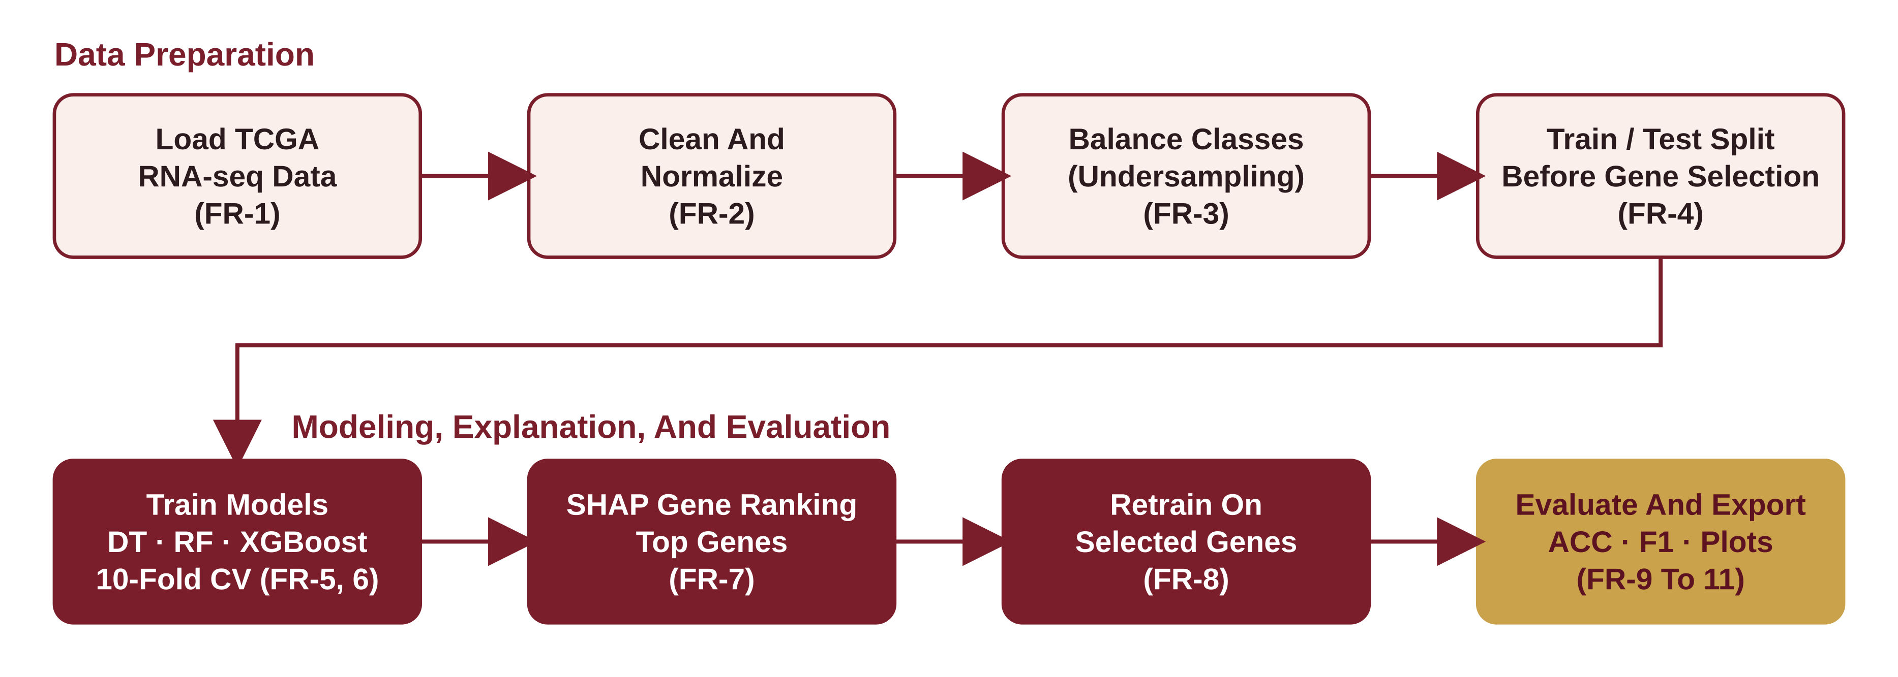
Figure 1: System Pipeline

3. Functional Requirements
Figure 2 shows who uses the system and which requirements each use case covers.
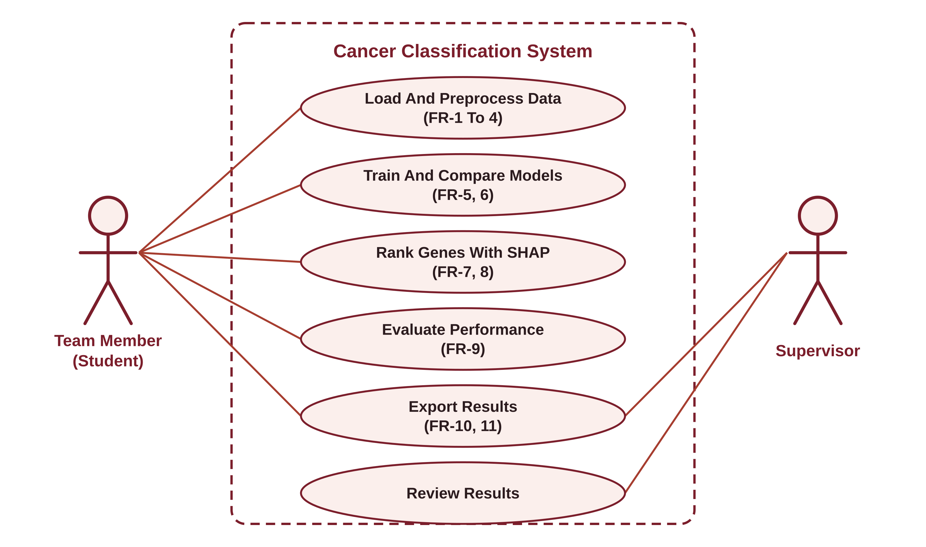
Figure 2: Use Case Diagram
ID | Requirement | Priority
FR-1 | The system shall load TCGA RNA-seq data for 5 cancer types (BRCA, LUAD, THCA, OV, COAD) | High
FR-2 | The system shall clean the data (remove missing and constant genes) and normalize it | High
FR-3 | The system shall balance classes (undersampling) | High
FR-4 | The system shall split data into train and test before any gene selection | High
FR-5 | The system shall train Decision Tree, Random Forest, and XGBoost classifiers | High
FR-6 | The system shall evaluate with 10-fold cross-validation | High
FR-7 | The system shall compute SHAP values and rank the top genes | High
FR-8 | The system shall retrain models on the selected genes only and compare before and after | High
FR-9 | The system shall output ACC, precision, recall, F1, and a confusion matrix per model | High
FR-10 | The system shall plot the top genes and the model comparison | Medium
FR-11 | The system shall save results (tables and figures) to files | Medium
FR-4 prevents data leakage: gene selection sees the training data only, and the test set is used once, at the end (Figure 3).
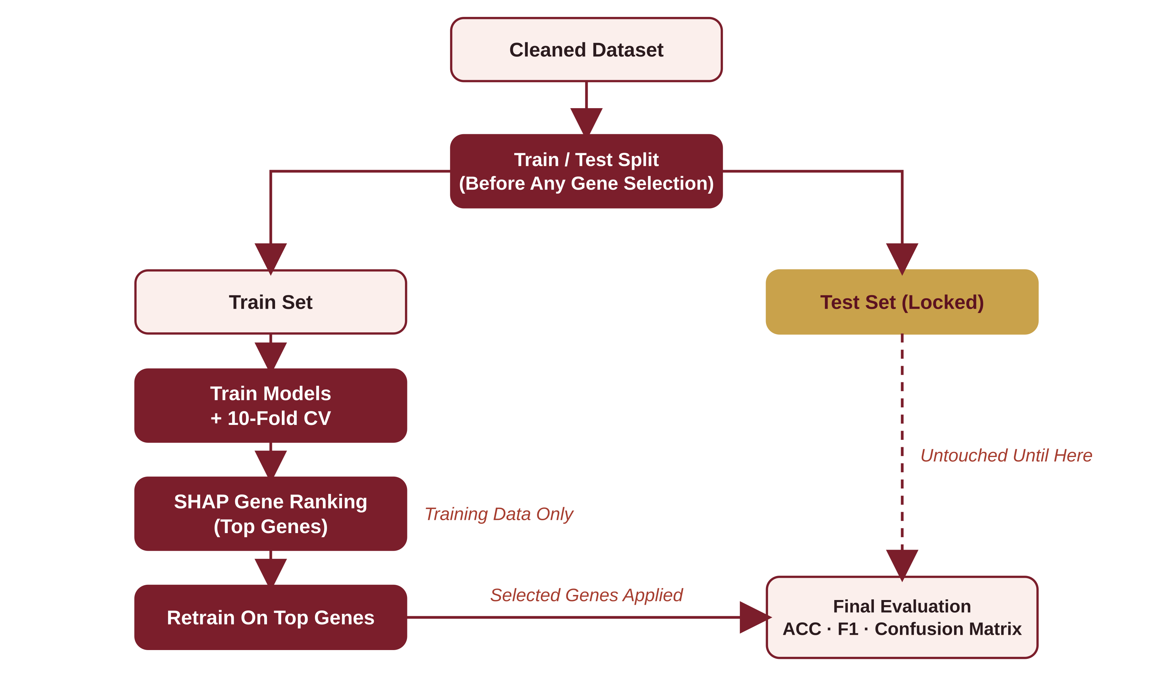
Figure 3: Data Flow With Train/Test Split Before Gene Selection (FR-4)

4. Non-Functional Requirements
ID | Category | Requirement
NFR-1 | Performance | Target: full training and evaluation finish in under 30 minutes on a laptop
NFR-2 | Accuracy | Target: ACC and macro F1 of at least 95% on the test set
NFR-3 | Reproducibility | Fixed random seeds; a requirements.txt, and a Dockerfile if Docker is used
NFR-4 | Interpretability | Every reported top gene is listed with its SHAP score and a short biological note
NFR-5 | Maintainability | Modular code (load, preprocess, train, explain, report) with comments, hosted on GitHub
NFR-6 | Scalability (future) | Design should allow larger datasets (single-cell) later

5. Data Requirements
- Source: TCGA RNA-seq (public).
- Expected size: about 3,000 samples × about 21,000 genes.
- Format: CSV with one row per sample and one column per gene, plus a label column.
- Privacy: no personal data is collected or stored.

6. Acceptance Criteria
The project is accepted when:
- All FR-1 to FR-9 run end-to-end without errors.
- The best model meets the accuracy target (NFR-2).
- The top genes are listed and checked against the literature.
- Results are reproducible by another team member from the README.

7. Out Of Scope
Deep learning, clinical use, real-time prediction, a web or mobile interface, and single-cell analysis (listed as future work).

