Project Design Diagrams
Use Case · DFD · Activity · Class · Sequence · ERD
Project | Cancer Gene Expression Classification Using Classical Machine Learning
Team | [Student Name 1] · [Student Name 2] · [Student Name 3] · [Student Name 4] · [Student Name 5] · [Student Name 6]
Supervisor | Dr. [Supervisor Name]

No. | Diagram | Purpose
1 | Use Case Diagram | Who uses the system and what it does
2 | DFD Level 0 | System as one process with its external entities
3 | Activity Diagram | Step-by-step workflow with the improvement loop
4 | DFD Level 1 | Six processes and four data stores
5 | Class Diagram | Main classes of the Python code
6 | Sequence Diagram | Order of calls in one experiment run
7 | ERD | Data model for dataset, settings, and results

1. Use Case Diagram
Two actors use the system. Requirement IDs (FR) refer to the Mini SRS.
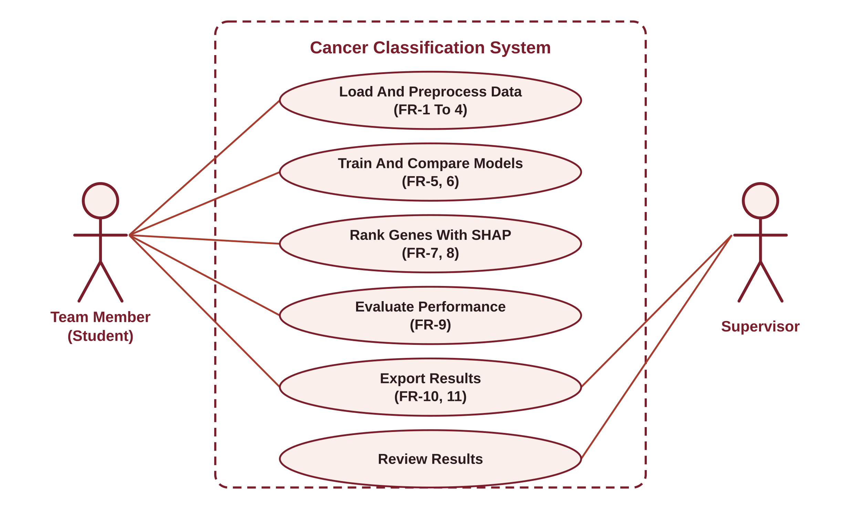
Figure 1: Use Case Diagram

2. DFD Level 0 (Context)
The whole system as one process, with the data it receives and sends.
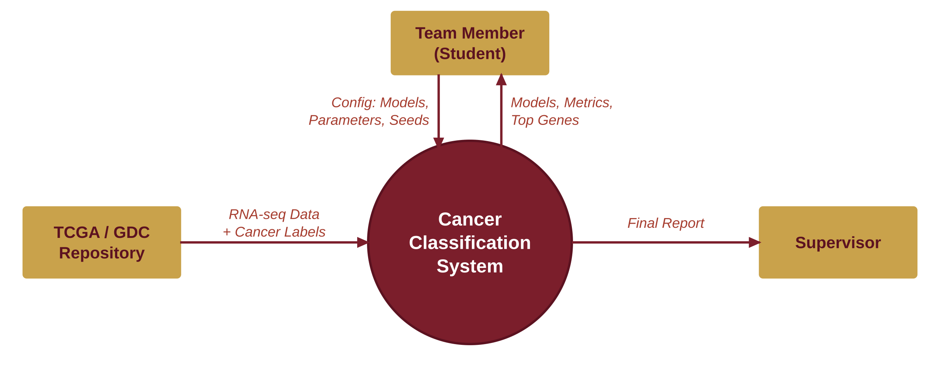
Figure 2: DFD Level 0

3. Activity Diagram
Workflow from data loading to export. If the accuracy and F1 targets are not met, the team adjusts parameters or the number of genes and trains again (the iteration loop of the design process).
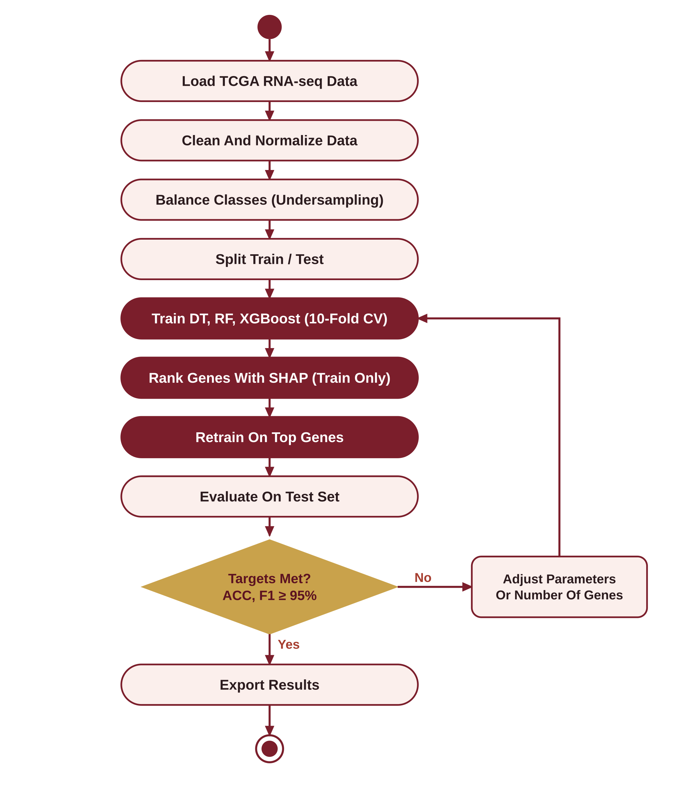
Figure 3: Activity Diagram

4. DFD Level 1
Six processes (P1 to P6) and four data stores (D1 to D4).
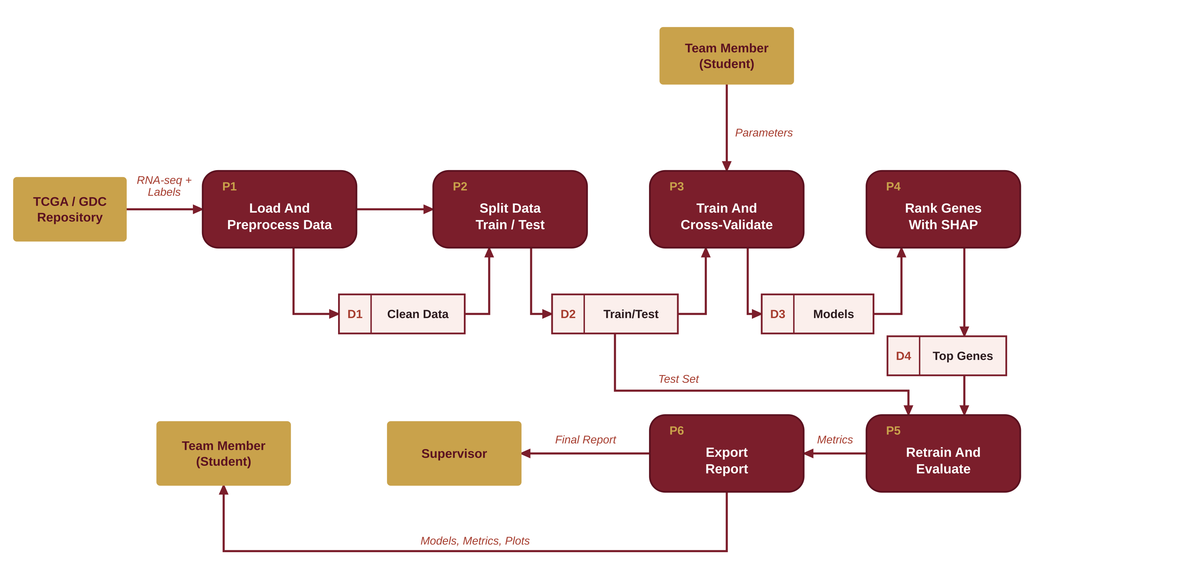
Figure 4: DFD Level 1

5. Class Diagram
Main classes of the Python code. Classifier is abstract, with Decision Tree, Random Forest, and XGBoost subclasses.
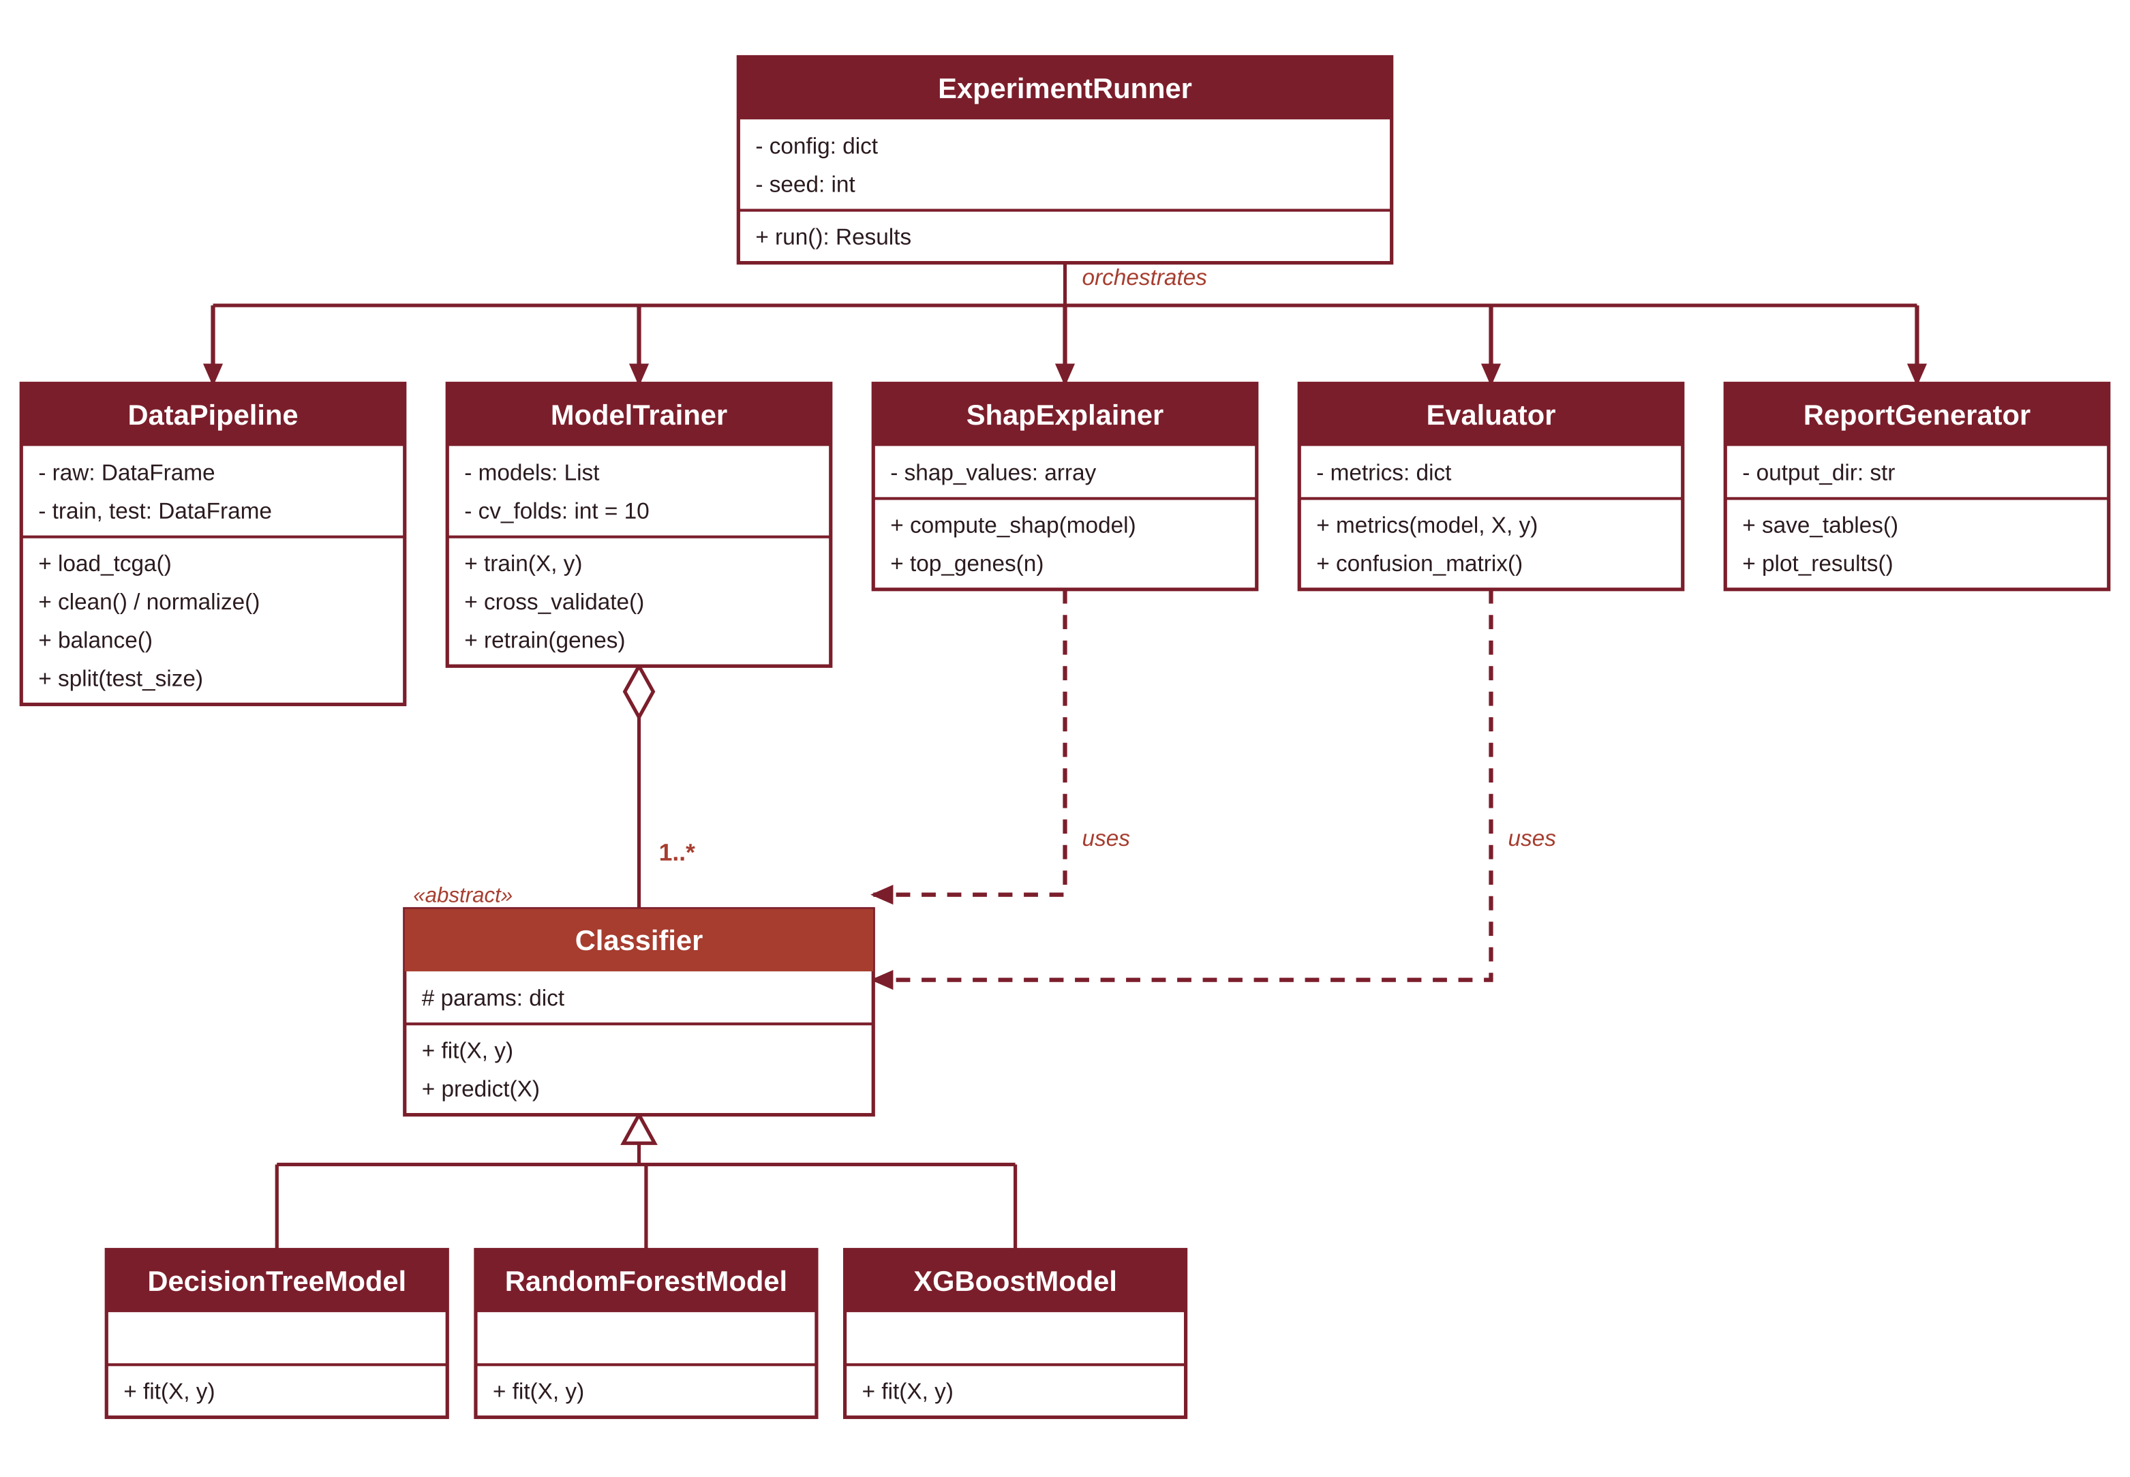
Figure 5: Class Diagram

6. Sequence Diagram
Order of calls for one full experiment run, from the team member's request to the saved results.
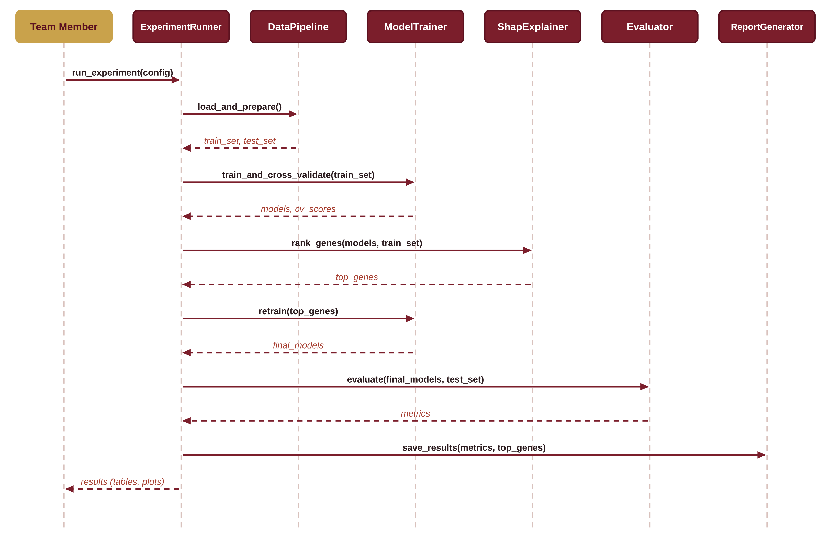
Figure 6: Sequence Diagram

7. Entity Relationship Diagram (ERD)
Logical data model for the dataset, experiment settings, and results. It can be stored as CSV files or SQLite tables.
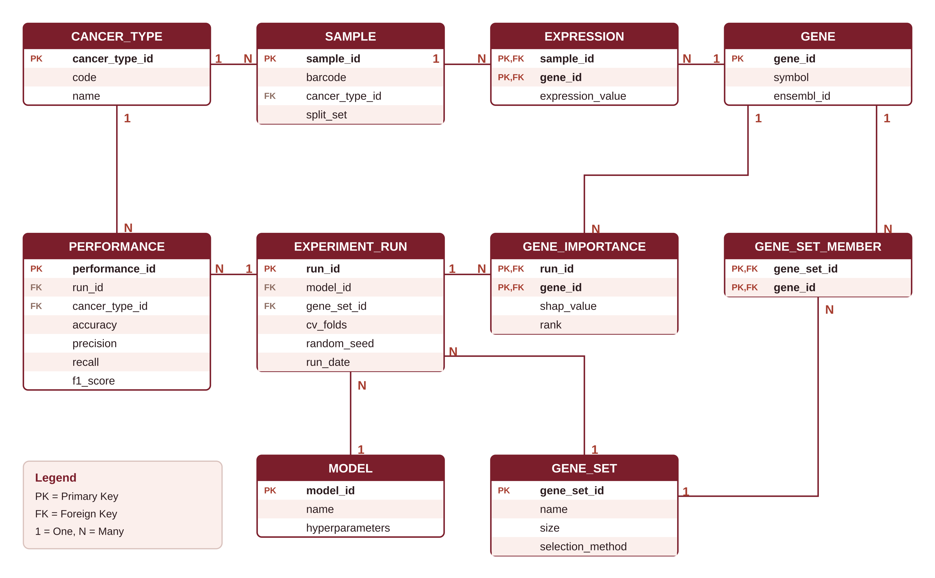
Figure 7: ERD

Relationships
Relationship | Type | Meaning
CANCER_TYPE – SAMPLE | 1 : N | Each sample belongs to one cancer type
SAMPLE – EXPRESSION | 1 : N | A sample has one expression value per gene
GENE – EXPRESSION | 1 : N | EXPRESSION resolves the many-to-many link between SAMPLE and GENE
GENE_SET – GENE_SET_MEMBER | 1 : N | A gene set (all genes or SHAP top-N) lists its member genes
GENE – GENE_SET_MEMBER | 1 : N | GENE_SET_MEMBER resolves the many-to-many link between GENE_SET and GENE
MODEL – EXPERIMENT_RUN | 1 : N | One model (DT, RF, XGBoost) is used in many runs
GENE_SET – EXPERIMENT_RUN | 1 : N | Each run uses one gene set
EXPERIMENT_RUN – PERFORMANCE | 1 : N | Metrics per class and overall for each run
CANCER_TYPE – PERFORMANCE | 1 : N | Per-class metrics; empty cancer_type_id means overall score
EXPERIMENT_RUN – GENE_IMPORTANCE | 1 : N | SHAP ranking is stored per run
GENE – GENE_IMPORTANCE | 1 : N | Each ranked gene links back to the GENE table

