Backend local server is running perfectly:

1. VS code: 
2. <http://127.0.0.1:8000/admin/music/>

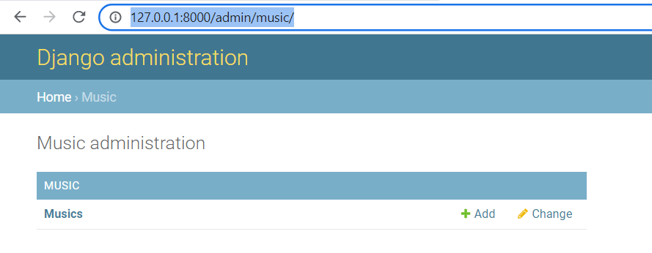

1. Postman:

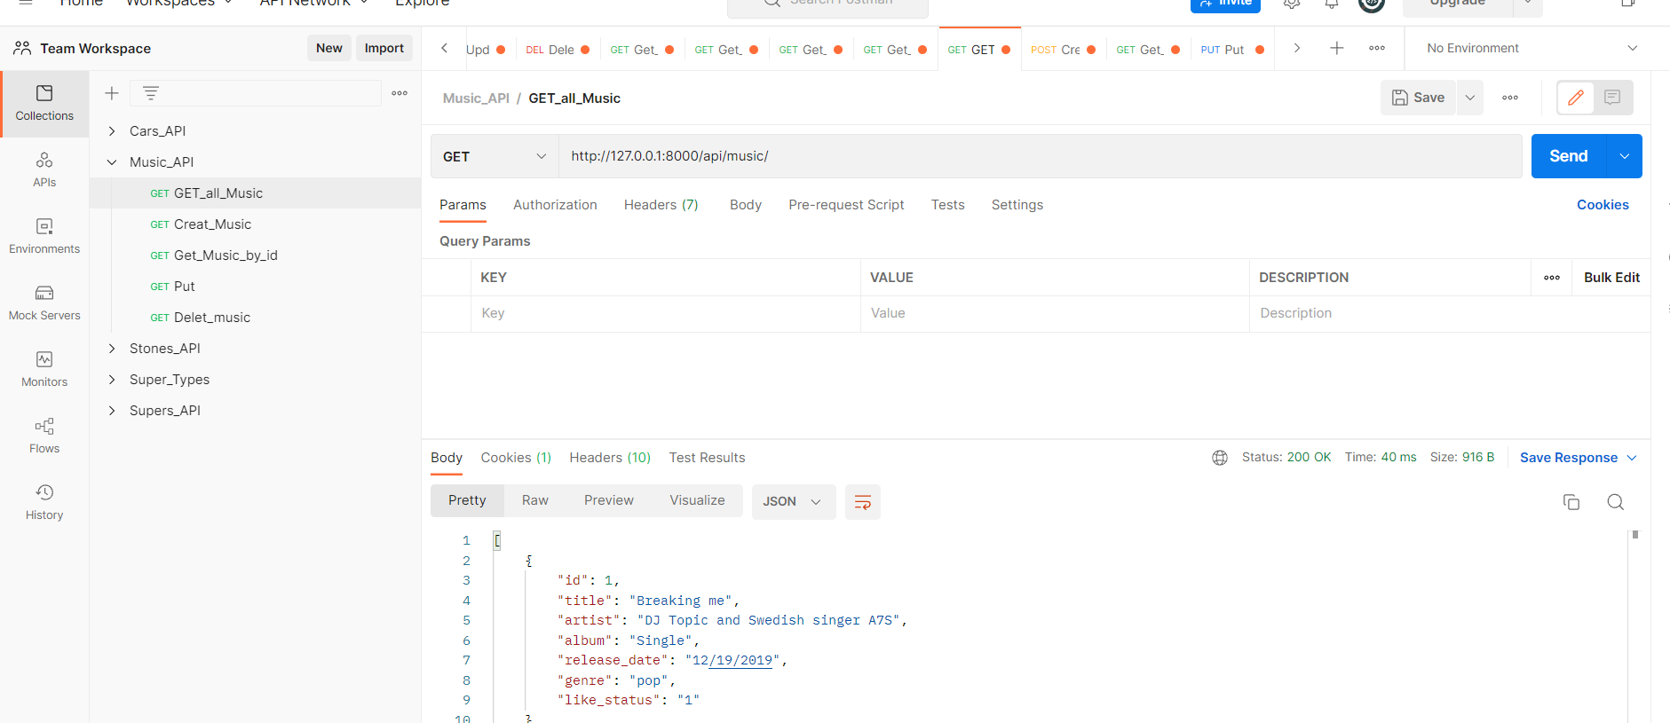

After axios installation:

http://localhost:3001/

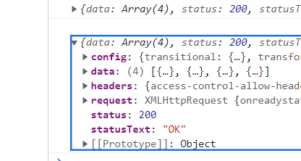

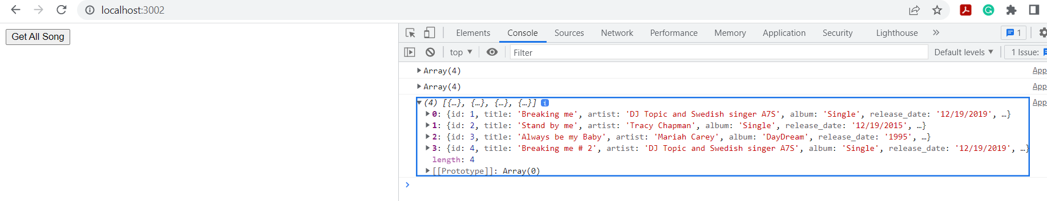

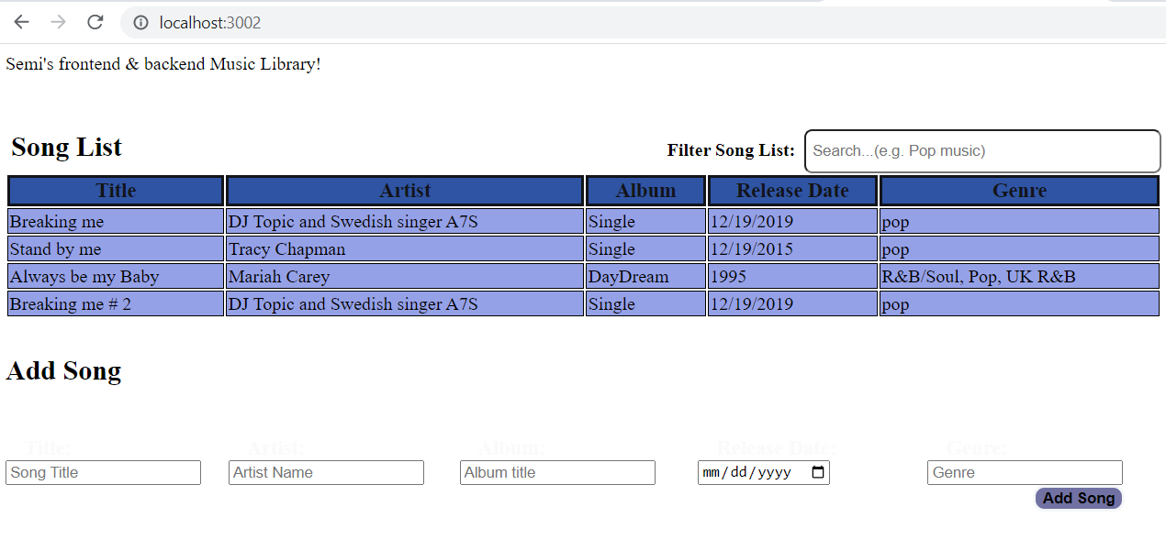

**08/04/2022, 12 pm: Filter works, add is not yet**