Hi,

Week 8 screen shots of mysqlworkbench and POSTMAN:

Mysqlworkbench:

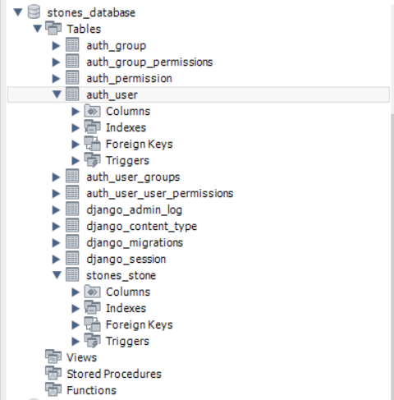

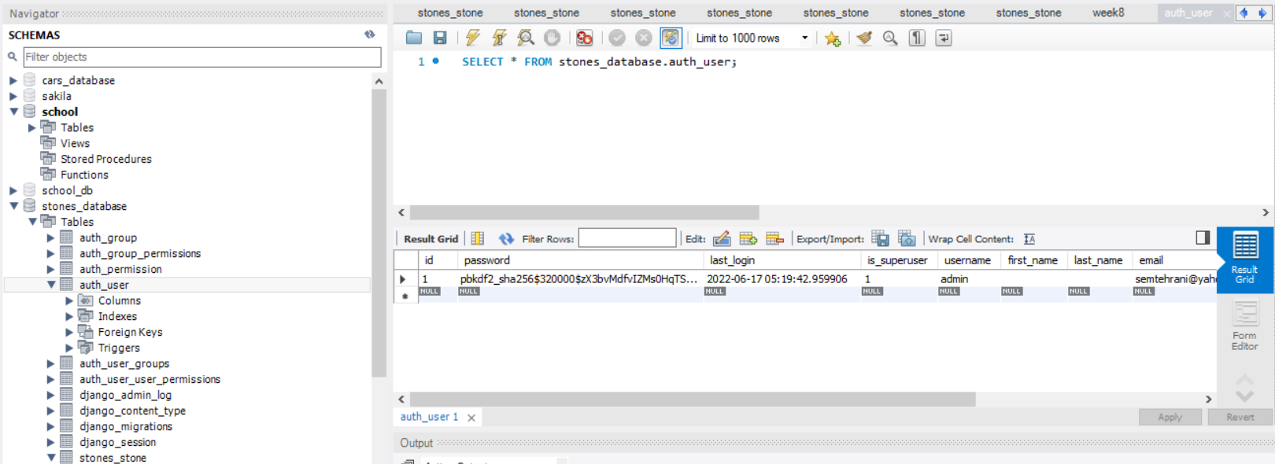

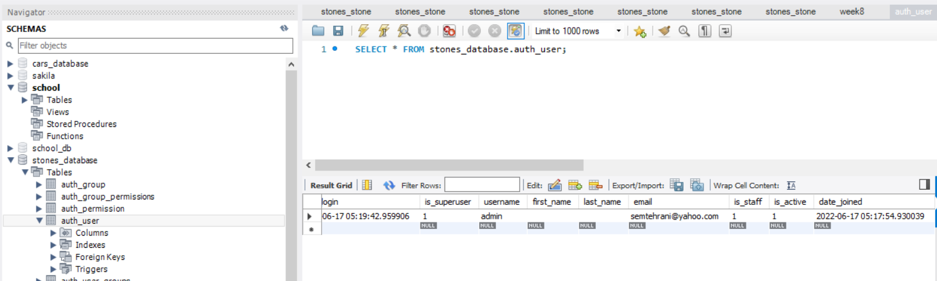

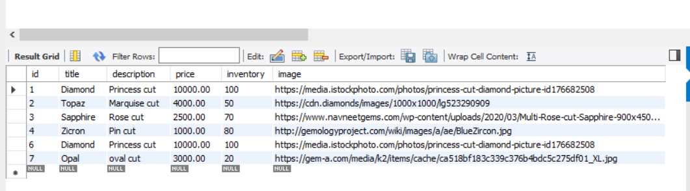

POSTMAN:

POSTMAN GET @ <http://127.0.0.1:8000/api/stones/>

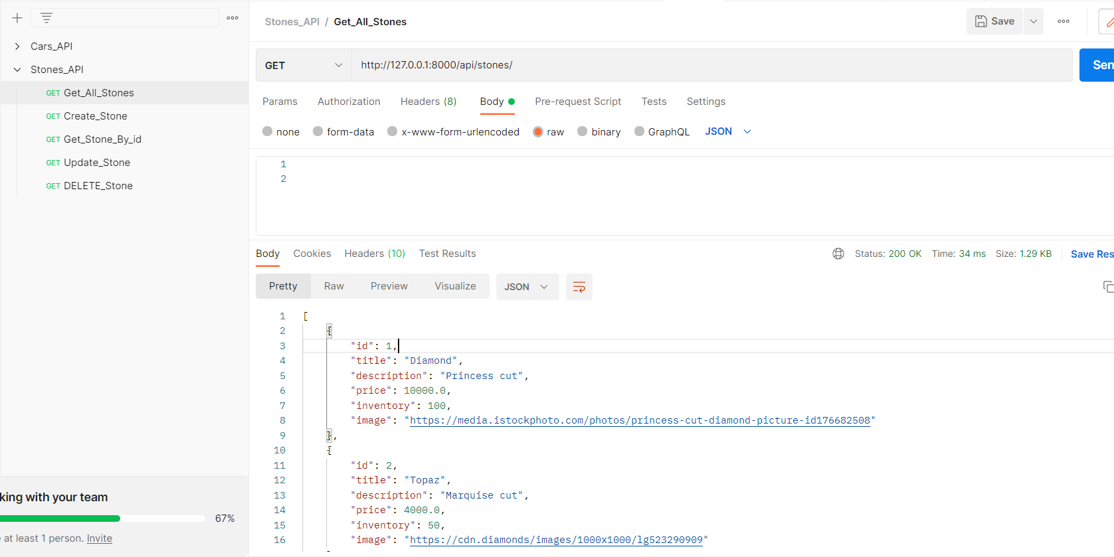

[

    {

        "id": 1,

        "title": "Diamond",

        "description": "Princess cut",

        "price": 10000.0,

        "inventory": 100,

        "image": "https://media.istockphoto.com/photos/princess-cut-diamond-picture-id176682508"

    },

    {

        "id": 2,

        "title": "Topaz",

        "description": "Marquise cut",

        "price": 4000.0,

        "inventory": 50,

        "image": "https://cdn.diamonds/images/1000x1000/lg523290909"

    },

    {

        "id": 3,

        "title": "Sapphire",

        "description": "Rose cut",

        "price": 2500.0,

        "inventory": 70,

        "image": "https://www.navneetgems.com/wp-content/uploads/2020/03/Multi-Rose-cut-Sapphire-900x450.jpg"

    },

    {

        "id": 4,

        "title": "Zicron",

        "description": "Pin cut",

        "price": 1000.0,

        "inventory": 80,

        "image": "http://gemologyproject.com/wiki/images/a/ae/BlueZircon.jpg"

    },

    {

        "id": 6,

        "title": "Diamond",

        "description": "Princess cut",

        "price": 10000.0,

        "inventory": 100,

        "image": "https://media.istockphoto.com/photos/princess-cut-diamond-picture-id176682508"

    },

    {

        "id": 7,

        "title": "Opal",

        "description": "oval cut",

        "price": 3000.0,

        "inventory": 20,

        "image": "https://gem-a.com/media/k2/items/cache/ca518bf183c339c376b4bdc5c275df01_XL.jpg"

    }

]

POSTMAN POST @ <http://127.0.0.1:8000/api/stones/>

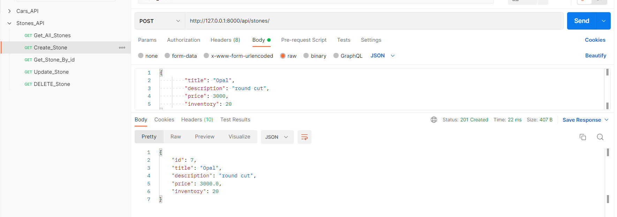

POSTMAN GET @ http://127.0.0.1:8000/api/stones/3/

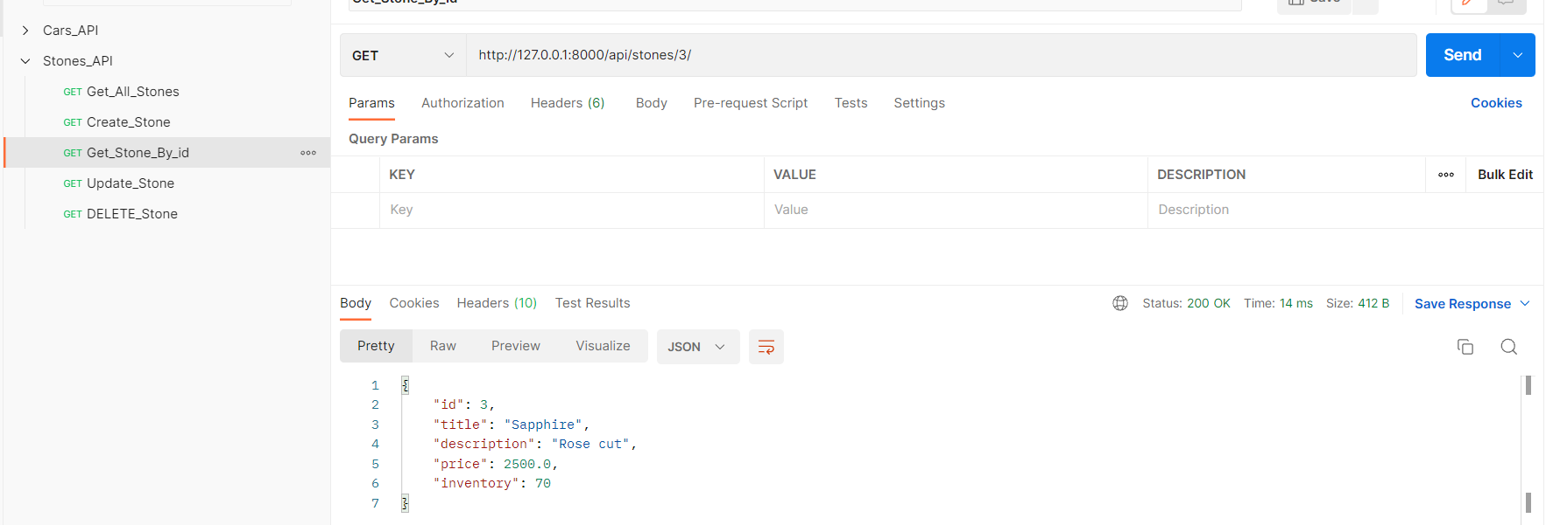

POSTMAN PUT @ http://127.0.0.1:8000/api/stones/5/

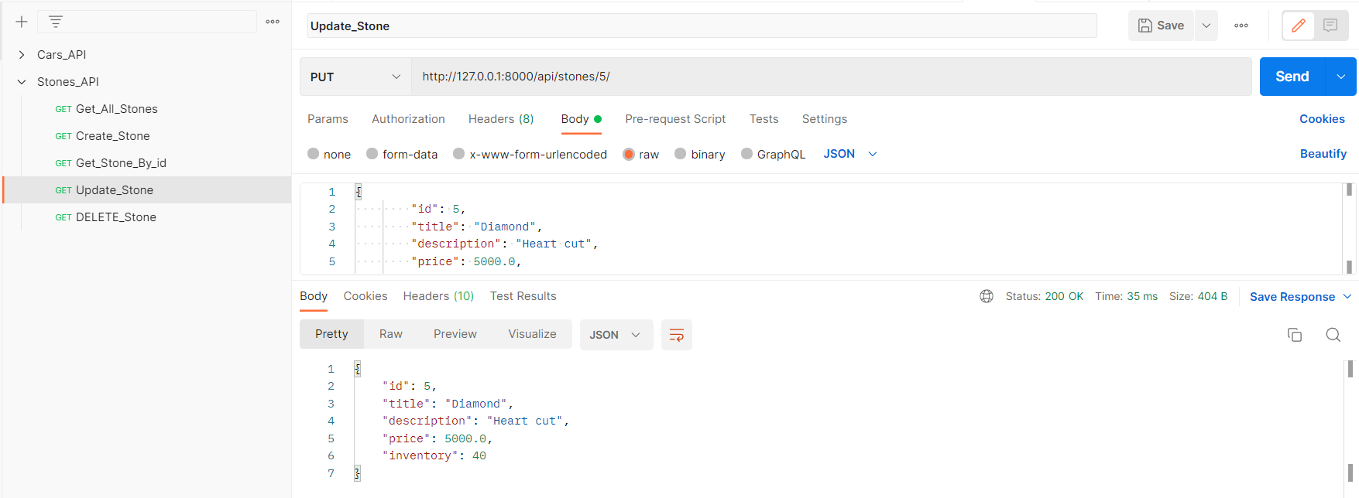

POSTMAN DELETE @ http://127.0.0.1:8000/api/stones/5/

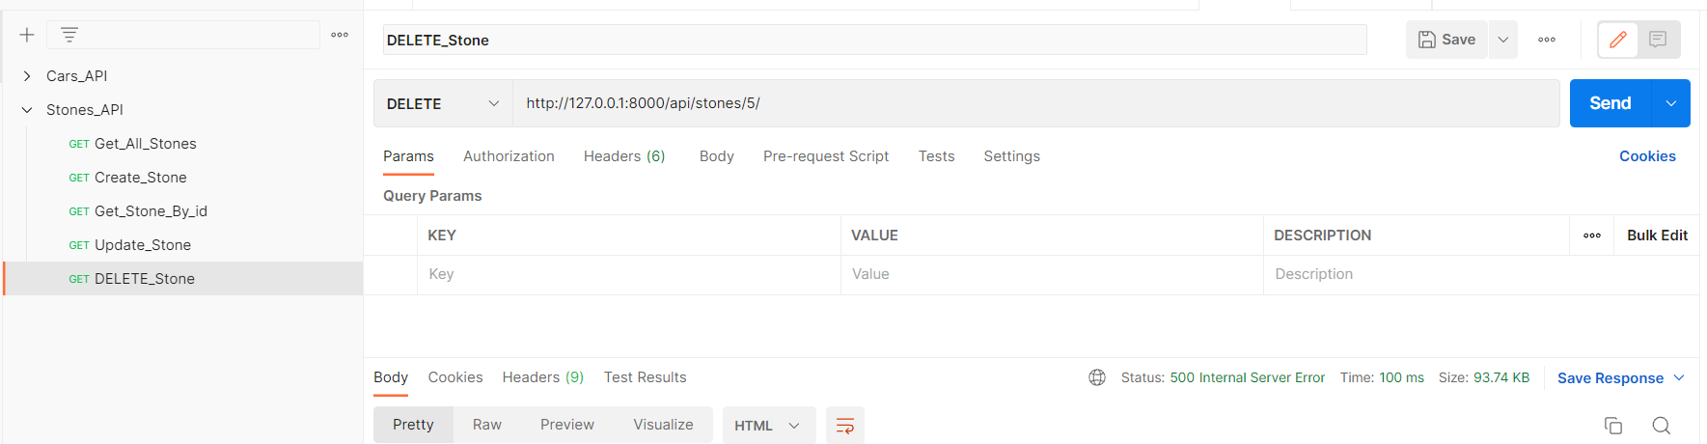

User name: root

Password: root

