Supportive screen shots for week 9 project: Heros & Villains

I tried to capture as many screen shots to show my progress. I just noticed that I missed adding ‘id’ in the fields in serializers.py . so all the prints won’t show the id in the table.

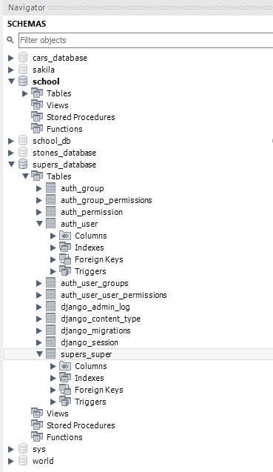

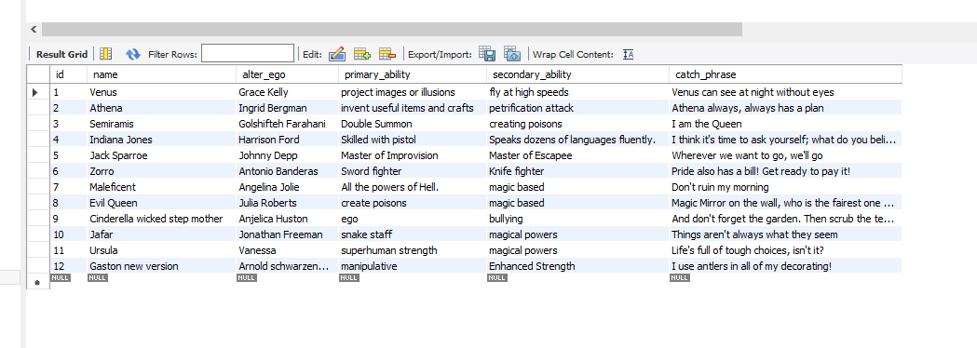

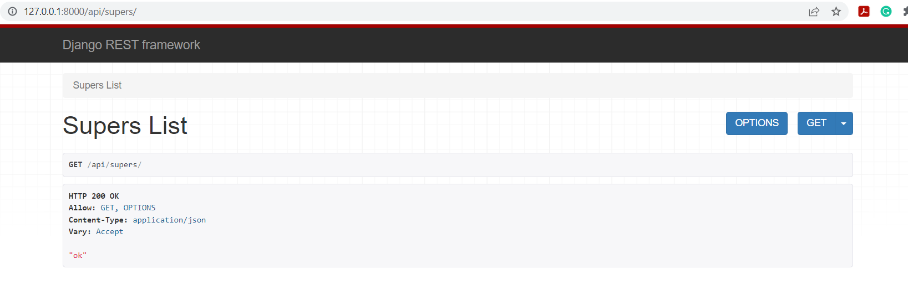

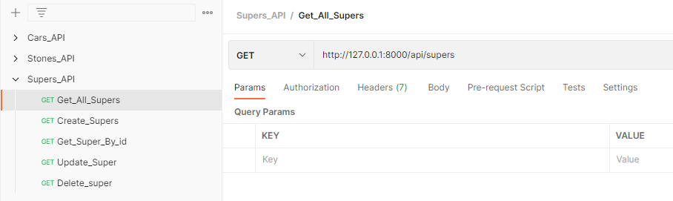



[

    {

        "name": "Venus",

        "alter_ego": "Grace Kelly",

        "primary_ability": "project images or illusions",

        "secondary_ability": "fly at high speeds",

        "catch_phrase": "Venus can see at night without eyes"

    },

    {

        "name": "Athena",

        "alter_ego": "Ingrid Bergman",

        "primary_ability": "invent useful items and crafts",

        "secondary_ability": "petrification attack",

        "catch_phrase": "Athena always, always has a plan"

    },

    {

        "name": "Semiramis",

        "alter_ego": "Golshifteh Farahani",

        "primary_ability": "Double Summon",

        "secondary_ability": "creating poisons",

        "catch_phrase": "I am the Queen"

    },

    {

        "name": "Indiana Jones",

        "alter_ego": "Harrison Ford",

        "primary_ability": "Skilled with pistol",

        "secondary_ability": "Speaks dozens of languages fluently.",

        "catch_phrase": "I think it's time to ask yourself; what do you believe in"

    },

    {

        "name": "Jack Sparroe",

        "alter_ego": "Johnny Depp",

        "primary_ability": "Master of Improvision",

        "secondary_ability": "Master of Escapee",

        "catch_phrase": "Wherever we want to go, we'll go"

    },

    {

        "name": "Zorro",

        "alter_ego": "Antonio Banderas",

        "primary_ability": "Sword fighter",

        "secondary_ability": "Knife fighter",

        "catch_phrase": "Pride also has a bill! Get ready to pay it!"

    },

    {

        "name": "Maleficent",

        "alter_ego": "Angelina Jolie",

        "primary_ability": "All the powers of Hell.",

        "secondary_ability": "magic based",

        "catch_phrase": "Don't ruin my morning"

    },

    {

        "name": "Evil Queen",

        "alter_ego": "Julia Roberts",

        "primary_ability": "create poisons",

        "secondary_ability": "magic based",

        "catch_phrase": "Magic Mirror on the wall, who is the fairest one of all?"

    },

    {

        "name": "Cinderella wicked step mother",

        "alter_ego": "Anjelica Huston",

        "primary_ability": "ego",

        "secondary_ability": "bullying",

        "catch_phrase": "And don't forget the garden. Then scrub the terrace, sweep the halls and the stairs, clean the chimneys"

    },

    {

        "name": "Jafar",

        "alter_ego": "Jonathan Freeman",

        "primary_ability": "snake staff",

        "secondary_ability": "magical powers",

        "catch_phrase": "Things aren't always what they seem"

    },

    {

        "name": "Ursula",

        "alter_ego": "Vanessa",

        "primary_ability": "superhuman strength",

        "secondary_ability": "magical powers",

        "catch_phrase": "Life's full of tough choices, isn't it?"

    },

]

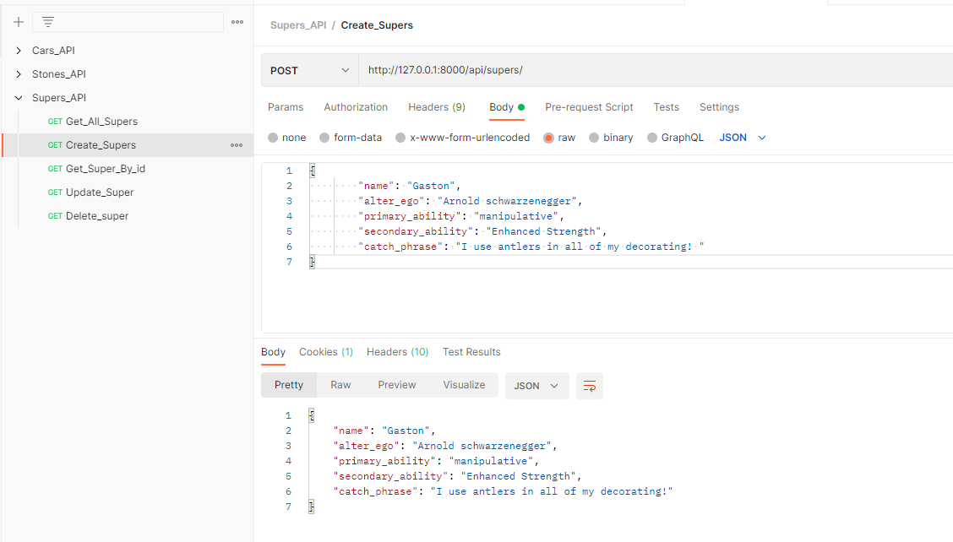

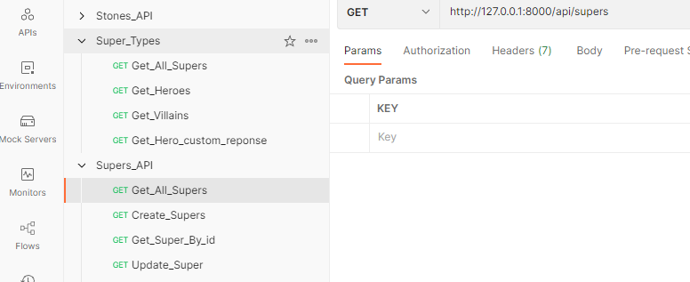

[

    {

        "name": "Venus",

        "alter_ego": "Grace Kelly",

        "primary_ability": "project images or illusions",

        "secondary_ability": "fly at high speeds",

        "catch_phrase": "Venus can see at night without eyes"

    },

    {

        "name": "Athena",

        "alter_ego": "Ingrid Bergman",

        "primary_ability": "invent useful items and crafts",

        "secondary_ability": "petrification attack",

        "catch_phrase": "Athena always, always has a plan"

    },

    {

        "name": "Semiramis",

        "alter_ego": "Golshifteh Farahani",

        "primary_ability": "Double Summon",

        "secondary_ability": "creating poisons",

        "catch_phrase": "I am the Queen"

    },

    {

        "name": "Indiana Jones",

        "alter_ego": "Harrison Ford",

        "primary_ability": "Skilled with pistol",

        "secondary_ability": "Speaks dozens of languages fluently.",

        "catch_phrase": "I think it's time to ask yourself; what do you believe in"

    },

    {

        "name": "Jack Sparroe",

        "alter_ego": "Johnny Depp",

        "primary_ability": "Master of Improvision",

        "secondary_ability": "Master of Escapee",

        "catch_phrase": "Wherever we want to go, we'll go"

    },

    {

        "name": "Zorro",

        "alter_ego": "Antonio Banderas",

        "primary_ability": "Sword fighter",

        "secondary_ability": "Knife fighter",

        "catch_phrase": "Pride also has a bill! Get ready to pay it!"

    },

    {

        "name": "Maleficent",

        "alter_ego": "Angelina Jolie",

        "primary_ability": "All the powers of Hell.",

        "secondary_ability": "magic based",

        "catch_phrase": "Don't ruin my morning"

    },

    {

        "name": "Evil Queen",

        "alter_ego": "Julia Roberts",

        "primary_ability": "create poisons",

        "secondary_ability": "magic based",

        "catch_phrase": "Magic Mirror on the wall, who is the fairest one of all?"

    },

    {

        "name": "Cinderella wicked step mother",

        "alter_ego": "Anjelica Huston",

        "primary_ability": "ego",

        "secondary_ability": "bullying",

        "catch_phrase": "And don't forget the garden. Then scrub the terrace, sweep the halls and the stairs, clean the chimneys"

    },

    {

        "name": "Jafar",

        "alter_ego": "Jonathan Freeman",

        "primary_ability": "snake staff",

        "secondary_ability": "magical powers",

        "catch_phrase": "Things aren't always what they seem"

    },

    {

        "name": "Ursula",

        "alter_ego": "Vanessa",

        "primary_ability": "superhuman strength",

        "secondary_ability": "magical powers",

        "catch_phrase": "Life's full of tough choices, isn't it?"

    },

    {

        "name": "Gaston",

        "alter_ego": "Arnold schwarzenegger",

        "primary_ability": "manipulative",

        "secondary_ability": "Enhanced Strength",

        "catch_phrase": "I use antlers in all of my decorating!"

    }

]

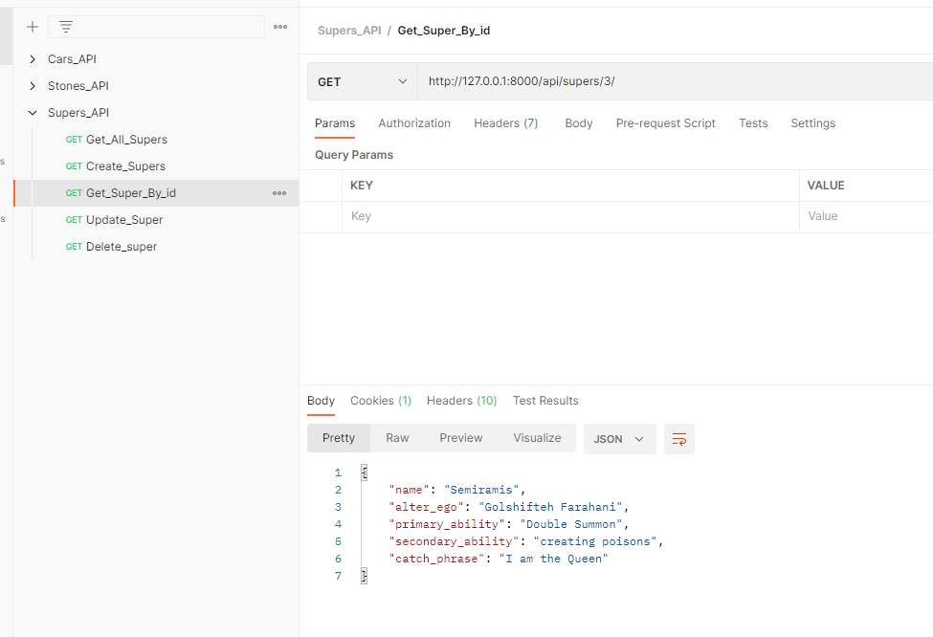

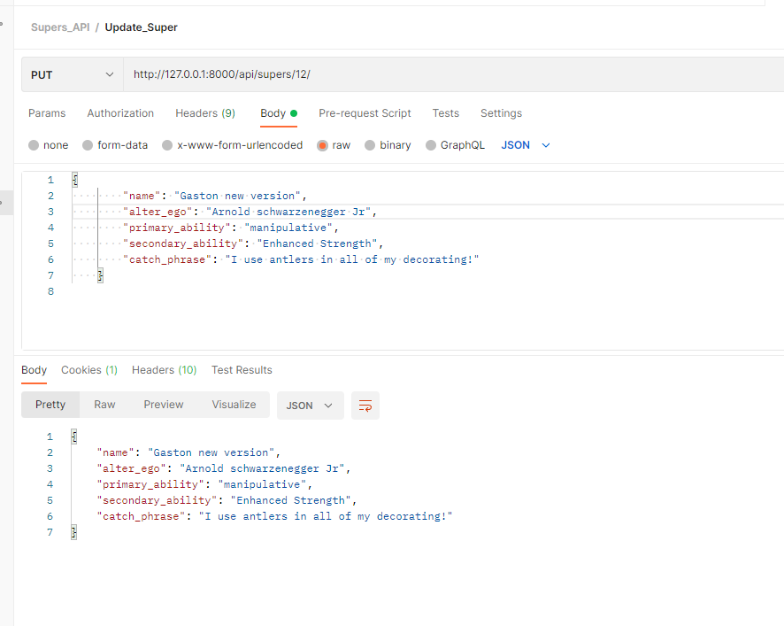

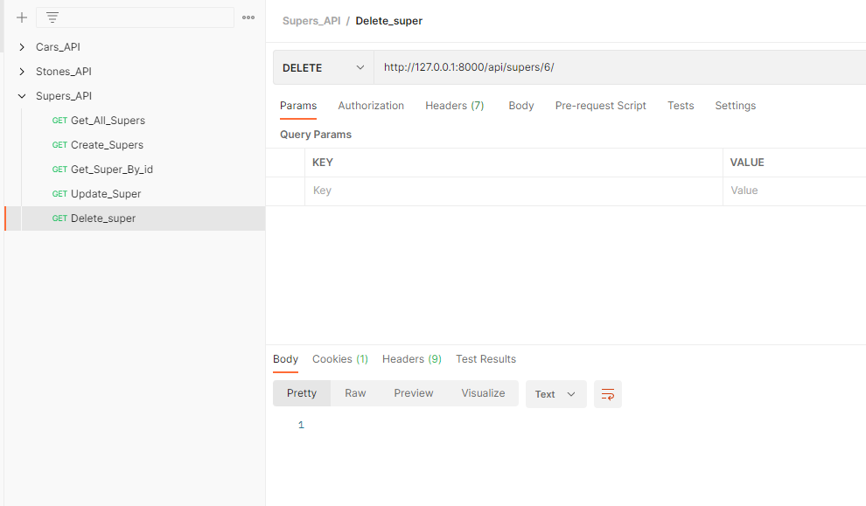

[

    {

        "name": "Venus",

        "alter_ego": "Grace Kelly",

        "primary_ability": "project images or illusions",

        "secondary_ability": "fly at high speeds",

        "catch_phrase": "Venus can see at night without eyes"

    },

    {

        "name": "Athena",

        "alter_ego": "Ingrid Bergman",

        "primary_ability": "invent useful items and crafts",

        "secondary_ability": "petrification attack",

        "catch_phrase": "Athena always, always has a plan"

    },

    {

        "name": "Semiramis",

        "alter_ego": "Golshifteh Farahani",

        "primary_ability": "Double Summon",

        "secondary_ability": "creating poisons",

        "catch_phrase": "I am the Queen"

    },

    {

        "name": "Indiana Jones",

        "alter_ego": "Harrison Ford",

        "primary_ability": "Skilled with pistol",

        "secondary_ability": "Speaks dozens of languages fluently.",

        "catch_phrase": "I think it's time to ask yourself; what do you believe in"

    },

    {

        "name": "Jack Sparroe",

        "alter_ego": "Johnny Depp",

        "primary_ability": "Master of Improvision",

        "secondary_ability": "Master of Escapee",

        "catch_phrase": "Wherever we want to go, we'll go"

    },

    {

        "name": "Maleficent",

        "alter_ego": "Angelina Jolie",

        "primary_ability": "All the powers of Hell.",

        "secondary_ability": "magic based",

        "catch_phrase": "Don't ruin my morning"

    },

    {

        "name": "Evil Queen",

        "alter_ego": "Julia Roberts",

        "primary_ability": "create poisons",

        "secondary_ability": "magic based",

        "catch_phrase": "Magic Mirror on the wall, who is the fairest one of all?"

    },

    {

        "name": "Cinderella wicked step mother",

        "alter_ego": "Anjelica Huston",

        "primary_ability": "ego",

        "secondary_ability": "bullying",

        "catch_phrase": "And don't forget the garden. Then scrub the terrace, sweep the halls and the stairs, clean the chimneys"

    },

    {

        "name": "Jafar",

        "alter_ego": "Jonathan Freeman",

        "primary_ability": "snake staff",

        "secondary_ability": "magical powers",

        "catch_phrase": "Things aren't always what they seem"

    },

    {

        "name": "Ursula",

        "alter_ego": "Vanessa",

        "primary_ability": "superhuman strength",

        "secondary_ability": "magical powers",

        "catch_phrase": "Life's full of tough choices, isn't it?"

    },

    {

        "name": "Gaston new version",

        "alter_ego": "Arnold schwarzenegger Jr",

        "primary_ability": "manipulative",

        "secondary_ability": "Enhanced Strength",

        "catch_phrase": "I use antlers in all of my decorating!"

    }

]

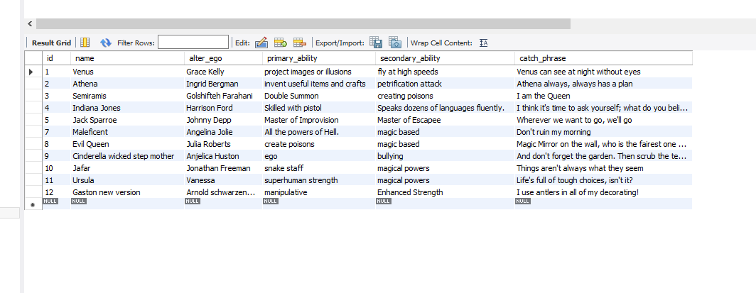



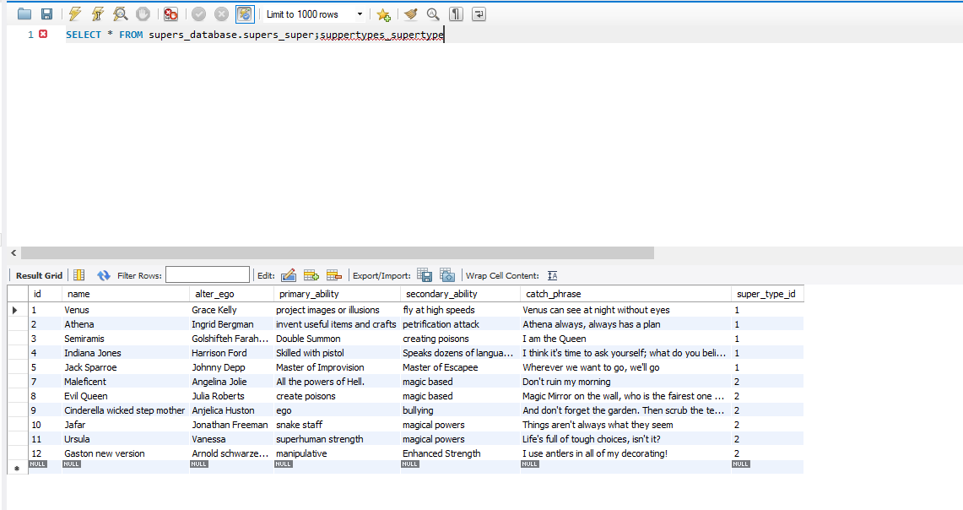

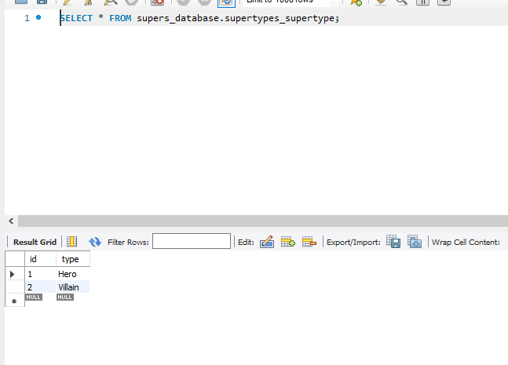



"name": "Venus",

        "alter_ego": "Grace Kelly",

        "primary_ability": "project images or illusions",

        "secondary_ability": "fly at high speeds",

        "catch_phrase": "Venus can see at night without eyes",

        "super_type": {

            "id": 1,

            "type": "Hero"

        }

    },

    {

        "name": "Athena",

        "alter_ego": "Ingrid Bergman",

        "primary_ability": "invent useful items and crafts",

        "secondary_ability": "petrification attack",

        "catch_phrase": "Athena always, always has a plan",

        "super_type": {

            "id": 1,

            "type": "Hero"

        }

    },

    {

        "name": "Semiramis",

        "alter_ego": "Golshifteh Farahani",

        "primary_ability": "Double Summon",

        "secondary_ability": "creating poisons",

        "catch_phrase": "I am the Queen",

        "super_type": {

            "id": 1,

            "type": "Hero"

        }

    },

    {

        "name": "Indiana Jones",

        "alter_ego": "Harrison Ford",

        "primary_ability": "Skilled with pistol",

        "secondary_ability": "Speaks dozens of languages fluently.",

        "catch_phrase": "I think it's time to ask yourself; what do you believe in",

        "super_type": {

            "id": 1,

            "type": "Hero"

        }

    },

    {

        "name": "Jack Sparroe",

        "alter_ego": "Johnny Depp",

        "primary_ability": "Master of Improvision",

        "secondary_ability": "Master of Escapee",

        "catch_phrase": "Wherever we want to go, we'll go",

        "super_type": {

            "id": 1,

            "type": "Hero"

        }

    },

    {

        "name": "Maleficent",

        "alter_ego": "Angelina Jolie",

        "primary_ability": "All the powers of Hell.",

        "secondary_ability": "magic based",

        "catch_phrase": "Don't ruin my morning",

        "super_type": {

            "id": 2,

            "type": "Villain"

        }

    },

    {

        "name": "Evil Queen",

        "alter_ego": "Julia Roberts",

        "primary_ability": "create poisons",

        "secondary_ability": "magic based",

        "catch_phrase": "Magic Mirror on the wall, who is the fairest one of all?",

        "super_type": {

            "id": 2,

            "type": "Villain"

        }

    },

    {

        "name": "Cinderella wicked step mother",

        "alter_ego": "Anjelica Huston",

        "primary_ability": "ego",

        "secondary_ability": "bullying",

        "catch_phrase": "And don't forget the garden. Then scrub the terrace, sweep the halls and the stairs, clean the chimneys",

        "super_type": {

            "id": 2,

            "type": "Villain"

        }

    },

    {

        "name": "Jafar",

        "alter_ego": "Jonathan Freeman",

        "primary_ability": "snake staff",

        "secondary_ability": "magical powers",

        "catch_phrase": "Things aren't always what they seem",

        "super_type": {

            "id": 2,

            "type": "Villain"

        }

    },

    {

        "name": "Ursula",

        "alter_ego": "Vanessa",

        "primary_ability": "superhuman strength",

        "secondary_ability": "magical powers",

        "catch_phrase": "Life's full of tough choices, isn't it?",

        "super_type": {

            "id": 2,

            "type": "Villain"

        }

    },

    {

        "name": "Gaston new version",

        "alter_ego": "Arnold schwarzenegger Jr",

        "primary_ability": "manipulative",

        "secondary_ability": "Enhanced Strength",

        "catch_phrase": "I use antlers in all of my decorating!",

        "super_type": {

            "id": 2,

            "type": "Villain"

        }

    }

]

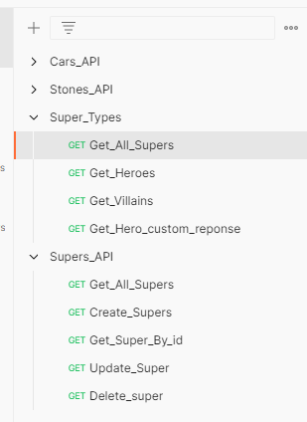

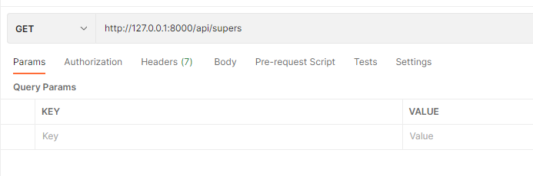

[

    {

        "name": "Venus",

        "alter_ego": "Grace Kelly",

        "primary_ability": "project images or illusions",

        "secondary_ability": "fly at high speeds",

        "catch_phrase": "Venus can see at night without eyes",

        "super_type": {

            "id": 1,

            "type": "Hero"

        }

    },

    {

        "name": "Athena",

        "alter_ego": "Ingrid Bergman",

        "primary_ability": "invent useful items and crafts",

        "secondary_ability": "petrification attack",

        "catch_phrase": "Athena always, always has a plan",

        "super_type": {

            "id": 1,

            "type": "Hero"

        }

    },

    {

        "name": "Semiramis",

        "alter_ego": "Golshifteh Farahani",

        "primary_ability": "Double Summon",

        "secondary_ability": "creating poisons",

        "catch_phrase": "I am the Queen",

        "super_type": {

            "id": 1,

            "type": "Hero"

        }

    },

    {

        "name": "Indiana Jones",

        "alter_ego": "Harrison Ford",

        "primary_ability": "Skilled with pistol",

        "secondary_ability": "Speaks dozens of languages fluently.",

        "catch_phrase": "I think it's time to ask yourself; what do you believe in",

        "super_type": {

            "id": 1,

            "type": "Hero"

        }

    },

    {

        "name": "Jack Sparroe",

        "alter_ego": "Johnny Depp",

        "primary_ability": "Master of Improvision",

        "secondary_ability": "Master of Escapee",

        "catch_phrase": "Wherever we want to go, we'll go",

        "super_type": {

            "id": 1,

            "type": "Hero"

        }

    },

    {

        "name": "Maleficent",

        "alter_ego": "Angelina Jolie",

        "primary_ability": "All the powers of Hell.",

        "secondary_ability": "magic based",

        "catch_phrase": "Don't ruin my morning",

        "super_type": {

            "id": 2,

            "type": "Villain"

        }

    },

    {

        "name": "Evil Queen",

        "alter_ego": "Julia Roberts",

        "primary_ability": "create poisons",

        "secondary_ability": "magic based",

        "catch_phrase": "Magic Mirror on the wall, who is the fairest one of all?",

        "super_type": {

            "id": 2,

            "type": "Villain"

        }

    },

    {

        "name": "Cinderella wicked step mother",

        "alter_ego": "Anjelica Huston",

        "primary_ability": "ego",

        "secondary_ability": "bullying",

        "catch_phrase": "And don't forget the garden. Then scrub the terrace, sweep the halls and the stairs, clean the chimneys",

        "super_type": {

            "id": 2,

            "type": "Villain"

        }

    },

    {

        "name": "Jafar",

        "alter_ego": "Jonathan Freeman",

        "primary_ability": "snake staff",

        "secondary_ability": "magical powers",

        "catch_phrase": "Things aren't always what they seem",

        "super_type": {

            "id": 2,

            "type": "Villain"

        }

    },

    {

        "name": "Ursula",

        "alter_ego": "Vanessa",

        "primary_ability": "superhuman strength",

        "secondary_ability": "magical powers",

        "catch_phrase": "Life's full of tough choices, isn't it?",

        "super_type": {

            "id": 2,

            "type": "Villain"

        }

    },

    {

        "name": "Gaston new version",

        "alter_ego": "Arnold schwarzenegger Jr",

        "primary_ability": "manipulative",

        "secondary_ability": "Enhanced Strength",

        "catch_phrase": "I use antlers in all of my decorating!",

        "super_type": {

            "id": 2,

            "type": "Villain"

        }



[

    {

        "name": "Venus",

        "alter_ego": "Grace Kelly",

        "primary_ability": "project images or illusions",

        "secondary_ability": "fly at high speeds",

        "catch_phrase": "Venus can see at night without eyes",

        "super_type": {

            "id": 1,

            "type": "Hero"

        }

    },

    {

        "name": "Athena",

        "alter_ego": "Ingrid Bergman",

        "primary_ability": "invent useful items and crafts",

        "secondary_ability": "petrification attack",

        "catch_phrase": "Athena always, always has a plan",

        "super_type": {

            "id": 1,

            "type": "Hero"

        }

    },

    {

        "name": "Semiramis",

        "alter_ego": "Golshifteh Farahani",

        "primary_ability": "Double Summon",

        "secondary_ability": "creating poisons",

        "catch_phrase": "I am the Queen",

        "super_type": {

            "id": 1,

            "type": "Hero"

        }

    },

    {

        "name": "Indiana Jones",

        "alter_ego": "Harrison Ford",

        "primary_ability": "Skilled with pistol",

        "secondary_ability": "Speaks dozens of languages fluently.",

        "catch_phrase": "I think it's time to ask yourself; what do you believe in",

        "super_type": {

            "id": 1,

            "type": "Hero"

        }

    },

    {

        "name": "Jack Sparroe",

        "alter_ego": "Johnny Depp",

        "primary_ability": "Master of Improvision",

        "secondary_ability": "Master of Escapee",

        "catch_phrase": "Wherever we want to go, we'll go",

        "super_type": {

            "id": 1,

            "type": "Hero"

        }

    }

]

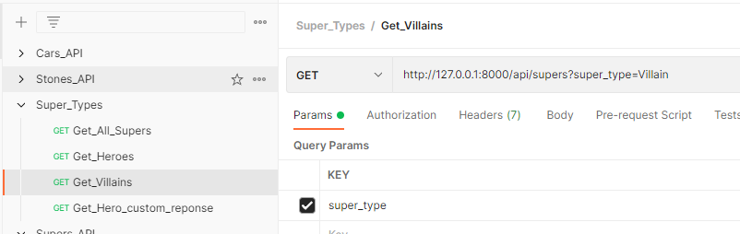

[

    {

        "name": "Maleficent",

        "alter_ego": "Angelina Jolie",

        "primary_ability": "All the powers of Hell.",

        "secondary_ability": "magic based",

        "catch_phrase": "Don't ruin my morning",

        "super_type": {

            "id": 2,

            "type": "Villain"

        }

    },

    {

        "name": "Evil Queen",

        "alter_ego": "Julia Roberts",

        "primary_ability": "create poisons",

        "secondary_ability": "magic based",

        "catch_phrase": "Magic Mirror on the wall, who is the fairest one of all?",

        "super_type": {

            "id": 2,

            "type": "Villain"

        }

    },

    {

        "name": "Cinderella wicked step mother",

        "alter_ego": "Anjelica Huston",

        "primary_ability": "ego",

        "secondary_ability": "bullying",

        "catch_phrase": "And don't forget the garden. Then scrub the terrace, sweep the halls and the stairs, clean the chimneys",

        "super_type": {

            "id": 2,

            "type": "Villain"

        }

    },

    {

        "name": "Jafar",

        "alter_ego": "Jonathan Freeman",

        "primary_ability": "snake staff",

        "secondary_ability": "magical powers",

        "catch_phrase": "Things aren't always what they seem",

        "super_type": {

            "id": 2,

            "type": "Villain"

        }

    },

    {

        "name": "Ursula",

        "alter_ego": "Vanessa",

        "primary_ability": "superhuman strength",

        "secondary_ability": "magical powers",

        "catch_phrase": "Life's full of tough choices, isn't it?",

        "super_type": {

            "id": 2,

            "type": "Villain"

        }

    },

    {

        "name": "Gaston new version",

        "alter_ego": "Arnold schwarzenegger Jr",

        "primary_ability": "manipulative",

        "secondary_ability": "Enhanced Strength",

        "catch_phrase": "I use antlers in all of my decorating!",

        "super_type": {

            "id": 2,

            "type": "Villain"

        }

    }

]

