PRODUCT REVIEW

Dama Web Usability and Visual Quality Review
Interface findings and implementation requirements

Review purpose
This report records the usability, visual, and motion issues observed in the current mobile Dama Web experience. The requested changes focus on clearer guidance, stronger visual hierarchy, consistent game-piece presentation, and reliable animation feedback.

Review outcome
The match board and the daily spin require the highest attention because they affect the core game and reward flows. The remaining findings should be resolved in the same release to keep the interface consistent from onboarding through live play.
Product | Dama Web
Review date | 8 October 2026
Scope | Mobile web interface and motion behavior

Prioritized findings
The seven findings below are ordered by the user journey rather than severity. Priority indicates the effect on comprehension, core gameplay, or completion of a reward action.
ID | Area | Priority | Required correction
1 | Tutorial | P2 | Demonstrate the move with a short piece-to-target animation.
2 | Bottom navigation | P3 | Introduce white or near-white interior contrast and clearer active states.
3 | Match entry | P2 | Remove the competing token backdrop and center the piece precisely.
4 | Matchmaking | P2 | Keep token artwork and motion consistent while an opponent is found.
5 | Rules | P2 | Replace the native menu with a rounded control and neutralize warning-like text.
6 | Live match | P1 | Give the board visual priority and eliminate scaled raster blur.
7 | Daily spin | P1 | Run a complete wheel animation before revealing the reward.

Recommended implementation order
- Correct the live-match layout and asset rendering, then verify the board on 320, 360, 393, and 430 pixel viewport widths.
- Repair the daily spin and matchmaking motion states, including reduced-motion behavior and repeated-action protection.
- Finish the tutorial, match-entry card, rules control, and navigation styling as one visual consistency pass.

Finding 1 Replace the tutorial arrow with a move demonstration
P2 priority Onboarding
Observed behavior. The tutorial uses a static arrow beside the red piece. The arrow suggests a direction, but it does not clearly demonstrate that the piece itself must travel to the highlighted yellow circle.
Required change. Remove the arrow and animate the red piece diagonally from its starting square to the yellow target. The target should pulse briefly before the move, and the sequence should reset cleanly for another loop.
User impact. A direct move demonstration reduces interpretation and teaches the interaction before the player enters a match.

Acceptance criteria
- The red piece travels from the original square to the marked square without displaying the arrow.
- One loop lasts approximately 1 to 1.5 seconds, followed by a short pause before reset.
- The piece remains sharp and centered throughout the movement on common phone widths.
- Reduced-motion mode replaces travel with a simple start-and-end highlight.
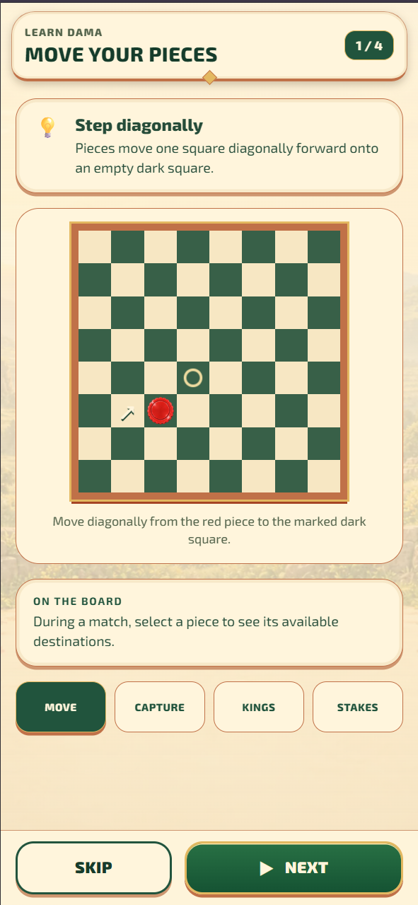
Figure 1 The current tutorial uses a static arrow instead of demonstrating the piece movement.

Finding 2 Add white contrast to the bottom navigation
P3 priority Global navigation
Observed behavior. The navigation buttons read as broad blocks of cream and green. The solid fills reduce separation between the button surfaces, icons, and surrounding panel.
Required change. Introduce white or near-white space inside each navigation item. Keep the active item distinct through a restrained outline, shadow, or small accent while preserving the existing green icon language.

Acceptance criteria
- Every navigation item has a visible light interior or highlight rather than a single uninterrupted solid fill.
- The active state remains clear without reducing label or icon contrast.
- All four items keep equal width, alignment, and touch targets of at least 44 by 44 CSS pixels.
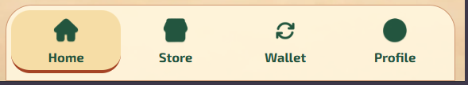
Figure 2 The current bottom navigation appears visually flat and overly solid.

Finding 3 Correct the ranked match piece presentation
P2 priority Match entry
Observed behavior. The piece on the ranked match card sits over a busy checker-pattern backing and does not appear optically centered within the circular badge.
Required change. Use a clean neutral or transparent backing behind the piece and center the token within the badge using the artwork bounds rather than the source image canvas.

Acceptance criteria
- The token is centered horizontally and vertically at every supported mobile width.
- The backing does not compete with the piece edge, crown, or color.
- The same scale and padding are used for red, dark, and king pieces.
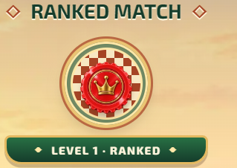
Figure 3 The ranked match badge combines a busy backing with an off-center piece.

Finding 4 Stabilize the opponent search animation
P2 priority Matchmaking
Observed behavior. During opponent search, the piece animation changes appearance between states. The change reads as an asset swap or visual glitch rather than a deliberate searching sequence.
Required change. Use one consistent set of piece assets for the entire search state. Animate position, opacity, or a subtle pulse while keeping each piece's identity, scale, background, and alignment unchanged.
User impact. Stable motion makes matchmaking feel active and reliable while the system waits for an opponent.

Acceptance criteria
- No piece changes color, crown state, background, or source artwork during the search loop.
- The loop has no visible jump, flash, stretch, or reset frame.
- The selected players replace the searching state only after a match is confirmed.
- Reduced-motion mode uses a static layout with a text or opacity update.
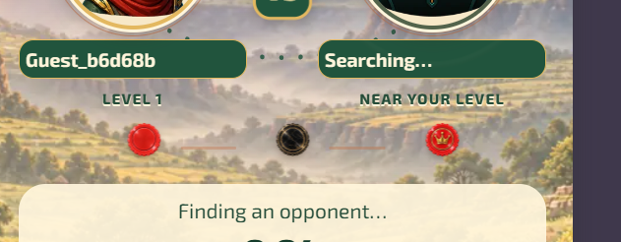
Figure 4 The matchmaking state displays multiple piece treatments that do not read as one continuous animation.

Finding 5 Redesign the rules selector and color treatment
P2 priority Rules
Observed behavior. The language selector opens as a standard rectangular browser menu. Its square option panel and bright system-blue selection do not match the rounded control or the rest of the Dama interface. Rule values also use red, which makes normal settings look like warnings or errors.
Required change. Replace the native menu with an accessible rounded listbox or popover that follows the width and corner radius of the closed control. Use a calm neutral, muted gold, or soft green for rule values while maintaining readable contrast against the cream rows.

Acceptance criteria
- The open menu has rounded corners, consistent padding, and no system-blue selection bar.
- Keyboard, touch, and screen-reader selection remain supported.
- The chosen option remains visible and uses a deliberate product color.
- Standard rule values no longer appear red; warning colors are reserved for destructive or invalid states.
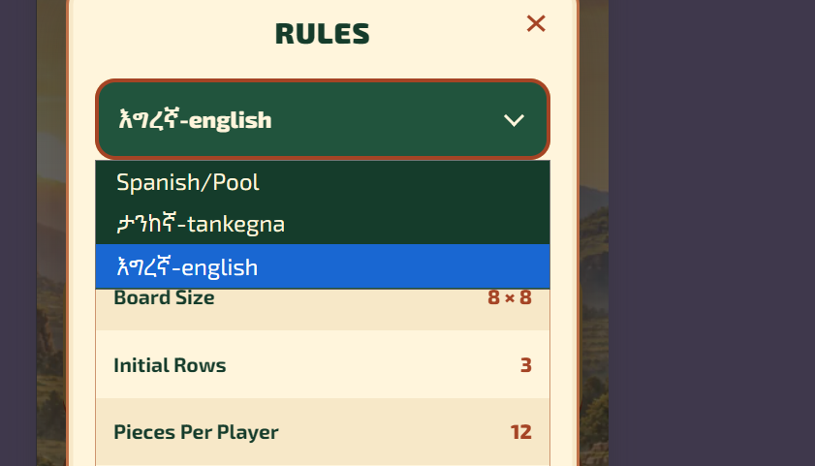
Figure 5 The native rectangular menu breaks the rounded visual language of the rules panel.
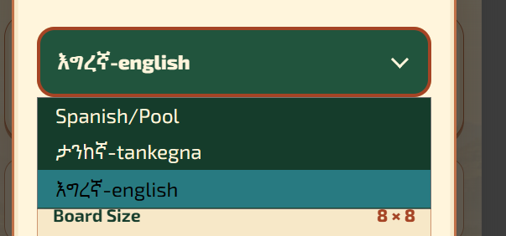
Figure 6 The active language uses a system-style blue highlight instead of the product palette.

Rules value styling
The feature table presents ordinary configuration values in red. Because red already signals danger, failure, or destructive action in most interfaces, the values should use a calmer accent that remains readable on both cream row colors.
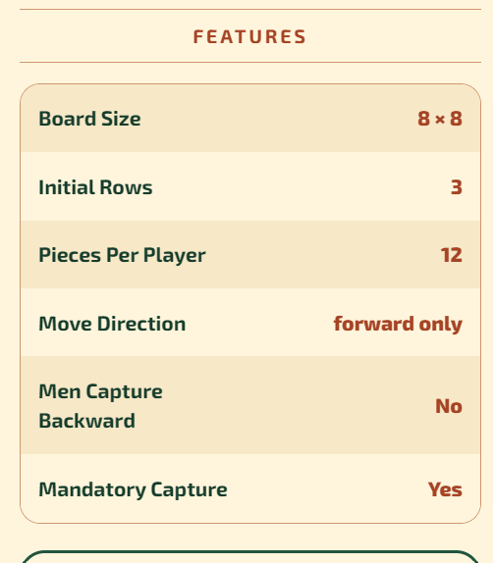
Figure 7 Normal rule values currently use a warning-like red treatment.

Finding 6 Give the board visual priority and remove pixelation
P1 priority Live match
Observed behavior. The player cards, timer, stake bar, game type, and scenic gap consume a large share of the vertical viewport before the board begins. The board and pieces also appear soft or pixelated at their displayed size.
Required change. Compress the match header, remove unnecessary vertical space above the board, and make the board the dominant element. Render the grid with CSS or vector geometry where possible, and supply piece and frame images at two to three times their displayed pixel dimensions.
User impact. A larger, sharper board improves move recognition, reduces mis-taps, and keeps attention on play instead of match metadata.

Acceptance criteria
- The board starts directly below the match controls without a large decorative spacer.
- At 360 to 430 CSS pixels wide, the board occupies at least 92 percent of the available content width and remains the largest visual element.
- Player cards, timer, stake information, and controls remain readable in a compact header region.
- Board lines, frame details, and pieces remain crisp at device pixel ratios of 1, 2, and 3.
- Touch targets stay aligned with the rendered squares after every responsive resize.
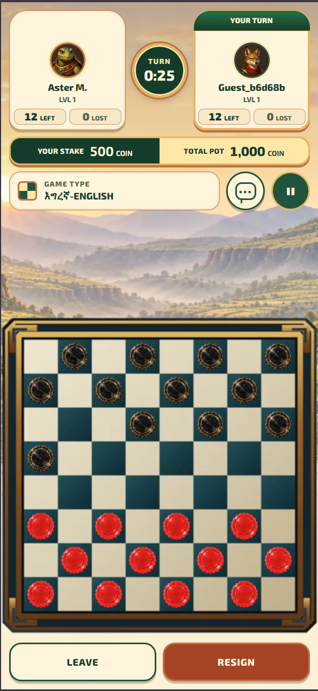
Figure 8 The live-match header and scenic space delay the board, while enlarged raster artwork appears soft.

Finding 7 Restore the daily spin animation
P1 priority Reward flow
Observed behavior. The daily spin reaches the reward result without a working wheel animation. The missing motion makes the interaction feel unresponsive and weakens the connection between the spin action and the awarded coins.
Required change. Start the wheel animation immediately after the spin is accepted, rotate through multiple full turns, decelerate into the server-selected segment, and reveal the reward only after the pointer settles.
Implementation note. The server should remain authoritative for the reward. The animation should visualize the confirmed result rather than calculate it on the client.

Acceptance criteria
- The wheel begins moving within 100 milliseconds of an accepted spin.
- The animation completes in approximately 2.8 to 4 seconds with a smooth deceleration and no backward snap.
- The winning segment aligns with the pointer before the reward panel appears.
- The spin control is disabled while the request and animation are active, preventing duplicate rewards.
- Reduced-motion mode uses a short fade or segment highlight while preserving the same result timing and server validation.
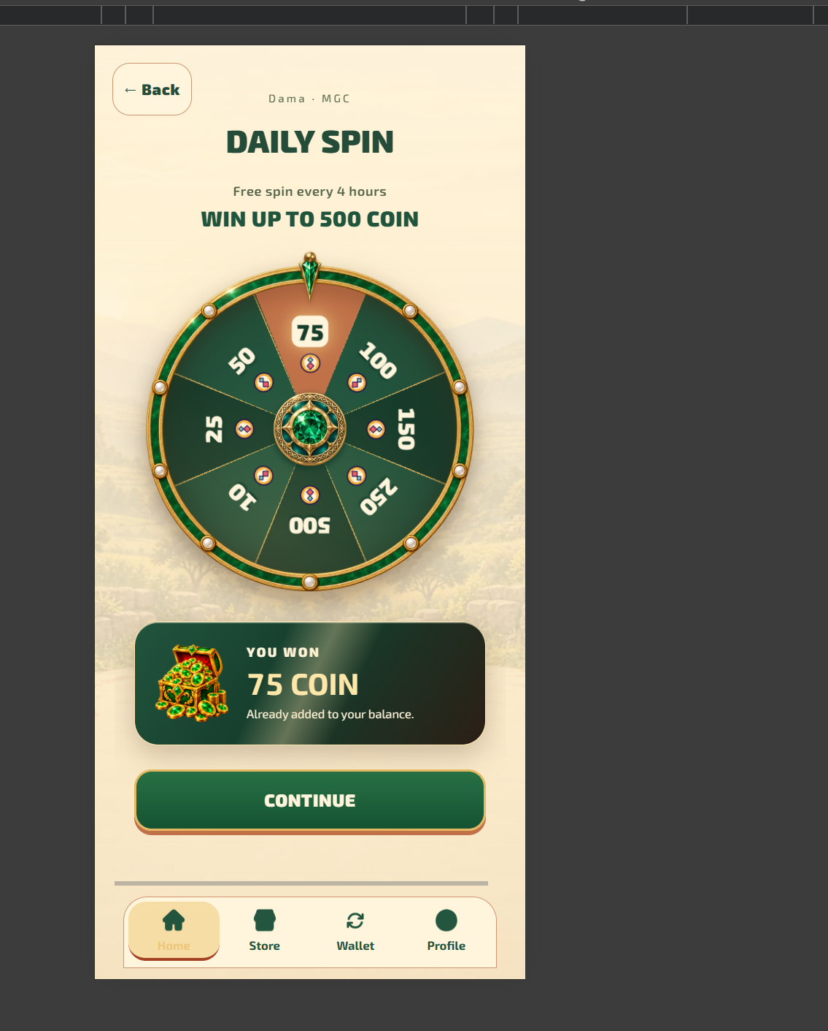
Figure 9 The daily spin screen shows the final reward state, but the wheel animation does not run reliably.

