DBI Protokoll – Elias, Rasti

Content:

* Workplan
* Setup
* Triggers
* Use Cases + Tests
* Log Table

Working Plan

Tables der DB; Rasti, Elias

Logging Table + Logging trigger; Rasti

Other 2 triggers - Elias

Tests; Rasti

User setup, inserts - Elias

Use case 1 - 10; Elias

Use case 11, 12; Rasti

Documentation; Rasti + Elias

SETUP:

* Open the setup folder
* Execute the user.sql file as admin of your oracle sql database
* Connect to the newly created user:
  + Username: casino
  + Password: oracle
* Execute the table.sql as the casino user
* Execute the inserts.sql as the casino user

The drop.sql file is there if all tables need to be dropped

* Get back into the project_2025 folder
* Execute the log_trg.sql file as casino user
* Execute the trigger.sql file as casino user
* Go into the package folder
* Execute all the following sql files
  + Customer.sql
  + Game.sql
  + Game_session.sql
  + Personal.sql
  + Reports.sql
  + Table.sql

The Database should be setup now.

Use Cases:

Customer Use Case 1, 2, 3, 4 (Register New Customer, Get Customer Balance, Update Customer Info, Get Customer Game History):

In the package folder in the customer.sql file there is the package for the first 4 use cases. The 4 public use cases are defined in the package.

In the body of the package there is the corresponding code and the private helper functions which are needed.

Use Case 1 (Register New Customer):

Uses helper functions

* Get default money and validate age

Test for use case 1:

All the tests for the packages are in the package test folder and in the corresponding file.

No data with the svz

After execution:

Use Case 2 (Get Customer Balance):

Helper function:

Test for use case 2:

Prints out the customers balance in this case the one of the created customer

Use Case 3 (Update Customer Info):

Helper functions (same as the ones before):

* Get customer id by svz
* Validate age

Test for use case 3:

After execution:

Use Case 4 (Get Customer Game History):

Helper function:

* Get customer id by svz

Test for use case 4:

Because there are no records of our newly created user the user with the svz C015 is used.

All the played games get printed:

Game Use Case 5 (Add new Game):

Use Case 5 (Add New Game):

Test for use case 5:

Games with blackjack before:

After execution:

Personal Use Case 6,7 (add personal contract, get the personal of a table):

Use case 6 (add personal contract):

Helper function:

Test for use case 6:

Before execution:

After execution:

Use Case 7 (get the personal of a table):

Helper function:

Test for use case 7:

Prints the personal which is on the table right now and the time:

Use Case 8 (Customer plays a game and wins or loses):

Helper functions:

Test for use case 8:

After execution:

Game gets added in game history table:



+

A trigger auto updates the money of the customer:

Use Case 9, 10 (make a daily report of the people who played today and the total sum they made, return the money of all customers in descending order):

Use Case 9 (make a daily report of the people who played today and the total sum they made):

The sql errors are only shown in the script even though they are not really there

Test for use case 9:

Alle ergebnisse werden ausgeprinted

Dieser customer hat heute nur gespielt und insgesamt 300€ dazugewonnen

Use Case 10 (return the money of all customers in descending order):

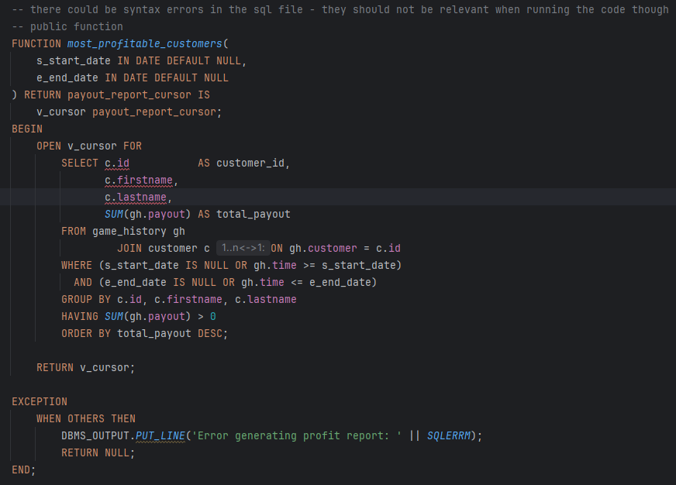

Test for use Case 10:

Alle customers mit positive payout werden ausgegeben.

Use Case 11,12 (assign a game to a table, assign personal to a table for a time):

Use Case 11 (assign a game to a table):

Test for use case 11:

All bevore:

After execution:

Use Case 12 (assign personal to a table for a time):

Helper functions:

Test for use case 12:

Before execution:

After execution:

LOG TABLE:

Also there is a log table which captures all actions (the trigger was added during the tests so there is not everything there)

it loggs the actions on the tables with this schema

Script is to long to copy here. It can be found in the log_trg.sql file.

For the tests there are also testpackages available for everything besides the normal tests.