Readme file

1) To execute the code, you need to have all three files:

1)makearranumbers1.txt file is just a file with 100 integers in it, so the code can read it and transmit the integers into the array.

2) Make array.h is a header file where all class function declarations are made.

3)CPP file is where all the functions and function implementations are made.

I also have a MAIN function inside the CPP file.(That is where the function implementations are made)

2) To launch the execution, you need to run the CPP file. After that, you will be given a prompt of commands that you car input(inArray, modify, add, replace, print, end).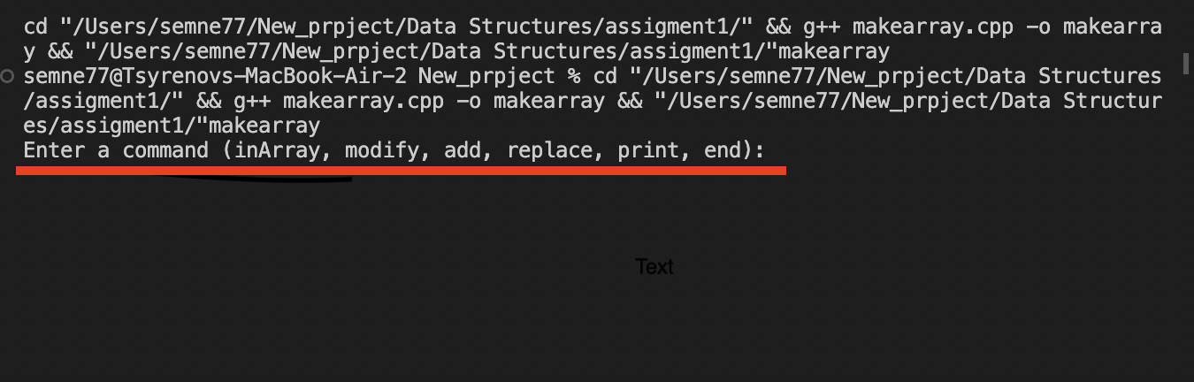

3)Some of the commands will require further input from you. For example, the command “inArray’’ will ask you to enter an integer if it is presented in the array. 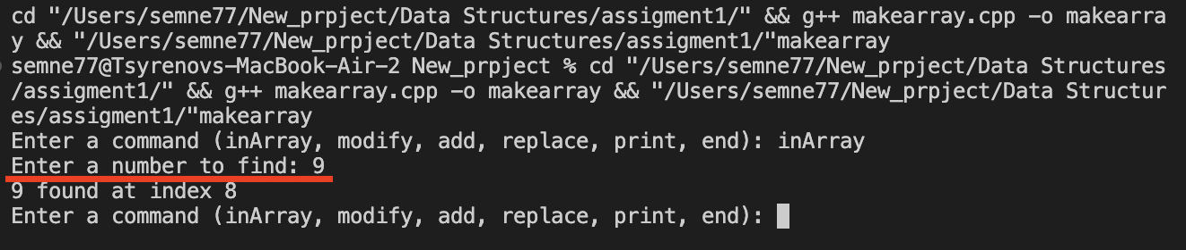

If you input the modified command, it will ask you to type 2 numbers divided by the blank space, so you can do it like this

4) When the command has been executed, you will be given the same prompt of commands to enter((inArray, modify, add, replace, print, end).

5) If your input is wrong, you have first to call the method that you want to use(inArray, modify, add, replace, print, end) and then try to enter the valid input again.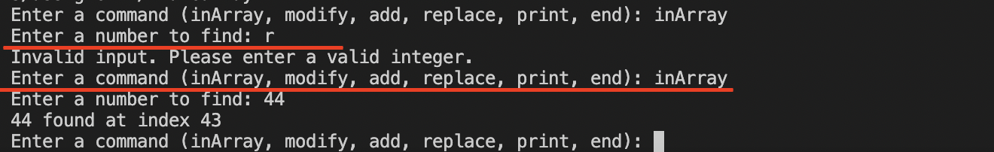

6) To finish execution, enter “end” to the input.

