PNEUMONIC PLAGUE OUTBREAK IN NORTHEAST INDIA

Zenabu, Zinhle, and Joseph

17/01/2020

Table of Contents

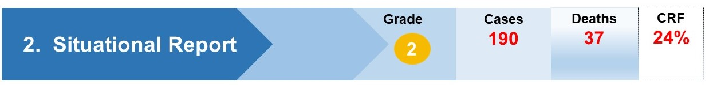

# Background

Plague is a zoonotic disease caused by a bacteria found in rodents (1). Individuals who are infected with plague usually manifest symptoms after an incubation period of three to seven days. There are three main forms of the plague disease: bubonic, septicaemic and pneumonic (2). Transmission of the plague infection is through bites of an infected rodent or inhalation of infected human respiratory droplets (1). It was once a dreaded disease in India and claimed nearly 13 000 000 lives between the years 1898 and 1994 (2,3). This disease has occurred in India since the sixteenth century(2).

# Case definition

Plague diagnosis is confirmed by laboratory diagnosis which can either be by the isolation of Y. pestis from a clinical specimen or a significant (fourfold or more) change in paired serum antibody titer to *Y. pestis* F1 antigen (4).

# Symptoms

Symptoms of pneumonic plague include fever, headache, development of pneumonia within a short space of time, followed by shortness of breath, chest pain and cough. The patient may progress to respiratory failure and shock if not treated within 2 to 4 days. If not treated, pneumonic plague can be fatal (5).

# Prevention

Currently, there is no vaccine for plague. People who came into direct contact with infectious people must take antibiotics for seven days to decrease chances of being infected (5). Patients who suspect they might be infected with plague must wear surgical masks to prevent spreading the diseases. Plague is usually caused by rodents and fleas, as part of prevention, people are encouraged to reduce rodent habitats around them and to keep fleas off their pets (6).

# Situation update

We report on the progression of the recent pneumonic plague outbreak in a community in northeast India which commenced on 12 October 2019. The community has a population of 302 people. Between the 12th of October 2019 and 29th of November 2019, there were 189 reported cases, 160 confirmed cases and 29 probable cases. The outbreak has caused 24 deaths to date.

The first case of the plague outbreak of India was detected on 11-Oct-19 and reached it’s peak on 6-Nov-19. Majority 85% out of 189 plague cases were Lab confirmed.

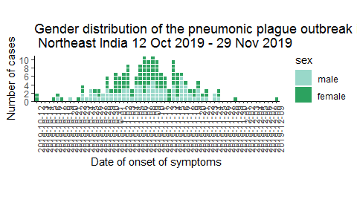

Of the 190 cases, majority 56.32% were female. The first 3 cases of the plague occured in females (Figure above) and it was five days later on the 17-October 2019 when the first case was recored in the males.

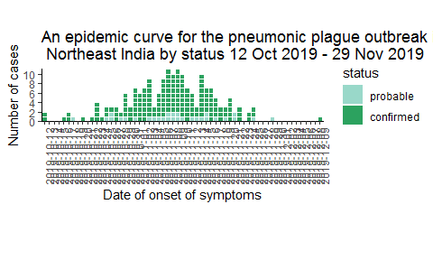

# Data needs

We need genomic data on confirmed cases to study transmission patterns in the dataset and GIS data to study the geographical distribution of the cases in Himachal Pradesh, India.

# References

**1** World Health Organization (WHO). Plague <https://www.who.int/news-room/fact-sheets/detail/plague> [accessed: 17 January 2020]

**2** World Health Organization (WHO). Plague Outbreak in Madagascar. <https://apps.who.int/iris/bitstream/handle/10665/259208/Ex-PlagueMadagascar0992017.pdf?sequence=2> [accessed: 17 January 2020]

**3** Epidemiological studies of plague in India. <https://www.ncbi.nlm.nih.gov/pmc/articles/PMC2555600/pdf/bullwho00328-0149.pdf> [accessed: 17 January 2020]

**4** Centers for Disease Control and Prevention. (2020). Plague (Yersinia pestis). <https://wwwn.cdc.gov/nndss/conditions/plague/case-definition/2020/> [accessed: 17 January 2020]

**5** Centers for Disease Control and Prevention. (4 April 2018). Facts about pneumonic plague. <https://emergency.cdc.gov/agent/plague/factsheet.asp> [ accessed: 17 january 2020]

**6** Centers for Disease Control and Prevention. (27 November 2018). Plague: prevention. <https://www.cdc.gov/plague/prevention/index.html> [accessed: 17 January 2020]