**Critical Thinking – Module 7**

Semra Chernet

Colorado State University Global

CSC500-2

Mr. Steven Evans

7/28/2024

The Critical Thinking Module 7 assignment focuses on creating a dictionary. The task is to write a program that create a dictionary containing course number and the room numbers, course number and the instructor name and course number and meeting time for each courses. The Assignment already has Key-Pairs for each ask. The first thing I did was to define a dictionary called “rooms” and paired course number with rooms

rooms = {

    "CSC101": "3004",

    "CSC102": "4501",

    "CSC103": "6755",

    "NET110": "1244",

    "COM241": "1411"

}

Following that I created another dictionary called “instructors” and paired the course number with the instructor for each course

instructors = {

    "CSC101": "Haynes",

    "CSC102": "Alvarado",

    "CSC103": "Rich",

    "NET110": "Burke",

    "COM241": "Lee"

}

Finally, I created a dictionary called “times” that pair course number with meeting time.

times = {

    "CSC101": "8:00 a.m.",

    "CSC102": "9:00 a.m.",

    "CSC103": "10:00 a.m.",

    "NET110": "11:00 a.m.",

    "COM241": "1:00 p.m."

}

Once we have the pairing done, we need to collect the course number from the user. This will have two result, one is the course detail the other is ‘invalid’ message when course code is incorrect.

course_number = input("What is the course number (Note: course number is case sensetive): ")

Once we collect course number from user, the below code will return either course detail or invalid message.

# This will return the course detail

if course_number in rooms and course_number in instructors and course_number in times:

    print(f"Course Number: {course_number}")

    print(f"Room Number: {rooms[course_number]}")

    print(f"Instructor: {instructors[course_number]}")

    print(f"Meeting Time: {times[course_number]}")

else:

    print("Sorry, invalid course number.")

Code Result: when I enter correct course number

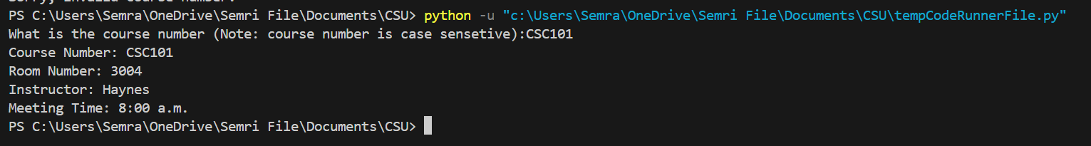

Code Result: when I enter invalid course number

