**Portfolio Milestone – Module 4**

Semra Chernet

Colorado State University Global

CSC500-2

Mr. Steven Evans

7/28/2024

**Online Shopping Cart**

The portfolio Milestone assignment focuses on building an online shopping cart. This application can be scaled to manage personal finance or for small businesses like restaurants to monitor expenses and budgets depending on the business need. The assignment maining focuses on creating a class with specifications like attributes, item_name, item_price, item_quantity, default constructor, Initializes item's name = "none", item's price = 0, item's quantity = 0, Method and print_item_cost(). Here I created a class called ShoppingList.

The first line defines a new class named ShoppingList. A class in python is a blueprint for creating an object/instance.

_init_ is a constructor. It gets automatically called when an instance of the class is created. , item_name, item_price, and item_quantity are attributes that stores the item name, price and quantity accordingly.

The self keyword is used to refer to the instance of the class. It is a convention in Python to use self as the first parameter in instance methods. Total cost calculated the total cost and the print line will have details.

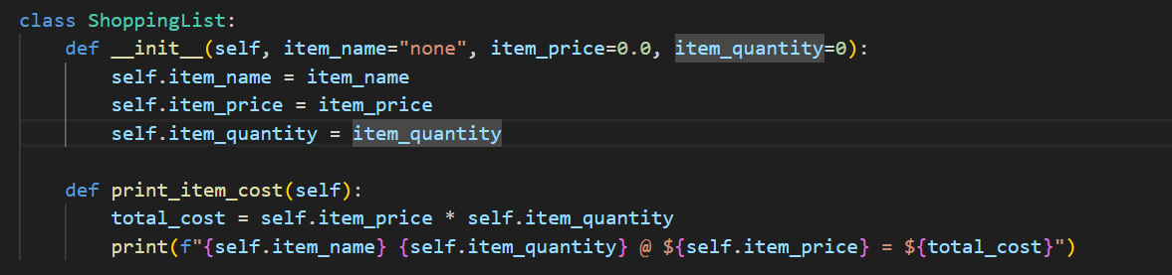

The second step is to build a code that prompts the user for two items and create two objects of the ShoppingList. The code creates two ShoppingList objects (item1 and item2) by prompting the user for the name, price, and quantity of two items. These objects can then be used to access the attributes and methods defined in the ShoppingList class, such as calculating and printing the total cost of the items.

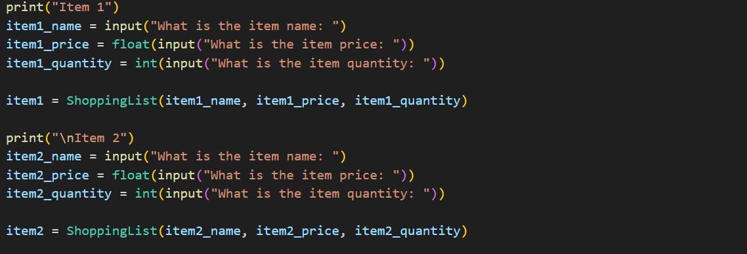

Cost calculation and display that add the cost of the two items together and output the total cost. The print_item_cost() method is called for each item to display the cost details. The program calculates the total cost of both items by summing the products of each item's price and quantity. It then prints the total cost. Overall, the program demonstrates how to use classes and objects in Python to manage data and perform calculations, providing a structured way to handle shopping cart items and their costs.

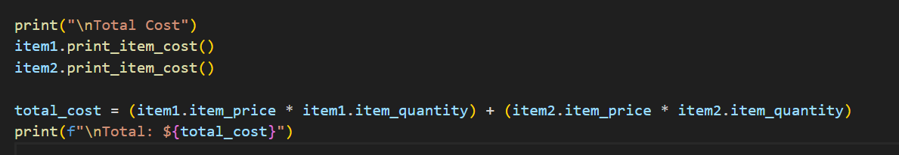

Here when I execute the code it let me to enter the item name, price, and quantity. The first item is cake which is 2 dollars and the quantity is 4. The second item is apples, the price is 4 and the quantity is 1. The prices are not actual and they are just for example. The total cost have a detail for both items and the total add the two items.

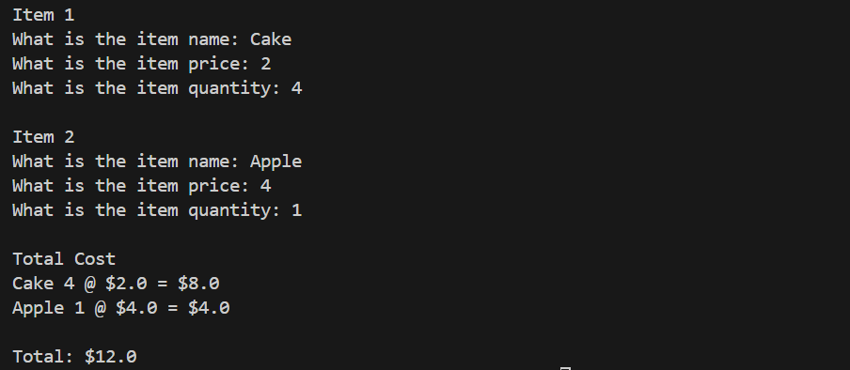

Overall, this program allows users to enter items, prices, and quantities. For now, it will allow the user to enter two items in detail. They it will calculate the total cost.