**Portfolio Milestone – Module 8**

Semra Chernet

Colorado State University Global

CSC500-2

Mr. Steven Evans

8/2/2024

**Online Shopping Cart M6**

This portfolio Milestone assignment focuses on building up the Portfolio Milestone M4 and M6 on building an online shopping cart. The ShoppingList class is designed to represent an individual item that can be added to the cart. It has the details of the items like the name, price, and quantity.

The ShoppingList class has three attributes **item_name** which holds the title of the items that the user can easily identify in the shopping cart. **Item_price**  this is very important in order to calculate the total cost of the items in the cart. **Item_quantity** which is also critical to calculate the total cost.

The ShoppingList class also has a method which is a user-defined method that is used to print the cost of the items based on the quantity and price. Total cost is basically calculated by multiplying the item price by the item quantity.

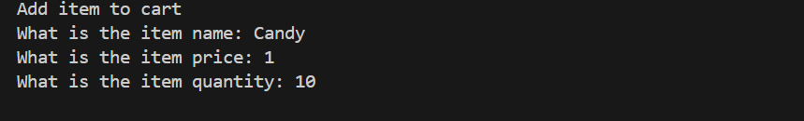

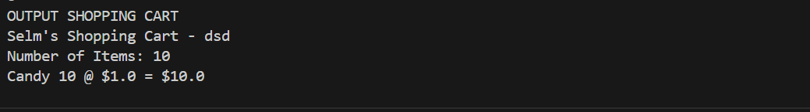

I also have a ShoppingCart class that serves as a bucket for multiple shopping list where user can add, remove or modify item in the cart.

The shopping cart has three attributes. **customer_name** which is a string data type that helps to get the customer's name. **current_date** which is also an string that helps to capture the last modified data. **cart_item** which has all the items added to the cart.

This class also has user-defined methods. **add_item** that takes an ItemToPurchase object as a parameter and adds it to the cart_items list. **remove_item** by using the item name this method removes an item from the cart if it is not found it prints a message **modify_item** allows for modification of an item's details in the cart. get_num_items_in_cart returns the total quantity of all items in the cart by summing up the item_quantity of each ItemToPurchase object in the cart_items list. This gives an overview of the total number of items the customer intends to purchase. **get_cost_of_cart** calculates and returns the total cost of all items in the cart by summing the product of item_price and item_quantity for each item. This provides the total amount the customer will need to pay. **print_total** this method prints a detailed summary of the shopping cart, including the customer’s name, the current date, the number of items, and the cost breakdown for each item. **print_descriptions** outputs a description for each item in the cart, displaying the name and quantity.

There is also a print_menu function that helps the user to interact with what is in the cart. 'a' to add an item to the cart. 'r' to remove an item from the cart, 'c' to change the quantity of an item, 'i' to output the descriptions of items in the cart, 'o' to output the total cost of the shopping cart and 'q' to quit the menu.

The new addition is to prompt the user for a customer's name and today's date. Output the name and date. Also implement Add item to cart menu option, which I have included previous but will be the final and implement remove item menu option. Implement change item quantity menu option.

Overall, this program allows users to manage and interact with the shopping cart.

