Ex. No:1 – A) LIST OPERATIONS

#1. a)Python List different Operations

print("Python List operations")
print("1.Repetition","2.Concatenation","3.Length","4.Iteration","5.Membership")
List2=["one","two","three","four","five"]
#Repetition Operator*
l= List2*2
print (l)
list1=[12,14,16,18,20]
#Concatenation Operator+
l=list1 + List2
print(l)
#Length
print(len(List2))
#Iteration
fori in List2:
print(i)
#Membership of the list
print(16 in list1)
print("three" in List2)

OUTPUT:
Python List operations
1.Repetition 2.Concatenation 3.Length 4.Iteration 5.Membership
['one', 'two', 'three', 'four', 'five', 'one', 'two', 'three', 'four', 'five']
[12, 14, 16, 18, 20, 'one', 'two', 'three', 'four', 'five']
5
one
two
three
four
five
True
True

Ex.No:1 (b) –LIST FUNCTIONS

#1. b) Python List Functions

alist=['Samsung','Vivo','Oppo','redmi']
blist=['a','b','c']
def view1():
print(alist)
def insert1():
no=int(input('Enter the index value:'))
name=input('Enter the value to insert:')
alist.insert(no,name)
def remove1():
name=input('Enter the value to remove:')
alist.remove(name)
def pop1():
no=int(input('Enter the index to pop:'))
alist.pop(no)
def reverse1():
alist.reverse()
def extend1():
alist.extend(blist)
print('********List Functions********')
while True:
print('1.View the List')print('2.Insert')print('3.Remove')print('4.Pop')print('5.Reverse')print('6.Extend')
n=int(input('Enter the number to execute list functions:'))
if(n==1):
view1()
elif(n==2):
insert1()
elif(n==3):
remove1()
elif(n==4):
pop1()
elif(n==5):
reverse1()
elif(n==6):
extend1()
else:
print("The program is terminated")
print()
OUTPUT:
********List Functions********
1.view the List
2.insert
3.Remove
4.Pop
5.Reverse
6.Extend
Enter the number to execute list functions:2
Enter the index value:0
Enter the value to insert:89
1.View the List 2.insert 3.Remove 4.Pop 5.Reverse 6.Extend

Enter the number to execute list functions:1
['89', 'Samsung', 'Vivo', 'Oppo', 'redmi']

Ex.No:1 –c) Tuple

# Python Tuple

Marks=(96,45,89,49,68,96,73,96)
print(Marks)
print("************Length***************")
print(len(Marks))
print("************Accessing the index*************")
print(Marks[2])
print(Marks[-3])
print("Index of Mark 68 is :",Marks.index(68))
print("*******Slicing*******")
print(Marks[1:6])
print(Marks[3:6])
print(Marks[:-2])
print(Marks[-4:])
print(Marks[::-1])
print("********Concatenate***********")
Marks2=(77,98,56)
a=Marks+Marks2
print(a)
print(Marks.count(96))
print("************Membership operator********")
print(85 in Marks)
print(96 in Marks)
print(45 in Marks)
print("**************Maximum value*************")
print(max(Marks))
print("*************Minimum value************")
print(min(Marks))
print(Marks*3)
OUTPUT:
(96, 45, 89, 49, 68, 96, 73, 96)
************Length***************
8
************Accessing the index*************
89
96
Index of Mark 68 is : 4
*******Slicing*******
(45, 89, 49, 68, 96)
(49, 68, 96)
(96, 45, 89, 49, 68, 96)
(68, 96, 73, 96)
(96, 73, 96, 68, 49, 89, 45, 96)
********Concatenate***********
(96, 45, 89, 49, 68, 96, 73, 96, 77, 98, 56)
3
************Membership operator********
False
True
True
**************Maximum value*************
96
*************Minimum value************
45
(96, 45, 89, 49, 68, 96, 73, 96, 96, 45, 89, 49, 68, 96, 73, 96, 96, 45, 89, 49, 68, 96, 73, 96)

Ex.No:1 –d) BOOK MAINTENANCE USING DICTIONARY

# Python Dictionary

print("*********Book maintenance********")
dict1={'1':'C programming','2':'python programming','3':'web programming','4':'Software engineering'}
print("Access the book......")
print("Delete the book.....")
print("Add the new book.....")
defget_book():
bid=input("Enter the book id....")
print("Enter the book name....")
print(dict1.get(bid))
print("-----------SUCCESSFULLY BOOK FOUND--------------")
defdel_book():
bookid=input("Enter the book id to delete......")
newlist=(dict1.pop(bookid))
print("-----------SUCESSFULLY BOOK REMOVED------------")
print("***********Now available books are************")
print(dict1)
defadd_book():
bid1=input("Enter the book id.....")
bookname=input("Enter the book name to insert......")
dict1.update({bid1:bookname})
while True:
ch=int(input("Enter the choice[1/2/3/4]:"))
if(ch==1):
print("\n\n**********Access the book***********")
print("the Available book............")
print(dict1)
get_book()
elif(ch==2):
print("\n\n*********Remove the book*********")
del_book()
elif(ch==3):
add_book()
else:
print("The program goes to terminate")
break

OUTPUT:
*********Book maintenance********
Access the book......
Delete the book.....
Add the new book.....
Enter the choice[1/2/3/4]:1

**********Access the book***********
the Available book............
{'1': 'C programming', '2': 'python programming', '3': 'web programming', '4': 'Software engineering'}
Enter the book id....1
Enter the book name....
C programming
-----------SUCCESSFULLY BOOK FOUND--------------

Enter the choice[1/2/3/4]:3
Enter the book id.....5
Enter the book name to insert......Python programming
Enter the choice[1/2/3/4]:1

**********Access the book***********
the Available book............
{'1': 'C programming', '2': 'python programming', '3': 'web programming', '4': 'Software engineering', '5': 'Python programming'}

Ex.No:2 – A) DECISION MAKING –CONTROL STATEMENTS

# a)Largest Number Among Three
num1=int(input("Enter First Number:"))
num2=int(input("Enter Second Number:"))
num3=float(input("Enter Third Number:"))
if(num1>=num2)and(num1>=num3):
largest=num1
elif(num2>=num1)and(num2>=num3):
largest=num2
else:
largest=num3
print("The Largest Number is",largest)

OUTPUT:
Enter First Number:12
Enter Second Number:65
Enter Third Number:8
The Largest number is 65
----------------------------------------------------------------------------------------------------------------------------------
# b)Positive or Negative
num=float(input("Enter a Number:"))
ifnum>0:
print("Positive number")
elif num==0:
print("Negative Number")

OUTPUT:
Enter a Number:-89
Negative Number
----------------------------------------------------------------------------------------------------------------------------------

#c) Odd or Even
num=int(input("Enter a Number:"))
if(num%2)==0:
print("{0}is Even".format(num))
else:
print("{0}is Odd".format(num))

OUTPUT:
Enter a Number:-89
-89 is Odd
>>>
----------------------------------------------------------------------------------------------------------------------------------

EX.NO:2 – B) DECISION MAKING - LOOPING STATEMENTS

# a) Palindrome Number

print("Find the Given Number is Palindrome")
n=int(input("Enter the Number"))
sum=0
a=n
while(n>0):
m=n%10
sum=sum*10+m
n=n//10
if(sum==a):
print("The Given Number is Palindrome")
else:
print("The Given Number is not Palindrome")
OUTPUT:
Find the Given Number is Palindrome
Enter the Number 7887
The Given Number is Palindrome
>>>
Find the Given Number is Palindrome
Enter the number 772222
The Given Number is not Palindrome
----------------------------------------------------------------------------------------------------------------------------------
#b) Sum of n Numbers
number = int(input("Enter the Number: "))
sum = 0
for value in range(1, number + 1):
sum = sum + value
print(sum)
OUTPUT:
Enter the Number: 10
55
----------------------------------------------------------------------------------------------------------------------------------
# c) Leap Year
print("To find whether the given year is leap or not")
print("************************************")
year=int(input("Enter the year....:"))
if(year%100==0):
if(year%400==0):
print("Given",year," is a Leap year...")
else:
print("Given",year,"is not a Leap year")
elif(year%4==0):
print("Given",year," is a Leap year...")
else:
print("Given",year,"is not a Leap year")
OUTPUT:
To find whether the given year is leap or not
************************************
Enter the year....:2004
Given 2004 is a Leap year
To find whether the given year is leap or not
************************************
Enter the year....:2002
Given 2002 is not a Leap year

Ex.No:3 REGULAR EXPRESSIONS

# Regular Expression
“””Primary conditions for password validation:
- Minimum 8 characters.
- The alphabets must be between [a-z]
- At least one alphabet should be of Upper Case [A-Z]
- At least 1 number or digit between [0-9].
- At least 1 character from [ _ or @ or $ ].”””

import re
print("--------PASSWORD VALIDATION USING REGUALR EXPRESSION-----")
print(" *********************************************")
password=input("Enter the Password......:")
#password = "R@m@_f0rtu9e$"
flag = 0
while True:
if (len(password)<8):
flag = -1
break
elif not re.search("[a-z]", password):
flag = -1
break
elif not re.search("[A-Z]", password):
flag = -1
break
elif not re.search("[0-9]", password):
flag = -1
break
elif not re.search("[_@$]", password):
flag = -1
break
elif re.search("\s", password):
flag = -1
break
else:
flag = 0
print("You entered :",password,"Valid Password")
break
if flag ==-1:
print("You entered ",password," Not a Valid Password")

OUTPUT:
--------PASSWORD VALIDATION USING REGUALR EXPRESSION-----
*********************************************
Enter the Password......:Gd_o@$76
You entered : Gd_o@$76 Valid Password

--------PASSWORD VALIDATION USING REGUALR EXPRESSION-----
*********************************************
Enter the Password......:peter@45
You entered peter@45 Not a Valid Password

Ex.No:4- CALENDAR FUNCTIONS

# Calendar Functions used to display the Month and Year
import calendar
defdispcal():
year=int(input("Enter the year........:"))
calendar.parcal(year)
defdispmonth():
year1=int(input("Enter the year........"))
mon1=int(input("Enter the month........"))
print(calendar.month(year1,mon1))
print("----------CALENDAR FUNCTIONS-------")
print("1.DISPLAY THE CALENDAR....")
print("2.DISPLAY THE MONTH.....")
while True:
choice = int(input("Enter your choice :"))
if choice == 1:
dispcal()
elif choice == 2:
dispmonth()
else:
print("program goes to terminate.......:")
break
print("Bye.....")

OUTPUT:
-------CALENDAR FUNCTIONS-------
1.DISPLAY THE CALENDAR....
2.DISPLAY THE MONTH....
Enter your choice :1
Enter the year.....:2020
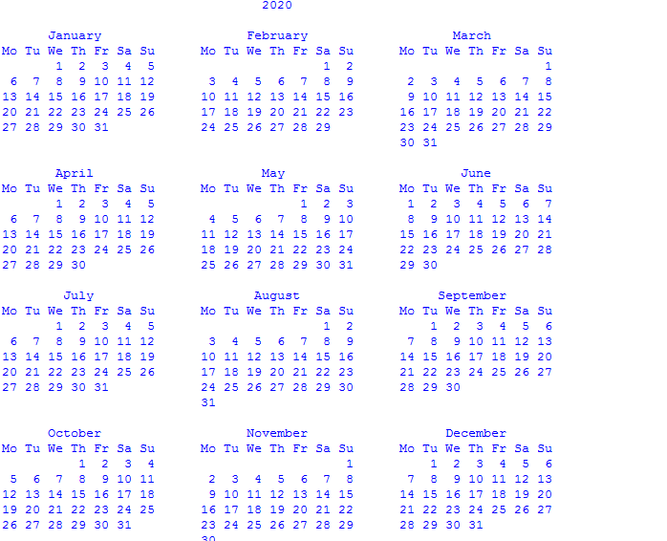

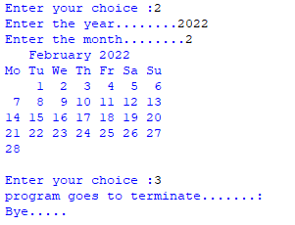

Ex.No:5 – PYTHON GUI using Tkinter app

# a) Simple Calculation using Tkinter

From tkinter import *
classMyWindow:
def __init__(self, win):
self.lbl1=Label(win, text='First number')
self.lbl2=Label(win, text='Second number')
self.lbl3=Label(win, text='Result')
self.t1=Entry(bd=3)
self.t2=Entry()
self.t3=Entry()
self.btn1 = Button(win, text='Add')
self.btn2=Button(win, text='Subtract')
self.lbl1.place(x=100, y=50)
self.t1.place(x=200, y=50)
self.lbl2.place(x=100, y=100)
self.t2.place(x=200, y=100)
self.b1=Button(win, text='Add',command=self.add)
self.b2=Button(win, text='Subtract')
self.b2.bind('<Button-1>',self.sub)
self.b1.place(x=100, y=150)
self.b2.place(x=200, y=150)
self.lbl3.place(x=100, y=200)
self.t3.place(x=200, y=200)
def add(self):
self.t3.delete(0,'end')
num1=int(self.t1.get())
num2=int(self.t2.get())
result=num1+num2
self.t3.insert(END, str(result))
def sub(self, event):
self.t3.delete(0,'end')
num1=int(self.t1.get())
num2=int(self.t2.get())
result=num1-num2
self.t3.insert(END, str(result))
window=Tk()
mywin=MyWindow(window)
window.title('Hello Python')
window.geometry("400x300+10+10")
window.mainloop()

Ex.No:5 – MESSAGE BOX CREATION using Tkinter

# b) Message box Creation Using Tkinter

from tkinter import*
from tkinter import messagebox
window=Tk()
window.geometry("100x100")
messagebox.showerror("error box","error")
messagebox.showwarning("warning box","time over")
messagebox.askquestion("confirm dialog box","click yes to confirm")
messagebox.askokcancel("redirection","redirecting you to google.com")
messagebox.askyesno("application proceeds","go to next page")
window.mainloop()

Ex.No:5 – BUTTON CREATION using Tkinter

# c) Button Creation Using Tkinter

from tkinter import*
root=Tk()
frame=Frame(root)
frame.pack()
bottomframe=Frame(root)
bottomframe.pack(side=BOTTOM)
redbutton=Button(frame,text='red',fg='red')
redbutton.pack(side=LEFT)
greenbutton=Button(frame,text='green',fg='green')
greenbutton.pack(side=LEFT)
bluebutton=Button(frame,text='blue',fg='blue')
bluebutton.pack(side=LEFT)
blackbutton=Button(bottomframe,text='black',fg='black')
blackbutton.pack(side=LEFT)
root.mainloop()

