**高等工程热力学**

---流体热物性

组员：

杨本超 3120303012 S0034

罗晗 3120303024 S0034

2020年12月

**3.1请用PR方程计算制冷剂R290,R600a,R1234yf,R1234ze(E)和混合制冷剂R290/R600a:50/50Wt%的pvt性质。**

**程序：**

#include<iostream>

#include "math.h"

using namespace std;

#define R 8.31451

double Newton(double A,double B,double x)

{

double x0;

double f,df;

do

{

x0=x;

f=x*x*x-(1-B)*x*x+(A-3*B*B-2*B)*x-(A*B-B*B-B*B*B);

df=3*x*x-2*(1-B)*x+(A-3*B*B-2*B);

x=x-f/df;

}while(fabs(x-x0)>1e-6);

return x;

}

void R290(double T,double p,double *a,double *b,double *M)

{

double Tc,pc,w,k,a1,Tr;

*M=44.096e-3;

Tc=369.89;

pc=4251200;

w=0.1521;

k=0.37464+1.54226*w-0.26992*w*w;

Tr=T/Tc;

a1=pow(1+k*(1-pow(Tr,0.5)),2);

*a=0.45727*a1*R*R*Tc*Tc/pc;

*b=0.07780*R*Tc/pc;

}

void R600a(double T,double p,double *a,double *b,double *M)

{

double Tc,pc,w,k,a1,Tr;

*M=58.122e-3;

Tc=407.81;

pc=3629000;

w=0.184;

k=0.37464+1.54226*w-0.26992*w*w;

Tr=T/Tc;

a1=pow(1+k*(1-pow(Tr,0.5)),2);

*a=0.45727*a1*R*R*Tc*Tc/pc;

*b=0.07780*R*Tc/pc;

}

void R1234yf(double T,double p,double *a,double *b,double *M)

{

double Tc,pc,w,k,a1,Tr;

*M=114.04e-3;

Tc=367.85;

pc=3382200;

w=0.276;

k=0.37464+1.54226*w-0.26992*w*w;

Tr=T/Tc;

a1=pow(1+k*(1-pow(Tr,0.5)),2);

*a=0.45727*a1*R*R*Tc*Tc/pc;

*b=0.07780*R*Tc/pc;

}

void R1234ze(E)(double T,double p,double *a,double *b,double *M)

{

double Tc,pc,w,k,a1,Tr;

*M=114.04e-3;

Tc=382.52;

pc=3636300;

w=0.313;

k=0.37464+1.54226*w-0.26992*w*w;

Tr=T/Tc;

a1=pow(1+k*(1-pow(Tr,0.5)),2);

*a=0.45727*a1*R*R*Tc*Tc/pc;

*b=0.07780*R*Tc/pc;

}

void Hun(double T,double p,double *a,double *b,double *M)

{

double a1,a2,b1,b2,x1,x2,k12,M1,M2;

k12=0.01;

R290(T,p,&a1,&b1,&M1);

R600a(T,p,&a2,&b2,&M2);

x1=1/(1+M1/M2);

x2=1/(1+M2/M1);

*a=x1*x1*a1+x2*x2*a2+2*x1*x2*(1-k12)*sqrt(a1*a2);

*b=x1*b1+x2*b2;

*M=x1*M1+x2*M2;

}

int main()

{

double M,T,a,b,p,A,B;

int i;

N1:

cout<<"please enter 1(R290),2(R600a),3(R1234yf),4(R1234ze(E))or5(Hun)"<<endl;

cin>>i;

if(i!=1&&i!=2&&i!=3&&i!=4&&i!=5)

{

cout<<"The number is wrong"<<endl;

goto N1;

}

cout<<"please enter T(K)"<<endl;

cin>>T;

cout<<"please enter p(Mpa)"<<endl;

cin>>p;

p=p*1e6;

if(i==1)

{

R290(T,p,&a,&b,&M);

}

else if(i==2)

{

R600a(T,p,&a,&b,&M);

}

else if(i==3)

{

R1234yf(T,p,&a,&b,&M);

}

else if(i==4)

{

R1234ze(E)(T,p,&a,&b,&M);

}

else if(i==5)

{

Hun(T,p,&a,&b,&M);

}

A=a*p/(R*R*T*T);

B=b*p/(R*T);

double z1=Newton(A,B,1000);

double z2=Newton(A,B,0.001);

if(fabs(z1-z2)<1e-4)

{

double v1=z1*R*T/p/M;

cout<<" 单位比体积为: "<<v1<<"m^3/kg"<<endl;

}

else

{

double v1=z1*R*T/p/M;

double v2=z2*R*T/p/M;

cout<<" 气体单位比体积为： "<<v1<<"m^3/kg"<<endl;

cout<<" 液体单位比体积为： "<<v2<<"m^3/kg"<<endl;

}

}

**结果：**

please enter 1(R290),2(R600a),3(R1234yf),4(R1234ze(E))or5(Hun)

1

please enter T(K)

300

please enter p(Mpa)

0.02

气体单位比体积为：2.81919m^3/kg

液体单位比体积为：0.00198825m^3/kg

--------------------------------

**整理得：**以温度300K为例，不同压力下各工质比体积的计算数据和标准数据（注：标准数据来自REFPROP）

1. R290：

|  |  |  |  |
| --- | --- | --- | --- |
| p/Mpa | v计算值/m3·kg-1 | v标准值/ m3·kg-1 | 误差/% |
| 0.02 | 2.81919 | 2.81960 | 0.015 |
| 0.04 | 1.40501 | 1.40538 | 0.026 |
| 0.06 | 0.933599 | 0.93397 | 0.040 |
| 0.08 | 0.697886 | 0.69823 | 0.049 |
| 0.1 | 0.556449 | 0.55679 | 0.061 |

(2) R600a：

|  |  |  |  |
| --- | --- | --- | --- |
| p/Mpa | v计算值/ m3·kg-1 | v标准值/ m3·kg-1 | 误差/% |
| 0.02 | 2.13508 | 2.13502 | 0.003 |
| 0.04 | 1.06214 | 1.06208 | 0.006 |
| 0.06 | 0.704471 | 0.70437 | 0.014 |
| 0.08 | 0.525615 | 0.52551 | 0.021 |
| 0.10 | 0.418283 | 0.41818 | 0.024 |

(3) R1234yf

|  |  |  |  |
| --- | --- | --- | --- |
| p/Mpa | v计算值/ m3·kg-1 | v标准值/ m3·kg-1 | 误差/% |
| 0.02 | 1.08909 | 1.08902 | 0.006 |
| 0.04 | 0.542263 | 0.54221 | 0.009 |
| 0.06 | 0.359979 | 0.35991 | 0.019 |
| 0.08 | 0.268829 | 0.26876 | 0.026 |
| 0.10 | 0.214134 | 0.21406 | 0.033 |

(4) R1234ze(E)

|  |  |  |  |
| --- | --- | --- | --- |
| p/Mpa | v计算值/ m3·kg-1 | v标准值/ m3·kg-1 | 误差/% |
| 0.02 | 1.08885 | 1.08870 | 0.014 |
| 0.04 | 0.542021 | 0.54186 | 0.030 |
| 0.06 | 0.359733 | 0.35958 | 0.042 |
| 0.08 | 0.268582 | 0.26843 | 0.056 |
| 0.10 | 0.213885 | 0.21373 | 0.075 |

(5) R290/R600a

|  |  |  |  |
| --- | --- | --- | --- |
| p/Mpa | v计算值/ m3·kg-1 | v标准值/ m3·kg-1 | 误差/% |
| 0.02 | 2.48003 | 2.47752 | 0.101 |
| 0.04 | 1.23649 | 1.23397 | 0.204 |
| 0.06 | 0.821966 | 0.81940 | 0.257 |
| 0.08 | 0.614701 | 0.61214 | 0.256 |
| 0.10 | 0.490337 | 0.48776 | 0.528 |

**3.2请用PR方程计算工质R290,R600a,R1234yf,R1234ze(E)和混合制冷剂R290/R600a的导出热力性质焓和熵。**

**程序：**

**R290、R600a、R1234yf、R1234ze(E)的导出热力性质焓和熵**

#include<iostream>

#include<math.h>

using namespace std;

#define R 8.31451

double get_a(double w,double T,double Tc,double pc)

{

double k=0.37464+1.54226*w-0.26992*w*w;

double ar=(1+k*(1-sqrt(T/Tc)))*(1+k*(1-sqrt(T/Tc)));

double a=0.45724*ar*R*R*Tc*Tc/pc;

return a;

}

double get_b(double Tc,double pc)

{

double b=0.0778*R*Tc/pc;

return b;

}

double Newton(double A,double B,double x)

{

double x0;

double f,df;

do

{

x0=x;

f=x*x*x-(1-B)*x*x+(A-3*B*B-2*B)*x-(A*B-B*B-B*B*B);

df=3*x*x-2*(1-B)*x+(A-3*B*B-2*B);

x=x-f/df;

}while(fabs(x-x0)>1e-6);

return x;

}

double get_ar(double T,double v,double vv,double a,double b)

{

double ar=R*T*log((v-b)/v)-a/(2*1.414*b)*(log((v-0.414*b)/(v+2.414*b))) +R*T*log(v/vv);

return ar;

}

double get_sr(double T,double v,double vv,double a,double b,double bb)

{

double sr=-1*R*log((v-b)/v)+bb/(2*1.414*b)*(log((v-0.414*b)/(v+2.414*b))) -R*log(v/vv);

return sr;

}

void get_hr(double Tc,double pc,double w,double T,double p,double *hr,double *sr,double zz)

{

double a=get_a(w,T,Tc,pc);

double b=get_b(Tc,pc);

double bb=(get_a(w,T+0.25,Tc,pc)-get_a(w,T-0.25,Tc,pc))/0.5;

double A=a*p/(R*R*T*T);

double B=b*p/(R*T);

double z=Newton(A,B,zz);

double v=z*R*T/p;

double vv=R*T/p;

double ar=get_ar(T,v,vv,a,b);

*sr=get_sr(T,v,vv,a,b,bb);

*hr=ar+T*(*sr)+R*T*(1-z);

}

int main()

{

int i;

double M;

double w;

double h0=200.0;

double s0=1.0;

double T0;

double p0;

double c0,c1,c2,c3;

double T,p,Tc,pc;

double hr0,sr0,hrv,hrl,srv,srl;

double pM[4]={44.096,58.122,114.04,114.04};

double pTc[4]={369.89,407.81,367.85,382.52};

double ppc[4]={4251200,3629000,3382200,3636300};

double pT0[4]={273.15,273.15,273.15,273.15};

double pp0[4]={474460,156960,315820,216480};

double pw[4]={0.1521,0.184,0.276,0.313};

double pc0[4]={-95.80,-23.91,18.349,55.389};

double pc1[4]={6.945,6.605,128.316,10.784};

double pc2[4]={-3.597*1e-3,-3.176*1e-3,-33.354,99.250};

double pc3[4]={7.290*1e-7,-4.981*1e-7,2.086,-49.88};

N1:

cout<<"please enter 1(R290),2(R600a),3(R1234yf),4(R1234ze(E))"<<endl;

cin>>i;

if(i==1||i==2||i==3||i==4)

{

M=pM[i-1];

Tc=pTc[i-1];

pc=ppc[i-1];

T0=pT0[i-1];

p0=pp0[i-1];

w=pw[i-1];

c0=pc0[i-1];

c1=pc1[i-1];

c2=pc2[i-1];

c3=pc3[i-1];

}

else

{

cout<<"The number is wrong"<<endl;

goto N1;

}

cout<<"please enter T(K)"<<endl;

cin>>T;

cout<<"please enter p(Mpa)"<<endl;

cin>>p;

p=p*1e6;

get_hr(Tc,pc,w,T0,p0,&hr0,&sr0,0.001);

get_hr(Tc,pc,w,T,p,&hrv,&srv,1.1);

get_hr(Tc,pc,w,T,p,&hrl,&srl,0.001);

if(fabs(hrv-hrl)<1e-4)

{

double h=h0*M+hr0-hrv+R*(c0*(T-T0)+c1/2/Tc*(pow(T,2)

-pow(T0,2))+c2/3/pow(Tc,2)*(pow(T,3)-pow(T0,3))+c3/4/pow(Tc,3)

*(pow(T,4)-pow(T0,4)));

double s=s0*M+sr0-srv-R*log(p/p0)+R*(c0*log(T/T0)+c1*(T-T0)/Tc

+c2/2/pow(Tc,2)*(pow(T,2)-pow(T0,2))+c3/3/pow(Tc,3)*(pow(T,3)-pow(T0,3)));

h=h/M;

s=s/M;

cout<<"h="<<h<<"kJ/kg"<<endl;

cout<<"s="<<s<<"kJ/(kg*K)"<<endl;

}

else

{

double h=h0*M+hr0-hrv+R*(c0*(T-T0)+c1/2/Tc*(pow(T,2)

-pow(T0,2))+c2/3/pow(Tc,2)*(pow(T,3)-pow(T0,3))+c3/4/pow(Tc,3)

*(pow(T,4)-pow(T0,4)));

double s=s0*M+sr0-srv-R*log(p/p0)+R*(c0*log(T/T0)+c1*(T-T0)/Tc

+c2/2/pow(Tc,2)*(pow(T,2)-pow(T0,2))+c3/3/pow(Tc,3)*(pow(T,3)-pow(T0,3)));

h=h/M;

s=s/M;

cout<<" 气相 "<<endl;

cout<<"h="<<h<<"kJ/kg"<<endl;

cout<<"s="<<s<<"kJ/(kg*K)"<<endl;

h=h0*M+hr0-hrl+R*(c0*(T-T0)+c1/2/Tc*(pow(T,2)

-pow(T0,2))+c2/3/pow(Tc,2)*(pow(T,3)-pow(T0,3))+c3/4/pow(Tc,3)

*(pow(T,4)-pow(T0,4)));

s=s0*M+sr0-srl-R*log(p/p0)+R*(c0*log(T/T0)+c1*(T-T0)/Tc

+c2/2/pow(Tc,2)*(pow(T,2)-pow(T0,2))+c3/3/pow(Tc,3)*(pow(T,3)-pow(T0,3)));

h=h/M;

s=s/M;

cout<<" 液相 "<<endl;

cout<<"h="<<h<<"kJ/kg"<<endl;

cout<<"s="<<s<<"kJ/(kg*K)"<<endl;

}

}

**R290/R600a的导出热力性质焓和熵**

#include<iostream>

#include<math.h>

using namespace std;

#define R 8.31451

#define k12 0.01

double get_a(double w1,double w2,double T,double Tc1,double pc1,double Tc2,

double pc2,double x1,double x2)

{

double k=0.37464+1.54226*w1-0.26992*w1*w1;

double ar=(1+k*(1-sqrt(T/Tc1)))*(1+k*(1-sqrt(T/Tc1)));

double a1=0.45724*ar*R*R*Tc1*Tc1/pc1;

k=0.37464+1.54226*w2-0.26992*w2*w2;

ar=(1+k*(1-sqrt(T/Tc2)))*(1+k*(1-sqrt(T/Tc2)));

double a2=0.45724*ar*R*R*Tc2*Tc2/pc2;

double a=2*x1*x2*(1-k12)*sqrt(a1*a2)+x1*x1*a1+x2*x2*a2;

return a;

}

double get_b(double Tc1,double pc1,double Tc2,double pc2,double x1,double x2)

{

double b1=0.0778*R*Tc1/pc1;

double b2=0.0778*R*Tc2/pc2;

double b=x1*b1+x2*b2;

return b;

}

double get_bb(double w1,double w2,double T,double Tc1,double pc1,double Tc2,

double pc2,double x1,double x2)

{

double a1=get_a(w1,w2,T+0.25,Tc1,pc1,Tc2,pc2,x1,x2);

double a2=get_a(w1,w2,T-0.25,Tc1,pc1,Tc2,pc2,x1,x2);

double bb=(a1-a2)/0.5;

return bb;

}

double Newton(double A,double B,double x)

{

double x0;

double f,df;

do

{

x0=x;

f=x*x*x-(1-B)*x*x+(A-3*B*B-2*B)*x-(A*B-B*B-B*B*B);

df=3*x*x-2*(1-B)*x+(A-3*B*B-2*B);

x=x-f/df;

}while(fabs(x-x0)>1e-6);

return x;

}

double get_ar(double T,double v,double vv,double a,double b)

{

double ar=R*T*log((v-b)/v)-a*log((v-0.414*b)/(v+2.414*b))/(2*1.414*b)+R*T*log(v/vv);

return ar;

}

double get_sr(double T,double v,double vv,double a,double b,double bb)

{

double sr=-1*R*log((v-b)/v)+bb*log((v-0.414*b)/(v+2.414*b))/(2*1.414*b)-R*log(v/vv);

return sr;

}

int main()

{

double M1=44.096;

double Tc1=369.89;

double pc1=4251200;

double Ts1=273.15;

double ps1=474460;

double w1=0.1521;

double x1;

double c01=-95.80;

double c11=6.945;

double c21=-3.597*1e-3;

double c31=7.290*1e-7;

double M2=58.122;

double Tc2=407.81;

double pc2=3629000;

double Ts2=273.15;

double ps2=156960;

double w2=0.184;

double x2;

double c02=-23.91;

double c12=6.605;

double c22=-3.176*1e-3;

double c32=4.981*1e-7;

double T0=273.15;

double p0=329790;

double hr0,sr0,hrv,srv,hrl,srl,h,s;

double p,T;

x1=(M2)/(M1+M2);

x2=1-x1;

double M=M1*x1+M2*x2;

double a=get_a(w1,w2,T0,Tc1,pc1,Tc2,pc2,x1,x2);

double b=get_b(Tc1,pc1,Tc2,pc2,x1,x2);

double bb=get_bb(w1,w2,T0,Tc1,pc1,Tc2,pc2,x1,x2);

double A=a*p0/(R*R*T0*T0);

double B=b*p0/(R*T0);

double z=Newton(A,B,0.001);

double v=z*R*T0/p0;

double vv=R*T0/p0;

double ar=get_ar(T0,v,vv,a,b);

sr0=get_sr(T0,v,vv,a,b,bb);

hr0=ar+T0*sr0+R*T0*(1-z);

cout<<"please enter T(K)"<<endl;

cin>>T;

cout<<"please enter p(Mpa)"<<endl;

cin>>p;

p=p*1e6;

a=get_a(w1,w2,T,Tc1,pc1,Tc2,pc2,x1,x2);

bb=get_bb(w1,w2,T,Tc1,pc1,Tc2,pc2,x1,x2);

A=a*p/(R*R*T*T);

B=b*p/(R*T);

z=Newton(A,B,0.001);

v=z*R*T/p;

vv=R*T/p;

ar=get_ar(T,v,vv,a,b);

srv=get_sr(T,v,vv,a,b,bb);

hrv=ar+T*srv+R*T*(1-z);

z=Newton(A,B,1.1);

v=z*R*T/p;

vv=R*T/p;

ar=get_ar(T,v,vv,a,b);

srl=get_sr(T,v,vv,a,b,bb);

hrl=ar+T*srl+R*T*(1-z);

double dh1=R*(c01*(T-T0)+c11/2/Tc1*(pow(T,2)-pow(T0,2))+

c21/3/pow(Tc1,2)*(pow(T,3)-pow(T0,3))+c31/4/pow(Tc1,3)*(pow(T,4)-pow(T0,4)));

double dh2=R*(c02*(T-T0)+c12/2/Tc2*(pow(T,2)-pow(T0,2))+

c22/3/pow(Tc2,2)*(pow(T,3)-pow(T0,3))+c32/4/pow(Tc2,3)*(pow(T,4)-pow(T0,4)));

double dh=dh1*x1+dh2*x2;

double ds1=-R*log(p/p0)+R*(c01*log(T/T0)+c11*(T-T0)/Tc1+

c21/2/pow(Tc1,2)*(pow(T,2)-pow(T0,2))+c31/3/pow(Tc1,3)*(pow(T,3)-pow(T0,3)));

double ds2=-R*log(p/p0)+R*(c02*log(T/T0)+c12*(T-T0)/Tc2+

c22/2/pow(Tc2,2)*(pow(T,2)-pow(T0,2))+c32/3/pow(Tc2,3)*(pow(T,3)-pow(T0,3)));

double ds=ds1*x1+ds2*x2;

if(fabs(hrv-hrl)<1e-4)

{

h=200+(hr0-hrv+dh)/M;

s=1.0+(sr0-srv+ds)/M;

cout<<"h="<<h<<"kJ/kg"<<endl;

cout<<"s="<<s<<"kJ/(kg*K)"<<endl;

}

else

{

h=200+(hr0-hrv+dh)/M;

s=1.0+(sr0-srv+ds)/M; cout<<" 气相 "<<endl;

cout<<"h="<<h<<"kJ/kg"<<endl;

cout<<"s="<<s<<"kJ/(kg*K)"<<endl;

h=200+(hr0-hrl+dh)/M;

s=1.0+(sr0-srl+ds)/M; cout<<" 液相 "<<endl; cout<<"h="<<h<<"kJ/kg"<<endl;

cout<<"s="<<s<<"kJ/(kg*K)"<<endl;

}

}

**整理得：**以温度300K为例，不同压力下各工质比焓和比熵的计算数据和标准数据（注：标注数据来自REFPROP）

1. R290：

|  |  |  |  |  |  |  |
| --- | --- | --- | --- | --- | --- | --- |
| p/Mpa | h计算值/ kJ·kg-1 | s计算值/ kJ·kg-1·K-1 | h标准值/ kJ·kg-1 | s标准值/ kJ·kg-1·K-1 | h误差/% | s误差/% |
| 0.020 | 634.68940 | 3.16010 | 635.74000 | 3.16610 | 0.165 | 0.190 |
| 0.040 | 634.18900 | 3.02835 | 635.18000 | 3.03410 | 0.156 | 0.189 |
| 0.060 | 633.68590 | 2.95083 | 634.62000 | 2.95640 | 0.147 | 0.188 |
| 0.080 | 633.18030 | 2.89551 | 634.06000 | 2.90090 | 0.139 | 0.186 |
| 0.100 | 632.67190 | 2.85235 | 633.50000 | 2.85750 | 0.131 | 0.180 |

1. R600a：

|  |  |  |  |  |  |  |
| --- | --- | --- | --- | --- | --- | --- |
| p/Mpa | h计算值/ kJ·kg-1 | s计算值/ kJ·kg-1·K-1 | h标准值/ kJ·kg-1 | s标准值/ kJ·kg-1·K-1 | h误差/% | s误差/% |
| 0.020 | 602.23830 | 2.75116 | 604.06000 | 2.75970 | 0.302 | 0.309 |
| 0.040 | 601.65760 | 2.65079 | 603.36000 | 2.65900 | 0.282 | 0.306 |
| 0.060 | 601.07200 | 2.59155 | 602.65000 | 2.59930 | 0.262 | 0.298 |
| 0.080 | 600.48130 | 2.54915 | 601.94000 | 2.55650 | 0.242 | 0.287 |
| 0.100 | 599.88530 | 2.51596 | 601.22000 | 2.52290 | 0.222 | 0.275 |

1. R1234yf

|  |  |  |  |  |  |  |
| --- | --- | --- | --- | --- | --- | --- |
| p/Mpa | h计算值/ kJ·kg-1 | s计算值/ kJ·kg-1·K-1 | h标准值/ kJ·kg-1 | s标准值/ kJ·kg-1·K-1 | h误差/% | s误差/% |
| 0.020 | 393.73100 | 1.89921 | 393.44000 | 1.89880 | 0.074 | 0.022 |
| 0.040 | 393.46770 | 1.84810 | 393.12000 | 1.84750 | 0.088 | 0.032 |
| 0.060 | 393.20250 | 1.81796 | 392.80000 | 1.81720 | 0.102 | 0.042 |
| 0.080 | 392.93550 | 1.79640 | 392.47000 | 1.79540 | 0.119 | 0.056 |
| 0.100 | 392.66670 | 1.77954 | 392.14000 | 1.77840 | 0.134 | 0.064 |

1. R1234ze(E)

|  |  |  |  |  |  |  |
| --- | --- | --- | --- | --- | --- | --- |
| p/Mpa | h计算值/ kJ·kg-1 | s计算值/ kJ·kg-1·K-1 | h标准值/ kJ·kg-1 | s标准值/ kJ·kg-1·K-1 | h误差/% | s误差/% |
| 0.020 | 411.89480 | 1.93909 | 411.75000 | 1.94040 | 0.035 | 0.068 |
| 0.040 | 411.61720 | 1.88795 | 411.41000 | 1.88900 | 0.050 | 0.056 |
| 0.060 | 411.33760 | 1.85778 | 411.07000 | 1.85870 | 0.065 | 0.049 |
| 0.080 | 411.05590 | 1.83618 | 410.72000 | 1.83690 | 0.082 | 0.039 |
| 0.100 | 410.77200 | 1.81929 | 410.37000 | 1.81980 | 0.098 | 0.028 |

1. R290/R600a

|  |  |  |  |  |  |  |
| --- | --- | --- | --- | --- | --- | --- |
| p/Mpa | h计算值/ kJ·kg-1 | s计算值/ kJ·kg-1·K-1 | h标准值/ kJ·kg-1 | s标准值/ kJ·kg-1·K-1 | h误差/% | s误差/% |
| 0.020 | 616.29990 | 2.95193 | 619.96000 | 2.96260 | 0.590 | 0.368 |
| 0.040 | 615.76850 | 2.83589 | 619.36000 | 2.84630 | 0.580 | 0.366 |
| 0.060 | 615.23370 | 2.76753 | 618.74000 | 2.77770 | 0.567 | 0.364 |
| 0.080 | 614.69530 | 2.71869 | 618.12000 | 2.72850 | 0.554 | 0.360 |
| 0.100 | 614.15340 | 2.68054 | 617.50000 | 2.69010 | 0.542 | 0.355 |

**5.5计算混合工质R290/R600a：50/50Wt%在常压、不同温度下的逸度系数。**

**程序：**

p=101325;

Pc1=4251200;

Tc1=369.89;

w1=0.1521;

Pc2=3629000;

Tc2=407.81;

w2=0.184;

R=8.31451;

t=input('输入温度t(℃):');

T=t +273.15;

Tr1=T/Tc1;

Tr2=T/Tc2;

K1=0.37464+1.54226*w1-0.26992*w1*w1;

al1=(1+K1*(1-sqrt(Tr1)))^2;

a1=0.45724*al1*(R*Tc1)^2/Pc1;

b1=0.07780*R*Tc1/Pc1;

K2=0.37464+1.54226*w2-0.26992*w2*w2;

al2=(1+K2*(1-sqrt(Tr2)))^2;

a2=0.45724*al2*(R*Tc2)^2/Pc2;

b2=0.07780*R*Tc2/Pc2;

a12=(1-0.01)*(a1*a2)^0.5;

x1=0.5; x2=1-x1;

a=x1*x1*a1+2*x1*x2*(1-0.01)*sqrt(a1*a2)+x2*x2*a2;

b=x1*b1+x2*b2;

A=a*p/(R*T)^2;

B=b*p/(R*T);

y1=(1-B);

y2=(A-3*B^2-2*B);

y3=(A*B-B^2-B^3);

Z=zeros(1,5000);

contem=1;%迭代初值

Z(1)=contem;

erro=1;

i=1;

while abs(erro)>1e-8&&i<10000 %设定误差

Z(i+1)=Z(i)-((Z(i))^3-y1*(Z(i))^2+y2*Z(i)-y3)/(3*(Z(i))^2-2*y1*Z(i)+y2);

erro=Z(i+1)-Z(i);

i=i+1;

end

z=Z(i);

f=exp(b2/b*(z-1)-log(z-B)-A*((y2*x1*a1+2*x2*a12)/a-b2/b)*log((z+2.414*B)/(z-0.414*B))/(2*sqrt(2)*B));

fprintf('该温度下混合工质 R290/R600a 的逸度系数为 f=%.4f\n',f);

**结果：**

输入温度t(℃):40

该温度下混合工质 R290/R600a 的逸度系数为 f=1.0033

**整理得：**

从0℃开始计算，5℃一个步长，截止100℃，将结果列入下表

|  |  |  |  |  |  |  |  |
| --- | --- | --- | --- | --- | --- | --- | --- |
| 温度/℃ | 0 | 5 | 10 | 15 | 20 | 25 | 30 |
| 逸度系数f | 1.0039 | 1.0038 | 1.0037 | 1.0036 | 1.0036 | 1.0035 | 1.0034 |
| 温度/℃ | 35 | 40 | 45 | 50 | 55 | 60 | 65 |
| 逸度系数f | 1,0033 | 1.0033 | 1.0032 | 1.0031 | 1.0031 | 1.0030 | 1.0030 |
| 温度/℃ | 70 | 75 | 80 | 85 | 90 | 95 | 100 |
| 逸度系数f | 1．0029 | 1.0029 | 1.0028 | 1.0028 | 1.0027 | 1.0027 | 1.0026 |

**6.1 水的饱和蒸汽压力方程可以表示为（水的临界温度Tc=647.14K、临界压力pc=22.064MPa）:ln pr=ln Tr[7.60794067+10.1932439(1-Tr)1.89+21.1083545(1-Tr)5.67]请画出水的相变的p-T图。**

**大气压和海拔高达h的关系式可以表示为：**

**ln p=5.25885*ln(288.15-0.0065h)-18.2573.**

**请用表格的形式给出纯水在0m、500m、1000m、2000m、3000m、4000m、5000m处的大气压及其对应的饱和温度.**

*1.画水的相变的p-T图*

**程序：**

Tc=647.14;

Pc=22.046e6;

e=2.71828;

for i=1:547.14 %¸

T(i)=100+1*i;

Tr(i)=T(i)/Tc;

Pr(i)=exp(log(Tr(i))*(7.60794067+10.1932439*(1-Tr(i))^1.89+21.1083545*(1-Tr(i))^5.67));

P(i)=Pr(i)*Pc;

end

plot(T,P,'m -')

title('水相变p-T图');

grid;

xlabel('T/K')

ylabel('P/Pa')

**结果：**

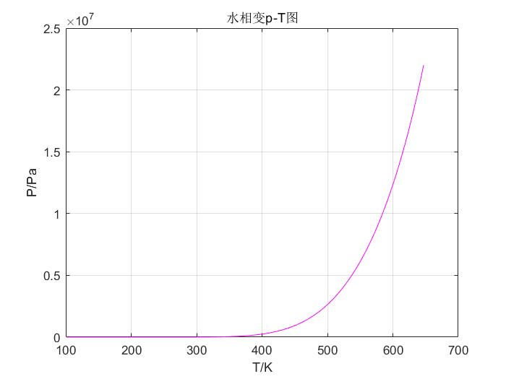

*2.大气压及对应饱和温度*

**程序：**

Tc=647.14;

Pc=22.046e6;

e=2.71828;

h=[0,500,1000,2000,3000,4000,5000];

Tr1=[0 0 0 0 0 0 0 ];

for i=1:7

Pa(i)=exp(5.25885*log(288.15-0.0065*h(i))-18.2573);

fprintf('p(%.4f)=%.4f Pa\n',i,Pa(i));

Pr1(i)=Pa(i)/Pc;

T1(i)=1;

while (abs(T1(i)-Tr1(i))>1e-8)

Tr1(i)=T1(i);

y(i)=log(Tr1(i))*(7.60794067+10.1932439*(1-Tr1(i))^1.89+21.1083545*(1-Tr1(i))^5.67)-log(Pr1(i));

y1(i)=(7.60794067+10.1932439*(1-Tr1(i))^1.89+21.1083545*(1-Tr1(i))^5.67)/Tr1(i)-log(Tr1(i))*(10.1932439*1.89*(1-Tr1(i))^0.89+21.1083545*5.67*(1-Tr1(i))^4.67);

T1(i)=Tr1(i)-y(i)/y1(i);

end

Tb(i)=T1(i)*Tc-273.13;

fprintf('T(%.4f)=%.4f ¡æ\n',i,Tb(i));

end

**结果：**

p(1.0000)=101325.9667 Pa

T(1.0000)=100.0458 ℃

p(2.0000)=95458.5300 Pa

T(2.0000)=98.3818 ℃

p(3.0000)=89869.3299 Pa

T(3.0000)=96.7159 ℃

p(4.0000)=79485.0608 Pa

T(4.0000)=93.3777 ℃

p(5.0000)=70094.6053 Pa

T(5.0000)=90.0304 ℃

p(6.0000)=61623.4910 Pa

T(6.0000)=86.6728 ℃

p(7.0000)=54001.2056 Pa

T(7.0000)=83.3039 ℃

**整理得：**

|  |  |  |
| --- | --- | --- |
| 高度/m | 大气压p/Pa | 饱和温度/℃ |
| 0 | 101325.9667 | 100.0458 |
| 500 | 95458.53 | 98.3818 |
| 1000 | 89869.3299 | 96.7159 |
| 2000 | 79485.0608 | 93.3777 |
| 3000 | 70094.6053 | 90.0304 |
| 4000 | 61623.491 | 86.6728 |
| 5000 | 54001.2056 | 83.3039 |

**6.2 试用Peng-Ronbinson方程计算纯质R290、R600a、R1234yf、R1234ze(E)的p-T相图和溶液R290/R600a分别在p=1atm和p=10atm下的T-x相图。**

**程序：**

*R290、R600a、R1234yf、R1234ze(E)的p-T相图程序：*

**主程序：**

p1=3e5;p2=3e5;p3=3e5;p4=3e5;dp=100;

N=20000;er=1e-8;

l=1;

i=input('Ñ¡Ôñ¹¤ÖÊ±àºÅ£º 1(R290) 2(R600a) 3(R1234yf) 4(R1234ze(E))');

while i<5

switch i

case 1

for T1=200:0.01:369.89

for n=1:N

func1v=func1(T1,p1,1.1);

func1L=func1(T1,p1,0.001);

if abs(func1v-func1L)<=er

Y(l)=p1;

X(l)=T1;

l=l+1;

break

else

p1=p1+dp;

end

end

if n==N+1

fprintf('error!')

break;

else

hold on;

end

end

plot(X,Y/10^6,'r-');

grid;

title('R290a工质的p-T相图');

xlabel('T/K');ylabel('p/MPa');

case 2

l=1;

for T2=200:0.01:369.89

for n=1:N

func2a=func2(T2,p2,1.1);

func2b=func2(T2,p2,0.001);

if abs(func2a-func2b)<=er

Y(l)=p2;

X(l)=T2;

l=l+1;

break

else

p2=p2+dp;

end

end

if n==N+1

fprintf('error!')

break;

else

hold on;

end

end

plot(X,Y/10^6,'b-');

grid;

title('R600a工质的p-T相图');

xlabel('T/K');ylabel('p/MPa');

case 3

l=1;

for T3=200:0.01:369.89

for n=1:N

func3a=func3(T3,p3,1.1);

func3b=func3(T3,p3,0.001);

if abs(func3a-func3b)<=er

Y(l)=p3;

X(l)=T3;

l=l+1;

break

else

p3=p3+dp;

end

end

if n==N+1

fprintf('error!')

break;

else

hold on;

end

end

plot(X,Y/10^6,'b-');

grid;

title('R1234yf工质的p-T相图');

xlabel('T/K');ylabel('p/MPa');

case 4

l=1;

for T4=200:0.01:369.89

for n=1:N

func4a=func4(T4,p4,1.1);

func4b=func4(T4,p4,0.001);

if abs(func4a-func4b)<=er

Y(l)=p4;

X(l)=T4;

l=l+1;

break

else

p4=p4+dp;

end

end

if n==N+1

fprintf('error!')

break;

else

hold on;

end

end

plot(X,Y/10^6,'g-');

grid;

title('R1234ze(E)工质的p-T相图');

xlabel('T/K');ylabel('p/MPa');

end

i=input(选择工质编号: 1--R290 2--R600a 3--R1234yf 4--R1234ze(E)');

end

**调用函数：**

1.

function [func1]=func1(T1,P1,Z)

R=8.31451;

M1=44.096e-3;

Tc1=369.89;

Pc1=4.2512e6;

w1=0.1512;

Tr1=T1/Tc1;

k1=0.37464+1.54226*w1-0.26992*w1^2;

al1=(1+k1*(1-Tr1^0.5))^2;

a1=0.45724*al1*(R^2)*(Tc1^2)/Pc1;

b1=0.07780*R*Tc1/Pc1;

A1=a1*P1/((R^2)*(T1^2));

B1=b1*P1/(R*T1);

Z=new(A1,B1,Z);

func1=exp(Z-1-log(Z-B1)-A1*log((Z+2.414*B1)/(Z-0.414*B1))/(2*sqrt(2)*B1));

end

2.

function [func2]=func2(T2,P2,Z)

R=8.31451;

M2=58.122e-3;

Tc2=407.81;

Pc2=3.629e6;

w2=0.184;

Tr2=T2/Tc2;

k2=0.37464+1.54226*w2-0.26992*w2^2;

al2=(1+k2*(1-Tr2^0.5))^2;

a2=0.45724*al2*(R^2)*(Tc2^2)/Pc2;

b2=0.07780*R*Tc2/Pc2;

A2=a2*P2/((R^2)*(T2^2));

B2=b2*P2/(R*T2);

Z=new(A2,B2,Z);

func2=exp(Z-1-log(Z-B2)-A2*log((Z+2.414*B2)/(Z-0.414*B2))/(2*sqrt(2)*B2));

end

3.

function [func3]=func3(T3,P3,Z)

R=8.31451;

M3=114.04e-3;

Tc3=367.85;

Pc3=3.3822e6;

w3=0.276;

Tr3=T3/Tc3;

k3=0.37464+1.54226*w3-0.26992*w3^2;

al1=(1+k3*(1-Tr3^0.5))^2;

a3=0.45724*al1*(R^2)*(Tc3^2)/Pc3;

b3=0.07780*R*Tc3/Pc3;

A3=a3*P3/((R^2)*(T3^2));

B3=b3*P3/(R*T3);

Z=new(A3,B3,Z);

func3=exp(Z-1-log(Z-B3)-A3*log((Z+2.414*B3)/(Z-0.414*B3))/(2*sqrt(2)*B3));

end

4.

function [func4]=func4(T4,P4,Z)

R=8.31451;

M4=114.04e-3;

Tc4=382.52;

Pc4=3.6363e6;

w4=0.313;

Tr4=T4/Tc4;

k4=0.37464+1.54226*w4-0.26992*w4^2;

al4=(1+k4*(1-Tr4^0.5))^2;

a4=0.45724*al4*(R^2)*(Tc4^2)/Pc4;

b4=0.07780*R*Tc4/Pc4;

A4=a4*P4/((R^2)*(T4^2));

B4=b4*P4/(R*T4);

Z=new(A4,B4,Z);

func4=exp(Z-1-log(Z-B4)-A4*log((Z+2.414*B4)/(Z-0.414*B4))/(2*sqrt(2)*B4));

end

**结果：**

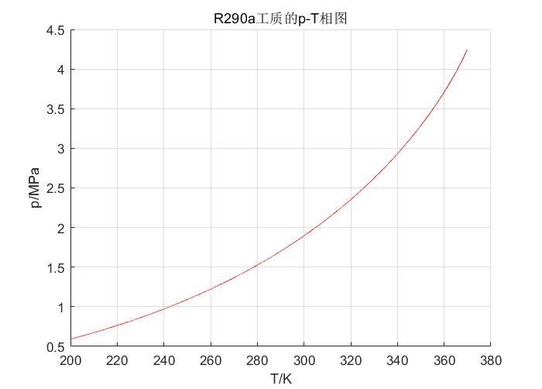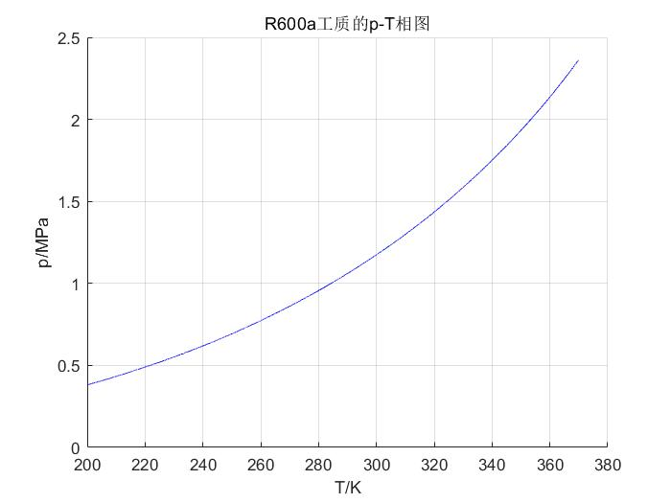

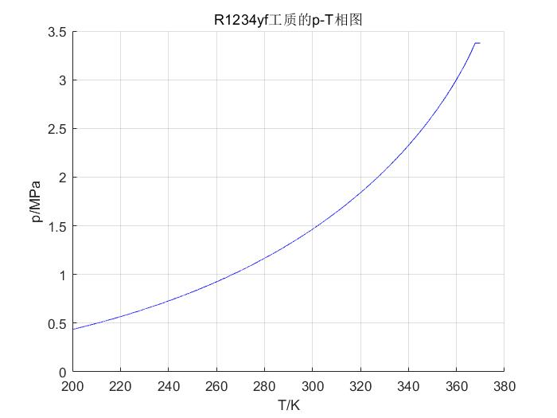

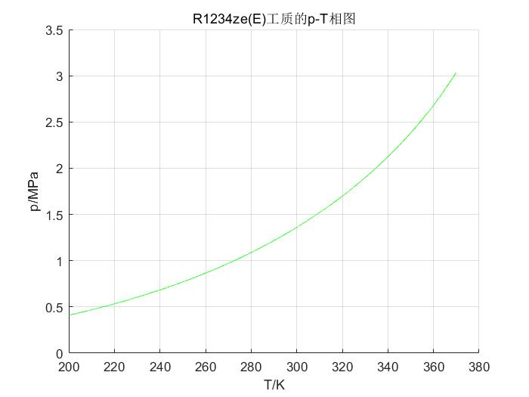

*R290/R600a分别在p=1atm和p=10atm下的T-x相图。*

**程序：**

Tc=[369.89,407.81];

Pc=[4.2512,3.629]*10^6;

w=[0.1521,0.184];

k12=0.01;

R=8.31451;

k=0.37464+1.54226*w-0.26992*w.^2;

b=0.07780*R.*Tc./Pc;

fp1=zeros(1,2);fp2=zeros(1,2);

u= input('选择压力: 1--1atm 2--10atm ');

for y1=0:0.001:1

if u==1

T=213;P=101e3;

Else

T=295;P=101e4;

end

y2=1-y1;

x1=0.1;

x2=1-x1;

x=0;

while abs(x-1)>=1e-3

T=T+0.1;

m=(1+k.*(1-(T./Tc).^0.5)).^2;

a=0.45724*m*R^2.*Tc.^2./Pc;

for i=1:2

if i==1

Z=0.0001;

am=x1^2*a(1,1)+2*x1*x2*(1-k12)*sqrt(a(1,1)*a(1,2))+x2^2*a(1,2);

bm=x1*b(1,1)+x2*b(1,2);

else

Z=1.1;

am=y1^2*a(1,1)+2*y1*y2*(1-k12)*sqrt(a(1,1)*a(1,2))+y2^2*a(1,2);

bm=y1*b(1,1)+y2*b(1,2);

end

A=am*P/(R*T)^2;

B=bm*P/R/T;

f=Z^3-(1-B)*Z^2+(A-3*B^2-2*B)*Z-(A*B-B^2-B^3);

f1=3*Z^2-2*(1-B)*Z+(A-3*B^2-2*B);

Y=Z-f/f1;

while abs(Y-Z)>10^(-6)

Z=Y;

f=Z^3-(1-B)*Z^2+(A-3*B^2-2*B)*Z-(A*B-B^2-B^3);

f1=3*Z^2-2*(1-B)*Z+(A-3*B^2-2*B);

Y=Z-f/f1;

end

if i==2

fp1(1,i)=exp(b(1,1)/bm*(Y-1)-log(Y-B)-A/B/sqrt(8)*(2*(y1*a(1,1)+y2*(1-k12)*sqrt(a(1,1)*a(1,2)))/am-b(1,1)/bm)*log((Y+2.414*B)/(Y-0.414*B)));

fp2(1,i)=exp(b(1,2)/bm*(Y-1)-log(Y-B)-A/B/sqrt(8)*(2*(y2*a(1,2)+y1*(1-k12)*sqrt(a(1,1)*a(1,2)))/am-b(1,2)/bm)*log((Y+2.414*B)/(Y-0.414*B)));

else

fp1(1,i)=exp(b(1,1)/bm*(Y-1)-log(Y-B)-A/B/sqrt(8)*(2*(x1*a(1,1)+x2*(1-k12)*sqrt(a(1,1)*a(1,2)))/am-b(1,1)/bm)*log((Y+2.414*B)/(Y-0.414*B)));

fp2(1,i)=exp(b(1,2)/bm*(Y-1)-log(Y-B)-A/B/sqrt(8)*(2*(x2*a(1,2)+x1*(1-k12)*sqrt(a(1,1)*a(1,2)))/am-b(1,2)/bm)*log((Y+2.414*B)/(Y-0.414*B)));

end

end

k1=fp1(1,2)/fp1(1,1);

k2=fp2(1,2)/fp2(1,1);

x1=k1*y1/(k1*y1+k2*y2);

x2=k2*y2/(k1*y1+k2*y2);

x0=x;

x=k1*y1+k2*y2;

while abs(x-x0)>1e-6

Z=0.0001;

am=x1^2*a(1,1)+2*x1*x2*(1-k12)*sqrt(a(1,1)*a(1,2))+x2^2*a(1,2);

bm=x1*b(1,1)+x2*b(1,2);

A=am*P/(R*T)^2;

B=bm*P/R/T;

f=Z^3-(1-B)*Z^2+(A-3*B^2-2*B)*Z-(A*B-B^2-B^3);

f1=3*Z^2-2*(1-B)*Z+(A-3*B^2-2*B);

Y=Z-f/f1;

while abs(Y-Z)>1e-6

Z=Y;

f=Z^3-(1-B)*Z^2+(A-3*B^2-2*B)*Z-(A*B-B^2-B^3);

f1=3*Z^2-2*(1-B)*Z+(A-3*B^2-2*B);

Y=Z-f/f1;

end

fp1(1,1)=exp(b(1,1)/bm*(Y-1)-log(Y-B)-A/B/sqrt(8)*(2*(x1*a(1,1)+x2*(1-k12)*sqrt(a(1,1)*a(1,2)))/am-b(1,1)/bm)*log((Y+2.414*B)/(Y-0.414*B)));

fp2(1,1)=exp(b(1,2)/bm*(Y-1)-log(Y-B)-A/B/sqrt(8)*(2*(x2*a(1,2)+x1*(1-k12)*sqrt(a(1,1)*a(1,2)))/am-b(1,2)/bm)*log((Y+2.414*B)/(Y-0.414*B)));

k1=fp1(1,2)/fp1(1,1);

k2=fp2(1,2)/fp2(1,1);

x1=k1*y1/(k1*y1+k2*y2);

x2=k2*y2/(k1*y1+k2*y2);

x0=x;

x=k1*y1+k2*y2;

end

end

plot(x1,T,'b.')

hold on

plot(y1,T,'k.')

hold on

end

if u==1

title('溶液R290/R600在10atm下的T-x相图');

xlabel('组分x(y)');

ylabel('温度 T/K');

else

title('溶液R290/R600在1atm下的T-x相图');

xlabel('组分x(y)');

ylabel('温度 T/K');

end

**结果：**

