高等工程热力学作业

组员：张梓睿3119303368 吕冠超3119103070

**第三章 实际气体状态方程**

一、请用PR方程计算工质R290、R600a、R1234yf、R1234ze和混合工质R290/R600a(50/50Wt%)的pvT性质。

PR方程的形式为：



 …… 





 …… 

 …………(R32/R125)

已知参数：R=8.31451;

R290： M=44.096g/mol Tc=369.89K pc=4.2512MPa w=0.1521

R600a：M=58.122g/mol Tc=407.81K pc=3.629Pa w=0.184

R1234yf： M=114.04g/mol Tc=367.85K pc=3.3822MPa w=0.276

R1234ze：M=114.04g/mol Tc=385.52K pc=3.6363Pa w=0.313

**解题思路：**

本题求解顺序

Tr K α a b A B

**1、程序如下**

纯质：

M=input('M=');

Tc=input('Tc=');

Pc=input('Pc=');

W=input('W=');

P=input('P=');

T=input('T=');

R=8.31451;

T=T+273.15;

Tr=T/Tc;

k=0.37464+1.54226*W-0.26992*W^2;

alpha=(1+k*(1-Tr^0.5))^2;

a=0.45724*(alpha*R^2*Tc^2/Pc);

b=0.07780*(R*Tc/Pc);

A=a*P/(R^2*T^2);

B=b*P/(R*T);

z=1;

D=1;

fz=1;

e1=0.00001;e2=0.00001;

while D>e1&&abs(fz)>e2

fz=z^3-(1-B)*z^2+z*(A-2*B-3*B^2)-(A*B-B^2-B^3);

fzz=3*z^2-2*(1-B)*z+A-2*B-3*B^2;

y=z;

z=z-fz/fzz;

D=abs((z-y)/z);

end

v=z*8.31451*T/(P*10^6);

fprintf('该温度及压力下的工质的摩尔体积为v=%.6fm3/mol\n',v);

**2、计算结果**

按照以上编程，用PR方程分别计算工质压力为1MPa.温度为25℃时，其摩尔体积值。

（1）R290

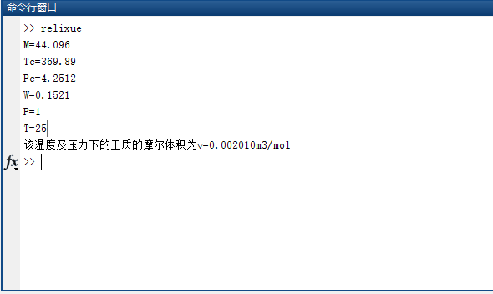

（2）R600a

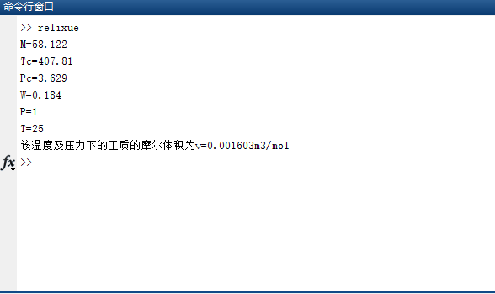

1. R1234yf

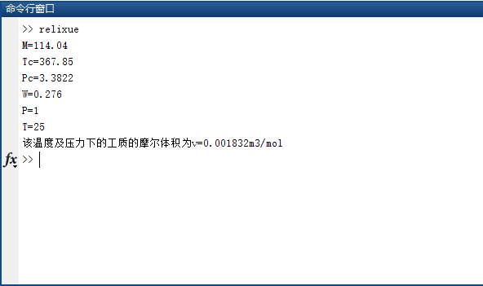

1. R1234ze

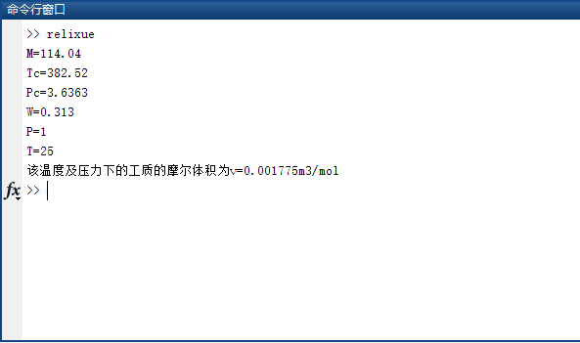

混合工质：

R290/R600a(50/50Wt%)

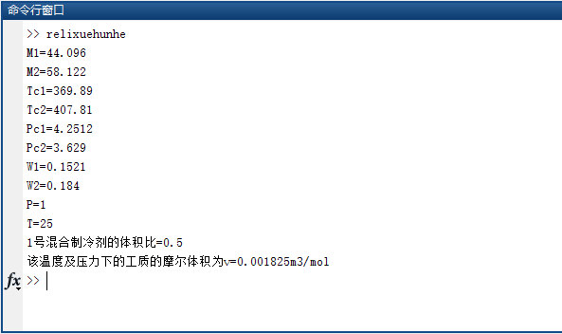

R600a饱和蒸汽比体积及其偏差

|  |  |  |  |  |
| --- | --- | --- | --- | --- |
| 温度 T(K) | 压力 P(Mpa) | 计算值(m^3/mol) | 文献值(m^3/mol) | 相对偏差% |
| 223.15 | 0.0168 | 0.109438 | 0.109222 | 0.198 |
| 243.15 | 0.0466 | 0.042497 | 0.042335 | 0.383 |
| 263.15 | 0.1084 | 0.019390 | 0.019299 | 0.472 |
| 283.15 | 0.2206 | 0.009952 | 0.009906 | 0.464 |
| 303.15 | 0.4047 | 0.005567 | 0.005546 | 0.379 |
| 323.15 | 0.6849 | 0.003308 | 0.003303 | 0.151 |
| 343.15 | 1.0876 | 0.002044 | 0.002049 | 0.244 |
| 363.15 | 1.6419 | 0.001284 | 0.001294 | 0.773 |

R290饱和蒸汽比体积及其偏差

|  |  |  |  |  |
| --- | --- | --- | --- | --- |
| 温度 T(K) | 压力 P(Mpa) | 计算值(m^3/mol) | 文献值(m^3/mol) | 相对偏差% |
| 223.15 | 0.0706 | 0.025617 | 0.025534 | 0.325 |
| 243.15 | 0.1678 | 0.011457 | 0.001404 | 0.468 |
| 263.15 | 0.3453 | 0.005802 | 0.005778 | 0.415 |
| 283.15 | 0.6366 | 0.003207 | 0.003199 | 0.250 |
| 303.15 | 1.0790 | 0.001879 | 0.001880 | 0.052 |
| 323.15 | 1.7133 | 0.001135 | 0.001142 | 0.613 |
| 343.15 | 2.5867 | 0.000682 | 0.000690 | 1.159 |
| 363.15 | 3.7641 | 0.000368 | 0.000371 | 0.809 |

**第四章 实际气体的导出热力学性质与过程**

二、请用PR方程计算工质R290、R600a和混合工质R290/R600a(50/50Wt%)的导出热力性质焓和熵。PR方程的余焓和余熵函数为：







理想气体比热：cp0=c0+ c1T+ c2T2 + c3T3 J/(kg.K)

R290： c0=-95.8 c1=6.945 c2=-3.597×10-3 c3=7.290×10-7

R600a： c0=-29.91 c1=6.605 c2=-3.176×10-3 c3=4.981×10-7

cp0=c0+ c1T+ c2T2 + c3T3 J/(mol.K)

R1234yf :c0=18.349 c1=128.316 c2=-33.354 c3=2.086

R1234ze： c0=55.388 c1=10.784 c2=99.250 c3=-49.88

0oC工质的饱和压力：

R290：ps=0.47446MPa R600a：ps=0.15696 MPa

R1234yf：ps=0.31582MPa R600a：ps=0.21648MPa

R290/R600a(50/50Wt%)：ps=0.32979 MPa(液相)

**解题思路：**

按照国际标准以0℃饱和液体为计算基准点。

取 

焓值计算



熵值计算

**解题思路**



function [hr,sr]=hr_sr(P,T,Pc,Tc,W,M)

R=8.31451;

tr=T/Tc;

k=0.37464+1.54226*W-0.26992*W^2;

alpha=(1+k*(1-tr^0.5))^2;

alpha1=-(1+k*(1-tr^0.5))*k*(1/T/Tc)^0.5;

a=0.45724*alpha*R^2*Tc^2/Pc*10^-6;

beta=0.45724*alpha1*R^2*Tc^2/Pc*10^-6;

b=0.07780*R*Tc/Pc*10^-6;

A=a*P*10^6/(R*T)^2;

B=b*P*10^6/T/R;

z=1.0;D=1;fz=1;

e1=0.00001;e2=0.00001;

while D>e1&&abs(fz)>e2

fz=z^3-(1-B)*z^2+z*(A-2*B-3*B^2)-(A*B-B^2-B^3);

fzz=3*z^2-2*(1-B)*z+A-2*B-3*B^2;

y=z;

z=z-fz/fzz;

D=abs((z-y)/z);

end

v=z*8.31451*T/P/10^6;

v1=R*T/P/10^6;

hr=(T*beta-a)/(2^1.5*b)*log((v-0.414*b)/(v+2.414*b))+R*T*(1-z);

sr=beta/(2^1.5*b)*log((v-0.414*b)/(v+2.414*b))-R*log((v-b)/v)-R*log(v/v1);

hr=hr/M;

sr=sr/M;

**R290**

M=44.096;

Tc=369.89;

Pc=4.2512;

W=0.1521;

P=0.4;

T=-3.15;

Ps=0.47446;

c0=-95.80;

c1=6.945;

c2=-3.597*10^-3;

c3=7.29*10^-7;

T0=273.15;

R=8.31451;

T=T+T0;

Tr=T/Tc;

[hr0 ,sr0]=hr_sr(Ps,273.15,Pc,Tc,W,M);

[hr,sr]=hr_sr(P,T,Pc,Tc,W,M);

hi=c0*(T-T0)+0.5*c1*(T^2-T0^2)+1/3*c2*(T^3-T0^3)+0.25*c3*(T^4-T0^4);

int2=c1*T+1/2*c2*T^2+1/3*c3*T^3+log(T/T0)-(c1*T0+1/2*c2*T0^2+1/3*c3*T0^3);

h=200+hr0+hi/1000-hr;

s=1+sr0+int2/1000-R*log(P/Ps)/M-sr;

s=s*M;

h=h*M;

fprintf('温度为%.2fK及压力为%.2fMpa时下工质的焓为h=%.8f J/mol\n',T,P,h);

fprintf('温度为%.2fK及压力为%.2fMpa时下工质的熵为s=%.8f J/mol.K\n',T,P,s);



**R600a**

M=58.122;

Tc=407.81;

Pc=3.629;

W=0.184;

P=0.4;

T=-3.15;

Ps=0.15696;

c0=-23.91;

c1=6.605;

c2=-3.176*10^-3;

c3=4.981*10^-7;

T0=273.15;

R=8.31451;

T=T+T0;

Tr=T/Tc;

[hr0 ,sr0]=hr_sr(Ps,273.15,Pc,Tc,W,M);

[hr,sr]=hr_sr(P,T,Pc,Tc,W,M);

hi=c0*(T-T0)+0.5*c1*(T^2-T0^2)+1/3*c2*(T^3-T0^3)+0.25*c3*(T^4-T0^4);

int2=c1*T+1/2*c2*T^2+1/3*c3*T^3+log(T/T0)-(c1*T0+1/2*c2*T0^2+1/3*c3*T0^3);

h=200+hr0+hi/1000-hr;

s=1+sr0+int2/1000-R*log(P/Ps)/M-sr;

s=s*M;

h=h*M;

fprintf('温度为%.2fK及压力为%.2fMpa时下工质的焓为h=%.8f J/mol\n',T,P,h);

fprintf('温度为%.2fK及压力为%.2fMpa时下工质的熵为s=%.8f J/mol.K\n',T,P,s);



**R1234yf**

M=114.04;

Tc=367.85;

Pc=3.3822;

W=0.276;

P=0.4;

T=-3.15;

Ps=0.31582;

c0=18.349;

c1=128.316;

c2=-33.354;

c3=2.086;

T0=273.15;

R=8.31451;

T=T+T0;

Tr=T/Tc;

[hr0 ,sr0]=hr_sr(Ps,273.15,Pc,Tc,W,M);

[hr,sr]=hr_sr(P,T,Pc,Tc,W,M);

hi=c0*(T-T0)+0.5*c1*(T^2-T0^2)/Tc+1/3*c2*(T^3-T0^3)/Tc/Tc+0.25*c3*(T^4-T0^4)/Tc/Tc/Tc;

int2=c1*T/Tc+1/2*c2*T^2/Tc/Tc+1/3*c3*T^3/Tc/Tc/Tc+log(T/T0)-(c1*T0/Tc+1/2*c2*T0^2/Tc/Tc+1/3*c3*T0^3/Tc/Tc/Tc);

int2=int2/M;

hi=hi/M;

h=200+hr0+hi-hr;

s=1+sr0+int2-R*log(P/Ps)/M-sr;

s=s*M;

h=h*M;

fprintf('温度为%.2fK及压力为%.2fMpa时下工质的焓为h=%.8f J/mol\n',T,P,h);

fprintf('温度为%.2fK及压力为%.2fMpa时下工质的熵为s=%.8f J/mol.K\n',T,P,s);



**R1234ze**

M=114.04;

Tc=382.52;

Pc=3.6363;

W=0.313;

P=0.4;

T=-3.15;

Ps=0.21648;

c0=55.389;

c1=10.784;

c2=99.250;

c3=-49.88;

T0=273.15;

R=8.31451;

T=T+T0;

Tr=T/Tc;

[hr0 ,sr0]=hr_sr(Ps,273.15,Pc,Tc,W,M);

[hr,sr]=hr_sr(P,T,Pc,Tc,W,M);

hi=c0*(T-T0)+0.5*c1*(T^2-T0^2)/Tc+1/3*c2*(T^3-T0^3)/Tc/Tc+0.25*c3*(T^4-T0^4)/Tc/Tc/Tc;

int2=c1*T/Tc+1/2*c2*T^2/Tc/Tc+1/3*c3*T^3/Tc/Tc/Tc+log(T/T0)-(c1*T0/Tc+1/2*c2*T0^2/Tc/Tc+1/3*c3*T0^3/Tc/Tc/Tc);

int2=int2/M;

hi=hi/M;

h=200+hr0+hi-hr;

s=1+sr0+int2-R*log(P/Ps)/M-sr;

s=s*M;

h=h*M;

fprintf('温度为%.2fK及压力为%.2fMpa时下工质的焓为h=%.8f J/mol\n',T,P,h);

fprintf('温度为%.2fK及压力为%.2fMpa时下工质的熵为s=%.8f J/mol.K\n',T,P,s);



**R290/R600a（50/50Wt%）**

function [hr ,sr]=Mix1 (p,t)

R=8.31451;

pc1=4.2512;tc1=369.89;w1=0.1521;M1=44.096;

tr1=t/tc1;

pc2=3.629;tc2=407.81;w2=0.184;M2=58.122;

tr2=t/tc2;

M=0.5686*M1+0.4314*M2;

k1=0.37464+1.54226*w1-0.26992*w1^2;

al1=(1+k1*(1-tr1^0.5))^2;

al11=-(1+k1*(1-tr1^0.5))*k1*(1/t/tc1)^0.5;

a1=0.45724*al1*R^2*tc1^2/pc1*10^-6;

a11=0.45724*al11*R^2*tc1^2/pc1*10^-6;

b1=0.07780*R*tc1/pc1*10^-6;

k2=0.37464+1.54226*w2-0.26992*w2^2;

al2=(1+k2*(1-tr2^0.5))^2;

al21=-(1+k2*(1-tr2^0.5))*k2*(1/t/tc2)^0.5;

a2=0.45724*al2*R^2*tc2^2/pc2*10^-6;

a21=0.45724*al21*R^2*tc2^2/pc2*10^-6;

b2=0.07780*R*tc2/pc2*10^-6;

k12=0.01;

am=0.3233*a1+0.1861*a2+0.4857*(1-k12)*sqrt(a1*a2);

am1=0.3233*a11+0.1861*a21+0.4857*(1-k12)*(1/sqrt(4*a1*a2)*(a11*a2+a1*a21));

bm=0.5686*b1+0.4314*b2;

A=am*p*10^6/(R*t)^2;

B=bm*p*10^6/t/R;

z=1.0;D=1;fz=1;

eps1=0.00001;eps2=0.00001;

while D>eps1&&abs(fz)>eps2

fz=z^3-(1-B)*z^2+z*(A-2*B-3*B^2)-(A*B-B^2-B^3);

fzz=3*z^2-2*(1-B)*z+A-2*B-3*B^2;

y=z;

z=z-fz/fzz;

D=abs((z-y)/z);

end

v=z*R*t/p/10^6;

v1=R*t/p/10^6;

hr=(t*am1-am)/(2^1.5*bm)*log((v-0.414*bm)/(v+2.414*bm))+R*t*(1-z);

sr=am1/(2^1.5*bm)*log((v-0.414*bm)/(v+2.414*bm))-R*log((v-bm)/v)-R*log(v/v1);

hr=hr/M;

sr=sr/M;

P=0.4;

T=-3.15;

T0=273.15;

T=T+T0;

R=8.31451;

Ps=0.32979;

M1=44.096;

M2=58.122;

M=0.5686*M1+0.4314*M2;

c01=-95.80;

c11=6.945;

c21=-3.597*10^-3;

c31=7.290*10^-7;

c02=-23.91;

c12=6.605;

c22=-3.176*10^-3;

c32=4.981*10^-7;

c0=0.5686*c01+0.4314*c02;

c1=0.5686*c11+0.4314*c12;

c2=0.5686*c21+0.4314*c22;

c3=0.5686*c31+0.4314*c32;

[hr, sr]=Mix1(P,T);

[hr0, sr0]=Mix1(Ps,T0);

int1=c0*T+1/2*c1*T^2+1/3*c2*T^3+1/4*c3*T^4-(c0*T0+1/2*c1*T0^2+1/3*c2*T0^3+1/4*c3*T0^4);

int2=c1*T+1/2*c2*T^2+1/3*c3*T^3+c0*log(T/T0)-(c1*T0+1/2*c2*T0^2+1/3*c3*T0^3);

h=200+hr0+int1/1000-hr;

s=1+sr0+int2/1000-R*log(P/Ps)/M-sr;

s=s*M;

h=h*M;

fprintf('温度为%.2fK及压力为%.2fMpa时下工质的焓为h=%.8f J/mol\n',T,P,h);

fprintf('温度为%.2fK及压力为%.2fMpa时下工质的熵为s=%.8f J/mol.K\n',T,P,s);



**第五章作业**

**4.计算混合工质R290/R600a：50/50Wt%在常压、不同温度下的逸度系数。**

*MATLAB实现程序：*

p=101325;

t=input('请输入温度t(摄氏度):');

Pc1=4251200;

Pc2=3629000;

Tc1=369.89;

Tc2=407.81;

Cs1=0.1521;

Cs2=0.184;

R=8.31451;

T=t +273.15;

Tr1=T/Tc1;

Tr2=T/Tc2;

K1=0.37464+1.54226*Cs1-0.26992*Cs1*Cs1;

K2=0.37464+1.54226*Cs2-0.26992*Cs2*Cs2;

al1=(1+K1*(1-sqrt(Tr1)))^2;

al2=(1+K2*(1-sqrt(Tr2)))^2;

a1=0.45724*al1*(R*Tc1)^2/Pc1;

a2=0.45724*al2*(R*Tc2)^2/Pc2;

b1=0.07780*R*Tc1/Pc1;

b2=0.07780*R*Tc2/Pc2;

a12=(1-0.01)*(a1*a2)^0.5;

x1=0.5;

x2=1-x1;

a=x1*x1*a1+2*x1*x2*(1-0.01)*sqrt(a1*a2)+x2*x2*a2;

b=x1*b1+x2*b2;

%PR方程的立方形式

A=a*p/(R*T)^2;

B=b*p/(R*T);

y1=(1-B);

y2=(A-3*B^2-2*B);

y3=(A*B-B^2-B^3);

Z=zeros(1,5000);

contem=1.1;%迭代初值

Z(1)=contem;

erro=1;

i=1;

%用牛顿迭代法求z

while abs(erro)>1e-6&&i<5000 %设定误差

Z(i+1)=Z(i)-((Z(i))^3-y1*(Z(i))^2+y2*Z(i)-y3)/(3*(Z(i))^2-2*y1*Z(i)+y2);

erro=Z(i+1)-Z(i);

i=i+1;

end

z=Z(i);

f=exp(b2/b*(z-1)-log(z-B)-A*((y2*x1*a1+2*x2*a12)/a-b2/b)*log((z+2.414*B)/(z-0.414*B))/(2*sqrt(2)*B));

fprintf('该温度下混合工质 R290/R600a 的逸度系数为 f=%.4f\n',f);

*计算结果：*

通过MATLAB编程计算了0℃到100℃以10℃为步长的常压下R290/R600a:50/50Wt%的逸度系数。不同温度下的逸度系数详细计算结果整理如下表

|  |  |
| --- | --- |
| R290/R600a:50/50Wt%常压下逸度系数 | |
| T（℃） | f |
| 0 | 1.0039 |
| 10 | 1.0037 |
| 20 | 1.0036 |
| 30 | 1.0034 |
| 40 | 1.0033 |
| 50 | 1.0031 |
| 60 | 1.0030 |
| 70 | 1.0029 |
| 80 | 1.0028 |
| 90 | 1.0027 |
| 100 | 1.0026 |

**第六章**

**试用Peng-Robinson方程计算纯质R290、R600a、R1234yf、R1234ze(E)的*p—T*相图和溶液R290/R600a分别在*p*=1atm和*p*=10atm下的*T—x*相图。**

***一、计算纯质R290、R600a、R1234yf、R1234ze(E)的p—T相图MATLAB实现程序：***

**（需要调用的函数）**

**1、**

function [gongshi1]=gongshi1(T1,P1,Z)

R=8.3145;

M1=44.096e-3;

Tc1=369.89;

Pc1=4.2512e6;

w1=0.1512;

Tr1=T1/Tc1;

k1=0.37464+1.54226*w1-0.26992*w1^2;

al1=(1+k1*(1-Tr1^0.5))^2;

a1=0.45724*al1*(R^2)*(Tc1^2)/Pc1;

b1=0.07780*R*Tc1/Pc1;

A1=a1*P1/((R^2)*(T1^2));

B1=b1*P1/(R*T1);

Z=newton(A1,B1,Z);

gongshi1=exp(Z-1-log(Z-B1)-A1*log((Z+2.414*B1)/(Z-0.414*B1))/(2*sqrt(2)*B1));

end

**2、**

function [gongshi2]=gongshi2(T2,P2,Z)

R=8.3145;

M2=58.122e-3;

Tc2=407.81;

Pc2=3.629e6;

w2=0.184;

Tr2=T2/Tc2;

k2=0.37464+1.54226*w2-0.26992*w2^2;

al2=(1+k2*(1-Tr2^0.5))^2;

a2=0.45724*al2*(R^2)*(Tc2^2)/Pc2;

b2=0.07780*R*Tc2/Pc2;

A2=a2*P2/((R^2)*(T2^2));

B2=b2*P2/(R*T2);

Z=newton(A2,B2,Z);

gongshi2=exp(Z-1-log(Z-B2)-A2*log((Z+2.414*B2)/(Z-0.414*B2))/(2*sqrt(2)*B2));

end

**3、**

function [gongshi3]=gongshi3(T3,P3,Z)

R=8.3145;

M3=114.04e-3;

Tc3=367.85;

Pc3=3.3822e6;

w3=0.276;

Tr3=T3/Tc3;

k3=0.37464+1.54226*w3-0.26992*w3^2;

al1=(1+k3*(1-Tr3^0.5))^2;

a3=0.45724*al1*(R^2)*(Tc3^2)/Pc3;

b3=0.07780*R*Tc3/Pc3;

A3=a3*P3/((R^2)*(T3^2));

B3=b3*P3/(R*T3);

Z=newton(A3,B3,Z);

gongshi3=exp(Z-1-log(Z-B3)-A3*log((Z+2.414*B3)/(Z-0.414*B3))/(2*sqrt(2)*B3));

end

**4、**

function [gongshi4]=gongshi4(T4,P4,Z)

R=8.3145;

M4=114.04e-3;

Tc4=382.52;

Pc4=3.6363e6;

w4=0.313;

Tr4=T4/Tc4;

k4=0.37464+1.54226*w4-0.26992*w4^2;

al4=(1+k4*(1-Tr4^0.5))^2;

a4=0.45724*al4*(R^2)*(Tc4^2)/Pc4;

b4=0.07780*R*Tc4/Pc4;

A4=a4*P4/((R^2)*(T4^2));

B4=b4*P4/(R*T4);

Z=newton(A4,B4,Z);

gongshi4=exp(Z-1-log(Z-B4)-A4*log((Z+2.414*B4)/(Z-0.414*B4))/(2*sqrt(2)*B4));

end

**5、**

function Z=newton(A,B,Z)

err=1e-6;

for n=0:1000

f=Z^3-(1-B)*Z^2+Z*(A-2*B-3*B^2)-(A*B-B^2-B^3);

Z=Z-f/(3*Z^2-2*(1-B)*Z+(A-2*B-3*B^2));

if(abs(f)<err)

break

end

end

end

**（主程序）**

p1=3e5;p2=3e5;p3=3e5;p4=3e5;dp=100;

N=20000;err=1e-8;

u=1;

i=input('请输入工质序号: 1--R290 2--R600a 3--R1234yf 4--R1234ze(E) 5--退出\n');

while i<5

switch i

case 1

for T1=200:0.1:369.89

for n=1:N

gongshi1v=gongshi1(T1,p1,1.1);

gongshi1L=gongshi1(T1,p1,0.001);

if abs(gongshi1v-gongshi1L)<=err

Y(u)=p1;

X(u)=T1;

u=u+1;

break

else

p1=p1+dp;

end

end

if n==N+1

fprintf('error!')

break;

else

hold on;

end

end

plot(X,Y/10^6,'r-');

grid;

title('R290a 工质 p-T 相图');

xlabel('T/K');ylabel('p/MPa');

case 2

u=1;

for T2=200:0.1:369.89

for n=1:N

gongshi2v=gongshi2(T2,p2,1.1);

gongshi2L=gongshi2(T2,p2,0.001);

if abs(gongshi2v-gongshi2L)<=err

Y(u)=p2;

X(u)=T2;

u=u+1;

break

else

p2=p2+dp;

end

end

if n==N+1

fprintf('error!')

break;

else

hold on;

end

end

plot(X,Y/10^6,'r-');

grid;

title('R600a 工质 p-T 相图');

xlabel('T/K');ylabel('p/MPa');

case 3

u=1;

for T3=200:0.1:369.89

for n=1:N

gongshi3v=gongshi3(T3,p3,1.1);

gongshi3L=gongshi3(T3,p3,0.001);

if abs(gongshi3v-gongshi3L)<=err

Y(u)=p3;

X(u)=T3;

u=u+1;

break

else

p3=p3+dp;

end

end

if n==N+1

fprintf('error!')

break;

else

hold on;

end

end

plot(X,Y/10^6,'r-');

grid;

title('R1234yf 工质 p-T 相图');

xlabel('T/K');ylabel('p/MPa');

case 4

u=1;

for T4=200:0.1:369.89

for n=1:N

gongshi4v=gongshi4(T4,p4,1.1);

gongshi4L=gongshi4(T4,p4,0.001);

if abs(gongshi4v-gongshi4L)<=err

Y(u)=p4;

X(u)=T4;

u=u+1;

break

else

p4=p4+dp;

end

end

if n==N+1

fprintf('error!')

break;

else

hold on;

end

end

plot(X,Y/10^6,'r-');

grid;

title('R1234ze(E)工质 p-T 相图');

xlabel('T/K');ylabel('p/MPa');

end

i=input('请输入工质序号: 1--R290 2--R600a 3--R1234yf 4--R1234ze(E) 5--退出\n');

end

***输出结果***

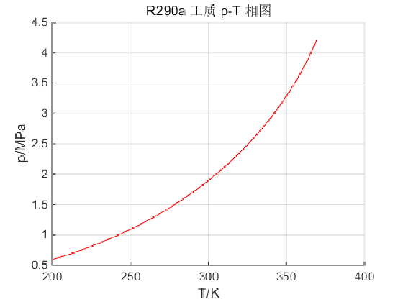

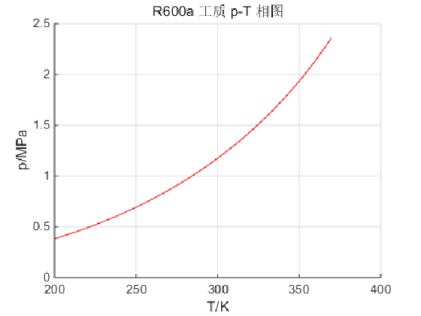

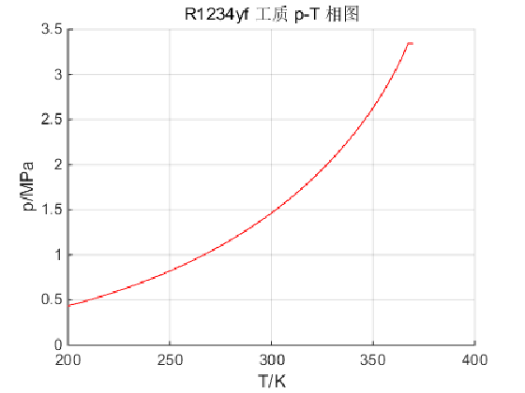

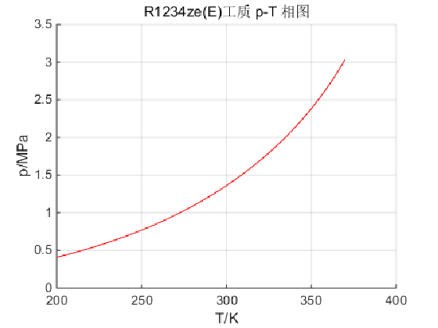

***二、溶液R290/R600a分别在p=1atm和p=10atm下的T—x相图的MATLAB实现***

Tc=[369.89,407.81];

Pc=[4.2512,3.629]*10^6;

w=[0.1521,0.184];

k12=0.01;

R=8.31451;%J/(mol·K)

k=0.37464+1.54226*w-0.26992*w.^2;

b=0.07780*R.*Tc./Pc;

fp1=zeros(1,2);fp2=zeros(1,2);

u= input('请输入压力序号: 1--10atm 2--1atm ');

for y1=0:0.001:1

if u==1

T=295;P=0.101e7; %P=10atm

else

T=213;P=0.101e6;%P=1atm

end

y2=1-y1;x1=0.1;x2=1-x1;x=0;

while abs(x-1)>=1e-2

T=T+0.1;

m=(1+k.*(1-(T./Tc).^0.5)).^2;

a=0.45724*m*R^2.*Tc.^2./Pc;

for i=1:2

if i==1

Z=0.0001;

am=x1^2*a(1,1)+2*x1*x2*(1-k12)*sqrt(a(1,1)*a(1,2))+x2^2*a(1,2);

bm=x1*b(1,1)+x2*b(1,2);

else

Z=1.1;

am=y1^2*a(1,1)+2*y1*y2*(1-k12)*sqrt(a(1,1)*a(1,2))+y2^2*a(1,2);

bm=y1*b(1,1)+y2*b(1,2);

end

A=am*P/(R*T)^2;

B=bm*P/R/T;

f=Z^3-(1-B)*Z^2+(A-3*B^2-2*B)*Z-(A*B-B^2-B^3);

f1=3*Z^2-2*(1-B)*Z+(A-3*B^2-2*B);

Y=Z-f/f1;

while abs(Y-Z)>10^(-6)

Z=Y;

f=Z^3-(1-B)*Z^2+(A-3*B^2-2*B)*Z-(A*B-B^2-B^3);

f1=3*Z^2-2*(1-B)*Z+(A-3*B^2-2*B);

Y=Z-f/f1;

end

if i==2

fp1(1,i)=exp(b(1,1)/bm*(Y-1)-log(Y-B)-A/B/sqrt(8)*(2*(y1*a(1,1)+y2*(1-k12)*sqrt(a(1,1)*a(1,2)))/am-b(1,1)/bm)*log((Y+2.414*B)/(Y-0.414*B)));

fp2(1,i)=exp(b(1,2)/bm*(Y-1)-log(Y-B)-A/B/sqrt(8)*(2*(y2*a(1,2)+y1*(1-k12)*sqrt(a(1,1)*a(1,2)))/am-b(1,2)/bm)*log((Y+2.414*B)/(Y-0.414*B)));

else

fp1(1,i)=exp(b(1,1)/bm*(Y-1)-log(Y-B)-A/B/sqrt(8)*(2*(x1*a(1,1)+x2*(1-k12)*sqrt(a(1,1)*a(1,2)))/am-b(1,1)/bm)*log((Y+2.414*B)/(Y-0.414*B)));

fp2(1,i)=exp(b(1,2)/bm*(Y-1)-log(Y-B)-A/B/sqrt(8)*(2*(x2*a(1,2)+x1*(1-k12)*sqrt(a(1,1)*a(1,2)))/am-b(1,2)/bm)*log((Y+2.414*B)/(Y-0.414*B)));

end

end

k1=fp1(1,2)/fp1(1,1);

k2=fp2(1,2)/fp2(1,1);

x1=k1*y1/(k1*y1+k2*y2);

x2=k2*y2/(k1*y1+k2*y2);

x0=x;

x=k1*y1+k2*y2;

while abs(x-x0)>1e-3

Z=0.0001;

am=x1^2*a(1,1)+2*x1*x2*(1-k12)*sqrt(a(1,1)*a(1,2))+x2^2*a(1,2);

bm=x1*b(1,1)+x2*b(1,2);

A=am*P/(R*T)^2;

B=bm*P/R/T;

f=Z^3-(1-B)*Z^2+(A-3*B^2-2*B)*Z-(A*B-B^2-B^3);

f1=3*Z^2-2*(1-B)*Z+(A-3*B^2-2*B);

Y=Z-f/f1;

while abs(Y-Z)>10^(-6)

Z=Y;

f=Z^3-(1-B)*Z^2+(A-3*B^2-2*B)*Z-(A*B-B^2-B^3);

f1=3*Z^2-2*(1-B)*Z+(A-3*B^2-2*B);

Y=Z-f/f1;

end

fp1(1,1)=exp(b(1,1)/bm*(Y-1)-log(Y-B)-A/B/sqrt(8)*(2*(x1*a(1,1)+x2*(1-k12)*sqrt(a(1,1)*a(1,2)))/am-b(1,1)/bm)*log((Y+2.414*B)/(Y-0.414*B)));

fp2(1,1)=exp(b(1,2)/bm*(Y-1)-log(Y-B)-A/B/sqrt(8)*(2*(x2*a(1,2)+x1*(1-k12)*sqrt(a(1,1)*a(1,2)))/am-b(1,2)/bm)*log((Y+2.414*B)/(Y-0.414*B)));

k1=fp1(1,2)/fp1(1,1);

k2=fp2(1,2)/fp2(1,1);

x1=k1*y1/(k1*y1+k2*y2);

x2=k2*y2/(k1*y1+k2*y2);

x0=x;

x=k1*y1+k2*y2;

end

end

plot(x1,T,'b.')

hold on

plot(y1,T,'r.')

hold on

end

if u==1

title('溶液R290/R600a在10atm下的相图');

xlabel('组分x(y)');

ylabel('温度 T/K');

else

title('溶液R290/R600a在1atm下的相图');

xlabel('组分x(y)');

ylabel('温度 T/K');

end

***输出结果***

