Hypothesis Test - Population Mean - Two Tailed Test

Abhirup Sen

13/05/2021

# writeLines('PATH="${RTOOLS40_HOME}\\usr\\bin;${C:\rtools40}"', con = "~/.Renviron")  
  
# install.packages("tinytex")

library(tinytex)

### For an insurance company the average liability insurance for each board seat is $2000.

###Significance level is 0.01. ###Population std dev = 947 ###Let’s test this hypothesis using the Growth Resources, Inc. survey data. ###Sample : n = 100,sample mean = 2700

###Solution

## Step 1:

###Set up null hypothesis and alternative hypothesis ###H0 = μ = 2000 # Null Hypothesis ###H1 = μ != 2000 # Alternative Hypothesis - Lower tailed test

α = 0.01 # level of significance  
n = 100 # Sample Size

## Step 2: Compute Test Statistics

Z = (2700 -2000)/(947/sqrt(100))  
Z

## [1] 7.391763

## Step 3: Compute critical value for significance level = 0.05 or Confidence Interval = 95%

Zα1 = qnorm(1-α, lower.tail = FALSE)  
Zα2 = qnorm(1-α, lower.tail = TRUE)  
Zα1

## [1] -2.326348

Zα2

## [1] 2.326348

x <- seq(0, 5400, by = 1)  
y <- dnorm(x, mean = 2700, sd = 947)  
  
#Some calcualatioins to plot the confidence interval - which i failed.  
U <- 5400 - Zα2  
xU <- seq(5000, 5400, 1)  
yU <- dnorm(xU, mean = 2700, sd = 947)  
y1 <- dnorm(U,mean = 2700, sd = 947)  
y1

## [1] 7.285333e-06

L <- Zα2  
xL <- seq(0, 400 ,1)  
yL <- dnorm(xL, mean = 2700, sd = 947)  
  
plot(x,y,type="l")  
polygon(c(x, rev(x)),c(y, rep(0, length(y))),border = NA, col = adjustcolor('red', alpha=0.3) )  
polygon(c(xL, rev(xL)),c(yL, rep(0, length(yL))),border = NA, col = adjustcolor('yellow', alpha=0.3) )  
polygon(c(xU, rev(xU)),c(yU, rep(0, length(yU))),border = NA, col = adjustcolor('green', alpha=0.3) )  
  
  
 lines(x,y)  
 abline(v=400)  
 abline(v=5000)  
  
 # lines(1000,y1,col ="red")  
 # lines(5000, col ="blue")  
 lines(xU,yU, lwd = 2, col ="red")  
 lines(xL,yL, lwd = 2, col ="blue")  
# points(U,yU, pch=16)  
# points(L,yL, pch=16)  
  
points(400,y1, col= "red", pch=20)  
points(5000,y1,col ="red", pch=20)  
  
  
box()

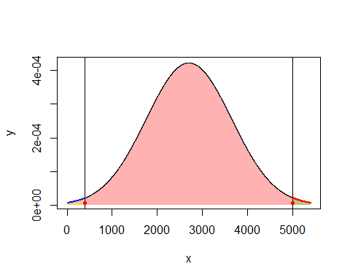

if ( Z < Zα1 || Z> Zα2){  
 print (" Z is not significant and the null hypothesis may, therefore, be accepted")  
} else {  
 print(" Z is significant and the null hypothesis is rejected")  
}

## [1] " Z is not significant and the null hypothesis may, therefore, be accepted"

## Step 4: Compare Test statistic with critical value and conclude the test

### Conclusion - the test statistic falls in the upper rejection region; therefore,

# Ho is rejected and the average insurance liability is more than $2000