参考网页：

[通用定时器 - ESP32 - — ESP-IDF 编程指南 v4.3 文档 (espressif.com)](https://docs.espressif.com/projects/esp-idf/zh_CN/v4.3/esp32/api-reference/peripherals/timer.html)

[ESP32学习笔记（42）——硬件定时器接口使用_Leung的博客-CSDN博客_esp32硬件定时器](https://blog.csdn.net/qq_36347513/article/details/119537681)

[FreeRTOS学习笔记（3）——消息队列_Leung的博客-CSDN博客](https://blog.csdn.net/qq_36347513/article/details/109488543)

API参考：



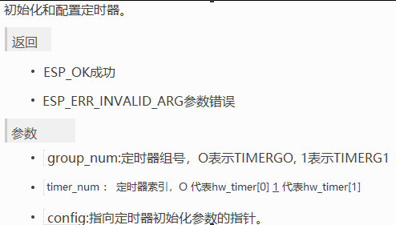



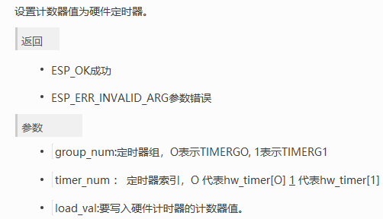



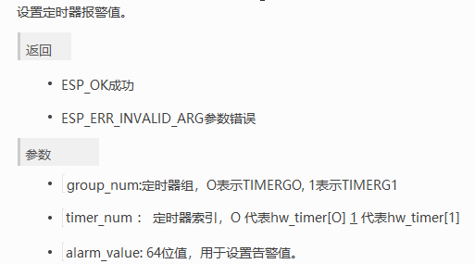



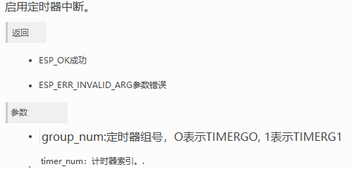

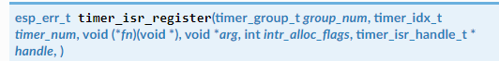

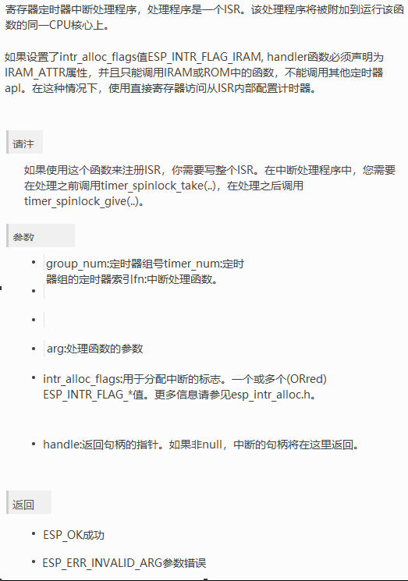



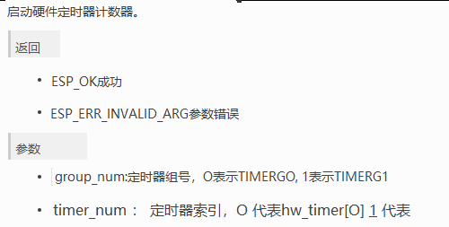



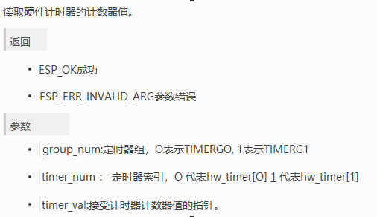



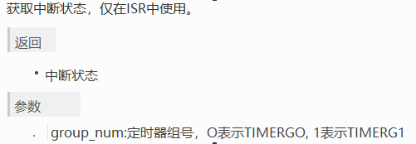



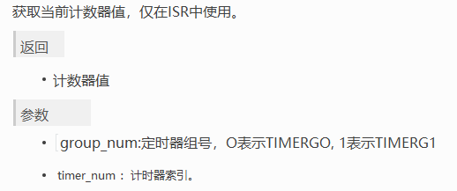



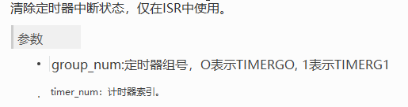



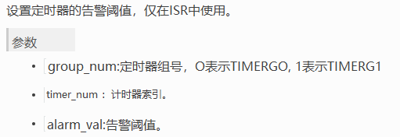



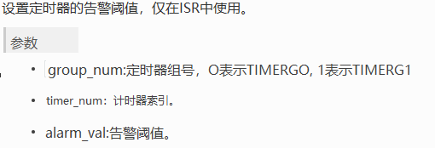

1. 定时器初始化，即相关设置

* 定时器参数结构体

typedef struct {

    int timer_group;//定时器组号

    int timer_idx;//定时器索引

    int alarm_interval;//定时器预警间隔

    bool auto_reload;//定时器是否自动重载

} example_timer_info_t;

/**

 * @brief A sample structure to pass events from the timer ISR to task

 *

 */

typedef struct {

    example_timer_info_t info;

    uint64_t timer_counter_value;//定时器计数值

} example_timer_event_t;

* 初始化

定时器初始化时是调用函数timer_init()，并给其传递一个包含定时器各种参数的结构体config（结构体名由编者自定）来达到初始化定时器的目的。

static void **example_tg_timer_init**(int group, int timer, bool auto_reload, int timer_interval_sec)

{

timer_config_t config = {

        .divider = TIMER_DIVIDER,//分频倍数

        .counter_dir = TIMER_COUNT_UP,//向上计数(1)/向下计数(0)

        .counter_en = TIMER_PAUSE,//定时器开(1)关(0)

        .alarm_en = TIMER_ALARM_EN,//定时器中断开(1)关(0)

        .auto_reload = auto_reload,//是否自动重载

    }; // default clock source is APB

**timer_init**(group, timer, &config);

**timer_set_counter_value**(group, timer, 0);//定时器计数起始值

    //设置中断阈值及中断使能

**timer_set_alarm_value**(group, timer, timer_interval_sec * TIMER_SCALE);

**timer_enable_intr**(group, timer);//中断使能

    example_timer_info_t *timer_info = **calloc**(1, sizeof(example_timer_info_t));

    timer_info->timer_group = group;

    timer_info->timer_idx = timer;

    timer_info->auto_reload = auto_reload;

    timer_info->alarm_interval = timer_interval_sec;

    /*

    timer_isr_callback_add的参数中，timer_info会传递给

timer_group_isr_callback的arg

*/

**timer_isr_callback_add**(group, timer, timer_group_isr_callback, timer_info, 0);

**timer_start**(group, timer);//启动定时器

}

1. 定时器控制

当定时器启用（即config结构体中.alarm_en = TIMER_ALARM_EN,）可调用：timer_set_counter_value()设置定时器的初始计数值，调用timer_get_counter_value()获取当前的计数值，调用timer_pause()暂停计数器，调用timer_start()重启计数器

1. 定时器中断

ESP32的硬件定时器有一个ISP程序，我们可以将定时器的回调函数配置在这个ISR程序中，即让ISR为我们执行回调函数，但要求回调函数尽可能简短，不执行任何耗时操作

* 队列

static xQueueHandle s_timer_queue;//定义队列句柄

//main函数中创建队列

s_timer_queue = **xQueueCreate**(10, sizeof(example_timer_event_t));

//ISR Callback函数中通过队列将定时器参数信息传给main

**xQueueSendFromISR**(s_timer_queue, &evt, &high_task_awoken);

//main函数中，接受回调函数中，通过队列传回的定时器参数信息

**xQueueReceive**(s_timer_queue, &evt, portMAX_DELAY);

* 创建ISP 回调函数

static bool IRAM_ATTR **timer_group_isr_callback**(void *args)

{

    BaseType_t high_task_awoken = pdFALSE;

example_timer_info_t *info = (example_timer_info_t *) args;

uint64_t timer_counter_value = **timer_group_get_counter_value_in_isr**(info->timer_group, info->timer_idx);

    /*

    Prepare basic event data that will be then sent back to task

    将本函数中由example_timer_info_t定义的结构体变量info传递给由

    example_timer_event_t定义的结构体变量evt

    注：建议将info变量更名为 info_temp 以便于区分

    如下:

    example_timer_info_t *info_temp = (example_timer_info_t *) args;

    example_timer_event_t evt = {

        .info.timer_group = info_temp->timer_group,

        .info.timer_idx = info_temp->timer_idx,

        .info.auto_reload = info_temp->auto_reload,

        .info.alarm_interval = info_temp->alarm_interval,

        .timer_counter_value = timer_counter_value

    };

     */

    example_timer_event_t evt = {

        .info.timer_group = info->timer_group,

        .info.timer_idx = info->timer_idx,

        .info.auto_reload = info->auto_reload,

        .info.alarm_interval = info->alarm_interval,

        .timer_counter_value = timer_counter_value

};

    if (!info->auto_reload) {

        //如果不自动重载，则设置下次预警值为此时的预警值加上预警间隔

        timer_counter_value += info->alarm_interval * TIMER_SCALE;

        //更新预警值

**timer_group_set_alarm_value_in_isr**(info->timer_group, info->timer_idx, timer_counter_value);

    }

    /* Now just send the event data back to the main program task */

**xQueueSendFromISR**(s_timer_queue, &evt, &high_task_awoken);

return high_task_awoken == pdTRUE;

}

注：其中args 用于接受在timer_isr_callback-add(ISR Callback注册函数)中穿进来的定时器的信息结构体指针

在ISR中可以调用：timer_group_get_counter_value_in_isr()来获取计数器的值，调用timer_group_set_alarm_value_in_isr()来设置定时器的预警值

**完整例程**

#include <stdio.h>

#include "freertos/FreeRTOS.h"

#include "freertos/task.h"

#include "freertos/queue.h"

#include "driver/timer.h"

#define **TIMER_DIVIDER**         (16)  //硬件定时器分频倍数Hardware timer clock divider

// 定时器计数频率convert counter value to seconds

#define **TIMER_SCALE**           (TIMER_BASE_CLK / TIMER_DIVIDER)

typedef struct {

    int timer_group;//定时器组号

    int timer_idx;//定时器索引

    int alarm_interval;//定时器预警间隔

    bool auto_reload;//定时器是否自动重载

} example_timer_info_t;

/**

 * @brief A sample structure to pass events from the timer ISR to task

 *

 */

typedef struct {

    example_timer_info_t info;

    uint64_t timer_counter_value;

} example_timer_event_t;

static xQueueHandle s_timer_queue;//队列句柄

/*

 * A simple helper function to print the raw timer counter value

 * and the counter value converted to seconds

 * inline：在定义函数的时候  将其定义为内联函数

 */

static void inline **print_timer_counter**(uint64_t counter_value)

{

**printf**("Counter: 0x%08x%08x\r\n", (uint32_t) (counter_value >> 32),

           (uint32_t) (counter_value));

**printf**("Time   : %.8f s\r\n", (double) counter_value / TIMER_SCALE);

}

static bool IRAM_ATTR **timer_group_isr_callback**(void *args)

{

    BaseType_t high_task_awoken = pdFALSE;

example_timer_info_t *info = (example_timer_info_t *) args;

uint64_t timer_counter_value = **timer_group_get_counter_value_in_isr**(info->timer_group, info->timer_idx);

    /*

    Prepare basic event data that will be then sent back to task

    将本函数中由example_timer_info_t定义的结构体变量info（见第41行）传递给由

    example_timer_event_t定义的结构体变量evt（见第63行）

    注：建议将info变量更名为 info_temp 以便于区分

    如下:

    example_timer_info_t *info_temp = (example_timer_info_t *) args;

    example_timer_event_t evt = {

        .info.timer_group = info_temp->timer_group,

        .info.timer_idx = info_temp->timer_idx,

        .info.auto_reload = info_temp->auto_reload,

        .info.alarm_interval = info_temp->alarm_interval,

        .timer_counter_value = timer_counter_value

    };

     */

    example_timer_event_t evt = {

        .info.timer_group = info->timer_group,

        .info.timer_idx = info->timer_idx,

        .info.auto_reload = info->auto_reload,

        .info.alarm_interval = info->alarm_interval,

        .timer_counter_value = timer_counter_value

};

    if (!info->auto_reload) {

        //如果不自动重载，则设置下次预警值为此时的预警值加上预警间隔

        timer_counter_value += info->alarm_interval * TIMER_SCALE;

        //更新预警值

**timer_group_set_alarm_value_in_isr**(info->timer_group, info->timer_idx, timer_counter_value);

}

    /* Now just send the event data back to the main program task */

**xQueueSendFromISR**(s_timer_queue, &evt, &high_task_awoken);

    return high_task_awoken == pdTRUE; // return whether we need to yield at the end of ISR

}

/**

 * @brief Initialize selected timer of timer group

 *

 * @param group Timer Group number, index from 0

 * @param timer timer ID, index from 0

 * @param auto_reload whether auto-reload on alarm event

 * @param timer_interval_sec interval of alarm

 */

static void **example_tg_timer_init**(int group, int timer, bool auto_reload, int timer_interval_sec)

{

    /* Select and initialize basic parameters of the timer */

    timer_config_t config = {

        .divider = TIMER_DIVIDER,//分频倍数

        .counter_dir = TIMER_COUNT_UP,//向上计数(1)/向下计数(0)

        .counter_en = TIMER_PAUSE,//定时器开(1)关(0)

        .alarm_en = TIMER_ALARM_EN,//定时器中断开(1)关(0)

        .auto_reload = auto_reload,//是否自动重载

    }; // default clock source is APB

**timer_init**(group, timer, &config);

    /* Timer's counter will initially start from value below.

       Also, if auto_reload is set, this value will be automatically reload on alarm */

**timer_set_counter_value**(group, timer, 0);//定时器计数起始值

    /*

    Configure the alarm value and the interrupt on alarm.

    设置中断阈值及中断使能

    */

**timer_set_alarm_value**(group, timer, timer_interval_sec * TIMER_SCALE);

**timer_enable_intr**(group, timer);//中断使能

    example_timer_info_t *timer_info = **calloc**(1, sizeof(example_timer_info_t));

    timer_info->timer_group = group;

    timer_info->timer_idx = timer;

    timer_info->auto_reload = auto_reload;

    timer_info->alarm_interval = timer_interval_sec;

    /*

    timer_isr_callback_add的参数中，timer_info会传递给

    timer_group_isr_callback的arg(详见51行)

    */

**timer_isr_callback_add**(group, timer, timer_group_isr_callback, timer_info, 0);

**timer_start**(group, timer);

}

void **app_main**(void)

{

s_timer_queue = **xQueueCreate**(10, sizeof(example_timer_event_t));

    //初始化两个定时器

**example_tg_timer_init**(TIMER_GROUP_0, TIMER_0, true, 3);

**example_tg_timer_init**(TIMER_GROUP_1, TIMER_0, false, 5);

    //测试前两个计数器是否准时

**example_tg_timer_init**(TIMER_GROUP_1, TIMER_1, false, 1);

    while (1) {

        /*

        定义一个example_timer_event_t结构体变量evt来接收从回调函数中通过队列传回的数据

        (详见第84行：xQueueSendFromISR(s_timer_queue, &evt, &high_task_awoken);)

        其中包括定时器组号：timer_group、定时器索引：timer_idx、

        定时器是否自动重载：auto_reload、定时器中断阈值：timer_interval_sec

        定时器当前计数值：timer_counter_value

        */

        example_timer_event_t evt;

**xQueueReceive**(s_timer_queue, &evt, portMAX_DELAY);

**printf**("\n");

**printf**("/*************************/\n");

        /* Print information that the timer reported an event */

        if (evt.info.auto_reload) {

**printf**("Timer Group with auto reload\n");

        } else {

**printf**("Timer Group without auto reload\n");

        }

**printf**("Group[%d], timer[%d] alarm event\n", evt.info.timer_group, evt.info.timer_idx);

        /* Print the timer values passed by event */

**printf**("------- EVENT TIME --------\n");

**print_timer_counter**(evt.timer_counter_value);

        /* Print the timer values as visible by this task */

**printf**("-------- TASK TIME --------\n");

        uint64_t task_counter_value;

**timer_get_counter_value**(evt.info.timer_group, evt.info.timer_idx, &task_counter_value);

**print_timer_counter**(task_counter_value);

**printf**("/*************************/\n");

**printf**("\n");

    }

}

23233