[Photo Editor | Go From Photo To Painting With BeFunky](https://www.befunky.com/create/photo-to-art/)

Default setting

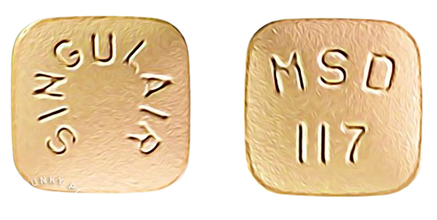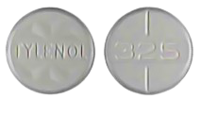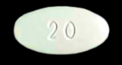

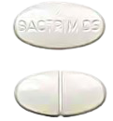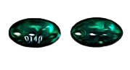

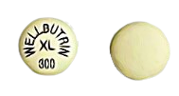

|  |  |
| --- | --- |
|  |  |
|  |  |
|  |  |
|  |  |
|  |  |
|  |  |
|  |  |
|  |  |
|  |  |
|  |  |
|  |  |
|  |  |
|  |  |
|  |  |
|  |  |

All components together in screenshot

|  |  |
| --- | --- |
|   **Montelukast Sodium 10 mg**  Take 1 tablet by mouth nightly. |   **Mirtazapine 7.5 mg**  Take 1 tablet by mouth nightly. |
|  |  |
|  |   **Isavuconazonium Sulfate 186 mg**  Take 2 capsules by mouth at the same time every morning. |
|  |  |
|  |  |
|  |  |
|   **Omeprazole 20mg**  Take 1 capsule by mouth every morning before breakfast. |   **Sofosbuvir-Velpatasvir 400mg/100mg**  Take 1 tablet by mouth daily in the afternoon. |
|  |  |
|  |   **Valcyte 450 mg**  Take 1 tablet by mouth every morning with breakfast. |
|  |  |
|  |  |
|  |  |
|  |  |
|  |  |
|  |  |

Level 1

