
ARC Capture User Guide
USER MANUAL

ARC Capture-Project List Screen
Upon double clicking on a specific customer from the customer list screen, you will get navigated to the Project list screen where you can view the list of Projects (Capture Profile/Project Based Workflows) created for that customer through the Configuration module.
Along with the list of projects, you can also view specific information such as the Name, Details, Created By, Phase, Created Date & Time, Address, Batch Name and Sub Branch Name of each project present in the project list screen.
Screenshot below displays the project list screen:
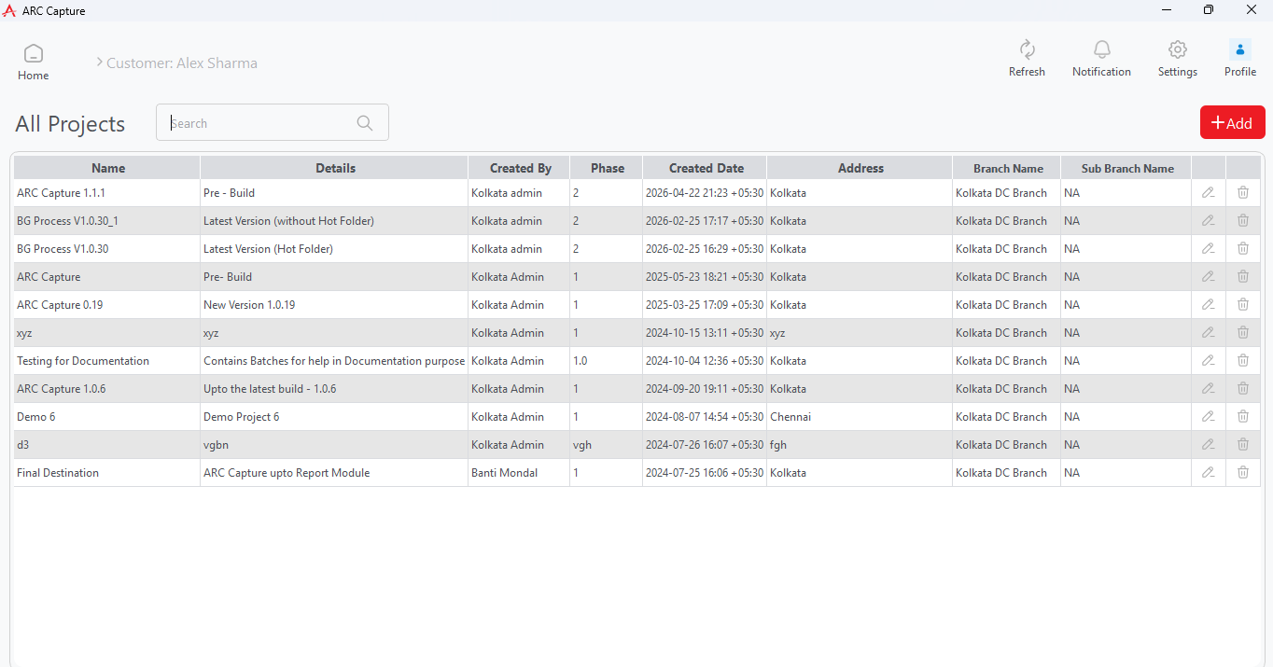
- From the Project list screen, you can either double-click on an existing project, or you can create a new project and then double-click on it.

Role – based Access Control

User Roles
The ARC Capture application provides three user roles to control access to features and data. The actions you can perform depends on your assigned role and branch.

Super Admin
The Super Admin has unrestricted access to all application features, branches, projects, workflows, batches, and system settings. This role can perform all administrative and operational activities across the application.
Branch Admin
The Branch Admin manages project, workflow, and batch-related activities within the assigned branches. This role can create, update, and manage projects, workflows, and batches, configure project settings, set up background processing, and access all projects and batches associated with the assigned branches.
Screenshot below displays the Project List screen when you have logged in as an admin: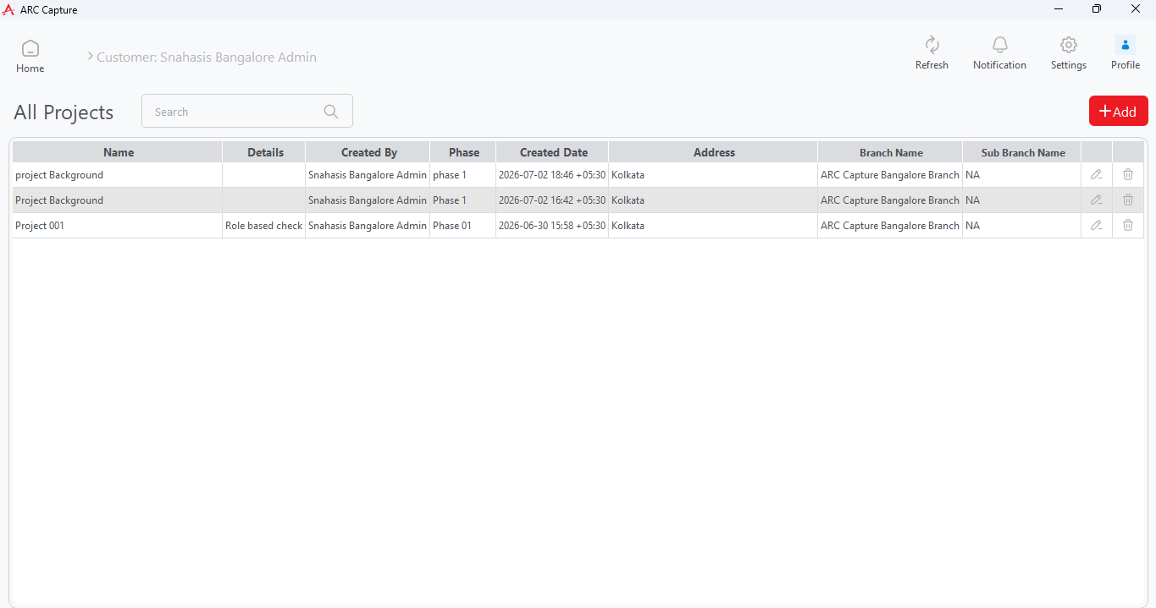
As a Branch Admin, you can perform the following activities:
- Add and edit projects.
- Delete projects.
- Add and edit workflows.
- Delete workflows.
- Add and edit batches.
- Delete batches.
- Configure advanced project settings.
- Perform other project- and batch-level administrative tasks.
Note: You can perform these activities only for projects and batches associated with the branches in which you have the Branch Admin role.
Branch Employee
The Branch Employee performs day-to-day batch processing activities within the assigned branch. This role has access only to batch-level operations and can manage batches associated with the assigned branch.
Screenshot below displays the Project List screen when you have logged in as an Employee: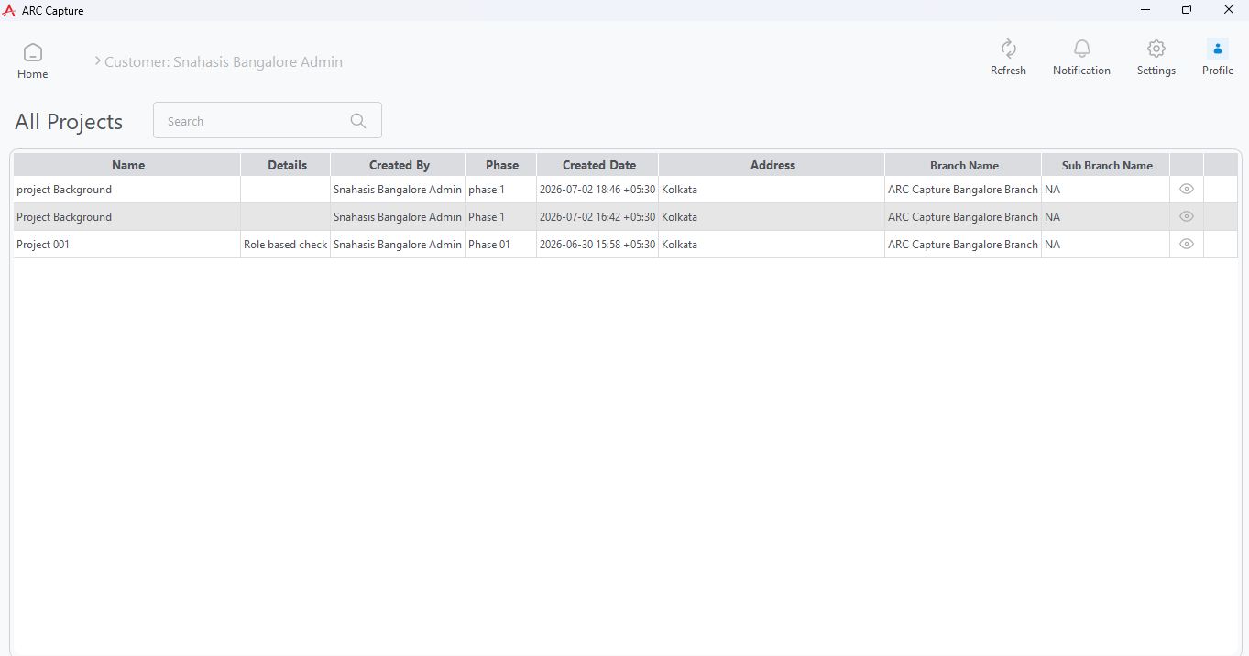
As a Branch Employee ,you can perform only the following activities:
- Add and edit batches.
- Delete batches.
- Configure background processing for batches.
- Process batches assigned to the branch.
Note: The [Add], [Edit] and [Delete] project buttons are not displayed on the Project List screen if you have only the Branch Employee role and do not have the Branch Admin role for the branch.

Project Visibility
The projects displayed in the application are determined by the branches you have access to. You can view only the projects associated with your authorized branches. If you do not have access to the branch associated with a project, that project is not displayed in the application.
The following examples illustrate how project visibility is determined.

Example 1
Project | Associated Branch
Project 009 | ARC Capture Kolkata Branch
User Access: ARC Capture Bangalore Branch only
Result: Project 009 is not displayed in the project list screen.
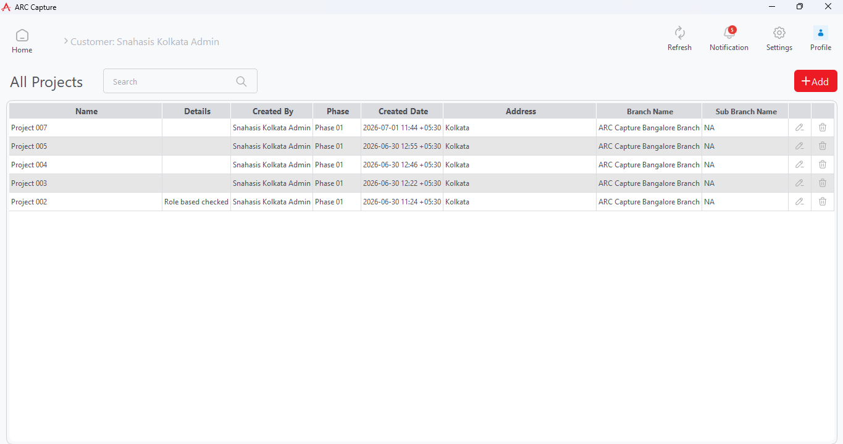

Example 2
Project | Associated Branch
Project 009 | ARC Capture Kolkata Branch
User Access: ARC Capture Kolkata Branch
Result: Project 009 is displayed.
Screenshot below displays the Project 009 in Project list screen:
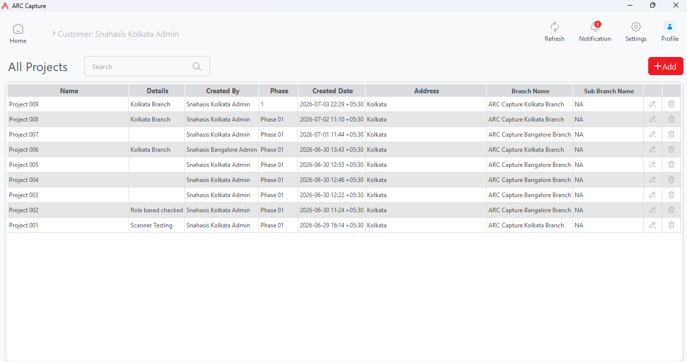

Example 3
Project | Associated Branch
Project 009 | ARC Capture Kolkata Branch
Project 010 | ARC Capture Bangalore Branch
User Access: ARC Capture Kolkata Branch and ARC Capture Bangalore Branch
Result: Both Project 009 and Project 010 are displayed.
Screenshot below displays the Project 009 & Project 010 in Project list screen:
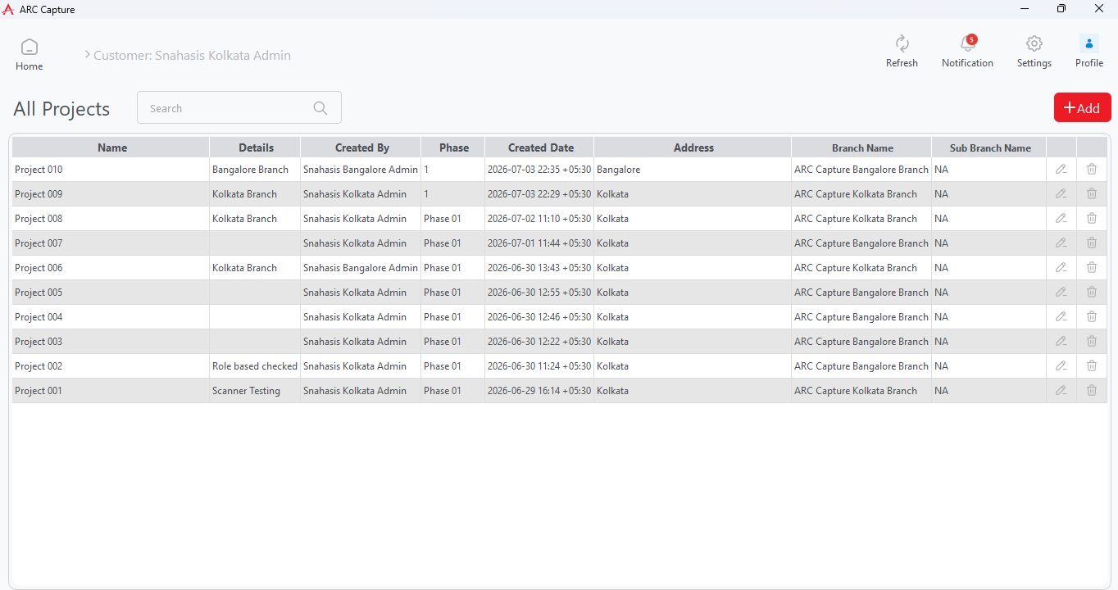
Note: After double clicking on a customer and getting navigated to the project list screen, if there are no preexisting projects created for that customer, then the add project screen will automatically open where you can create/add a new project.
Screenshot below displays the project list screen in case no preexisting projects exist:
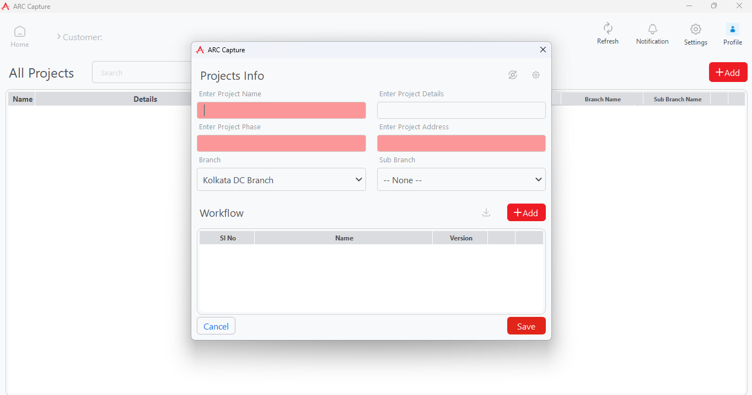

Adding a New Project
This section describes the process of adding a new project for a specific customer.
Step 1:
To create a new project, you must click on the [Add] button present at the top right corner of the project list screen.
Note: The Add button is displayed only if you have the Branch Admin role.
After clicking on the [Add] button, an Add project screen will open asking for the necessary details which have to be filled in to create a project.
Screenshot below displays the add project screen:
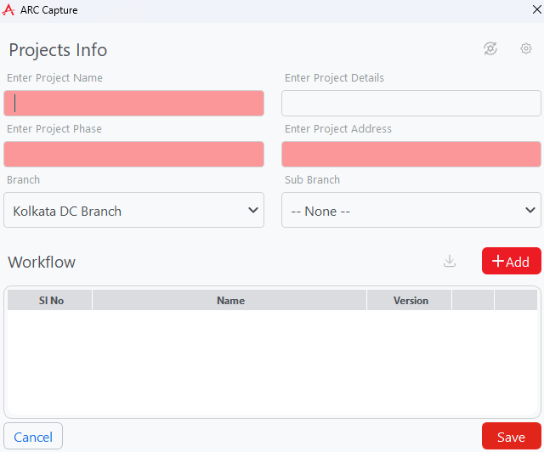
Step 2:
In the add project screen, you must fill/enter the information for the new project such as project name, project details, project phase and project address in the fields provided for the same, select the Branch & Sub Branch for the project and also add or import workflows for the project. Along with that you also get the option to set default project settings.
Note: The Enter Project Name, Enter Project Phase and Enter Project Address are mandatory fields which you must fill to create the new project.
To associate a branch with the project, click the Branch drop-down list below the Enter Project Phase field, and then select a branch from the list. The drop-down list displays only the branches for which you have Branch Admin access.
Note: By default, the last accessed branch is selected in the Branch field.
To associate a sub-branch with the project, click the Sub Branch drop-down list below the Enter Project Address field, and then select a sub-branch from the list. The drop-down list displays only the sub-branches associated with the selected branch.
Screenshot below displays the add project screen with the filled details:
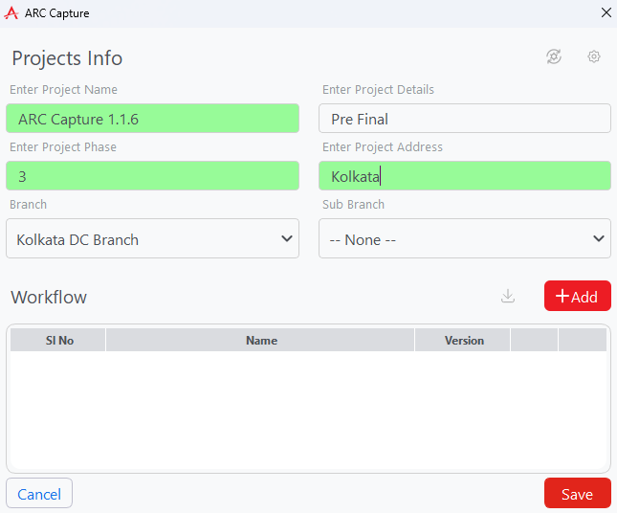
Note: When creating a new project, initially there will be no workflows added to the project, so you must create new workflows to add them in the project or import workflows from a different project or customer.
Note: If the project doesn’t contain any workflow, then you will not be able to process a batch in the further stage of the ARC Capture application.

Step 3:

Importing Workflows
Along with the option to create a new workflow, you also get the option to import any existing workflow/workflows from a different project of the same customer or from a different project of a different customer.
This section describes the process of importing a workflow.
Step 1:
For importing a workflow, you must click on the [Import Workflows] button present besides the [Add] button in the add project screen.
After clicking on the [Import Workflows] button, an import workflow screen will open.
Screenshot below displays the import workflow screen:
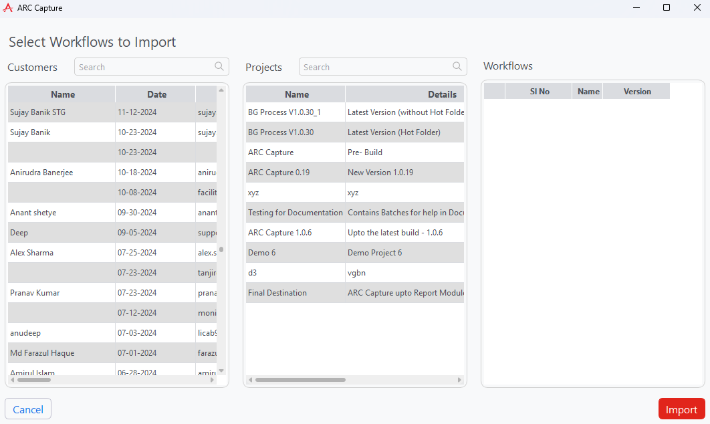
The import workflow screen consists of three sections each containing a list of customers (similar to customer list screen), projects (similar to project list screen) and the workflows.
The customers section displays the list of all the customers; the projects section displays the list of all the projects created for the customer selected in the customers section and the workflows section displays the list of all the workflows associated with the project selected in the projects section.
Note: By default, the current customer is selected in the customers section.
Step 2:
You must click on the customer which contains the projects from which you want to import the workflows in the customers section.
Once clicked, all the projects created for that customer will get displayed in the projects section.
Step 3:
After that you must click on the project from which you want to import the workflows. After clicking on that project, all the workflows associated with that project will get displayed in the workflows section.
Screenshot below displays the list of workflows in the workflows section:
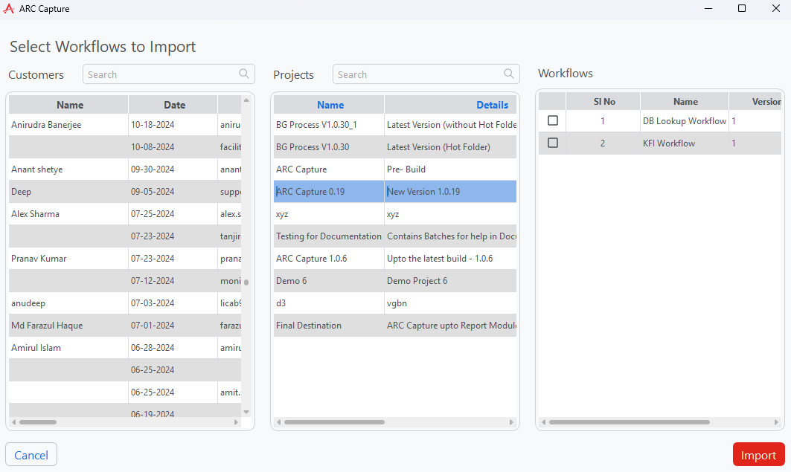
Step 4:
Every workflow displayed in the workflows section will have a checkbox besides them.
You must select the checkboxes of all those workflows which you want to import.
Step 5:
Once all the workflows have been selected, you must click on the 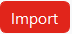 [Import] button present at the bottom right corner of the Import Workflows screen to successfully import those workflows.
- You can click on the 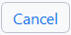 [Cancel] button present at the bottom left corner of the Import Workflows screen to close it if you don’t want to import a workflow.
Screenshot below displays the add project screen after importing the workflows:
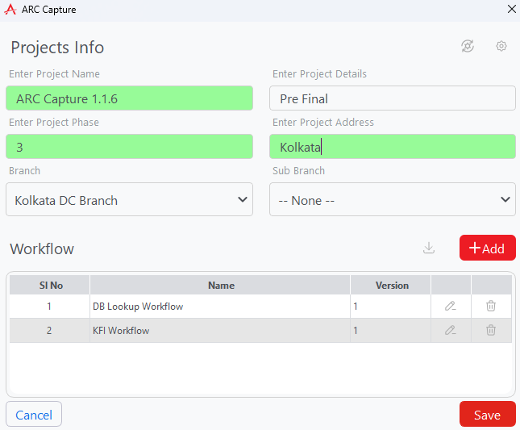

Adding a New Workflow
For adding a workflow in the project, you can either edit the preexisting workflows which are already added to the project shown in a list at the bottom of the add project screen or you can create a new workflow and then add it. The workflow list shows the name and version of all the preexisting/newly created workflows.
This section describes the process of adding a new workflow.
Step 1:
To create a new workflow, you must click on the  [Add] button present in the add project screen.
After clicking on the [Add] button, a create workflow screen will open.
Screenshot below displays the create workflow screen:
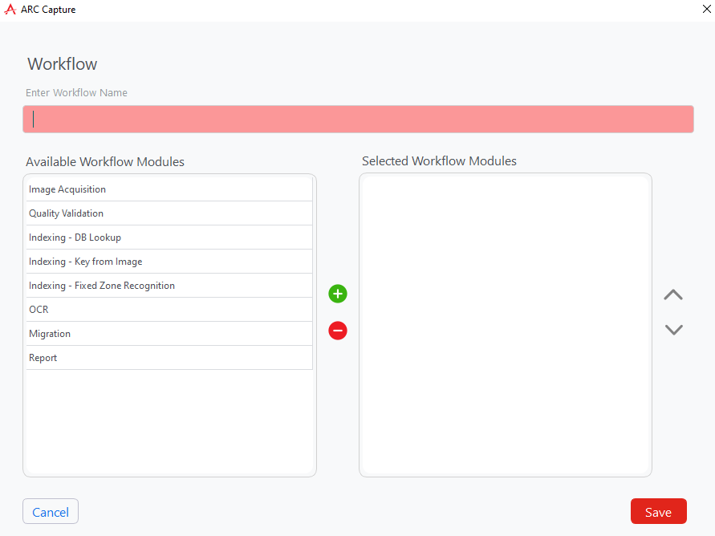
Step 2:
In the create workflow screen, you need to enter the name of the workflow to be created in the field provided and select the workflow modules from the available workflow modules.
All the available workflow modules that can be used are shown on the left side of the create workflow screen under the Available Workflow Modules section.
Screenshot below displays the create workflow screen with filled details:
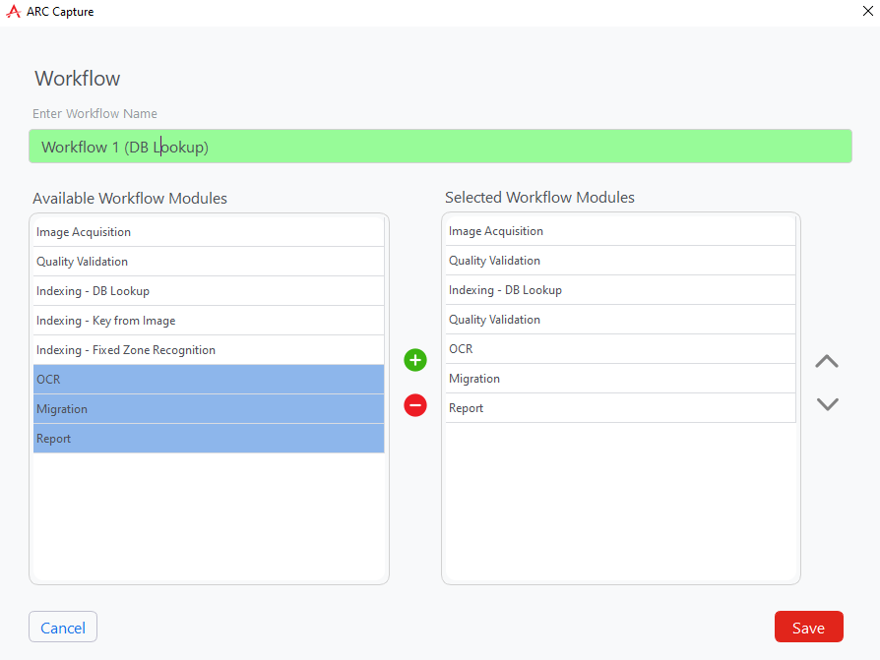
Step 3:
Now, you must select all the modules which you want to add to the workflow. For that, you must click on the module you want to choose and select it. You can select either a single module or multiple modules at the same time. The selected module/modules will be highlighted with a bule color.
Step 4:
After selecting all the necessary workflow modules, you must click on the [+] button present between the available workflow modules and selected workflow modules section to add the modules to the workflow. You will be able to view the added modules under the selected workflow modules section present at the right side of the screen.
- You can also change the order of the added modules by clicking on the  [Up and Down] arrow present on the right side of the selected workflow modules or you can simply just drag and drop the modules in the order you want.
If you don’t want any module, then you can select the modules from the selected workflow modules section and then click on the [–] button to deselect it.
NOTE: You must follow a valid workflow sequence/order while adding the modules to the workflow. A valid workflow sequence/order must follow the following points:
- It must start with the Image Acquisition module and end with the Report module.
- The modules Migration and Report must be present at least once.
- The modules Image Acquisition, Indexing (DB Look-up/Key from Image/Fixed Zone Recognition) and OCR must be present, and they can be used only once.
- In the sequence the Indexing module should be present only after Image Acquisition module and the OCR module should be present only after Indexing module.
Step 5:
After adding all the necessary modules needed for the workflow, you must click on the [Save] button on the create workflow screen to successfully create and add the new workflow.
- If you don’t want to create a new workflow, then you can click on the [Cancel] button on the bottom left corner of the screen to go back to the add project screen.
Upon clicking the [Save] button, you will be navigated back to the add project screen where you will be able to view the newly added workflow in the workflow list.
Screenshot below shows the add project screen with the newly added workflow:
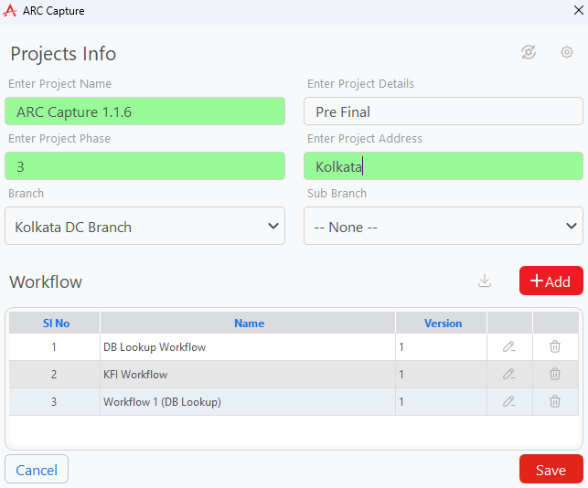

Editing an Existing/New Workflow
You also have the option to edit a preexisting workflow or the newly created workflow if you want to. This section describes the process of editing a workflow.
Step 1:
For editing a workflow, you must click on the [Edit] button present, besides the version section. After clicking on the edit button, you will get navigated to the Modify Workflow screen.
Screenshot below displays the modify workflow screen:
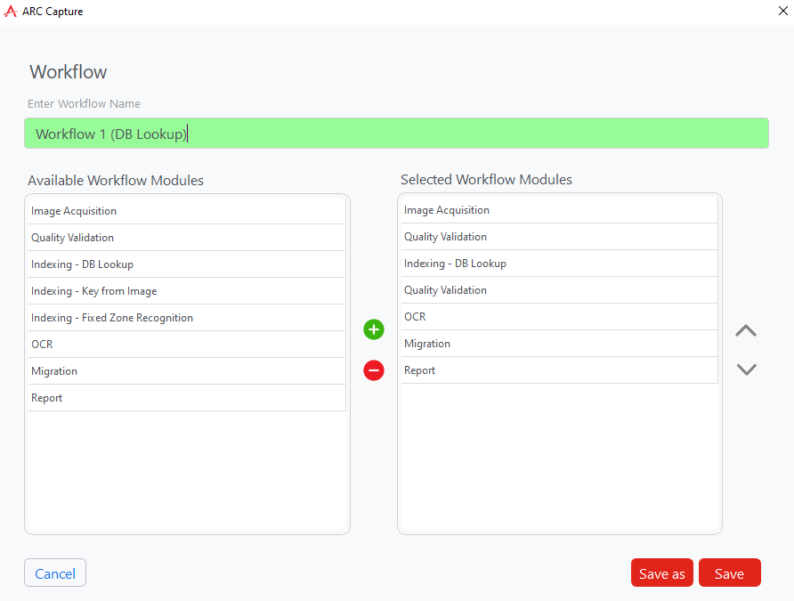
- Here, you will be able to view the existing information of the workflow.
- You can only change/modify the workflow modules or their sequence/order by following the same processes mentioned earlier.
- If you want to change/modify the name of the workflow, you must click on the  [Save As] button present besides the [Save] button which will create a new workflow with same workflow modules and their sequence but with a changed/modified workflow name.
NOTE: You must follow a valid workflow sequence while changing the workflow modules. A valid workflow sequence must abide the following points:
- It must start with the Image Acquisition module and end with the Report module.
- The modules Migration and Report must be present at least once.
- The modules Image Acquisition, Indexing (DB Look-up/Key from Image/Fixed Zone Recognition) and OCR must be present, and they can be used only once.
- In the sequence the Indexing module should be present only after Image Acquisition module and the OCR module should be present only after the Indexing module.
Screenshot below displays the modify workflow screen after modification:
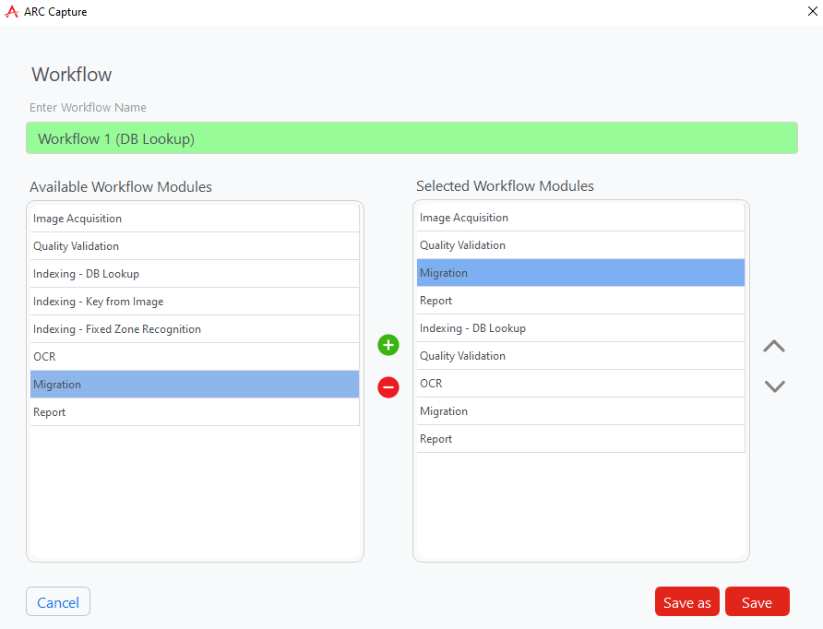
Step 2:
After you are done with the necessary changes, you must click on the [Save] button ( [Save As] button if name is change) to save the changes to the workflow. After that you will get navigated back to the add project screen.
- If you don’t want to modify anything, you can click on the [Cancel] on the bottom left corner of the screen to go back to the add project screen.
The updated/edited workflow will be shown in the workflow list as a new row with a different version.
Screenshot below displays the edited/updated workflow in the workflow list as a new row with different version:
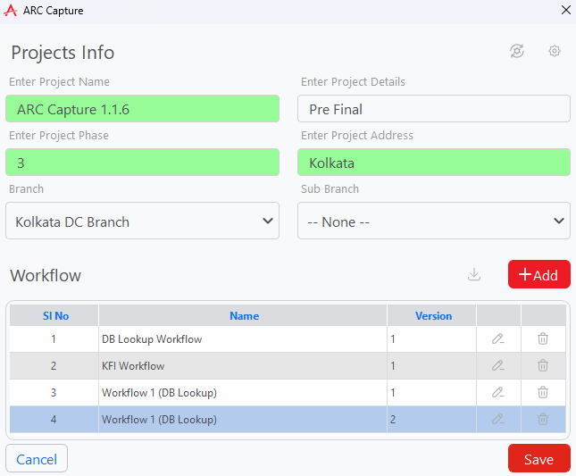

Deleting a Workflow
You also have the option to delete any preexisting workflow from the workflow list. This section describes the process of deleting a workflow.
Step 1:
For that you must click on the [Delete] button present, beside the [Edit] button.
After you click on the [Delete] button, a delete workflow popup will appear on the middle of screen asking you to confirm whether you want to delete the workflow or not.
Screenshot below displays the delete workflow popup after clicking the [Delete] button:
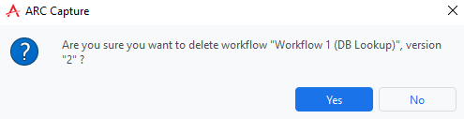

Step 2:
Now, you must click on the [Yes] button to successfully delete the workflow.
- You can click on the [No] button or the [cross] symbol to terminate the process of deleting the workflow.
Step 4: (of Adding a New Project)
You also get the option to set default project settings for Quality Validation, Indexing, OCR, Migration module, and Retention Settings beforehand in the add project screen which will be applied to all the batches in this project.
Note: You may or may not set the default project settings in the add project screen. In case you are not setting, default values will be set for the default project settings.

Default Project Settings:
This section describes the step-by-step process of setting the default project settings.
Step 1:
To set the default project settings, you must click on the [Default Project Settings] button present at the top right corner of the Add Project screen. Once you click on the [Default Project Settings] button, the “Default Project Settings” screen will appear in the middle.
Screenshot below displays the “Default Project Settings” screen:
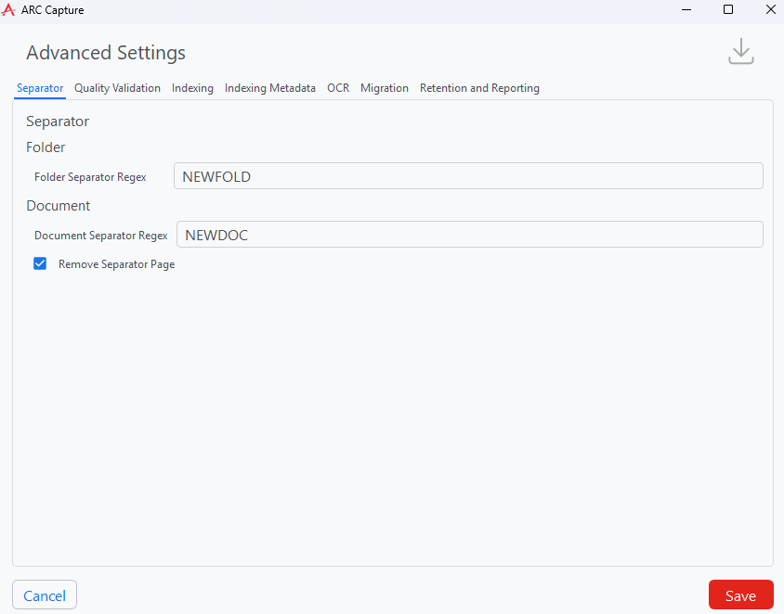
Step 2:
The “Default Project Settings” screen consists of different tabs each separately containing the default project settings for setting the custom separators, Quality Validation, Indexing, OCR, Migration module, Retention and Reporting Settings.
Note: You will land on the Separator tab by default, once the “Default Project Settings” screen appears. From the Separator tab, you can navigate to the other tabs by simply clicking on them.
Separator:
The Separator tab allows you to configure document-level and folder-level separation using custom barcode value patterns defined through regular expressions (regex) at the project level.
You need to provide the required regex values in the corresponding fields present in the separator tab under the folder and document sections to define the barcode patterns for separation.
Screenshot below displays the document and folder regex fields:
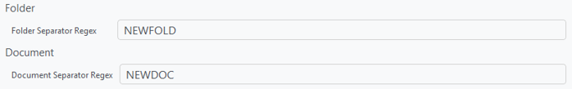
Note: By default, the NEWFOLD and NEWDOC barcode regex values are pre-filled in their respective fields. You may click inside the fields and modify these values as required. If no values are entered in the respective regex fields and they are left empty, the system will, by default, apply the predefined NEWDOC and NEWFOLD barcode patterns for document and folder separation.
- Once configured, ARC Capture will detect only barcodes that match the defined regex pattern, ignore unrelated barcodes, and trigger document or folder separation upon identifying a valid match.
You also have the option to exclude or include the separator barcode pages during document creation at the document-level.
For that, select or unselect the “Remove Separator Page” checkbox present in the separator tab, respectively.
Screenshot below displays the checkbox:
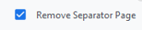
Note: By default, the checkbox is selected, meaning separator barcode pages are excluded during document creation.
Quality Validation:
Screenshot below displays the Quality Validation tab:
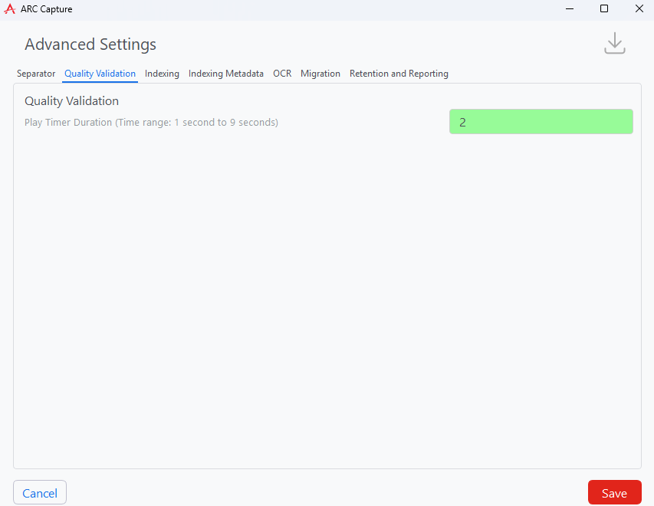
In the Quality Validation tab of the “Default Project Settings” screen, you get the option to set the Auto Play timer duration for Quality Validation module.
- You will be able to set the Auto Play Timer duration (set to 2 by default) which will be in the time range of 1 second to 9 second.
Indexing:
Screenshot below displays the indexing tab:
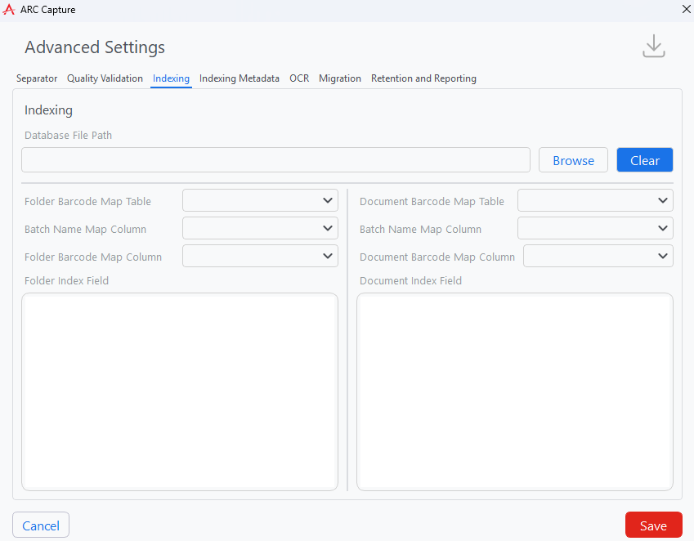
In the Indexing tab, you get the option to set the DB Lookup Indexing design beforehand as per your requirement. The detailed process of setting up the DB lookup Design is provided later in this document under the section “Database Lookup Design screen”.
Indexing Metadata:
Screenshot below displays the indexing metadata tab:
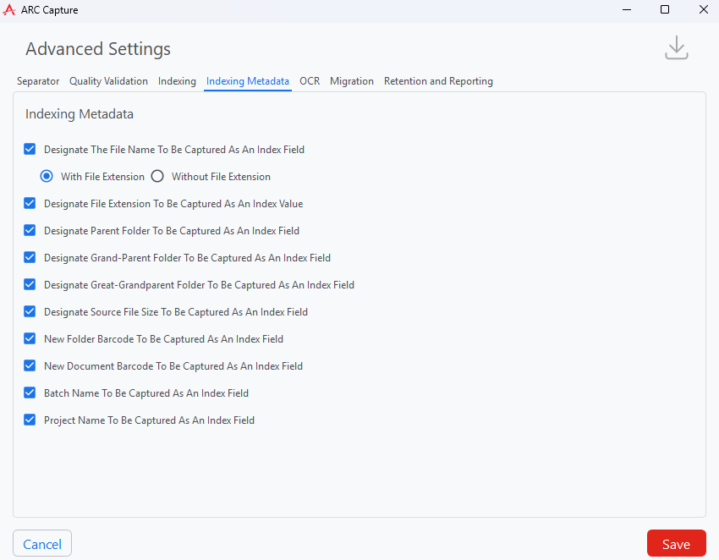
In the Indexing metadata tab, you get the option to select or deselect all the metadata fields which will be used for the indexing process.
Note: By default, all the metadata fields are selected.
OCR:
Screenshot below displays the OCR tab:
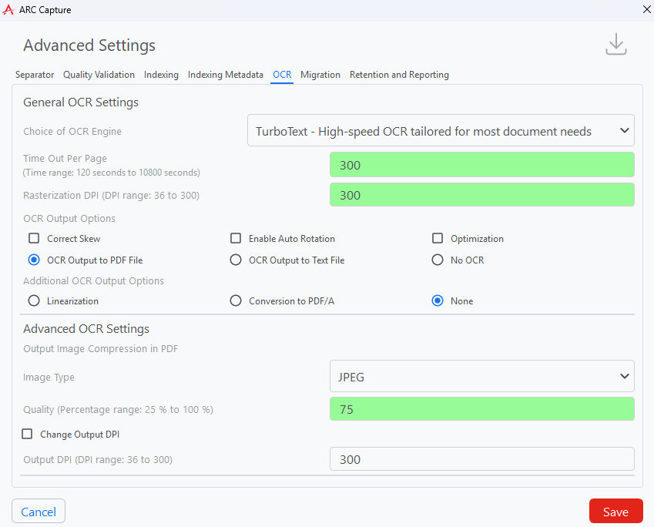
In the OCR tab, you get the option to set/change the OCR settings beforehand as per your requirement. The detailed process of setting/changing the OCR settings is provided later in this document under the section “OCR Settings”.
Migration:
Screenshot below displays the Migration tab:
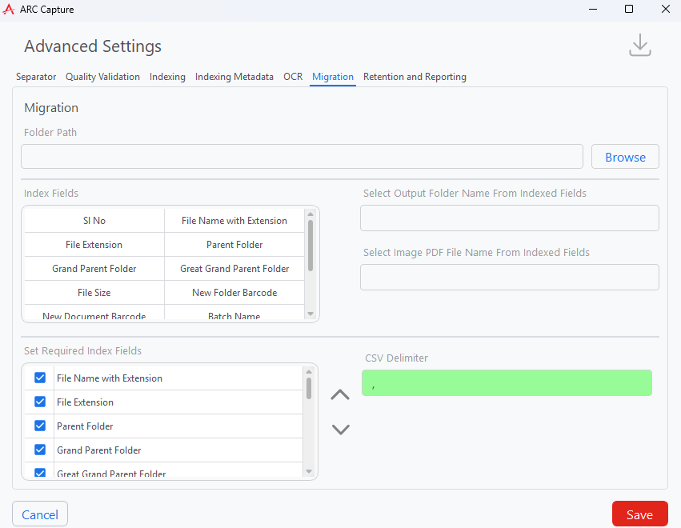
In the Migration tab, you get the option to set/change the Migration settings beforehand as per your requirement. The detailed process of setting/changing the Migration settings is provided later in this document under the section “Migration Settings”.
Retention and Reporting:
Screenshot below displays the Retention and Reporting tab:
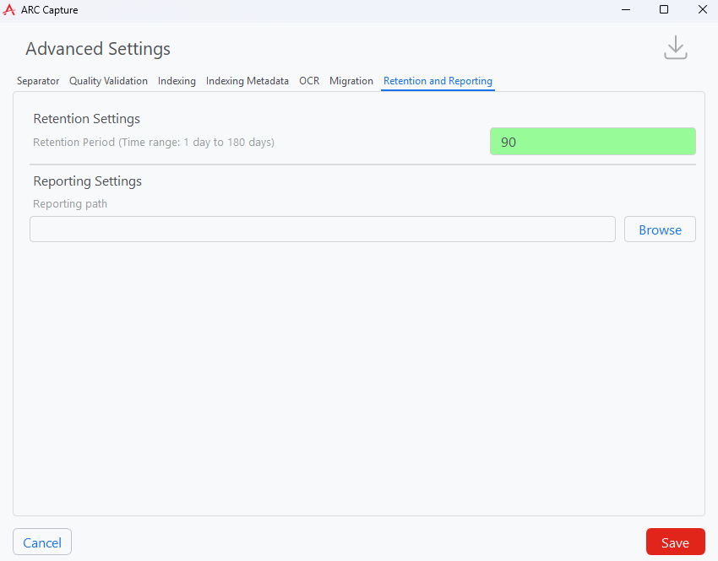
In the Retention and Reporting tab, you get the option to set/change the retention settings of the batch data. You can set/change the retention period (Range: 1 to 180 days) of the batch data from this tab.
Note: By default, retention period is set to 90 days.
Screenshot below displays the “Retention Settings” section:
You also have the option to define/set a default output folder that will store all Excel reports related to all the batches of the project.
For that you must either type (or copy & paste) the folder path in the “Reporting path” field or click on the [Browse] button and select the output folder present under the Reporting Settings section.
Screenshot below displays the “Reporting Settings” section:
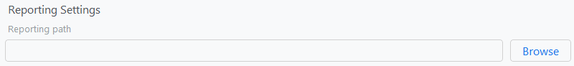
Step 3:
Once you are done with setting up all the settings as per your requirement, you must click on the [Save] button to successfully save the default project settings and go back to the add project screen.
- You can click on the [Cancel] button on the bottom left corner of the screen to close the “Default Project Settings” screen and go back to the add project screen.
Note: The settings saved in the “Default Project Settings” screen will be applied to the respective modules
(Quality Validation, Indexing, OCR & Migration) and these are not permanent as they can be changed from the respective module screens.

Importing Default Project Settings:
You also have the option to import Default Project Settings from a different project of the same customer or from a different project of a different customer.
This section describes the step-by-step process of importing Default Project Settings:
Step 1:
To import a Default Project Settings from a different project, you must click on the [Import Default Project Settings] button.
After clicking, an Import Default Project Settings screen will open.
Screenshot below displays the Import Default Project Settings screen:
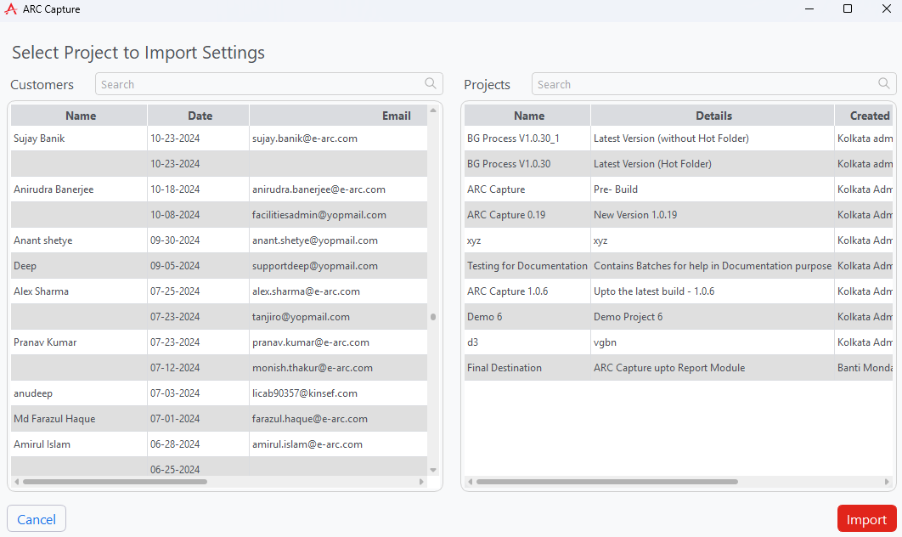
The import Default project settings screen consists of two sections each containing a list of customers (similar to customer list screen) and projects (similar to project list screen).
The customers section displays the list of all the customers, and the projects section displays the list of all the projects created for the customer selected in the customers section.
Note: By default, the current customer is selected in the customers section.
Step 2:
You must click on the customer which contains the projects from which you want to import the Default Project settings in the customers section.
Once clicked, all the projects created for that customer will get displayed in the projects section.
Step 3:
After that you must select the project from which you want to import the Default Project settings.
Once selected you must click on the [Import] button present at the bottom right corner of the Import Default project settings screen to successfully import the default projects setting of the selected project.
- You can click on the [Cancel] button present at the bottom left corner of the Import default project settings screen to close it if you don’t want to import the same.
Note: The imported default project settings will get applied for the current project only if you save the default project settings screen, else the default values will remain applied.
Background Batch Processing
You also have the option to configure Background Batch Processing, which enables batches to be processed automatically in the background without any manual intervention.
The detailed procedure for configuring this feature is provided later in the document under the “Setting Up Background Batch Processing” section.
Step 5: (of Adding a New Project)
After entering all the necessary information for the project, you must click on the [Save] button on the add project screen to successfully create the new project.
- If you don’t want to create a new project, then you can click the [Cancel] button to go back to the project list screen.
Upon clicking the [Save] button, you will be navigated back to the project list screen where you will be able to view the new project name at the top of the list.
Screenshot below displays the project list screen with the newly added project at the top:
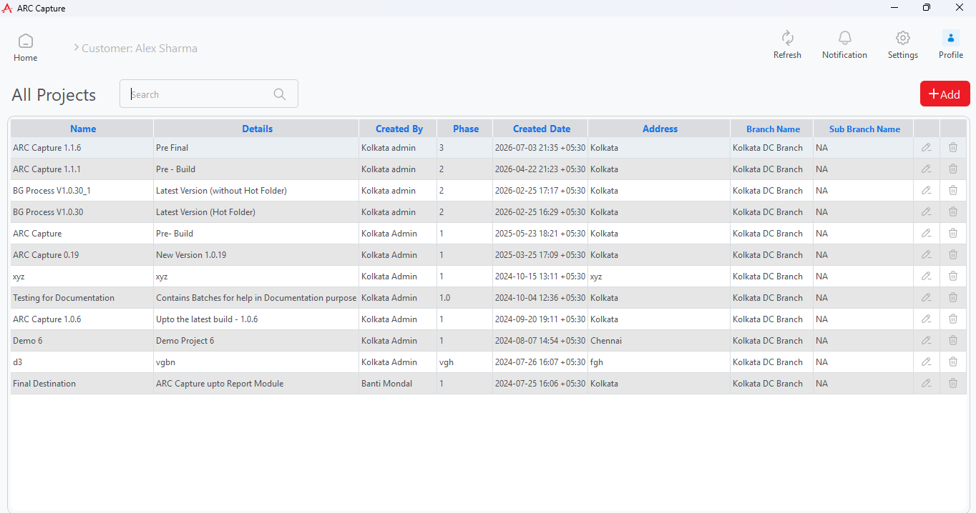

Editing an Existing Project
You also have the option to edit an existing project from the list. This section describes the process of editing an existing project for a specific customer.
Step 1:
For editing you must click on the [Edit] button present, besides the address section. After clicking on the [Edit] button, you will be navigated to the Edit Project screen.
Screenshot below displays the edit project screen:
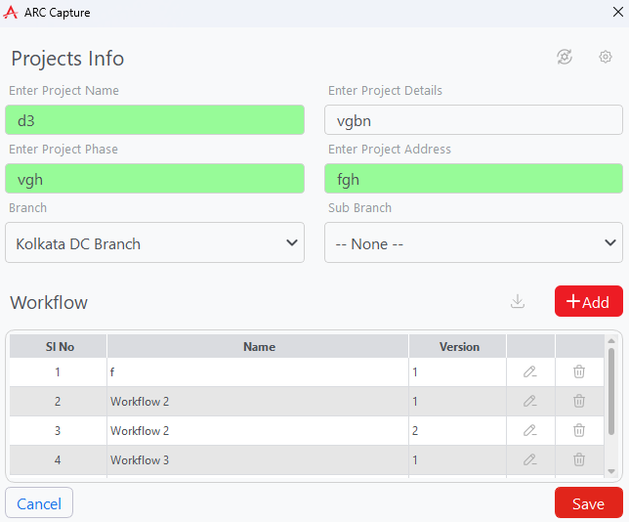
Here, you will be able to view all the existing information of the project which you can change as per your needs, along with that you can also view a list of preexisting workflows. You will be able to change the info such as the name, details, phase, address, Branch and Sub Branch as per your need.
Step 2:
You also get the option to create a new workflow (Adding a new Workflow) or edit/delete an existing workflow (Editing/Deleting a Workflow) by performing the same actions as mentioned above in the “Adding a New Project” section.

Step 3:
You also get the option to change the default project settings from the “Edit Project” screen by following the similar process mentioned in the “Default Project Settings” section of Adding a New Project.

Deleting a Project
Along with the options of adding and editing a project, you will also have the option of deleting an existing or a newly made project from the project list screen.
This section describes the step-by-step process of deleting a project.
Step 1:
For deleting a project, you must click on the [Delete] button present, besides the [Edit] button. After clicking on the [Delete] button a delete project popup will appear on the middle of the project list screen for confirming the action of deletion of the project. The popup will display the message "Are you sure you want to delete project <project name>?".
Screenshot below displays the delete project popup:
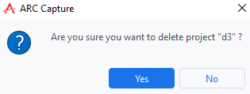
Step 2:
After that you must click on the [Yes] button at the bottom of the delete project popup to delete the selected project successfully.
If you don’t want to continue with the deletion, then you can click on the [X] button on the top right corner of the delete project popup or the [No] button at the bottom of the delete project popup to cancel the process.
- Initially, you will be able to view the first 100 records (projects) after landing on the Project List screen.
- When you reach the bottom by scrolling down to view more records, additional data will be loaded dynamically in batches of 100 records (equivalent to "pages") i.e., you can scroll infinitely until you reach the last record.
From the Project List screen, you must select and double-click on a specific project to get navigated to the Batch List screen. You can find the specific project which you want to select by scrolling through the list or you can use the search option present at the top of the Project List screen.
- For searching you must follow the same process as the “searching for a customer” section mentioned above (Searching for a Customer).
Screenshot below displays the result of a search operation on the project list screen:
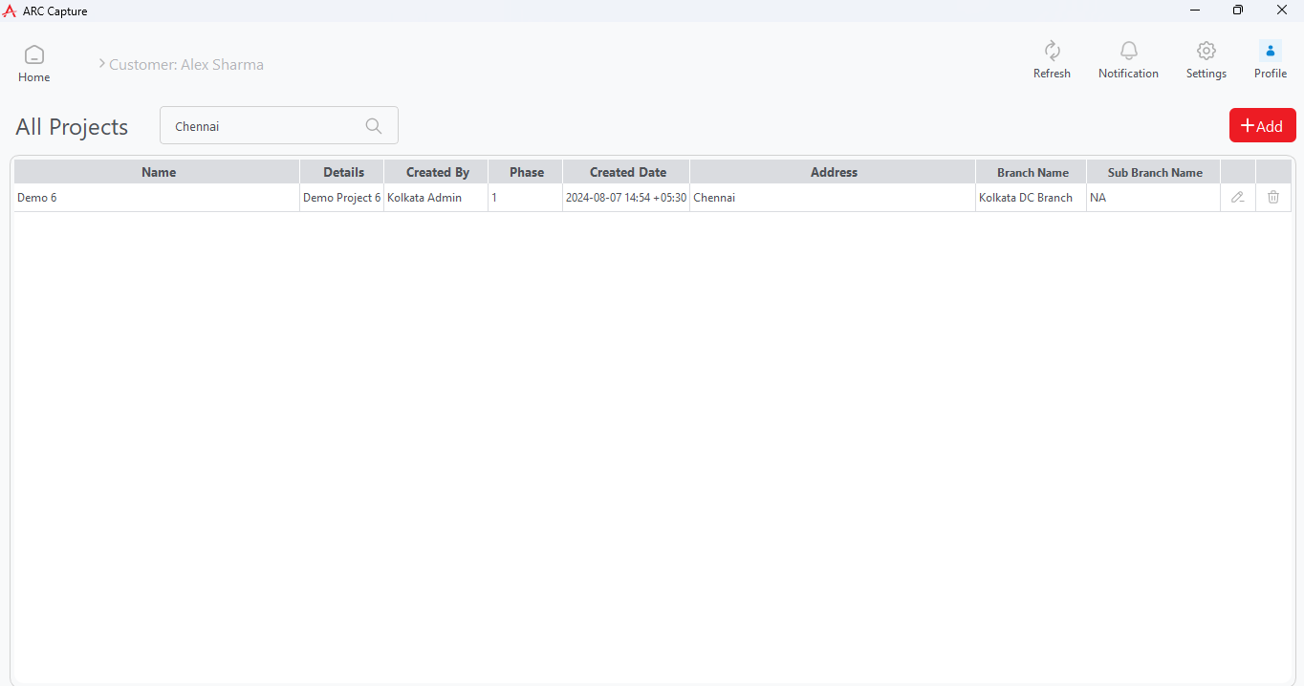
- You can also navigate back to the customer list screen by clicking on the  [Home] button present, at the top left corner of the project list screen.
You get the option to logout from the ARC Capture application anytime you want by following the same process as mentioned above in the document (Logout section).
You will also be able to view your current progress path on top left corner of the ARC Capture application.
Screenshot below displays the progress path:
