**Overview**

This is the computer science wwebsite for the University of Ghana. It is meant to give users an overview of what the department does, the courses it offers and what it stands for.

**Steps to clone the website**

To clone this website, you can visit github and open this repository (https://github.com/SenaDAfari/11317507-DCIT205). From there you must fork the repository and clone them so that you can make your changes to the website locally.

**Author**

My name is Sena Damien Afari and my student ID is 11317507.

**Screenshots**

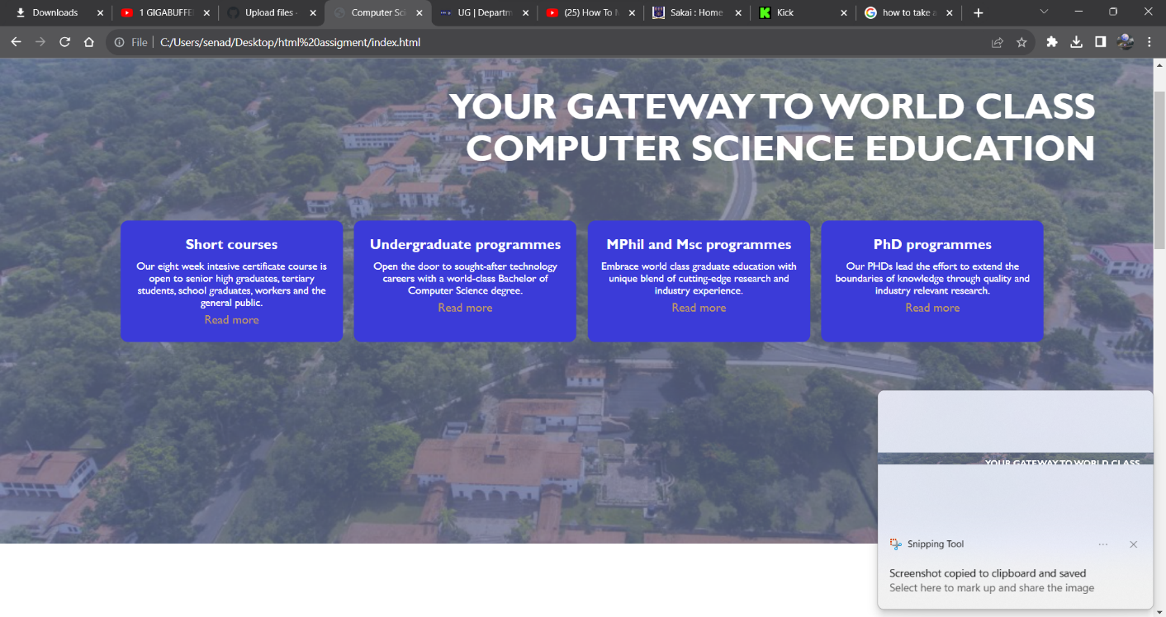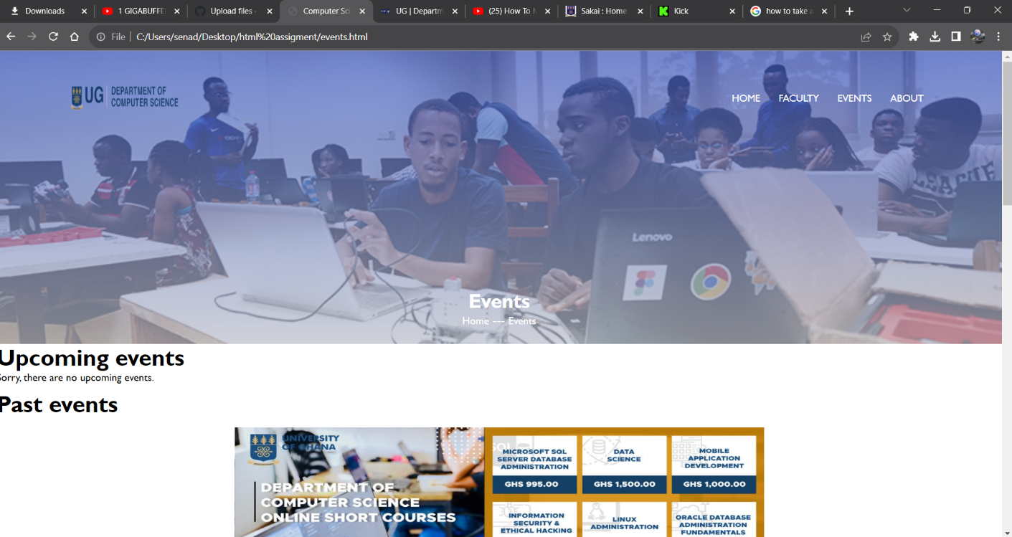

**Lessons learnt**

I've learnt the importance of creating classes for different tags and sections to enable easy styling and prevent your code from looking chunky.