Facebook and Fake News

Consider each of the below proposals, and fill in each of the below TODOs.

# Proposals

## Proposal 1

Facebook relies on an algorithm as well as individual users’ reports to identify content that is potentially "fake news." Once the content has been identified, it is sent to third party fact-checkers for verification. If the content is verified as fake news, it is publicly flagged with a warning that the content is disputed by fact-checkers.

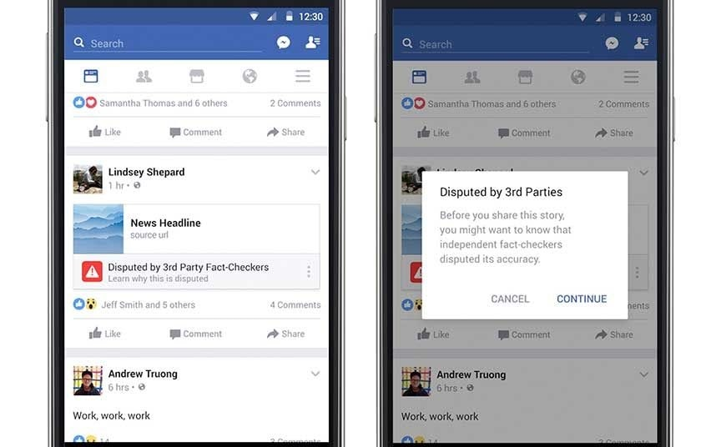

## Proposal 2

However, a designer at Facebook believes that there needs to be a different approach to content regulation. Their proposal is that content deemed problematic by third-party fact-checkers should be prevented from being shared on the platform altogether.

# 

# Questions

1. Which form of content regulation, Proposal 1 or Proposal 2, do you feel is better? Why?
   1. Proposal 1

In proposal 1 it protects the consumer rights of sharing and receiving contents while educating the users about the “fake news” and the sender of it by flagging and warning with a third party fact-checkers for verification. Which helps the users to be aware of that user and the contents next time. Proposal2 violates the regulations to some percentage by preventing the content being shared.

1. Which form of content regulation, Proposal 1 or Proposal 2, do you think best preserves or promotes the [five rights and opportunities necessary for a democratic public sphere](https://cs50.harvard.edu/college/2020/fall/labs/10/lecture/#five-rights-and-opportunities-for-a-democratic-public-sphere)?
   1. Which proposal best preserves or promotes Rights? Why?
      1. Proposal 1

Proposal 1 doesn’t prevent the content being shared even though it identified as “fake news”. That protects the content sender’s polocies, flagging and identifying the certain fault content, educates and protects the receivers’ policies too.

* 1. Which proposal best preserves or promotes Opportunity for Expression? Why?
     1. Proposal1

It preserves and promoted opportunity for expression by letting the fault news be shared even though it identified as a “fake news”. In proposal 2, it prevents from being shared which leading to halt the opportunities for expression.

* 1. Which proposal best preserves or promotes Access? Why?
     1. Proposal1

The receivers have access to deliver the false information of the content even though it is flagged means that in proposal 1 it promotes while preserving the access of the consumers.

* 1. Which proposal best preserves or promotes Diversity? Why?
     1. Proposal 1

False and correct information/news show the diversity of the platform. Both treated equally even though one is completely recognized as a “fake news”, completely exhibits, preserves and promotes the diversity.

* 1. Which proposal best preserves or promotes Communicative Power? Why?
     1. Proposal1

Communicative power displays precisly when individual users reports a potential fault information, in proposal1.