**T.C.**

**MARMARA UNIVERSITY FACULTY OF ENGINEERING**

**COMPUTER ENGINEERING DEPARTMENT**

**GROUP 10**

**Beyzanur Çabuk 150119632**

**Bihter Nilüfer Akdem 150119810**

**Eşref Emre Koca 150119798**

**Safa Şan 150119685**

**Senanur Yılmaz 150119801**

**Sena Nur Boylan 150119737**

**Şule Koca 150119057**

**Zeynep Destan 139019026**

**Supervised By:**

**Prof. Murat Can Ganiz**

**TABLE OF CONTENTS**

**1.Introduction…………………………......………………………………………………......3**

1.1 Purpose of the System 3

1.2 Scope of the System 3

1.3 Objectives and Success Criteria of the Project 3

1.4 Definitions and acronyms 3

1.5 SRS Standards 4

1.6 Overview 4

2. Proposed System 4

2.1 Overview 5

2.2 Functional Requirements 5

2.2.1 Product Functions 6

2.2.2 Operating Environment 6

2.2.3 Assumptions and Dependencies 6

2.2.4 Hardware Interfaces 7

2.2.5 Software Interfaces 7

3. Project Schedule 7

**4. Glossary…………………………………………………………………………………………………………………………8**

**5.References……………………………………………………………………………………………………………………..9**

**1. Introduction**

The purpose of the application we develop will be to create the University registration system simulation via Java.

### 1.1 Purpose of the System

### Purpose of the application It brings the course registration process approval processes to the system quickly and smoothly.

### 1.2 Scope of the System

The purpose of the course record analysis system simulation; It is to create functions such as creating course registration, grading, creating transcripts in an easy and effective way. This project is based on Marmara Computer Engineering Department courses and the prerequisite tree is determined accordingly. Progressed in accordance with OOP Standards

**1.3 Objectives and Success Criteria of the Project**

The primary objectives of our program. Adhering to Marmara University Engineering faculty prerequisites and course selection procedures.

Developed based on development and clean code in line with OOP standards.

### 1.5 SRS Standards

The Requirements Analysis Document will confirm to the IEEE standard IEEE Std 830-1998.

IEEE Computer Society. (1998, October 20). IEEE Recommended Practice for Software Requirements Specifications. IEEE Std 830-1998. IEEE Xplore.

Krüger, C. L. (2021, December 16). How to Write a Software Requirements Specificiation (SRS Document). Retrieved from www.perforce.com: <https://www.perforce.com/blog/alm/how-write-software-requirementsspecification-srs-document>

**1.7 Overview**

A student registration system simulation developed over Java based on the BYS system. Our project has a single user type experience. Based on the student model, student course selection and registration processes are available in our application.

# 2. Proposed System

The project, which proceeds on the basis of the BYS system simulation, embraces minimal values. Developed in accordance with the OOP system and clean code. It is aimed to create a student registration system simulation in the most optimum and simple way.

#### 2.2 Functional Requirements

This project is a small prototype of course registration analysis system simulation.

The modelling will contain the followings:

The database contains students' names, surnames, departments and ‘student ID’ information.

In the Course class, the names of the courses, course codes, credits and prerequisites are stored.

Student:

StudentID, First Name, Last Name, Semester.

Student informations like Passed Courses, Failed Courses etc. kept in separate .JSON files

Course:

Course Code, Course Name, Credit, Prerequisite, Course Type.

Advisor:

Advisor ID, Advisor Name, Advisor Password, Advisor E-mail.

* To approve registration for enrollment

Transcript:

Transcript_ID, GPA, Total Credit, Completed Credit , Semester, Student_ID

* Getting GPA
* Adding semester
* Failed courses
* Passed courses

CourseRegistrationSystem:

Course, Grade, Successful

-Log details

- Setting quota of course after registration

- Setting total credit of student after registration

#### 2.2.1 Product Functions

System simulation has the functions:

- View Transcript

- Choose a Course

1.Add Course

2.Drop Course

3.Exit

- View Remaining Courses

- Add Lesson

- Check Prerequisite

- Create log

- View log

#### 2.2.2 Operating Environment

-Visual Studio Code

* Java
* GitHub

-Trello

-Discord

#### 2.2.3 Assumptions and Dependencies

-Not specific database usage. Manually adding .json data.

- Total of years 4, each year has two semesters.

### 2.2.4 Hardware Interfaces

-Console Application.

### 

### 2.2.5 Software Interfaces

|  |  |
| --- | --- |
| Software Utility | Definition |
| Programing Language | Java |
| IDE | Visual Studio Code |
| Operating System | Windows |
| Data Format | .json |

## 3. Project Schedule

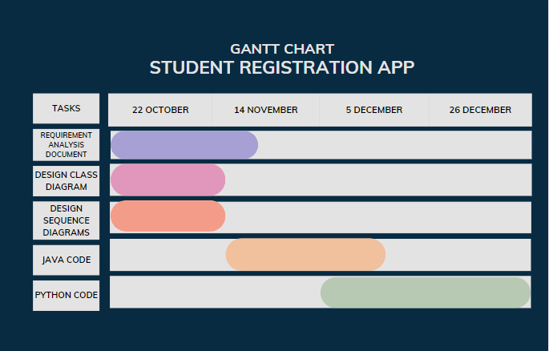

**4. Glossary**

Pre-requisite: A course or other requirement that a student must have taken prior to enrolling in a specific course or program.

Credit: Recognition for having taken a course at school or university, used as measure if enough hours have been made for graduation.

Semester: A calendar that divides the academic year into 15-17 week terms. There are generally two semester per academic year: Fall(beginning in August or September) and spring (beginning in January)

**5. References**

Medium, “Requirement Analysis Document (RAD) Nedir, Nasıl yazılır?” 8 Oct 2022 <https://medium.com/@emre_karaoglu/requirement-analysis-document-rad-nedir-nas%C4%B1l-yaz%C4%B1l%C4%B1r-faf4871986ab>.

Florida State University, “Requirements Analysis Document” 8 Oct 2022 <https://www.cs.fsu.edu/~lacher/courses/COP3331/rad.html>

Wrike, “How to Carry Out a Requirements Analysis” 8 Oct 2022 https://www.wrike.com/blog/how-carry-out-requirements-analysis/#What-is-a-requirements-analysis