Q1.

Code:

package Q_01;  
import javax.swing.*;  
public class Q1 {  
 public static void main(String[] args) {  
  
 JFrame frame = new JFrame();  
  
 frame.setSize(800, 600);  
 frame.setTitle("Welcome to java");  
 frame.setVisible(true);  
 }  
}

Output:

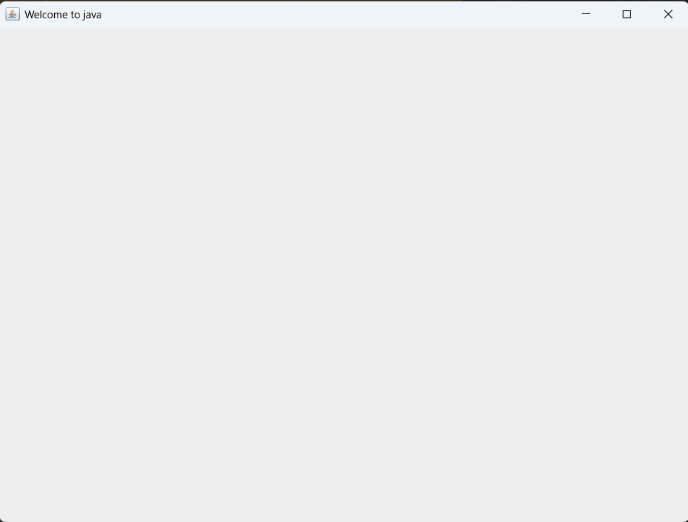

Q2.

Code:

package Q_02;  
import javax.swing.*;  
import java.util.*;  
public class Q2 {  
 public static void main(String[] args) {  
 Scanner scanner=new Scanner(System.*in*);  
 System.*out*.println("Enter your First Name :");  
 String firstName=scanner.nextLine();  
 System.*out*.println("Enter your Last Name :");  
 String lastName=scanner.nextLine();  
  
 JFrame frame=new JFrame();  
 frame.setSize(500,300);  
 frame.setTitle(firstName+" "+lastName);  
 frame.setVisible(true);  
 }  
  
}

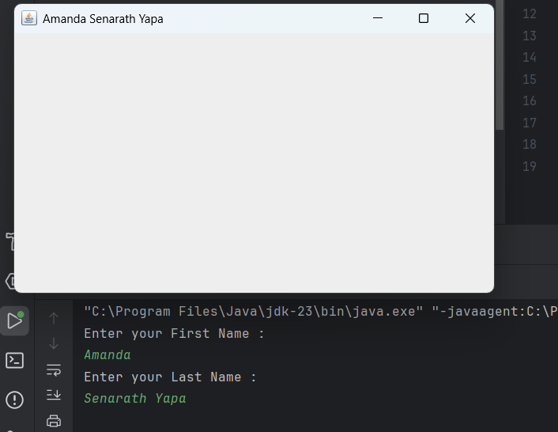Output:

Q3.

Code:

package Q_03;  
import java.util.*;  
public class Q3 {  
 public static void main(String[] args) {  
 Scanner scanner=new Scanner(System.*in*);  
 System.*out*.println("Enter the First Name:");  
 String firstName=scanner.nextLine();  
 System.*out*.println("Enter the Middle Name:");  
 String middleName=scanner.nextLine();  
 System.*out*.println("Enter the Last Name:");  
 String lastName=scanner.nextLine();  
 String initial=middleName.substring(0,1);  
  
 System.*out*.println("Full name is:"+firstName+" "+initial+"."+lastName);  
 }  
}

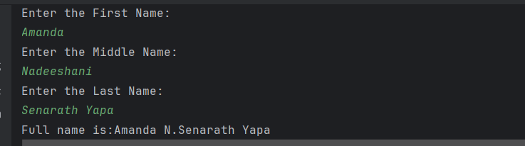Output:

Q4.

Code:

package Q_04;  
  
import java.text.SimpleDateFormat;  
import java.util.Date;  
public class Q4 {  
 public static void main(String[] args) {  
 Date today=new Date();  
 System.*out*.println(today);  
  
 SimpleDateFormat sdf=new SimpleDateFormat("dd MMMM yyyy");  
 System.*out*.println(sdf.format(today));  
 }  
}

Output:

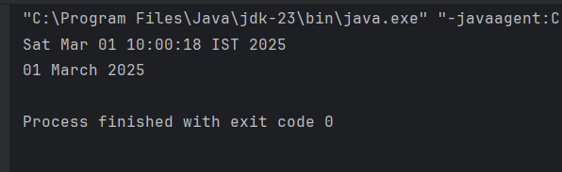

Q5:

Code:

package Q_05;  
import java.text.SimpleDateFormat;  
import java.util.Date;  
public class Q5 {  
 public static void main(String[] args) {  
 Date today=new Date();  
 System.*out*.println(today);  
 SimpleDateFormat sdf=new SimpleDateFormat("EEEE,MMMM MM,yyy");  
 System.*out*.println(sdf.format(today));  
 }  
}

Output:

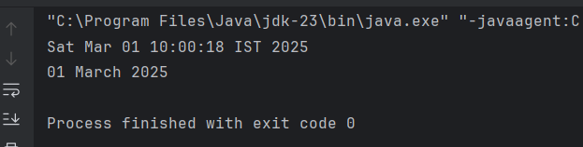

Q6.

Code:

package Q_06;  
import javax.swing.*;  
import java.util.*;  
public class Q6 {  
 public static void main(String[] args) {  
  
 Scanner scanner=new Scanner(System.*in*);  
 System.*out*.println("Enter the width (W):");  
 int width=scanner.nextInt();  
 System.*out*.println("Enter the height (H):");  
 int height =scanner.nextInt();  
  
 JFrame frame=new JFrame();  
 frame.setSize(width,height);  
 frame.setVisible(true);  
 }  
}

Output:



Q7.

Code:

package Q_07;  
import java.text.SimpleDateFormat;  
import javax.swing.*;  
import java.util.Date;  
public class Q7 {  
 public static void main(String[] args) {  
 Date today=new Date();  
 SimpleDateFormat sdf=new SimpleDateFormat("hh:mm:ss a");  
  
 JFrame frame=new JFrame();  
 frame.setTitle(sdf.format(today));  
 frame.setSize(500,500);  
 frame.setVisible(true);  
 }  
}

Output:

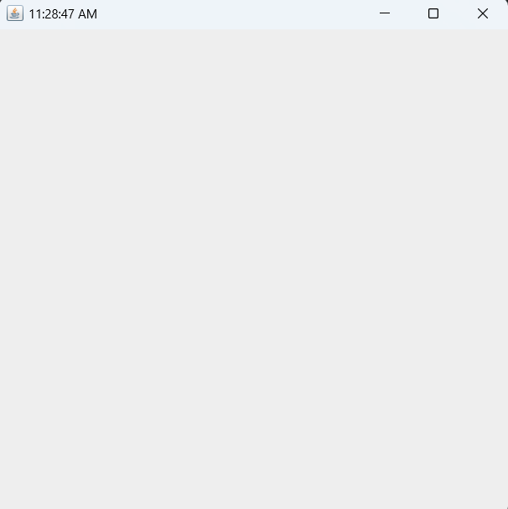

Q8.

Code:

package Q_08;  
import java.util.Scanner;  
public class Q8 {  
 public static void main(String[] args) {  
 Scanner scanner=new Scanner(System.*in*);  
 System.*out*.println("Enter the Sentence :");  
 String word=scanner.nextLine();  
  
 String[] sentence=word.split("!");  
 for (String sentences:sentence){  
 System.*out*.println(sentences);  
 }  
  
  
 }  
 }

Output:

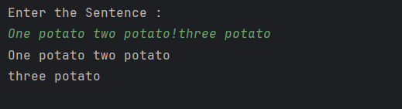

Q9.

Code:

package Q_09;  
import java.util.Scanner;  
public class Q9 {  
 public static void main(String[] args) {  
 Scanner scanner=new Scanner (System.*in*);  
 System.*out*.println("Write a sentence:");  
 String sentence=scanner.nextLine();  
  
 System.*out*.println(sentence.length());  
 System.*out*.println(sentence.charAt(0));  
 System.*out*.println(sentence.charAt(sentence.length()-1));  
  
 }  
}

Output:

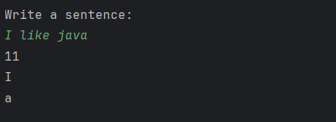

Q10.

Code:

package Q_10;  
import java.util.Scanner;  
public class Q10 {  
 public static void main(String[] args) {  
 Scanner scanner=new Scanner(System.*in*);  
 System.*out*.println("Enter Odd-number Word :");  
 String a=scanner.nextLine();  
  
  
 if (a.length()%2!=0) {  
 int middleIndex=a.length()/2;  
 System.*out*.println("Middle letter: "+a.charAt(middleIndex));  
 }  
 else{  
 System.*out*.println("Please enter odd-length word ");  
 }  
 }  
 }

Output:

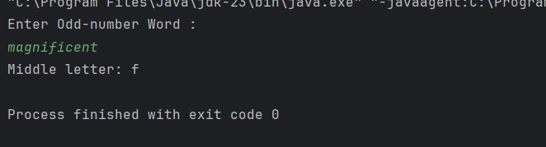

Q11.

Code:

package Q_11;  
  
import java.util.Scanner;  
  
public class Q11 {  
 public static void main(String[] args) {  
  
 Scanner scanner = new Scanner(System.*in*);  
 System.*out*.print("Enter your full name (first middle last): ");  
 String fullName = scanner.nextLine();  
  
 String[] nameParts = fullName.split(" ");  
  
 if (nameParts.length < 2) {  
 System.*out*.println("Invalid input. Please enter a first, middle (optional), and last name.");  
 } else {  
 String firstName = nameParts[0];  
 String lastName = nameParts[nameParts.length - 1];  
 String middleInitial = nameParts.length > 2 ? nameParts[1].charAt(0) + "." :"";  
  
 System.*out*.println(lastName + ", " + firstName + " " + middleInitial);  
 }  
  
 scanner.close();  
 }  
}

Output:

Q12.

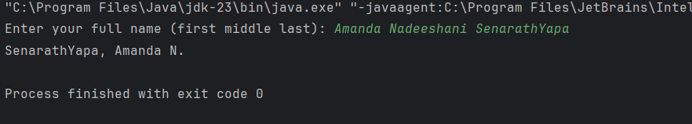

Code:

package Q_12;  
import javax.swing.*;  
public class Q12 {  
 public static void main(String[] args) {  
 JFrame frame=new JFrame();  
 frame.setSize(300,200);  
 frame.setTitle("My First Frame");  
 frame.setVisible(true);  
  
 frame.setLocation(100, 50);  
 frame.setDefaultCloseOperation(JFrame.*EXIT_ON_CLOSE*);  
 frame.setVisible(true);  
 }  
}

Output:

