**Q1.**

**Code:**

package Q_01;  
  
public class Q1 {  
 public static void main(String[] args) {  
 int A=10;  
 int B=20;  
 int C=30;  
 int X=50;  
 int Y=60;  
 int r=5;  
  
 double result1=Math.*sqrt*(Math.*pow*(B,2)+4*A*C);  
 double result2=Math.*sqrt*(X+4*Math.*pow*(Y,3));  
 double result3=Math.*cbrt*(X*Y);  
 double result4=Math.*PI*\*Math.*pow*(r,2);  
  
 System.*out*.println(result1);  
 System.*out*.println(result2);  
 System.*out*.println(result3);  
 System.*out*.println(result4);  
  
  
 }  
}

**Output:**

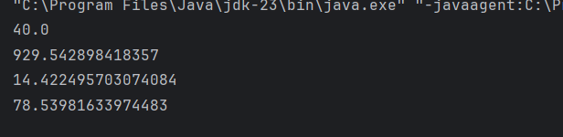

**Q2.**

**Code:**

package Q_02;  
import java.util.Scanner;  
public class Q2 {  
 public static void main(String[] args) {  
 Scanner scanner=new Scanner(System.*in*);  
  
 System.*out*.println("Enter values in centimetes: ");  
 int value=scanner.nextInt();  
  
 float outputinch= (float)(value/2.54);  
 float outputfeet= (float)(outputinch/12);  
  
 System.*out*.println("Value in inches: "+outputinch);  
 System.*out*.println("Value in feet: "+outputfeet);  
  
 }  
}

**Output:**

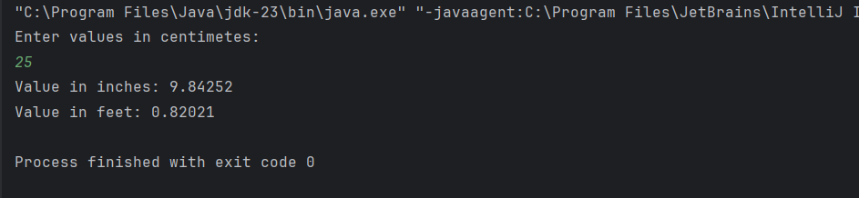

**Q3.**

**Code:**

package Q_03;  
import java.util.Scanner;  
public class Q3 {  
 public static void main(String[] args) {  
 Scanner scanner=new Scanner(System.*in*);  
  
 System.*out*.println("Enter temperature in degrees celcius: ");  
 int celcius=scanner.nextInt();  
  
 double result=1.8*celcius+32;  
 System.*out*.println("Temparature in degrees faranheit: "+result);  
  
  
 }  
}

**Output:**

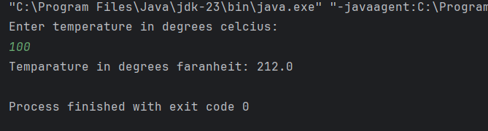

**Q4.**

**Code:**

package Q_04;  
import java.util.Scanner;  
  
public class Q4 {  
 public static void main(String[] args) {  
 Scanner scanner=new Scanner(System.*in*);  
  
 System.*out*.println("Enter the bodyweight in pounds: ");  
 double bodyweight=scanner.nextDouble();  
  
 double calories=bodyweight*19;  
 System.*out*.println("Number of calories the person needs in one day: "+calories);  
  
 }  
  
}

**Output:**

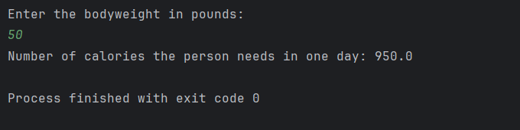

**Q5.**

**Code:**

package Q_05;  
import java.util.Scanner;  
public class Q5 {  
 public static void main(String[] args) {  
 Scanner scanner=new Scanner(System.*in*);  
  
 System.*out*.println("Enter temperature in degrees fahrenheit: ");  
 double fahrenheit=scanner.nextDouble();  
  
 double celsius=(fahrenheit-32)*5/9;  
 System.*out*.println("Temperature in degrees celsius: "+celsius);  
  
 }  
}

**Output:**

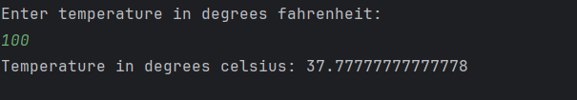

**Q6.**

**Code:**

package Q_06;  
import java.text.SimpleDateFormat;  
import java.util.Date;  
import java.util.Scanner;  
public class Q6 {  
 public static void main(String[] args) {  
 Scanner scanner=new Scanner(System.*in*);  
 System.*out*.println("Enter the born year: ");  
 int bornyear=scanner.nextInt();  
  
 Date date=new Date();  
 SimpleDateFormat sdf=new SimpleDateFormat("yyyy");  
 int age=Integer.*parseInt*(sdf.format(date))-bornyear;  
 System.*out*.println("You were born in "+bornyear+" and will be (are) "+age+" this year");  
  
  
 }  
}

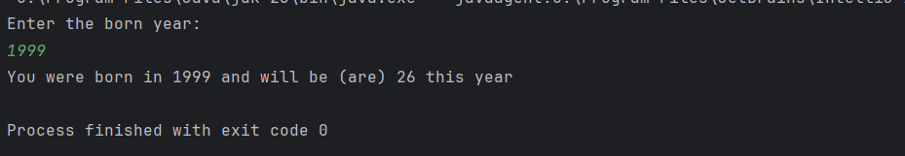

**Output:**



**Q7.**

**Code:**

package Q_07;  
import java.util.Scanner;  
  
public class Q7 {  
 public static void main(String[] args) {  
 Scanner scanner = new Scanner(System.*in*);  
 System.*out*.println("Enter the weight in kilograms(W): ");  
 int W=scanner.nextInt();  
 System.*out*.println("Enter the height in centimeters(H): ");  
 int H=scanner.nextInt();  
  
 double BMI=(Double)(W/Math.*pow*((H/100.0),2));  
  
 if (BMI>=20 && BMI<=25) {  
 System.*out*.println("Your BMI is within the normal range.");  
 }else if(BMI<20){  
 System.*out*.println("You are underweight.");  
 }else{  
 System.*out*.println("You are overweight.");  
 }  
  
 System.*out*.println("BMI value: "+BMI);  
  
 }  
}

**Output:**

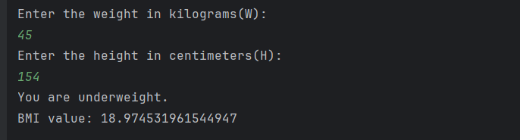

**Q8.**

**Code:**

package Q_08;  
import java.util.Scanner;  
  
public class Q8 {  
 public static void main(String[] args) {  
 Scanner scanner=new Scanner(System.*in*);  
 double PI=3.14;  
  
  
 System.*out*.println("Enter the radius(r): ");  
 double r=scanner.nextDouble();  
  
 double volume=(4.0/3)*(PI *Math.*pow*(r,3));  
 System.*out*.println("Volume is: "+volume);  
  
  
 }  
}

**Output:**

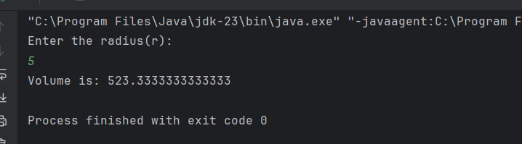

**Q9.**

**Code:**

package Q_09;  
import java.util.Scanner;  
public class Q9 {  
 public static void main(String[] args) {  
 Scanner scanner=new Scanner(System.*in*);  
  
 System.*out*.println("Enter invest dollar: ");  
 double P=scanner.nextDouble();  
 System.*out*.println("Enter annual percent interest: ");  
 double R=scanner.nextDouble();  
 System.*out*.println("Enter the No of years: ");  
 double N=scanner.nextDouble();  
  
 double amount=P*(1+Math.*pow*((R/100),N));  
 System.*out*.println("Amount is: "+amount);  
  
 }  
}

**Output:**

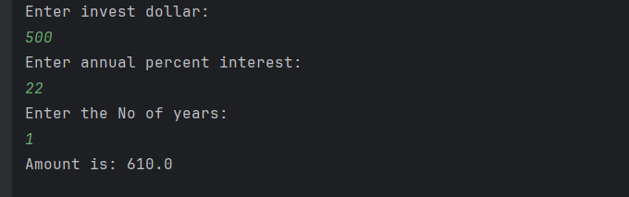

**Q10.**

**Code:**

package Q_10;  
  
import java.util.Scanner;  
public class Q10 {  
 public static final int *MONTHS_IN_YEAR*=12;  
  
 public static void main(String[] args) {  
 Scanner scanner=new Scanner(System.*in*);  
  
 System.*out*.println("Enter loan amount: ");  
 double loanAmount=scanner.nextDouble();  
  
 System.*out*.println("Enter the annual interest rate: ");  
 double annualInterest=scanner.nextDouble();  
  
 System.*out*.println("Enter loan period(year): ");  
 int loanperiod=scanner.nextInt();  
  
 double monthlyInterest=annualInterest/100.0/*MONTHS_IN_YEAR*;  
 int numberOfPayments = loanperiod * *MONTHS_IN_YEAR*;  
  
 double monthlyPayment = (loanAmount * monthlyInterest) /  
 (1 - Math.*pow*(1 / (1 + monthlyInterest), numberOfPayments));  
  
 double totalPayment = monthlyPayment * numberOfPayments;  
  
 System.*out*.printf("Monthly Payment: %.2f\n", monthlyPayment);  
 System.*out*.printf("Total Payment: %.2f\n", totalPayment);  
  
 }  
}

**Output:**

