Lab Worksheet-03 (Defining Classes)

01)

package Q_01;  
  
public class Temperature {  
 private double celsius;  
  
 public Temperature(){  
  
 }  
  
 public Temperature(double celsius) {  
 this.celsius = celsius;  
 }  
  
 public void setCelsius(double celsius){  
 this.celsius=celsius;  
 }  
  
 public double toCelsius(){  
 return celsius;  
 }  
  
  
 public double toFahrenheit(){  
 return (celsius * ((double)9/5)+32);  
 }  
  
 public void setFahrenheit(double fahrenheit){  
 this.celsius=(fahrenheit-32)*((double)5/9);  
 }  
  
  
}

package Q_01;  
  
import java.util.Scanner;  
  
public class Main {  
 public static void main(String[] args) {  
 Scanner scanner = new Scanner(System.*in*);  
  
 System.*out*.println("Enter the Temperature in Celsius: ");  
 double celsius = scanner.nextDouble();  
  
 Temperature temp = new Temperature();  
 temp.setCelsius(celsius);  
 System.*out*.println("The celsius convert into fahrenheit: " + temp.toFahrenheit());  
 }  
}

Output

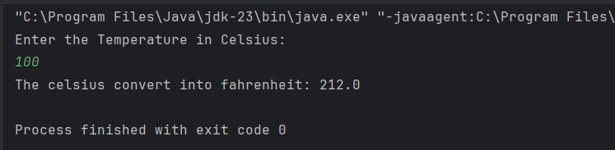

public class Main {  
 public static void main(String[] args) {  
 Scanner scanner = new Scanner(System.*in*);  
  
 //System.out.println("Enter the Temperature in Celsius: ");  
 // double celsius = scanner.nextDouble();  
  
 System.*out*.println("Enter the Temperature in Fahrenheit: ");  
 double fahrenheit = scanner.nextDouble();  
  
 //Temperature temp = new Temperature();  
 //temp.setCelsius(celsius);  
 //System.out.println("The celsius convert into fahrenheit: " + temp.toFahrenheit());  
  
 Temperature temp = new Temperature();  
 temp.setFahrenheit(fahrenheit);  
 System.*out*.println("The fahrenheit convert to celsius: " + temp.toCelsius());  
 }  
}

02)

Output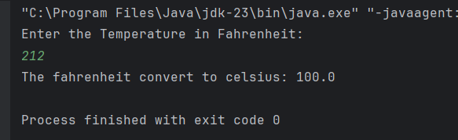

03)

package Q_03;  
  
public class Circle {  
 private double r;  
  
 public Circle(){  
  
 }  
  
 public Circle(double r) {  
 this.r = r;  
 }  
  
 public double getR() {  
 return r;  
 }  
  
 public void setR(double r) {  
 this.r = r;  
 }  
  
 public double computeArea(){  
 return Math.*PI*\*r*r;  
 }  
  
 public double computeCircumference(){  
 return 2*Math.*PI*\*r;  
 }  
  
}

package Q_03;  
import java.util.Scanner;  
public class Main {  
 public static void main(String[] args) {  
 Scanner scanner=new Scanner(System.*in*);  
  
 System.*out*.println("Enter the inner circle radius: ");  
 double innerRadius=scanner.nextDouble();  
  
 System.*out*.println("Enter the outer circle radius: ");  
 double outerRadius=scanner.nextDouble();  
  
 Circle innerCircle=new Circle(innerRadius);  
 Circle outerCircle=new Circle(outerRadius);  
  
 double area=outerCircle.computeArea()-innerCircle.computeArea();  
 System.*out*.println("The area is "+area);  
 }  
}

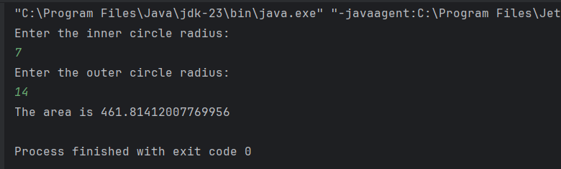Output

04)

package Q_04;  
  
public class Owner {  
 //Data Member  
 private String ownerName;  
 private String phoneNo;  
  
 //Constructor: Initializes the data member  
 public Owner(String ownerName, String phoneNo) {  
 this.ownerName = ownerName;  
 this.phoneNo = phoneNo;  
 }  
  
 public String getOwnerName() {  
 return ownerName;  
 }  
  
 public void setOwnerName(String name) {  
 ownerName = name;  
 }  
 public String getPhoneNo() {  
 return phoneNo;  
 }  
  
 public void setownerName(String ownerName){  
 this.ownerName=ownerName;  
 }  
  
 public void setPhoneNo(String num) {  
 phoneNo =phoneNo;  
 }  
}

package Q_04;  
  
public class Main {  
 public static void main(String[] args) {  
 Owner yapa=new Owner("yapa","0770088734");  
 Bicycle tomahawk=new Bicycle(yapa);  
  
 System.*out*.println("Owner Name: "+tomahawk.getBicycleOwner().getOwnerName());  
 System.*out*.println("Owner Telephone-No: "+tomahawk.getBicycleOwner().getPhoneNo());  
 }  
}

package Q_04;  
  
public class Bicycle {  
 Owner bicycleOwner;  
  
 public Bicycle(Owner bicycleOwner) {  
 this.bicycleOwner = bicycleOwner;  
 }  
  
 public Owner getBicycleOwner() {  
 return bicycleOwner;  
 }  
  
 public void setBicycleOwner(Owner bicycleOwner) {  
 this.bicycleOwner = bicycleOwner;  
 }  
}

Output

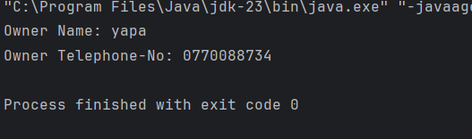

05)

package Q_05;  
  
public class Course {  
 private String courseName;  
 private String courseCode;  
 private Lecturer lecturerIncharge;  
  
 public String getCourseName() {  
 return courseName;  
 }  
  
 public void setCourseName(String courseName) {  
 this.courseName = courseName;  
 }  
  
 public String getCourseCode() {  
 return courseCode;  
 }  
  
 public void setCourseCode(String courseCode) {  
 this.courseCode = courseCode;  
 }  
  
 public Lecturer getLecturerIncharge() {  
 return lecturerIncharge;  
 }  
  
 public void setLecturerIncharge(Lecturer lecturerIncharge) {  
 this.lecturerIncharge = lecturerIncharge;  
 }  
}

package Q_05;  
  
public class Lecturer {  
 private String lecturerName;  
 private String courseTeaching;  
  
 public String getLecturerName() {  
 return lecturerName;  
 }  
  
 public void setLecturerName(String lecturerName) {  
 this.lecturerName = lecturerName;  
 }  
  
 public String getCourseTeaching() {  
 return courseTeaching;  
 }  
  
 public void setCourseTeaching(String courseTeaching) {  
 this.courseTeaching = courseTeaching;  
 }  
}

package Q_05;  
  
public class Student {  
 private String studentName;  
 private String degreeName;  
 private String courseFollowing;  
  
 public String getStudentName() {  
 return studentName;  
 }  
  
 public void setStudentName(String studentName) {  
 this.studentName = studentName;  
 }  
  
 public String getDegreeName() {  
 return degreeName;  
 }  
  
 public void setDegreeName(String degreeName) {  
 this.degreeName = degreeName;  
 }  
  
 public String getCourseFollowing() {  
 return courseFollowing;  
 }  
  
 public void setCourseFollowing(String courseFollowing) {  
 this.courseFollowing = courseFollowing;  
 }  
}

package Q_05;  
  
public class Main {  
 public static void main(String[] args) {  
 Course oop=new Course();  
 oop.setCourseName("Object Oriented Programme");  
 oop.setCourseCode("CTEC 22043");  
  
 Lecturer kumar=new Lecturer();  
 kumar.setLecturerName("kumar");  
 kumar.setCourseTeaching("Object Oriented Programme");  
  
 Student Sanga=new Student();  
 Sanga.setStudentName("yapa");  
 Sanga.setDegreeName("ICT");  
 Sanga.setCourseFollowing("Object Oriented Programme");  
  
 System.*out*.println("Student Details: ");  
 System.*out*.println("Student Name: "+Sanga.getStudentName());  
 System.*out*.println("Degree Name: "+Sanga.getDegreeName());  
 System.*out*.println("Course Name: "+Sanga.getCourseFollowing());  
  
 System.*out*.println("Course Details: ");  
 System.*out*.println("Course Name: "+oop.getCourseName());  
 System.*out*.println("Course Code: "+oop.getCourseCode());  
  
 System.*out*.println("Lecturer Details: ");  
 System.*out*.println("Lecturer name: "+kumar.getLecturerName());  
 System.*out*.println("Course Teaching: "+kumar.getCourseTeaching());  
  
 }  
}

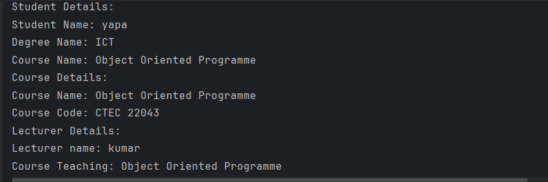Output