**Lab worksheet 5: Repetition Statements**

01)

package Q01;  
  
public class Q1 {  
 public static void main(String[] args) {  
 int start=10;  
 int end=49;  
  
 for(int i=start; i<=end;i++){  
 System.*out*.print(i+" ");  
  
 if ((i-start +1) % 10==0){  
 System.*out*.println();  
 }  
 }  
 }  
}

Output

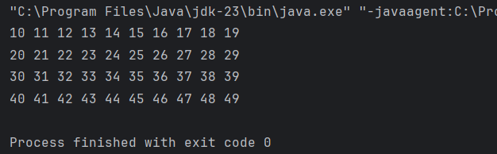

02)

package Q02;  
import java.util.Scanner;  
public class Q2 {  
 public static int countDigits(int number) {  
 if (number == 0) {  
 return 1;  
 }  
  
 int count = 0;  
 while (number != 0) {  
 number = number / 10;  
 count++;  
 }  
 return count;  
 }  
  
 public static void main(String[] args) {  
 Scanner scanner = new Scanner(System.*in*);  
 int input;  
  
  
 while (true) {  
 System.*out*.print("Enter a number (negative to stop): ");  
 input = scanner.nextInt();  
  
 if (input < 0) {  
 System.*out*.println("Negative number entered. Program stopped.");  
 break;  
 }  
  
 int digits = *countDigits*(input);  
 System.*out*.println("Number of digits in " + input + " is: " + digits);  
 }  
  
 scanner.close();  
 }  
 }

Output

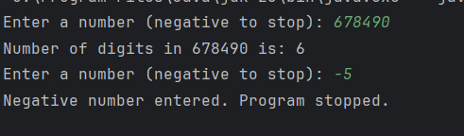

03)

package Q03;  
import java.util.Scanner;  
public class Q3 {  
 public static void main(String[] args) {  
 Scanner scanner = new Scanner(System.*in*);  
  
 System.*out*.print("Enter a number to print its multiplication table: ");  
 int N = scanner.nextInt();  
  
 System.*out*.println("Multiplication Table for " + N + ":");  
 for (int i = 1; i <= 10; i++) {  
 System.*out*.println(N + " x " + i + " = " + (N * i));  
 }  
  
 scanner.close();  
 }  
 }

Output

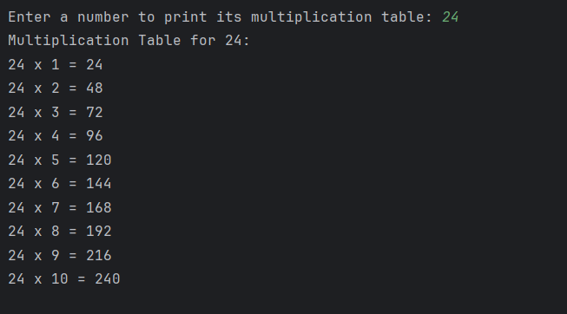

04)

package Q04;  
import java.util.Scanner;  
public class Q4 {  
 public static void main(String[] args) {  
 Scanner scanner = new Scanner(System.*in*);  
  
 System.*out*.print("Enter the number of rows for the pyramid: ");  
 int rows = scanner.nextInt();  
  
 for (int i = 1; i <= rows; i++) {  
 for (int j = 1; j <= rows - i; j++) {  
 System.*out*.print(" ");  
 }  
  
 for (int k = 1; k <= (2 * i - 1); k++) {  
 System.*out*.print("*");  
 }  
  
 System.*out*.println();  
 }  
  
 scanner.close();  
 }  
 }

Output

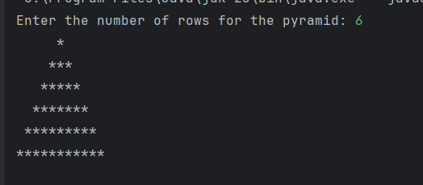

05)

package Q05;  
import java.util.Scanner;  
  
public class Q5 {  
 public static void main(String[] args) {  
 Scanner scanner=new Scanner(System.*in*);  
 System.*out*.println("Enter a word: ");  
 String word=scanner.nextLine();  
  
 if(*isPalindrome*(word)){  
 System.*out*.println("The given word is palindrome");  
 } else {  
 System.*out*.println("The given word is not palindrome");  
 }  
 }  
  
 public static boolean isPalindrome(String word){  
 String reverseWord="";  
 for (int i=word.length()-1;i>=0;i-- ){  
 reverseWord=reverseWord+word.charAt(i);  
 }  
 return word.equals(reverseWord);  
 }  
  
  
}

Output

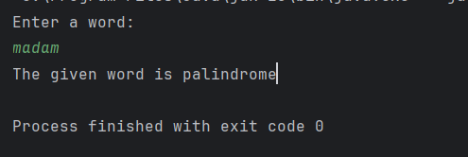

06)

package Q06;  
import java.util.Random;  
import java.util.Scanner;  
public class Q6 {  
 public static void main(String[] args) {  
 Scanner scanner=new Scanner(System.*in*);  
 Random random=new Random();  
  
 int secretNumber=random.nextInt(100)+1;  
 int guess;  
 int attempts=0;  
  
 System.*out*.println("Welcome to the number guessing game!");  
  
 do {  
 System.*out*.println("Enter your guess(1-100): ");  
 guess = scanner.nextInt();  
 attempts++;  
  
 if (guess > secretNumber) {  
 System.*out*.println("Higher");  
 } else if (guess < secretNumber) {  
 System.*out*.println("Lower");  
 } else {  
 System.*out*.println("Congratulation! you gussed the secret number correct in " + attempts + " attempts");  
 }  
 }while(guess!=secretNumber);  
  
 }  
}

Output

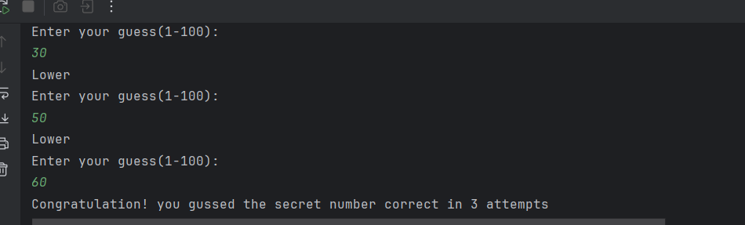

07)

package Q06;  
import java.util.Random;  
import java.util.Scanner;  
public class Q6 {  
 public static void main(String[] args) {  
 Scanner scanner=new Scanner(System.*in*);  
 Random random=new Random();  
  
 int secretNumber=random.nextInt(100)+1;  
 int guess;  
 int attempts=0;  
  
 System.*out*.println("Welcome to the number guessing game!");  
  
 do {  
 System.*out*.println("Enter your guess(1-100): ");  
 guess = scanner.nextInt();  
 attempts++;  
  
 if (guess > secretNumber) {  
 System.*out*.println("Higher");  
 } else if (guess < secretNumber) {  
 System.*out*.println("Lower");  
 } else {  
 System.*out*.println("Congratulation! you gussed the secret number correct in " + attempts + " attempts");  
 }  
 }while(guess!=secretNumber);  
  
 }  
}

Output

