New Issues
- When we select all users and create record it’s not working we need to take a look at it ( Mire )
- When approve record we need to make the user select our signature and teeter(Nati )
- The date should be in Amharic here
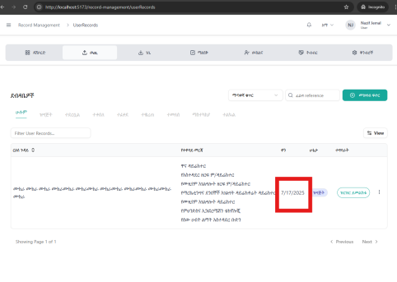
- The record status should be defined and give appropriate name both in English and Amharic(Estif )
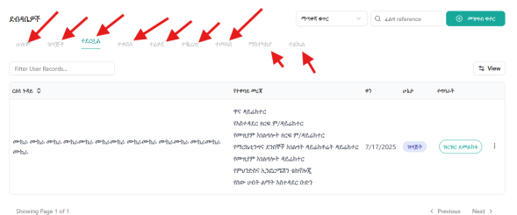
- Delegation Frontend ( Nati)
- Search should be functional it’s not currently and it should be from the back-end including the pagination (Mire )
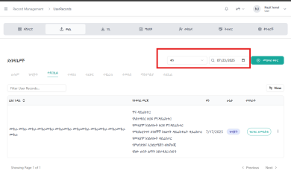
- On the view add all columns (Bereket)
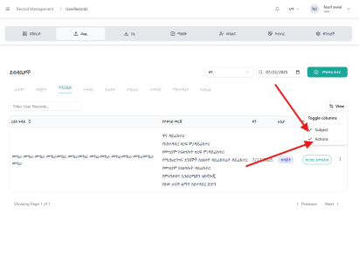
- Let’s add a user selection to give it a file name when they create a record (Bereketeab)
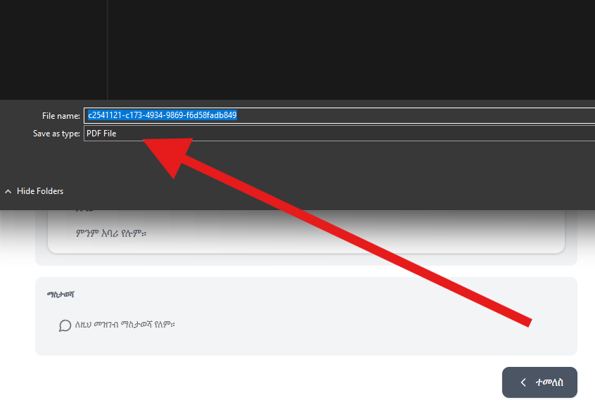

- On incoming the route is not working(Mire)
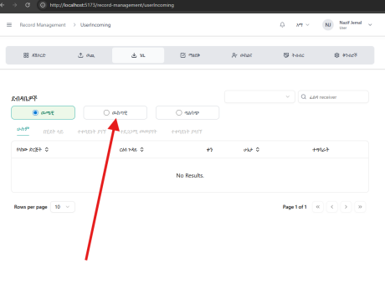
- here only shows the receiver by department not by username it should show username as well(Estif)
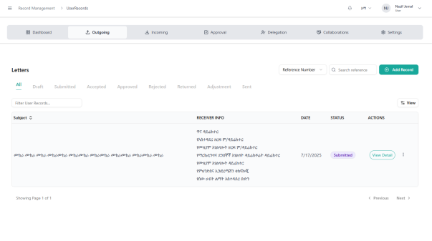
- Forward one record and see the record ( all the filters are not working )(Bereket)
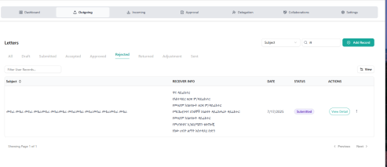
- Can’t delete the last item both the teeter and signature and also make sure to upload only two teeters and better to add what type of teeter it is ( English Or Aramaic) ( Nati)
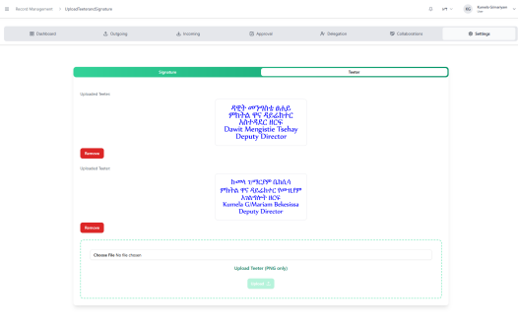
- After we take actions for the letter which comes from the below hierarchy it’s removed form out history( can’t catch approved, adjusted and rejected) (Mire)
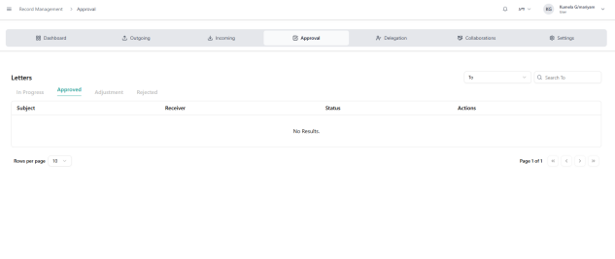
- on the record officer the incoming route is not working (Mire)
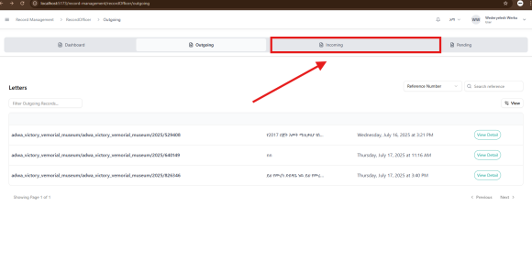
- Sorting for the whole table should be corrected ( last in first out)( Mire and Bereketeab)
- Delay on getting the generated PDF(Bereketeab)
- Here we should add the headers above on RO UI ( Dispatched Date, the RO who dispatch the Record)
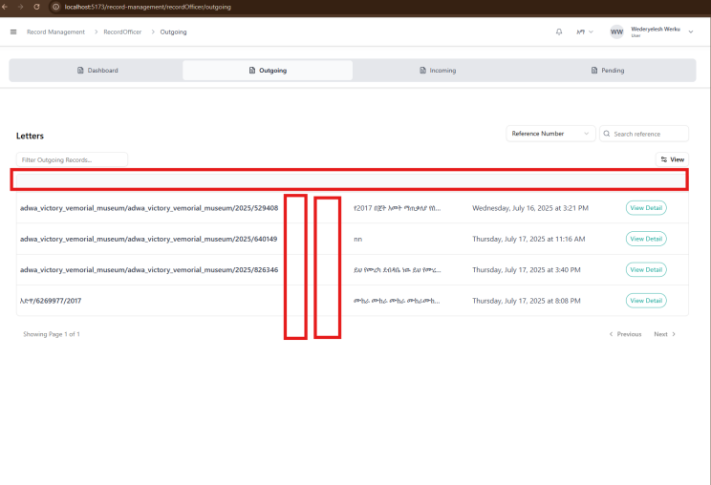
- Dynamic Data localization using i18n( Mihretu, Estif , Nati)
- Here on the internal records the prefix and suffix should be taken without even the user selection of them(Mire)

