symptoms that can cause DR:
type1,type2 diabetics
diabetics for long period
high blood sugar level,cholestrol level

early symptoms:
shapes floating in the vision
blurred or patchy vision
eye pain and redness

stage 1:Background retinopathy

tiny bulges called microanurisms and retinal Hemorrhages have been seen in blood vessels and also cause small amount of blood leak
This can develop the problem as DR
Represented as dot or blot

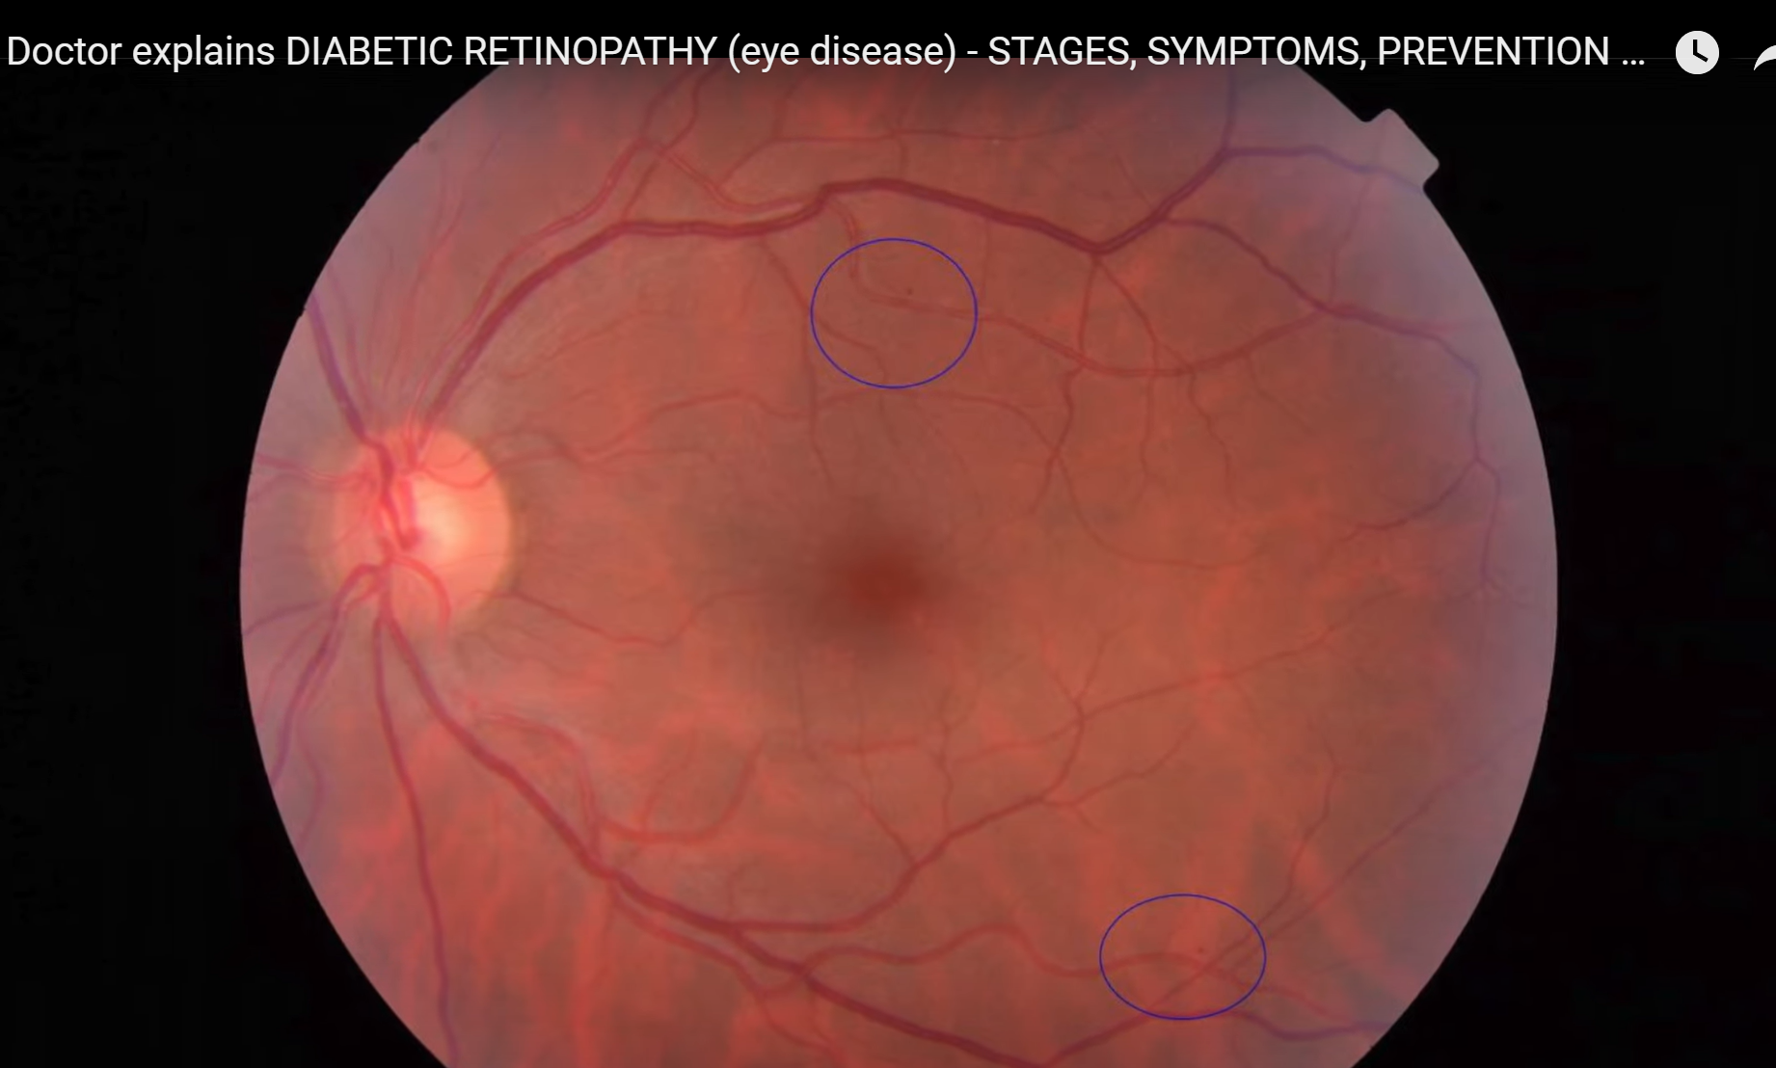

STAGE 2:PRE-PROLIFERATIVE RETINOPATHY
Server on , cause bleeding into retina
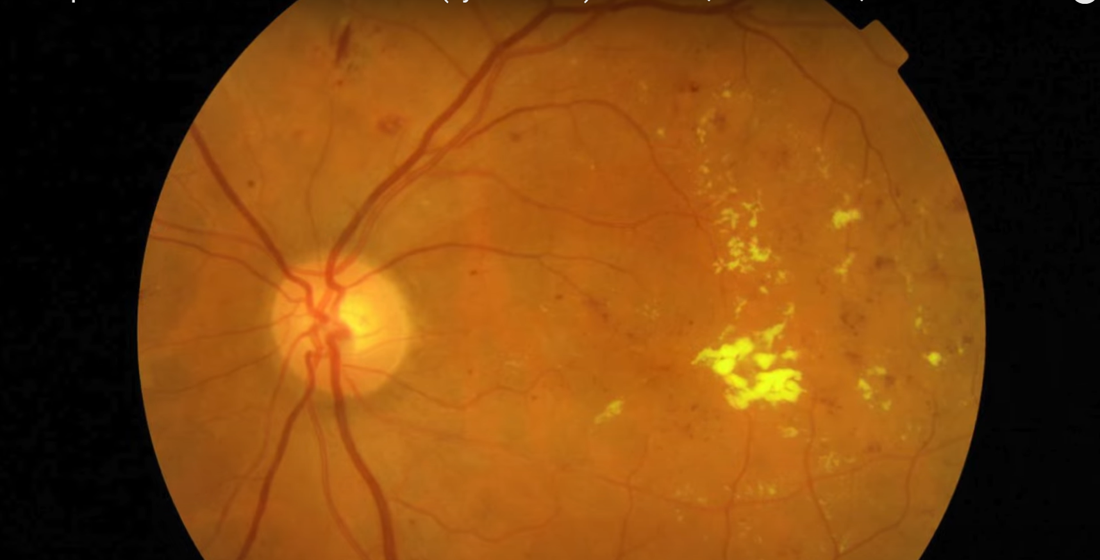

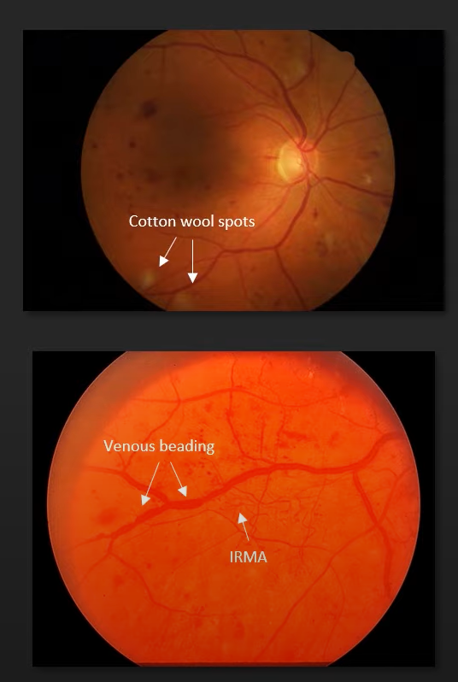

STAGE 3:PROLIFERATIVE RETINOPATHY

New blood vessels and scar tissues are formed in retina and cause bleeding in retina and at a certain limit the retina gets pulled away that is the retina is being detached
Vision loss is highly possible

