
Department of Software Engineering

SUMMER INTERSHIP
Project Proposal

Title: Planning and Reporting Management System

By:
NAME ID
1, Senay Bihon--------------------------------ETS 1167/13
2, Agumas Desalew ---------------------------ETS 1159/13
3, Habteyesus Tadesse-------------------------ETS 0566/13

Addis Ababa, Ethiopia
Table of Contents

1.1 Background 3
1.2 Statement of the problem 3
1.3 Objectives: 4
1.4 Methodology 5
1.5 Feasibility: 5
1.5.1 Economic and time feasibility 5
1.6 Technologies/Tools: 6
1.7 Task and Schedule 6
1.8 Scope and limitation 6
Conclusion 7
Chapter 2: System Design and Analysis 7
2.1 Existing System 7
2.2 New System 8
2.2.1 Functional Requirements 8
2.3 Use case diagram 9
2.4 System Architecture 10
2.5 Database Schema 11
2.6 API Endpoints 11
2.7 System Futures 11
2.8 Planning and Reporting Workflow 14
2.9 The functional hierarchy of systems users 16

1. Introduction:
We propose to develop a Plan and Report Management System using the Laravel PHP framework. This system aims to streamline the process of creating, managing, and tracking plans and reports within AASTU. By leveraging Laravel's robust features, we can create a scalable and efficient web application tailored to the specific needs of our client.

1.1 Background
The background of plan and report management systems can be traced back to the need for efficient and effective management of employee performance, goals, and reporting within organizations. Historically, employee plans and reports were often handled manually or through disparate systems, leading to inefficiencies, data inaccuracies, and a lack of visibility and alignment.
The evolution of technology, particularly in the field of human resources management, has paved the way for the development of dedicated software solutions to address these challenges. Plan and report management systems emerged as a response to the growing demand for streamlined processes, improved performance tracking, and data-driven decision-making.

1.2 Statement of the problem
The current plan and report management process in AASTU is inefficient and prone to errors. We face the following challenges and issues:

- Manual and Disorganized Process: The existing system relies heavily on manual entry and paper-based documentation, leading to a cumbersome and error-prone process. This results in time-consuming administrative tasks and difficulties in tracking and managing employee plans and reports.

- Lack of Centralized System: There is no centralized system for managing employee plans and reports. This leads to scattered information across various departments and makes it challenging to consolidate and analyze data for decision-making purposes.

- Lack of Collaboration and Communication: The absence of a dedicated system hampers effective collaboration and communication between employees, team leaders, directors, vice presidents, and the president. This leads to delays in plan approvals, difficulties in providing feedback and comments, and inefficiencies in the overall process.

- Inconsistent Plan Approval Process: The plan approval process lacks standardization and clear guidelines. This results in varying approval timelines, inconsistencies in feedback, and confusion among employees and managers regarding the status of their plans.

- Inefficient Reporting: Generating reports on employee plans and progress is a time-consuming and manual task. The lack of automated reporting features makes it difficult to obtain accurate and up-to-date information for decision-making and evaluation purposes.

- Lack of Visibility and Accountability: There is limited visibility and accountability throughout the employee plan and report management process. It is challenging to track the progress of individual plans, monitor performance, and ensure timely completion of tasks.
Many organizations rely on manual or disparate systems for managing employee plans and reports, leading to scattered data and a lack of centralized information. This makes it difficult to track progress, identify trends, and gain a holistic view of employee performance and goal achievement.
Without a dedicated system, it is challenging to ensure alignment between individual and team goals and broader organizational objectives. This lack of alignment can lead to a disconnect between employees' efforts and strategic priorities, resulting in inefficiencies and missed opportunities.

1.3 Objectives:

1.3.1 General objective

The general objective of a plan and report management system is to provide a centralized platform that facilitates the planning, tracking, and reporting of activities within an organization.

1.3.2 Specific objective
- Develop a user-friendly web application for managing plans and reports.
- Enable users to create, edit, view, and delete plans and reports.
- Implement role-based access control to ensure data security and privacy.
- Provide features for generating and exporting reports in various formats.e.g excel and pdf, graph
- Implement robust validation and error handling mechanisms to maintain data integrity.
- Ensure scalability and maintainability of the system for future enhancements.

1.4 Methodology
- Requirement gathering methods ▪
- Requirement modeling (Structured vs object oriented) ▪
- Agile Methodology: Adopt an agile development approach with regular sprints, feedback loops, and incremental delivery.
- Continuous Integration/Continuous Deployment (CI/CD): Implement CI/CD pipelines for automated testing and deployment.
- Code Reviews: Conduct regular code reviews to ensure code quality, adherence to coding standards, and knowledge sharing among team members.
- Documentation: Maintain comprehensive documentation covering system architecture, database schema, API endpoints, and user guides.

1.5 Feasibility:

1.5.1 Economic and time feasibility
An employee plan and report management system can bring several economic benefits to AASTU. Here are some aspects to consider when evaluating its economic feasibility:
- Cost reduction: Implementing an automated employee plan and report management system can lead to significant cost savings. It eliminates the need for manual paperwork, reduces administrative overhead, and minimizes the risk of errors that can be costly to rectify. Additionally, the system can streamline processes, saving time and improving efficiency.
- Increased productivity: An efficient plan and report management system enables employees to focus more on their core responsibilities rather than spending excessive time on administrative tasks. By automating repetitive and time-consuming activities, such as data entry and report generation, employees can allocate their time and skills to more value-added activities, leading to increased productivity.
- Enhanced decision-making: A robust plan and report management system provides accurate and real-time data on employee performance, project status, and resource allocation. This enables managers and decision-makers to make informed decisions promptly. Timely access to reliable information can improve strategic planning, resource allocation, and overall organizational performance.

1.6 Technologies/Tools:
- Laravel Framework: For building the backend of the web application.
- MySQL Database: For storing plans, reports, user data, and system logs.
- HTML, CSS, JavaScript: For frontend development and user interface design.
- Bootstrap: For responsive and modern UI design.
- Git: For version control and collaboration during development.
- PHPUnit: For unit testing to ensure code quality and reliability.

1.7 Task and Schedule
Phases | Aug 1-4 | Aug 5 - Oct 1 | Oct 2-6 | Oct 7-16
Design | X
Implementation |  | X
Testing |  |  | X
Maintenance |  |  |  | X

1.8 Scope and limitation
Scope:
- Employee Plan Management: The system will allow users to create, update, and track employee plans, including goal setting, performance objectives, and action plans.
- Report Management: The system will enable users to generate, store, and analyze various types of reports related to employee performance, progress, and achievements.
- Workflow Automation: The system will automate the workflow processes associated with employee plans and reports, including approval routing, notifications, and reminders.
- Collaboration and Communication: The system will facilitate collaboration among employees, managers, and stakeholders involved in the plan and report management process through features like comments, annotations, and document sharing.
- Data Analysis and Visualization: The system will provide tools for data analysis and visualization, allowing users to generate reports, charts, and dashboards to gain insights into employee performance and progress.
- Integration with HR Systems: The system will integrate with existing HR systems to synchronize employee data, organizational structure, and roles, ensuring data consistency and reducing manual data entry.
- Security and Access Control: The system will implement robust security measures, including user authentication and access control, to protect sensitive employee data and ensure that only authorized users can access and modify information.
Limitations:
- System Customization: The level of system customization may be limited, depending on the software's capabilities and configuration options. Some specific customization requests may require additional development or customization efforts.
- Learning Curve: Users may require training and time to adapt to the new system, especially if they are accustomed to the previous paper-based processes. Adequate training and support should be provided to ensure a smooth transition.
- Data Migration: If there is existing data in the paper-based system, migrating that data into the new system may pose challenges. Ensuring accurate and complete data migration may require manual data entry or data conversion efforts.

Conclusion
The comprehensive documentation provided ensures that stakeholders, developers, and end-users have a clear understanding of the Plan and Report Management System's architecture, functionality, and usage. It serves as a valuable resource for system implementation, maintenance, and support.

Chapter 2: System Design and Analysis

2.1 Existing System
The existing system for employee plan and report management was paper-based. This means that all employee plans and reports were created, stored, and managed using physical documents such as forms, spreadsheets, and printed reports. The process involved manual data entry, filing, and retrieval of paper documents.
Employees would typically fill out forms or templates manually to create their plans or reports, which were then submitted to the relevant Team leaders or Directors for review and approval.
Since the system was paper-based, there were limitations in terms of data accessibility, accuracy, and efficiency. Searching for specific information within the documents could be time-consuming and prone to errors. Additionally, manual data entry increased the risk of transcription errors and made it difficult to aggregate and analyze data across multiple plans or reports.
The paper-based system also posed challenges in terms of security and data backup. Physical documents were susceptible to loss, damage, or unauthorized access. In the event of a disaster or unforeseen circumstances, the loss of documents could have serious consequences for the organization's employee planning and reporting processes.
Overall, the existing system relied on manual processes, paper documents, and limited technological support. It lacked the advantages of automation, real-time data access, centralized storage, and efficient collaboration that a digital employee plan and report management system can provide.

2.2 New System

2.2.1 Functional Requirements
When transitioning from a paper-based system to a new digital employee plan and report management system, here are some functional requirements that you may consider:
- User Authentication and Access Control: Implement a secure user authentication system to ensure that only authorized personnel can access and modify employee plans and reports. Different levels of access control should be available based on user roles and responsibilities.
- Plan and Report Creation: Provide an intuitive interface for users to create new employee plans and reports. Include necessary fields and templates to capture relevant information, such as goals, objectives, timelines, and performance metrics. Allow users to save drafts, edit, and update their plans and reports as needed.
- Workflow Management: Define and automate workflows for the review, approval, and feedback processes associated with employee plans and reports. Enable notifications and reminders to keep stakeholders informed about pending tasks and deadlines. Ensure flexibility to accommodate different approval hierarchies and routing rules.
- Collaboration and Communication: Facilitate collaboration among employees, managers, and stakeholders involved in the plan and report management process. Provide features such as comments, annotations, and file attachments to enable discussions, feedback, and document sharing within the system.
- Data Visualization and Reporting: Offer robust reporting and data visualization capabilities to transform raw data into meaningful insights. Generate customizable reports, charts, and dashboards that present key performance indicators, progress tracking, and comparative analysis of employee plans and reports.
- Performance Tracking and Evaluation: Incorporate mechanisms to track and evaluate employee performance against their plans and goals. Enable the recording of actual achievements, milestones, and performance metrics. Automate the calculation of progress, completion rates, and performance scores.
- Document Management: Implement a centralized document repository where users can store and retrieve supporting documents related to employee plans and reports. Enable version control, document linking, and search functionalities for easy document management and retrieval.
- Integration with HR Systems: Integrate the employee plan and report management system with existing HR systems, such as HRIS (Human Resources Information System), to synchronize employee data, roles, and organizational structures. This integration ensures data consistency and reduces manual data entry.
- Notifications and Reminders: Send automated notifications and reminders to users for upcoming deadlines, pending approvals, or changes in plans and reports. These notifications can be delivered via email, in-app notifications, or through other preferred communication channels.
- Mobile Accessibility: Provide mobile accessibility to the system, allowing users to access, create, and manage employee plans and reports on-the-go using smartphones or tablets. Ensure that the system is responsive and optimized for mobile devices.

2.3 Use case diagram
Use case diagrams are graphical representation of overview of behavior of the system. Use case diagram shows the relationship between the actors and use cases in the system. Technically the use case diagram helps in defining the boundary of the system. The most important role of a use case diagram is to communicate the systems functionality and behavior to the customer or end user.
Figure 1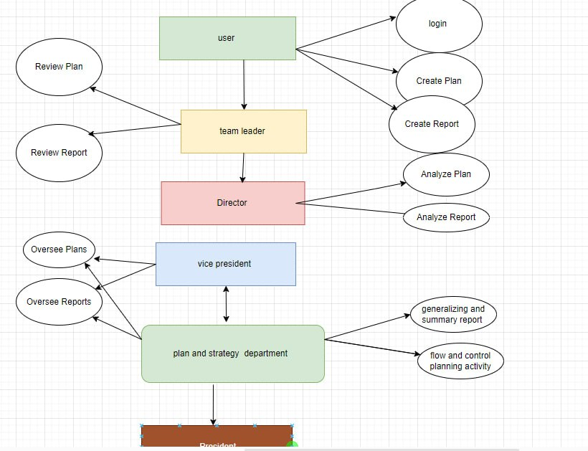

2.4 System Architecture
The Plan and Report Management System is built using the Laravel PHP framework for the backend, MySQL database for data storage, and HTML, CSS, and JavaScript for the frontend. The system follows a three-tier architecture:
- Presentation Layer: Handles user interaction through web pages and UI components. It includes views, templates, and frontend assets.
- Application Layer: Implements business logic and processes user requests. It consists of controllers, services, and middleware for handling authentication, authorization, and data manipulation.
- Data Layer: Manages data storage and retrieval. It includes database models, migrations, and query builders for interacting with the MySQL database.

2.5 Database Schema
The MySQL database schema consists of the following tables:
- Users: Stores user authentication information, including usernames, email addresses, and hashed passwords.
- Plans: Contains details of plans created by users, such as title, description, deadline, status, and assigned user IDs.
- Reports: Stores report data, including title, content, version, creation date, and associated plan ID.
- Roles: Defines user roles with corresponding permissions.
- Role_User: Many-to-many relationship table linking users to their roles.

2.6 API Endpoints
The system exposes RESTful API endpoints for interacting with plans and reports. API endpoints include:
- /api/plans: GET (retrieve all plans), POST (create a new plan)
- /api/plans/{id}: GET (retrieve a specific plan), PUT/PATCH (update a plan), DELETE (delete a plan)
- /api/reports: GET (retrieve all reports), POST (create a new report)
- /api/reports/{id}: GET (retrieve a specific report), PUT/PATCH (update a report), DELETE (delete a report)

2.7 System Futures

User Authentication
To access the system, users must register an account or log in with existing credentials. After authentication, users can perform various actions based on their assigned roles.

Plan Management
Users can create new plans, edit existing plans, assign tasks to team members, set deadlines, and track plan progress. They can also categorize plans and mark them as completed when finished.

Report Management
Users can generate new reports, edit existing reports, and track revisions. Reports are associated with specific plans and can be exported in various formats for sharing or archival purposes.

Role-based Access Control
The system supports multiple user roles, including Admin, Manager, and Staff. Each role has different levels of access to system features and data.
Functionality | Admin | Manager | Staff
User Authentication and Access Control | Yes | No | No
Plan and Report Creation | No | Yes | Yes
Workflow Management | Yes | Yes | No
Collaboration and Communication | Yes | Yes | Yes
Data Visualization and Reporting | Yes | Yes | Yes
Performance Tracking and Evaluation | No | Yes | Yes
Document Management | Yes | Yes | Yes
Integration with HR Systems | Yes | No | No
Notifications and Reminders | Yes | Yes | Yes
Mobile Accessibility | Yes | Yes | Yes
Security and Access Control | Yes | No | No
System Maintenance | Yes | No | No
Reports and Dashboards | Yes | Yes | Yes

Summary:
- Admins manage system configuration, user accounts, roles, permissions, and integration with HR systems, ensuring the system operates smoothly and securely.
- Managers oversee and approve plans and reports, monitor staff performance, provide feedback, and collaborate with their teams.
- Staff create and submit their performance plans and reports, track their progress, and collaborate with their managers and peers.

Dashboard
Users can view a personalized dashboard with an overview of their plans, reports, upcoming deadlines, and recent activity. The dashboard provides quick access to essential features and information.

Search and Filter
Users can search for specific plans or reports using keywords or apply filters to narrow down search results based on criteria such as title, status, or date.

Notifications
The system sends notifications to users about upcoming deadlines, assigned tasks, and changes to plans or reports via email or in-app notifications.
- Role-based Access Control: Each level of the organizational hierarchy has specific roles and permissions related to planning, reporting, and decision-making.
- Hierarchical Approval Process: Plans and reports move up the organizational hierarchy for review and approval, ensuring accountability and alignment with strategic objectives.
- Consolidated Reporting: Reports are aggregated and consolidated at each level of the organization, providing stakeholders with comprehensive insights into performance and progress.
- Feedback Mechanism: Staff members receive feedback and guidance from their team leaders, fostering professional development and continuous improvement.
- Exporting: Allow users to export plans and reports in common formats such as PDF or Excel.
- Audit Trail: Log all user actions and changes made to plans and reports for accountability and auditing purposes.
- Responsive Design: Ensure the application is responsive and accessible across various devices and screen sizes.
Data Analysis and Decision Support: Reports generated at higher levels of the organization facilitate data-driven decision-making and strategic planning

2.8 Planning and Reporting Workflow
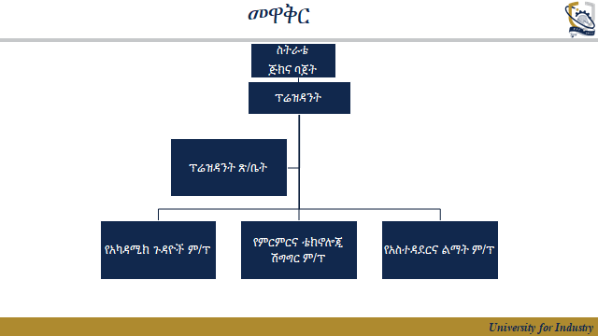
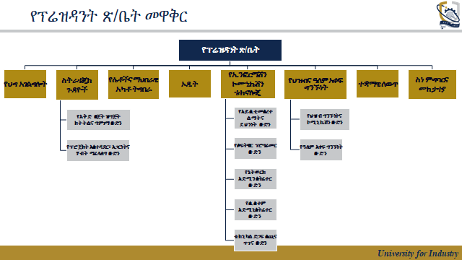
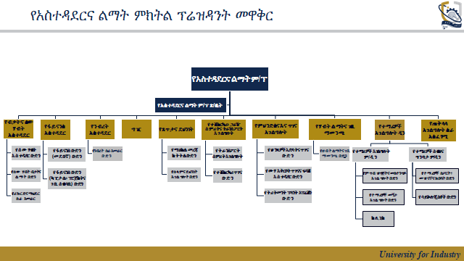
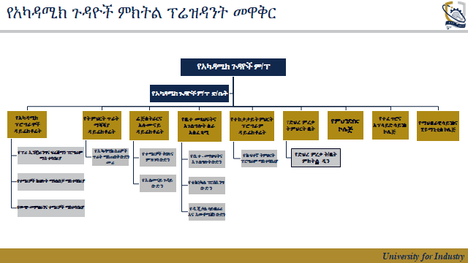
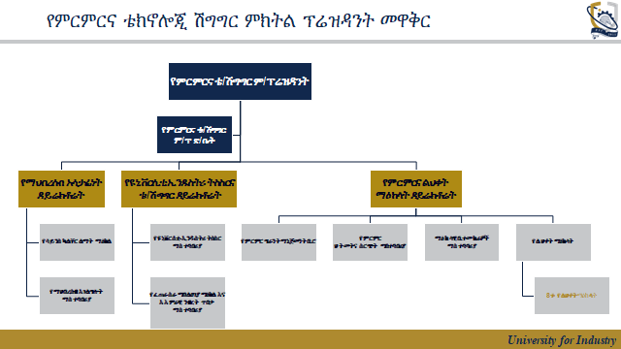

2.9 The functional hierarchy of systems users
- Staff Level
  - Ordinary staff members can create plans and reports related to their assigned tasks and projects.
  - Plans and reports are submitted to their respective team leaders for review and approval.
- Team Leader Level
  - Team leaders review plans and reports submitted by staff members under their supervision.
  - They can provide feedback, make revisions, and approve or reject plans and reports.
  - Team leaders have the authority to generate reports summarizing the activities and progress of their teams.
- Director/Department Level
  - Directors or department heads receive consolidated reports from team leaders within their respective departments.
  - They analyze departmental performance, identify key insights, and make strategic decisions based on the reports.
  - Directors can generate reports outlining departmental achievements, challenges, and future plans.
- Vice President and President Level
  - Vice presidents and the president receive reports from all departments and teams within the school.
  - They evaluate the overall performance of the organization, set strategic goals, and make high-level decisions based on the reports.
  - Reports generated at this level provide insights into the law firm's overall operations, financial health, and future directions.
- Strategic Plan Level:
- The strategic plan serves as the top-level hierarchy in the plan and report management system.
- It defines the long-term goals, vision, and strategic initiatives of the law firm.
- The strategic plan guides the development of departmental plans and reports, ensuring alignment with the organization's overall objectives.
- Reports generated at this level outline progress towards strategic goals, highlight challenges, and propose adjustments to the strategic plan if necessary.

