|  |
| --- |
| Report |

Assignment 1

*1DV701*

|  |
| --- |
| *Author:* Ghiath Al Omari  *Semester:* Spring 2023  *Email:* [*ga222kt@student.lnu.se*](mailto:ga222kt@student.lnu.se) |

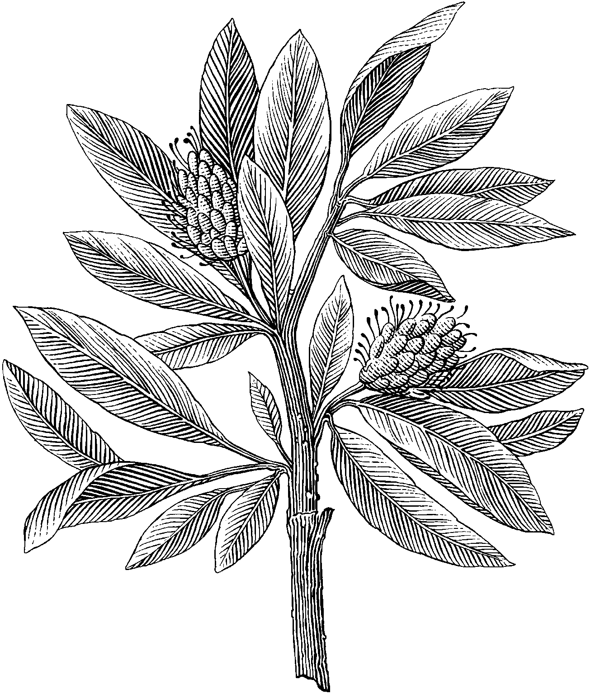

Table of Contents

Contents

1 Problem 1 2

T1_1: 2

T1_2: 2

T1-3: 2

2 Problem 2 2

T2-1 2

T2-2 3

3 Problem 3 3

T3-1 3

4 Problem 4 3

T4-1 3

T4-2 3

T4-3 4

5 Problem 5 4

T5-1 4

# Problem 1

## T1_1:

* TCP: Transmission Control Protocol: is a standard that explains how to set up and protect a network conversation by where applications can transfer data. It is a safer way to transfer data to ensure that the data is delivered.
* DNS: Domain name system protocol is used to us by converting the websites from numerical Ip addresses to letter so we can read it.
* TLSv1.2: “Transport layer security” it helps the client and the server to communicate over a secured layer, where data transformation is encrypted and can only be understood by the involved parties not by intrusions.
* ARP: address resolution protocol, it shows the Ip address and mac address and even the type of connection.

## T1_2:

After browsing for a while, I got 47 ipv4 and 3 ipv6. The reason why there are different amounts of ipv4 and ipv6 is because some websites and devices are not configured to support ipv6 yet, which forces the use of ipv4. Despite ipv6 having existed for a long time, still most of the websites use ipv4 as their primary protocol.

DNS servers are used to interpret domain names into proper Ip addresses. The Ip address of the DNS I was connected to is 172.27.129.124

## T1-3:

The protocols that are used in UDP are DNS and QUIC.

* DNS: Domain name system protocol is used to us by converting the websites from numerical Ip addresses to letter so we can read it.
* QUIC: “Quick UDP Internet Connections “it is a transport layer designed by google and its goal is to reduce latency.
* UDP: “user datagram protocol” it is a transport layer used to maintain low latency and loss tolerating connections between applications and the internet. UDP is also stateless protocol i.e., it doesn’t acknowledge if the packets that have been sent has been received

# Problem 2

## T2-1

My machine IP address is 172.27.134.47 and the destination’s address is 209.197.3.8.

I observe that the HTTP uses the GET method. This method is used to collect the data from the server we have requested.

## T2-2

As I see, the status code is 206 and the content length is 65536 bytes and last-modified: Thu, 26 May 2022 21:33:42 GMT\r\n.

The status code is a response from the server to the client. It consists of 3 digits.

Content length is the length of the message body in bytes.

last modified refers to when a message is modified last.

# Problem 3

## T3-1

A GET request is an HTTP request that fetches data from a server. It consists of a request line, headers, and an optional message body. The request line includes the GET method, the requested resource (URI), and the HTTP version. The headers provide additional information about the request, such as the accept type or referring page.

When the server responds to the GET request, the response includes a status line with the HTTP status code, which in our case is 200 OK. The headers in the response provide information about the content, such as the content length, content type, and the last modified date. The content length header allows the client to determine the expected size of the response, while the content type header provides information about the type of data that will be included in the response body. The Last-Modified header provides the timestamp for when the resource was last modified.

A GET request allows a client to request information from a server, and the response message is how the server provides that information.

# Problem 4

## T4-1

There is only one request[1].

After stripping off the MAC header and LLC header, which combined are 14 bytes in length, a frame in the data-link layer with a length of 554 bytes is transformed into a packet in the network layer that is 540 bytes in size. This packet contains an IP header with a length of 20 bytes and a TCP header of 20 bytes.

In the transport layer, the IP header is removed, and the resulting segment has a length of 520 bytes with a TCP header of 20 bytes. Finally, the payload is obtained by removing the TCP header, resulting in a payload of 500 bytes.

## T4-2

When the amount of data that may be sent surpasses the maximum transmission unit (MTU) of the network hardware, a problem occurs. To overcome this problem the packet can be broken up into smaller bits, which is done by fragmenting it. Next, one by one, these parts are sent via the TCP/IP layers in separate frames.

## T4-3

In my case I’ve got http status code 200 and 404. Status code 200 indicates that the client has requested packets from the server and that the server has replied to the client and given it the packets without disruption, it called *successful responses,* and it goes from 200- 299. Code 404 *not found,* it means that the server wasn’t able to find the requested resources, it has different appearance meanings for instance in browser it means that the URL was not recognized.

# Problem 5

## T5-1

As I see at first when I clicked on the link, I got 401 status code which means unauthorized i.e. I don’t have access to reach the resource on that server, at the second attempt when I entered the correct username and password, I got access and got status code 200 which means access granted.

However, the process of encoding credentials plays a critical role in safeguarding sensitive information from unauthorized interception and decoding during transmission. Once the server receives the encoded credentials, it can decode them and verify if they match with the permitted users' database. Based on the results of this verification, the server can either grant or deny access to the requested file.

# Image



image 1

# Reference

* [What is User Datagram Protocol (UDP)? Definition from SearchNetworking (techtarget.com)](https://www.techtarget.com/searchnetworking/definition/UDP-User-Datagram-Protocol#:~:text=User%20Datagram%20Protocol%20(UDP)%20is,provided%20by%20the%20receiving%20party.)
* [QUIC (Quick UDP Internet Connections) (es.net)](https://fasterdata.es.net/data-transfer-tools/quic-quick-udp-internet-connections/)
* [All you need to know about TLSv1.2 (oracle.com)](https://blogs.oracle.com/ee-ces/post/all-you-need-to-know-about-tlsv12)
* [What is Transmission Control Protocol (TCP)? Definition from SearchNetworking (techtarget.com)](https://www.techtarget.com/searchnetworking/definition/TCP)

1. See image 1